A453 – Computer SCIENCE

NAME: DAYYAN O’BRIEN CLASS: 12GB TEACHER: MR. DOWNING CANDIDATE NUMBER: 3097 CENTRE NUMBER: 71741

# Question 1:

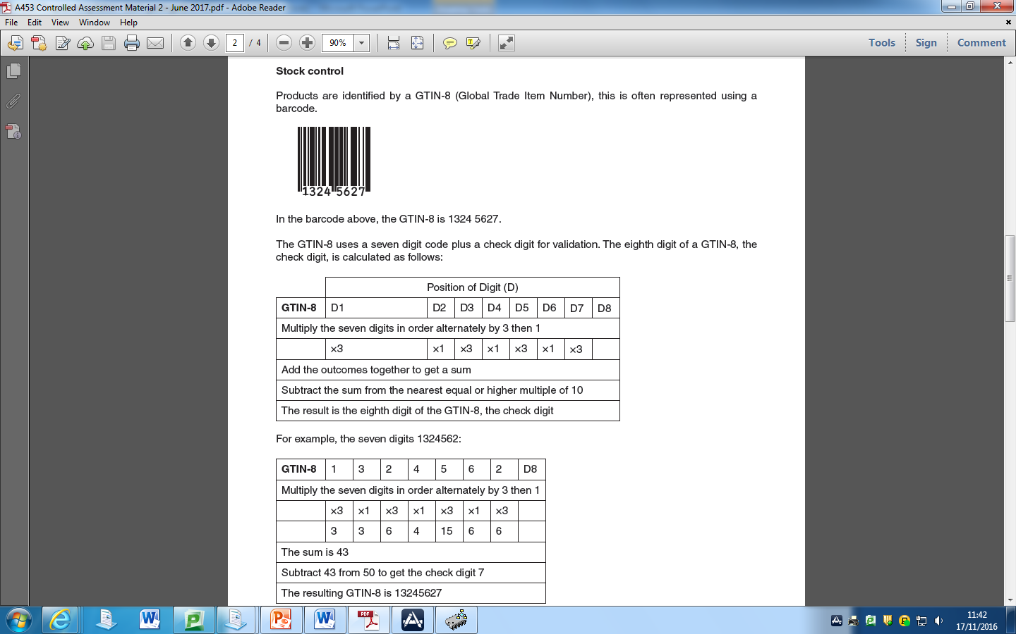

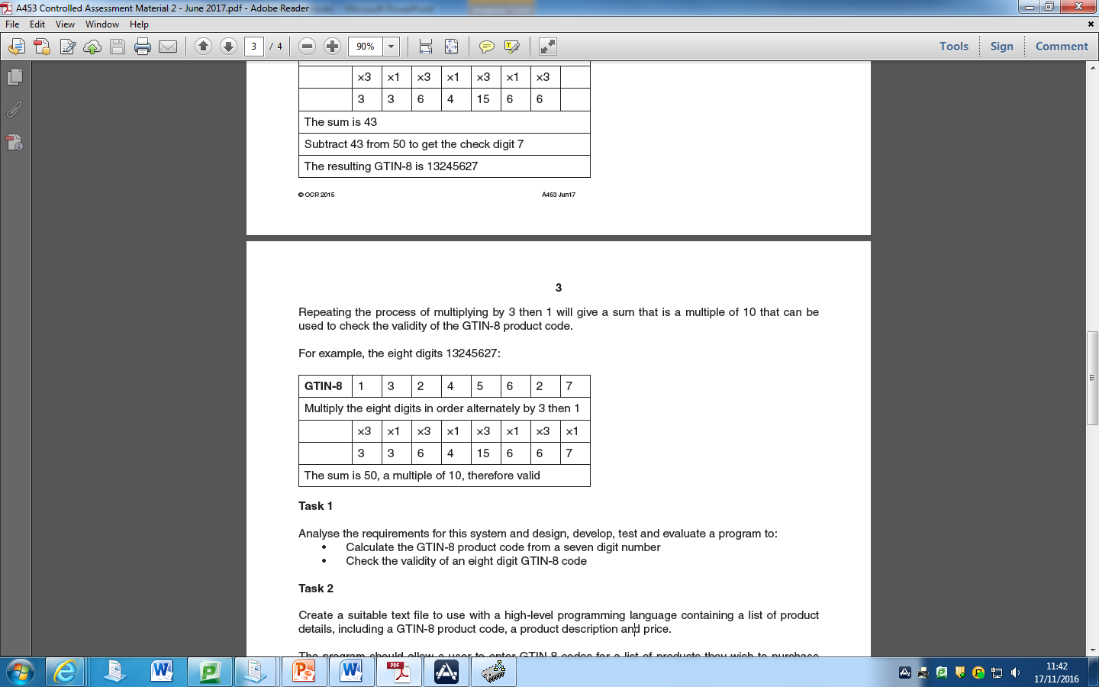

## What do I need to do?

### (i)

1. Get all seven digits and multiply them in alternately by 3 then 1.
2. Add all outcomes together
3. Subtract the sum from the nearest equal or highest multiple of ten.
4. The result is the eighth digit of the GTIN-8 code.

### (ii)

1. Get the first seven digits and multiply them in alternately by 3 then 1.
2. Add all the seven digits together.
3. Subtract the sum from the nearest equal or highest multiple of ten.
4. The result is the eighth digit of the GTIN-8 code. If this result is equal to the eighth digit of the GTIN-8 code, it is valid.

## How will I do it?

### (i)

1. Create a roundup function,
2. Ask for the first digit as an integer input named number1 and so on up to 7 digits,
3. Create a variable name AddedTogether getting all the seven digits that were inputted and multiplying them in alternately by 3 and then 1,
4. Create a new variable named RoundedUp which rounds-up AddedTogether,
5. Create a new variable called EighthDigit which takes AddedTogether away from RoundedUp,
6. Print EighthDigit.

### (ii)

1. Create a roundup function,
2. Ask for the first digit as an integer input named number1 and so on up to 8 digits,
3. Create a variable name AddedTogether getting the first seven digits that were inputted and multiplying them in alternately by 3 and then 1,
4. Create a new variable named RoundedUp which rounds-up AddedTogether,
5. Create a new variable called EighthDigit which takes AddedTogether away from RoundedUp,
6. Print EighthDigit.
7. If EighthDigit is equal to number8, print the GTIN-8 code is real.
8. If EighthDigit is not equal to number8, print the GTIN-8 code is fake.

## How will I roundup?

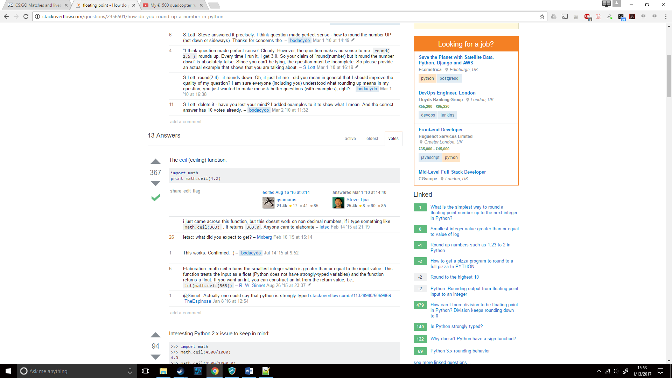I first looked up how to roundup in Python where I came across the following (http://stackoverflow.com/a/2356510/5985905):

I tested the code out on the Python IDLE where I came across this result:

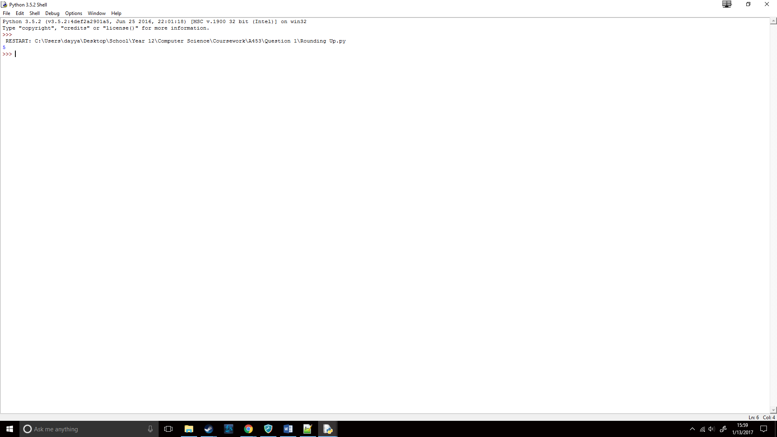

I immediately noticed that it rounded up to the nearest integer and not 10, so I changed my function to:

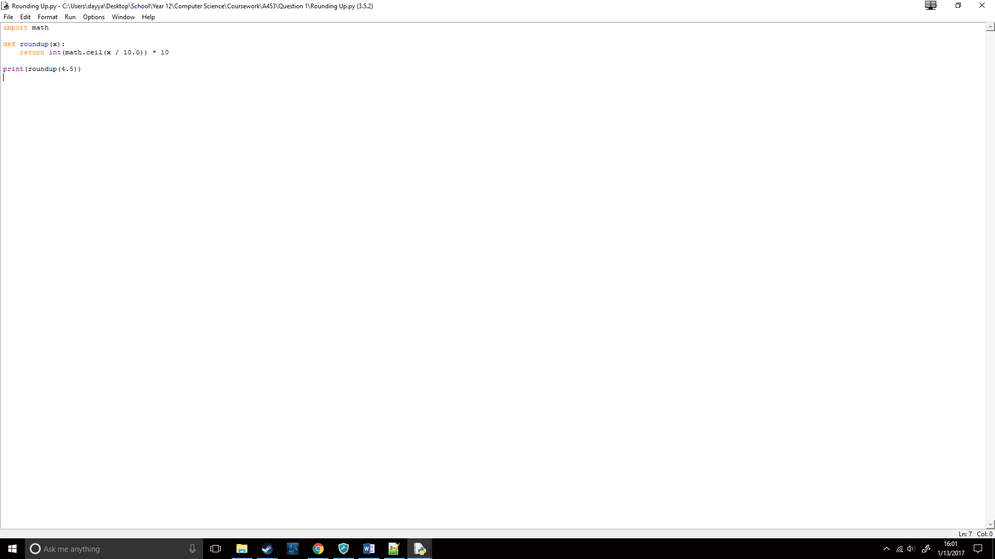

What I expected this to do is; divide x (the number I want to roundup) by 10, then it will roundup, this divided number and finally, multiply this divided, and then rounded up number by 10.

For example, with 4.5;

1. Divide 4.5 by ten, so 0.45
2. Roundup 0.45, so 1
3. Multiply it by 10, so 10.

I then tested it out with 4.5 and this was the result:

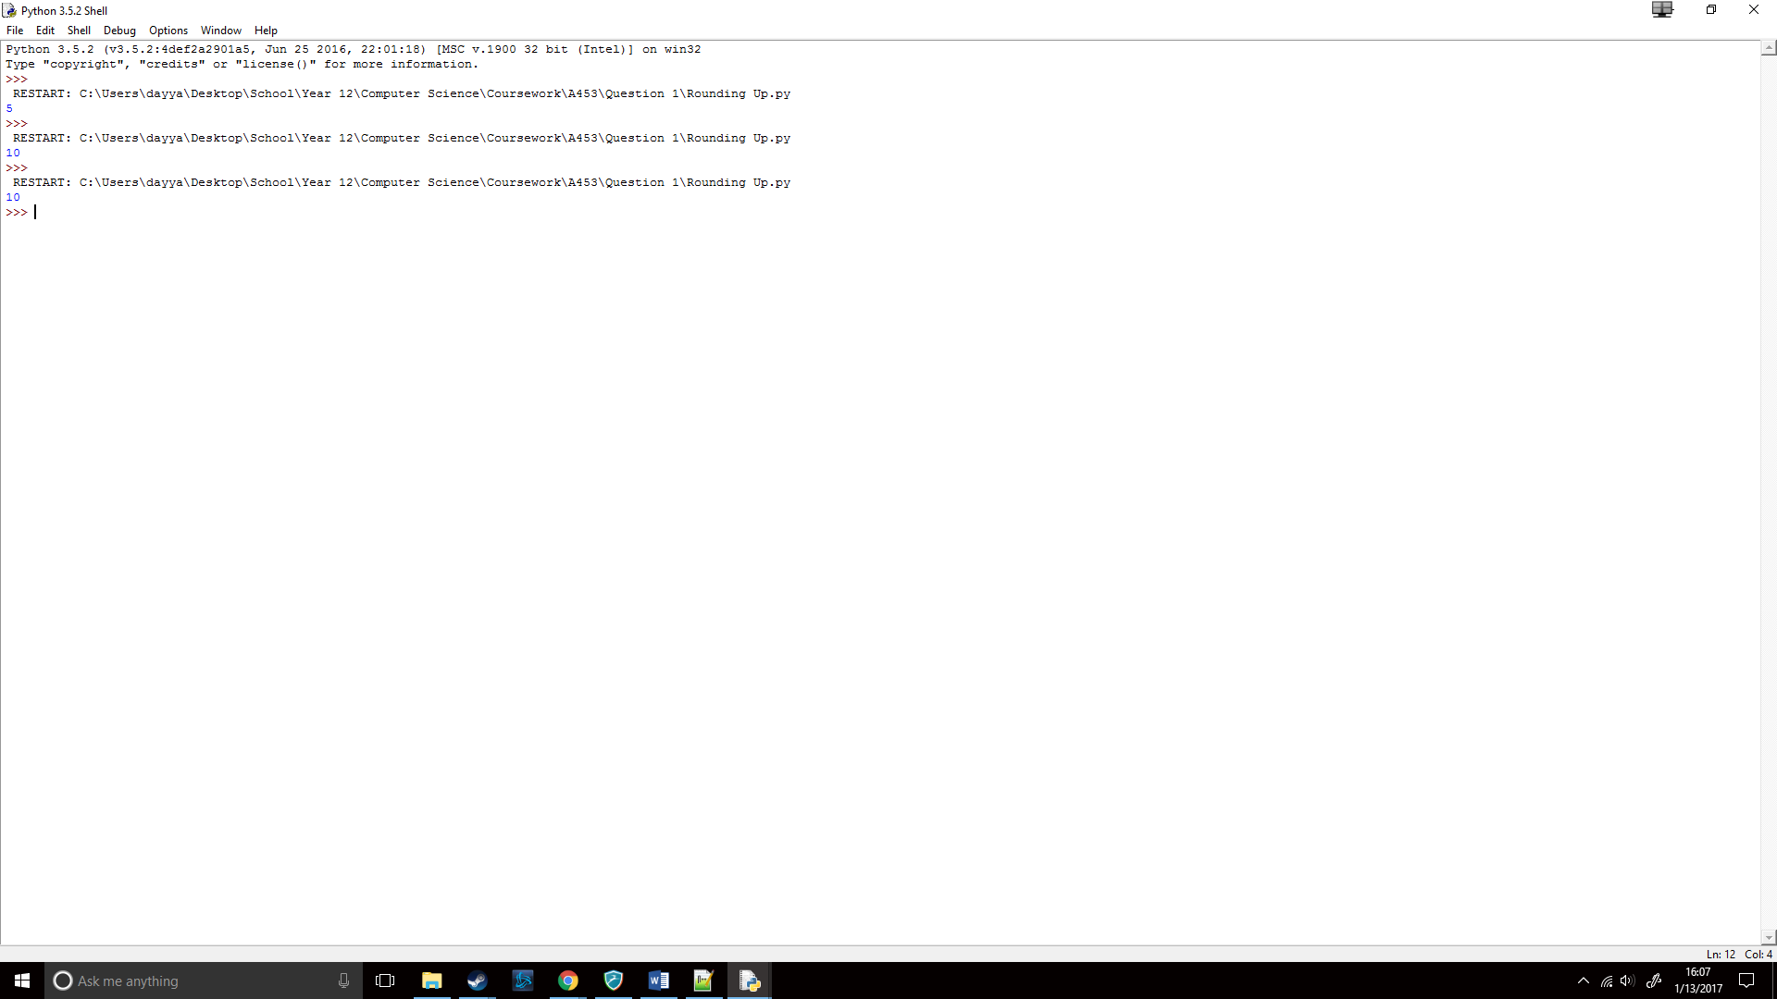

Success! Now I would have to deal with the inputs.

## How will I get inputs from the user?

With a fair knowledge of Python from experience, I started straight away. My first attempt was:

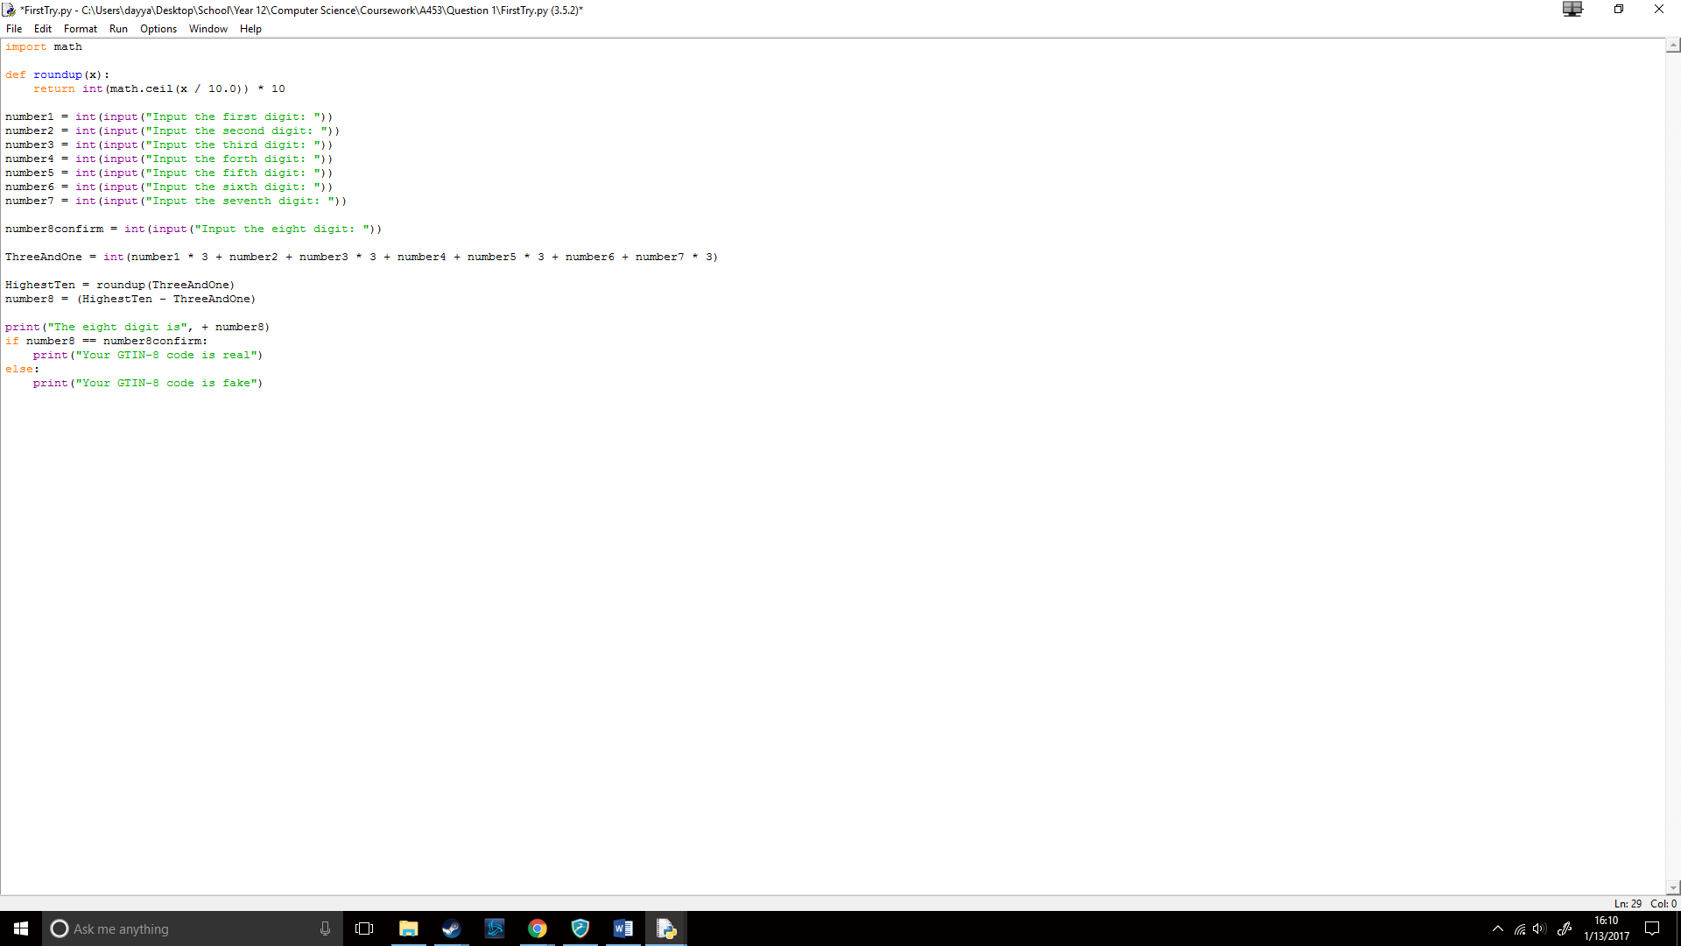

When I ran the code, it worked like this:

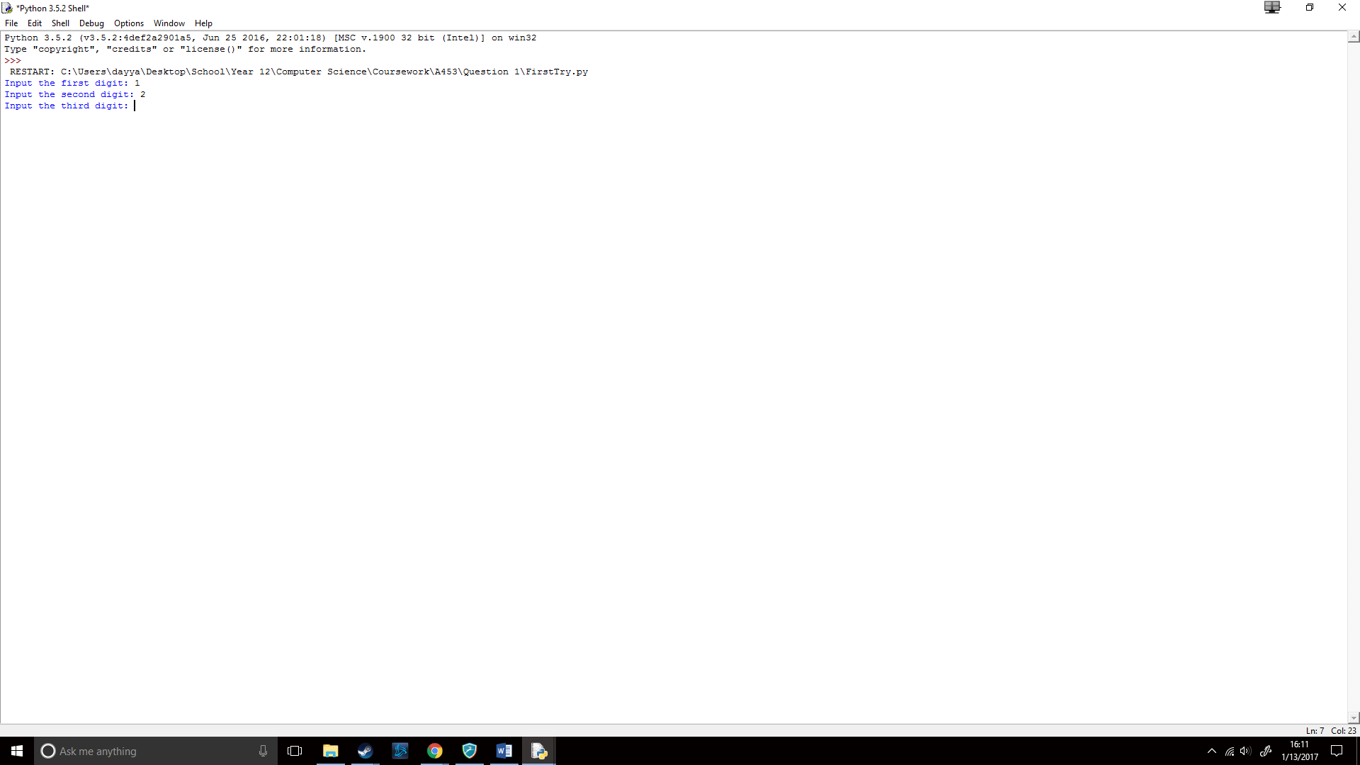

When I tried printing these digits, this was the result:

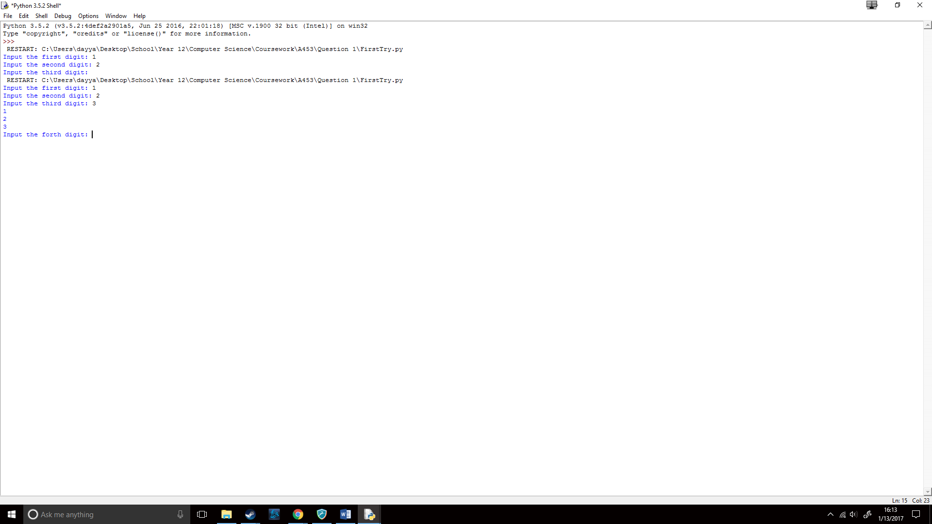

It worked! Success so far, now to try adding & multiplying the numbers.

## How will I add and multiply the numbers?

Like said previously, I already had a fair grasp on Python. So, I tried adding with the variables and this was the line of code I used: 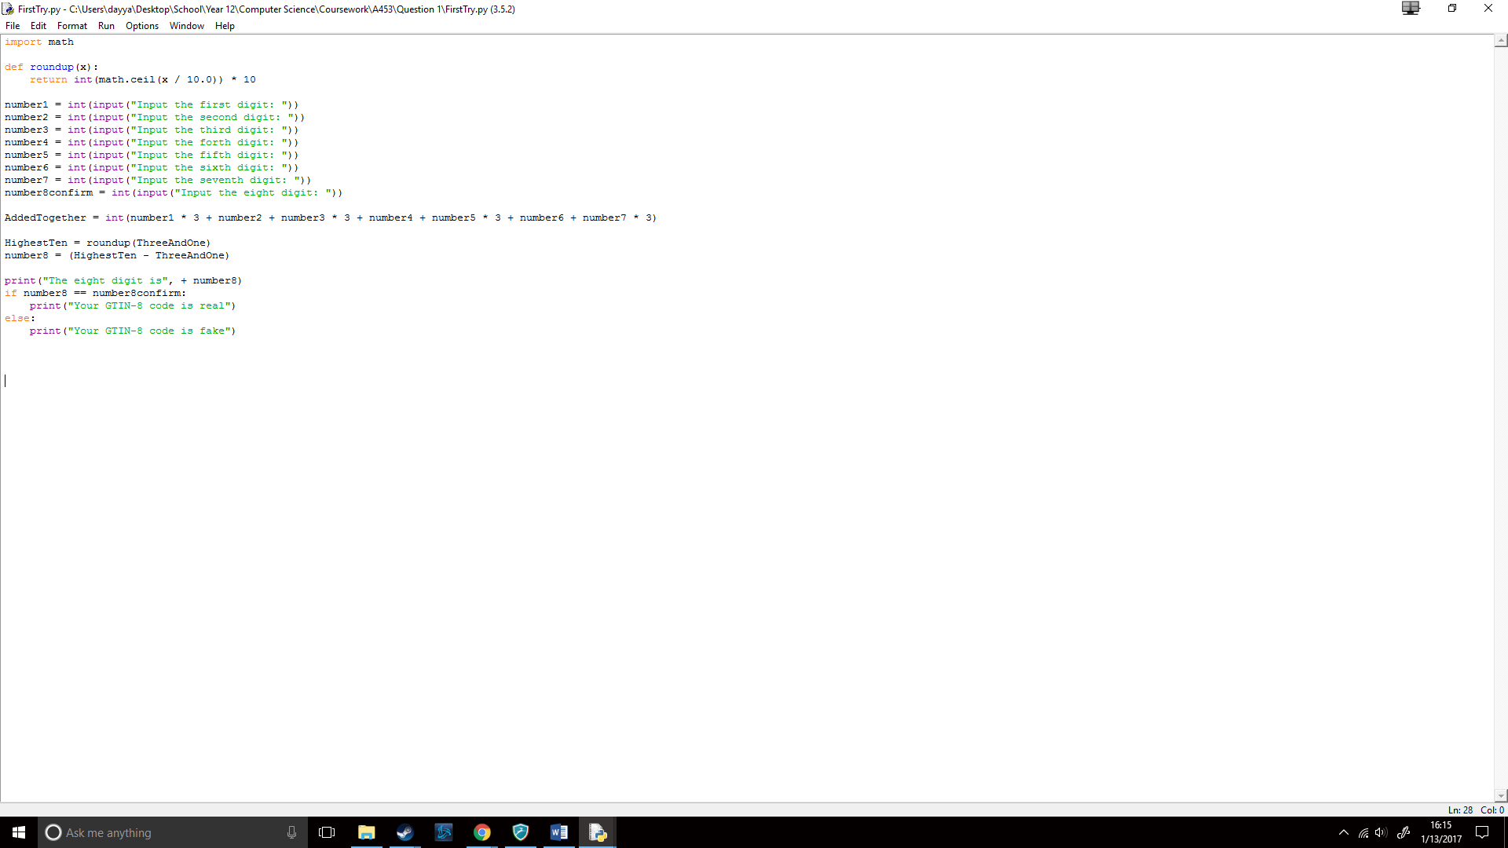

I then ran it to see if it would work:

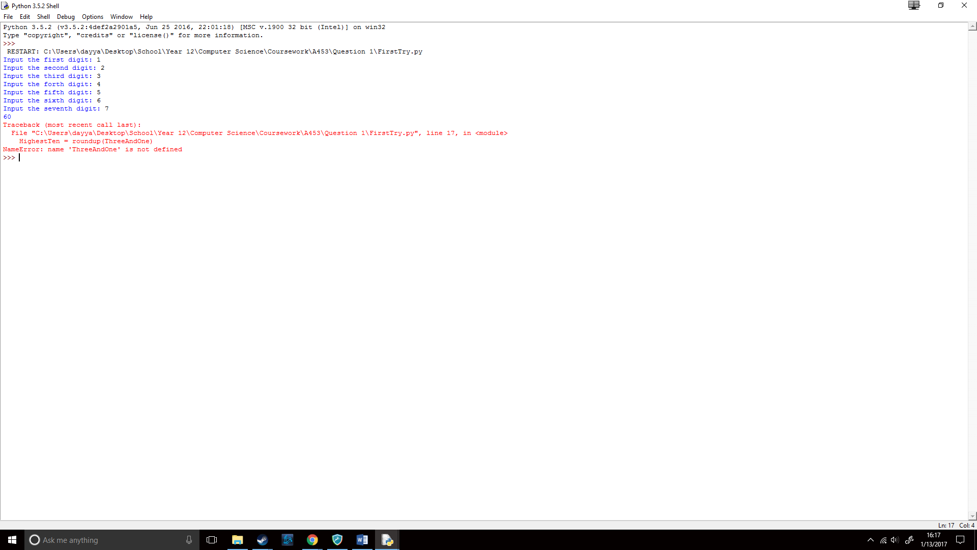

I then tested with a calculator to see if the result was correct. (1x3) + (2) + (3x3) + (4) + (5x3) + (6) + (7x3), which gave the result 60, showing that AddedTogether worked correctly.

## How will I take away AddedTogether away from RoundedUp?

I simply wrote:

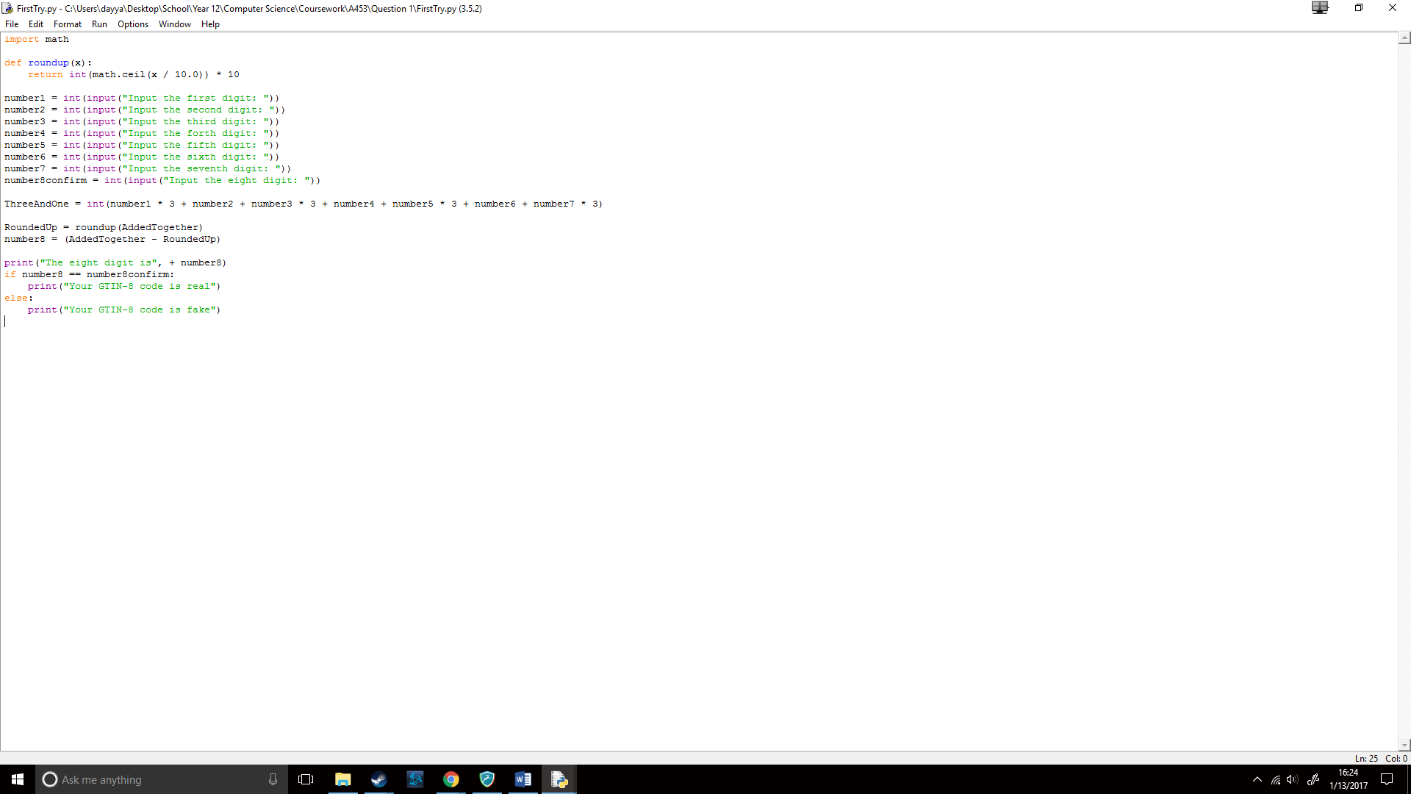

Which worked correctly on the first try!

## How is it all put together?

As I was working it on the same file the entire time, it was all together already. The code looked like this:

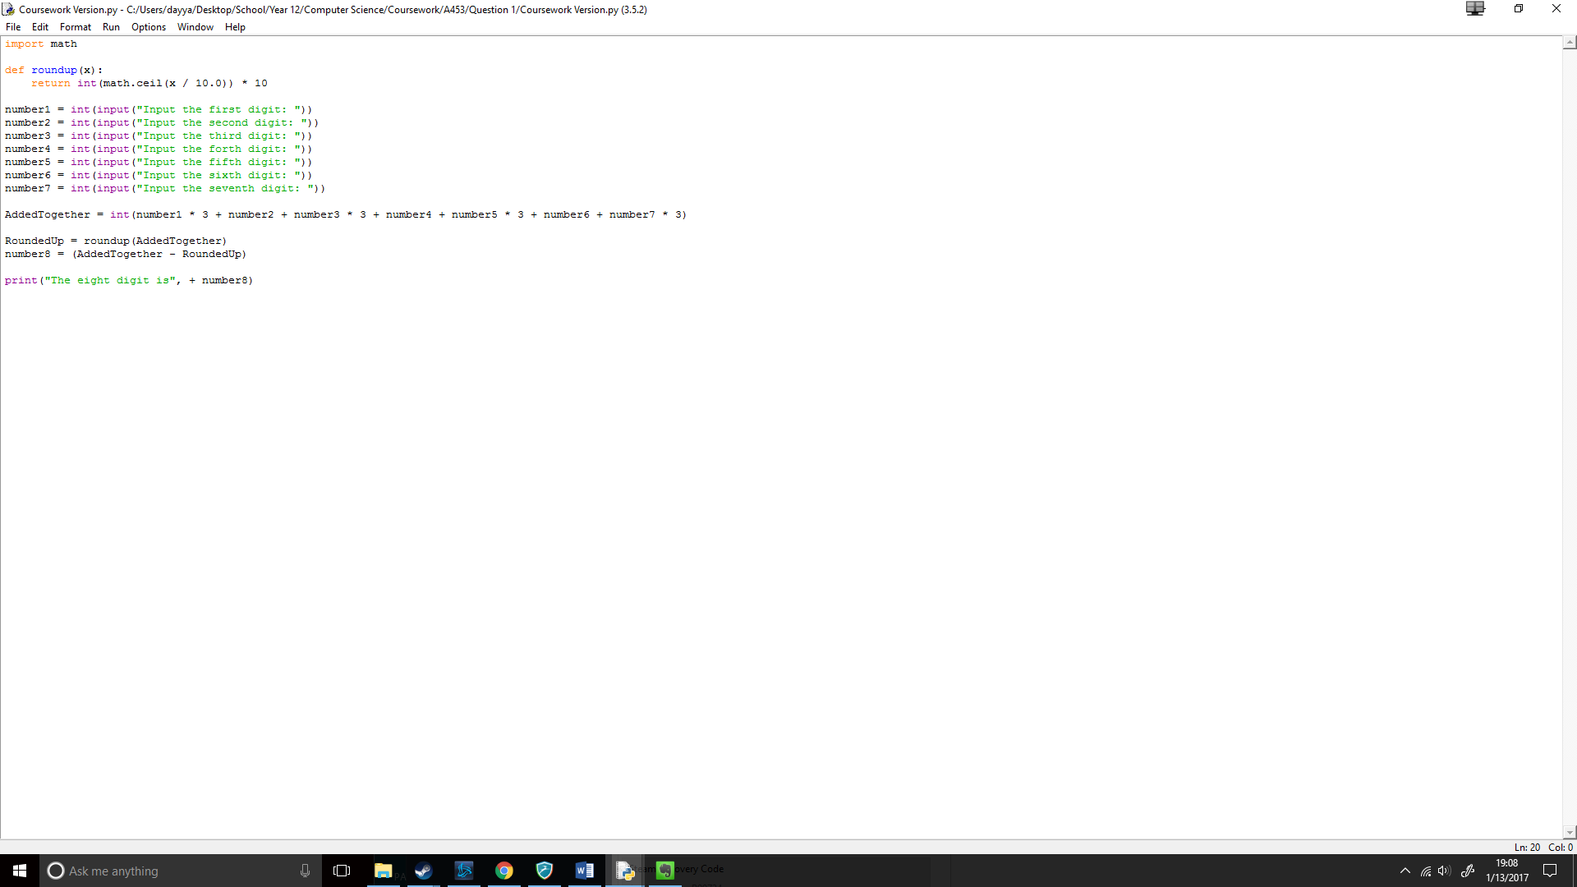

I then ran the code to test it, which gave the following result:

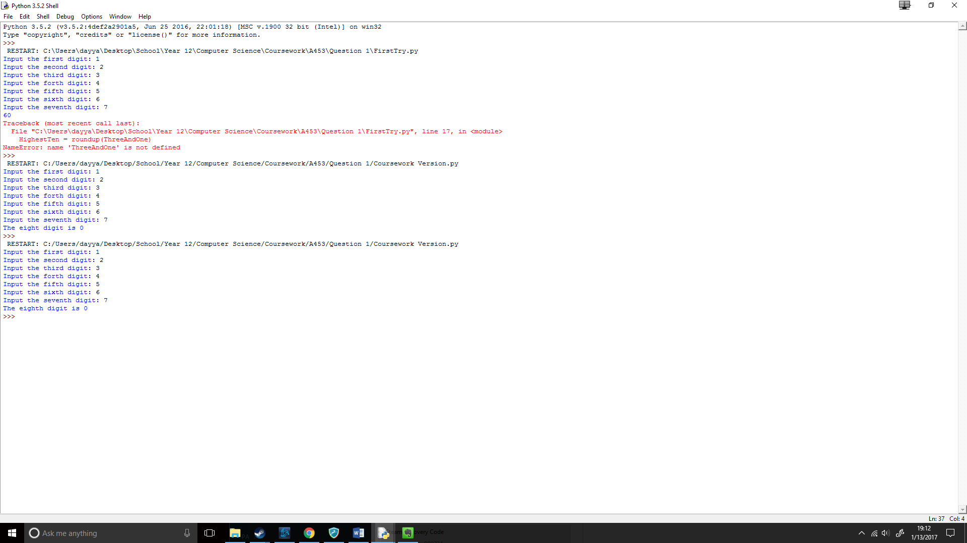

When I tested it with a calculator, the eighth digit was 0, meaning my code worked!

## How can I shorten the code?

My first goal was to ask for the GTIN-8 code in one line, I knew this would have to be done with [x], for which digit I would like to edit. I first created the input, where I asked for the code and then converted it to a string to allow me to choose each digit of the code, the code for it was the following:

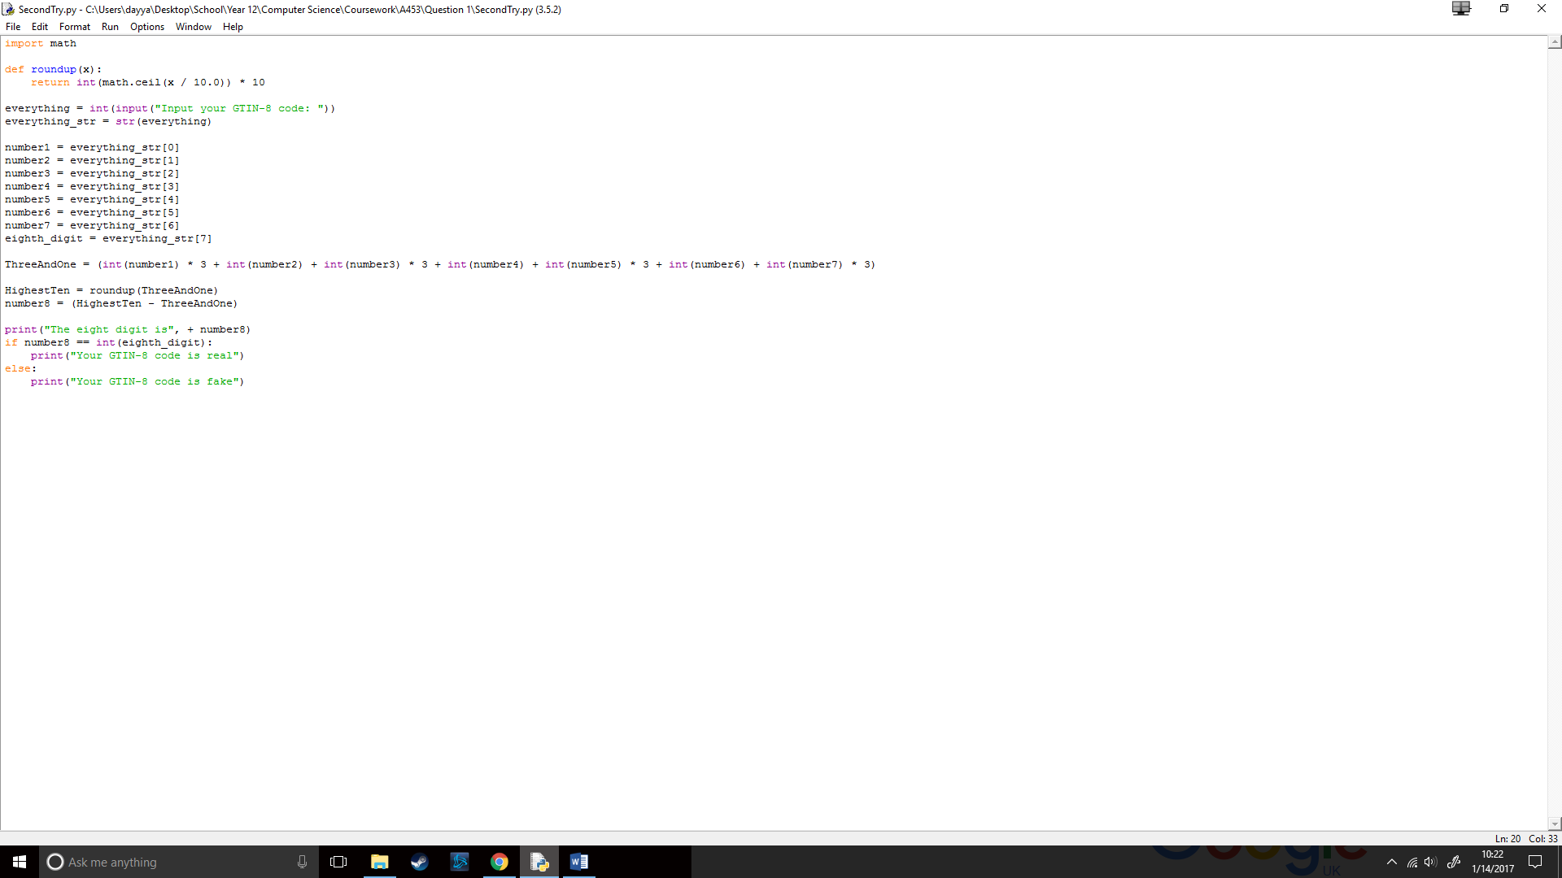

As I did python previously, including the year before I learnt about how to find the length of a string and choose a certain digit in it. So, I then made it so, with number1 it would check the first digit of the GTIN-8 code, with number2 the second digit and so on.



Then I took the rest from my first try and added it together so it would be functional code. Here’s how it worked:

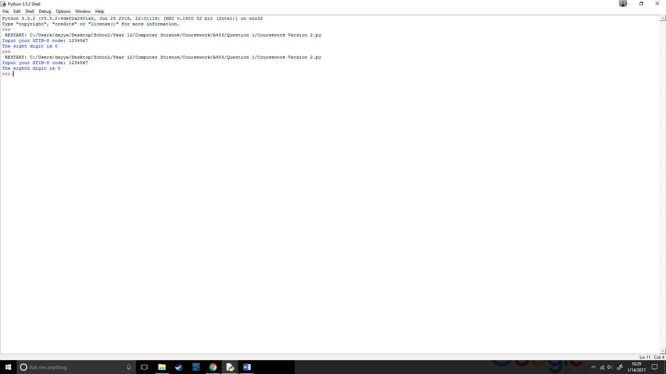

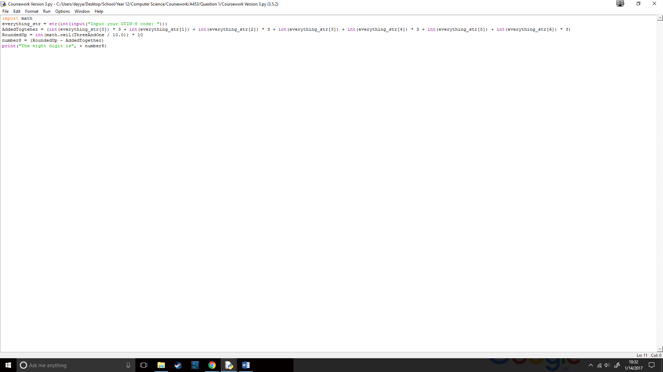It worked successfully, so I attempted to shorten my code even further. I figured out that I could check each digit of the code in the AddedTogether line allowing me to remove seven lines of code, so it now looked like this (since the line is so long, I am showing the same line in two pictures):

I then added str in-front of everything_str, to take off one line:

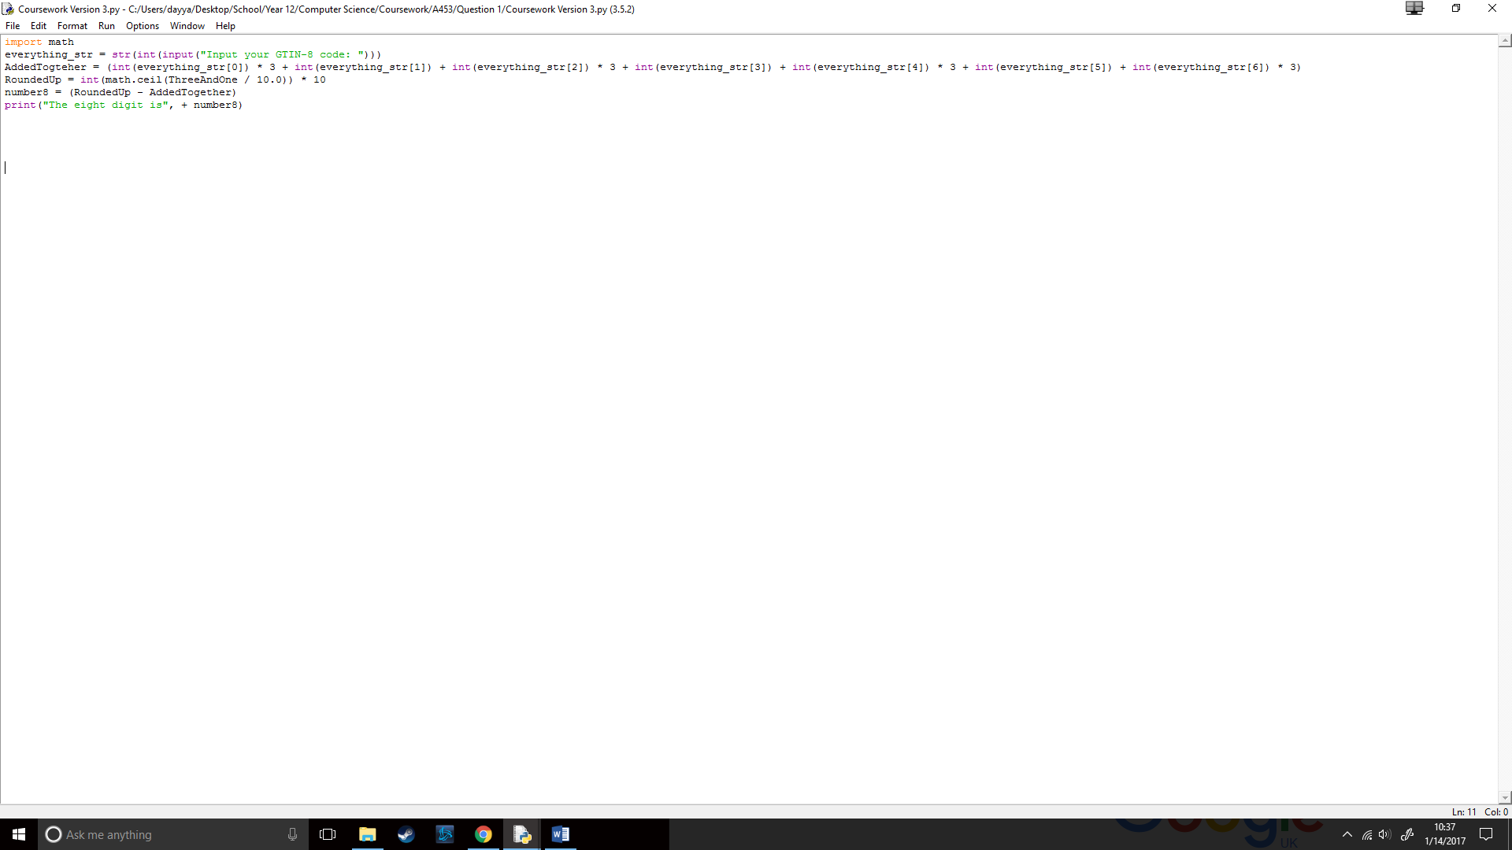

And finally, I removed the roundup function and did what that function did in the RoundedUp line:



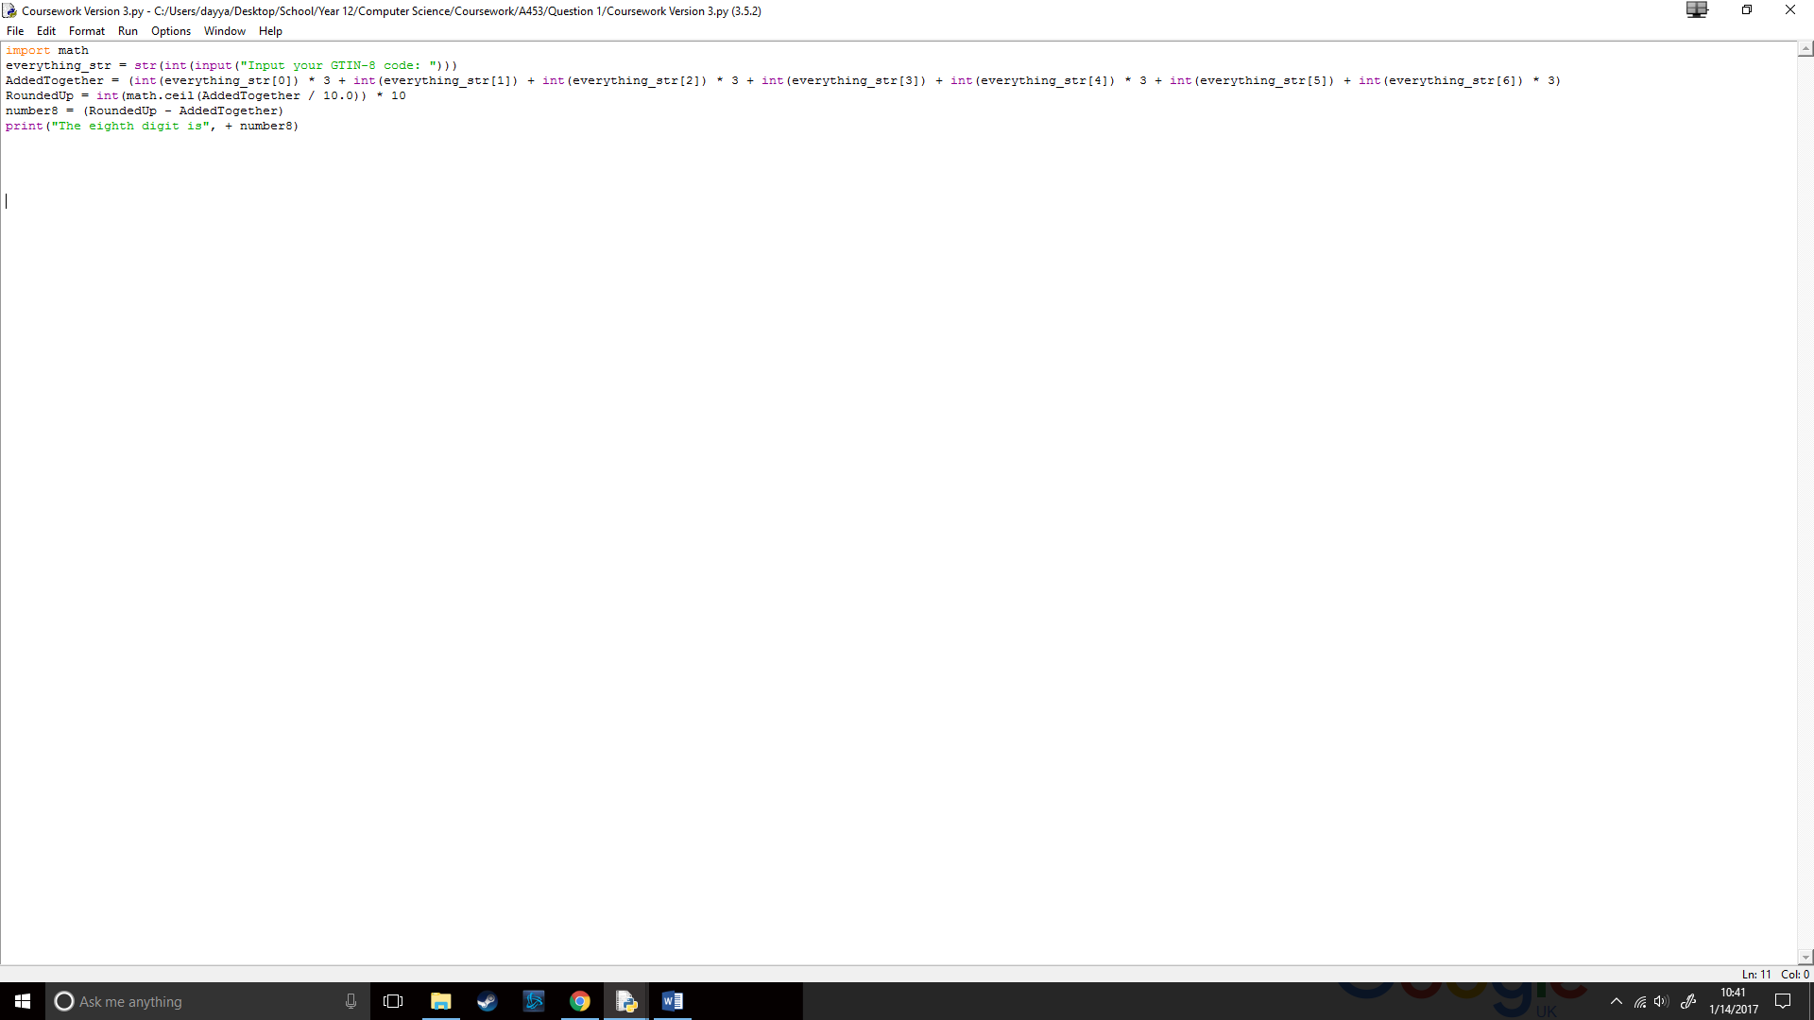My code now looked like this:

Which worked like this:

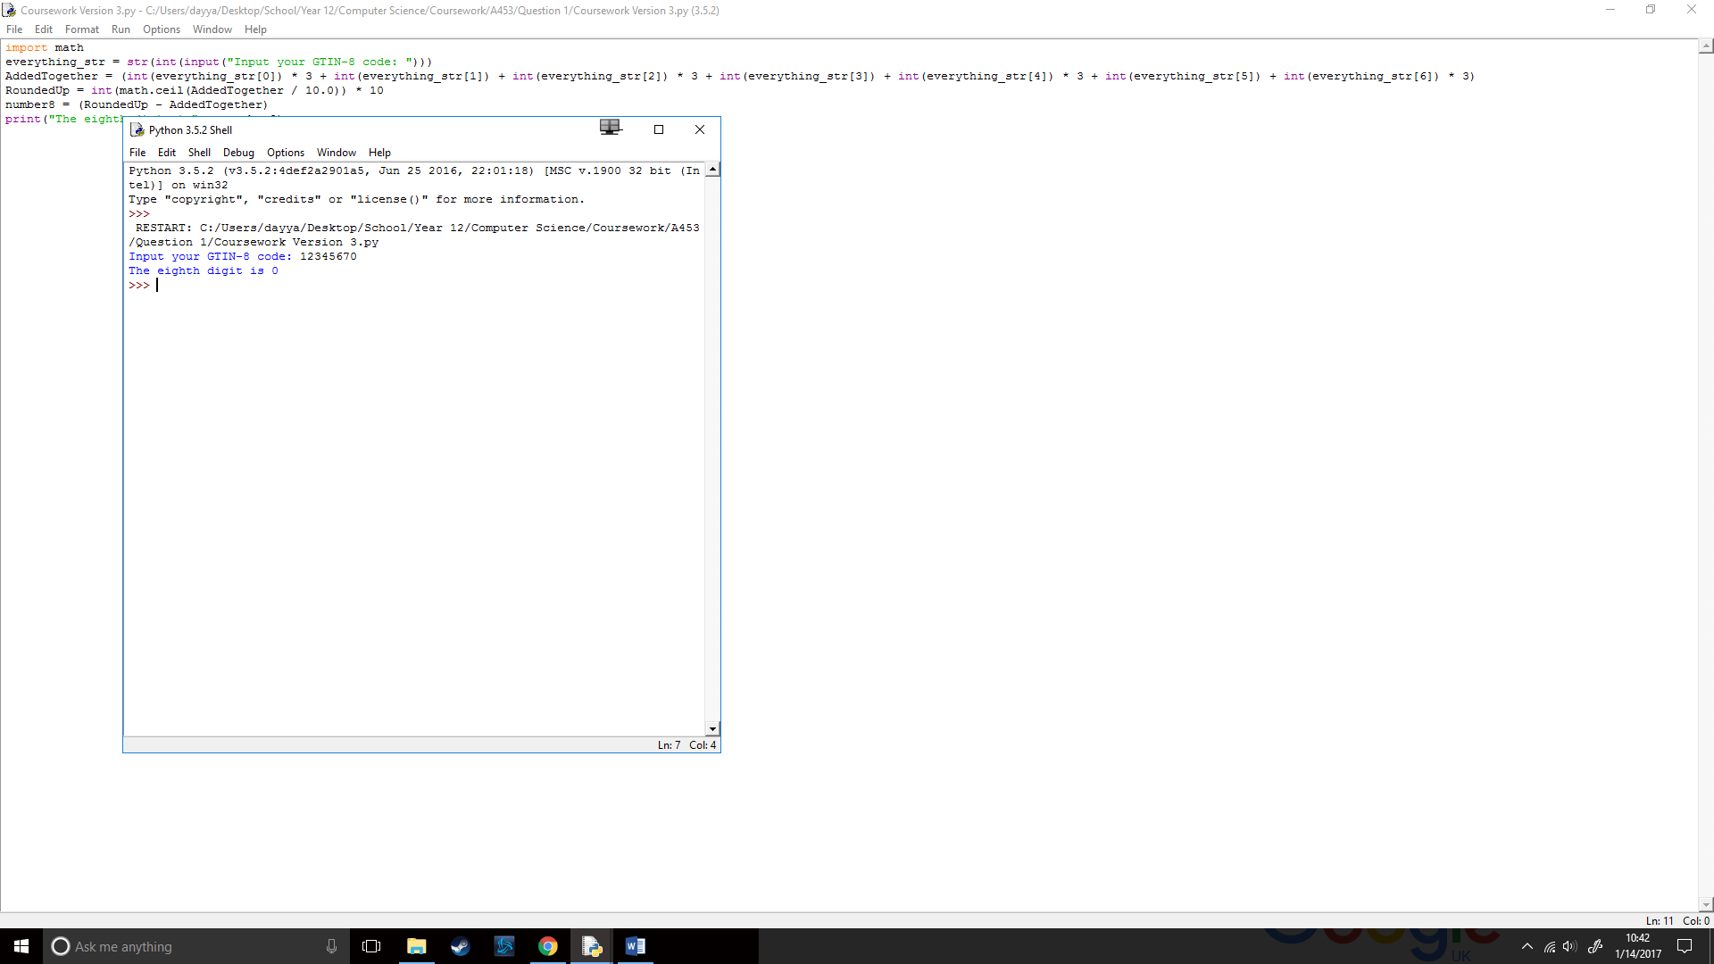

## How will I check the validity of an eight-digit GTIN-8 1code?

Using the bone structure of my shortened code, I just had to add a few lines to make it check the validity of an eight-digit code.

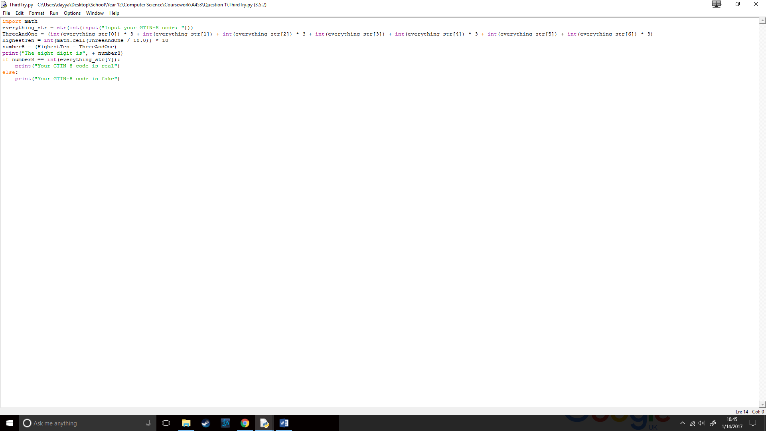

I then ran the code to see if it worked, which gave this result:

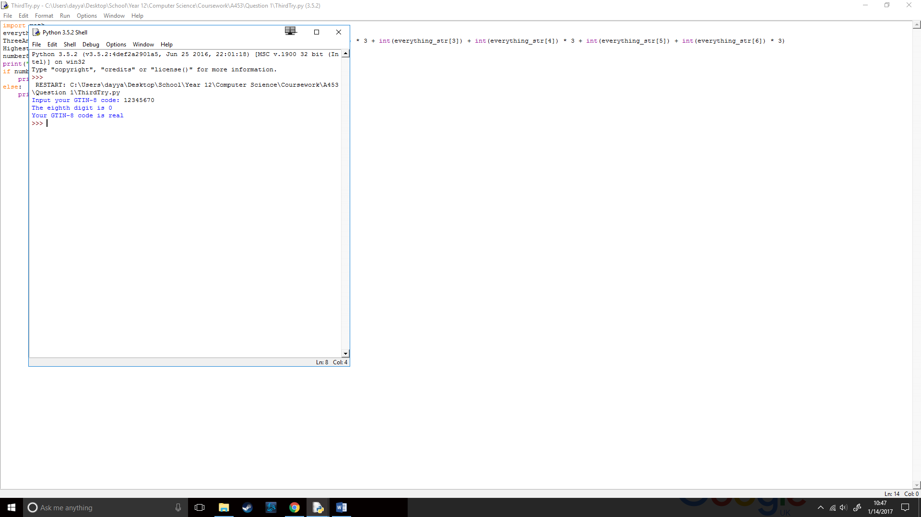

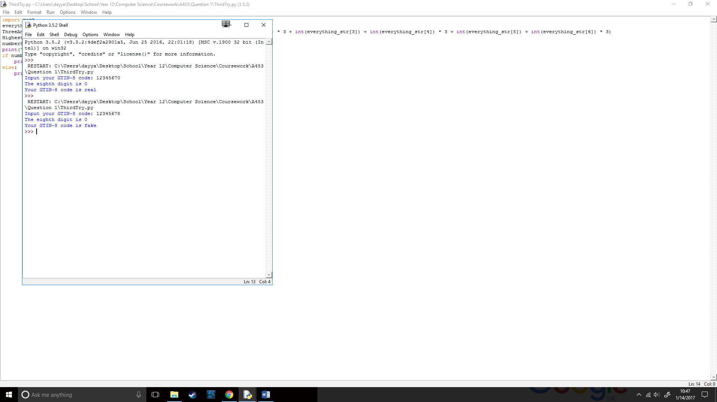

This meant my code worked perfectly!

## How will I make the GTIN-8 code detector better?

I then tried to implement an if statement what would check if the GTIN-8 code in a digit and tried to make sure that the length of the line is equal to 7 or 8 depending on (i) or (ii), to check of the length of the line I use an equals statement that would check if the length of the GTIN-8 code is equal to eight, I would also do the same but == 7 for (i):

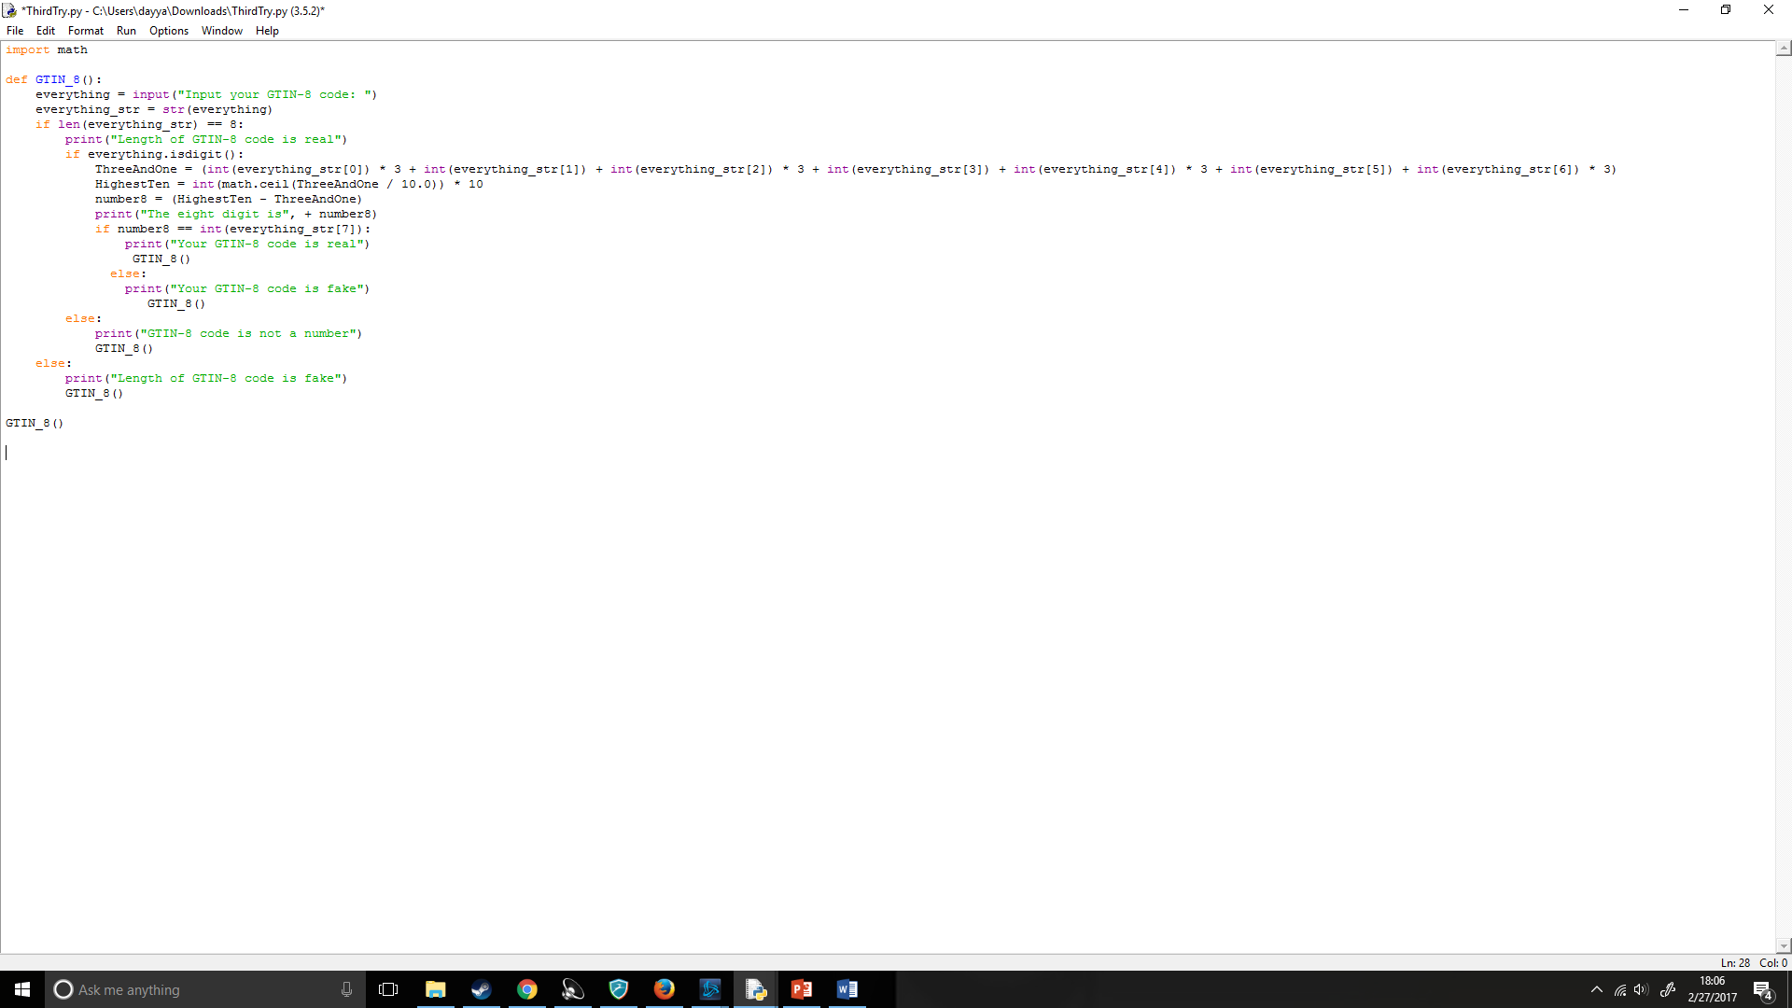

When running the code it worked like the following:

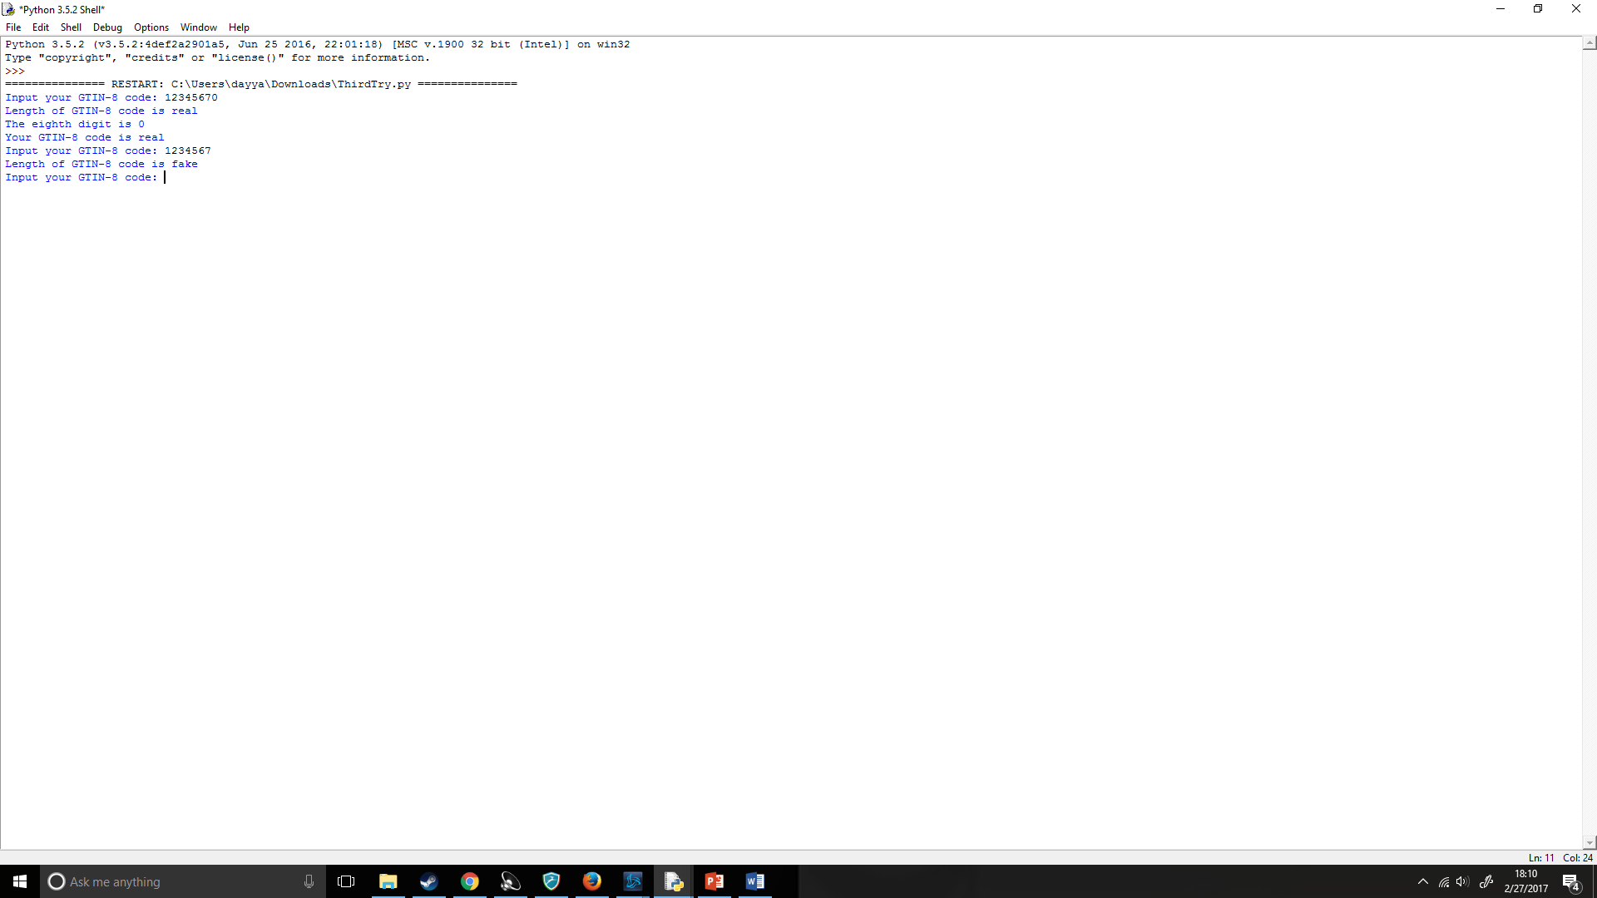

Now that the length checker would work I wanted to check for a number. I first tried by adding int to the start of the input():

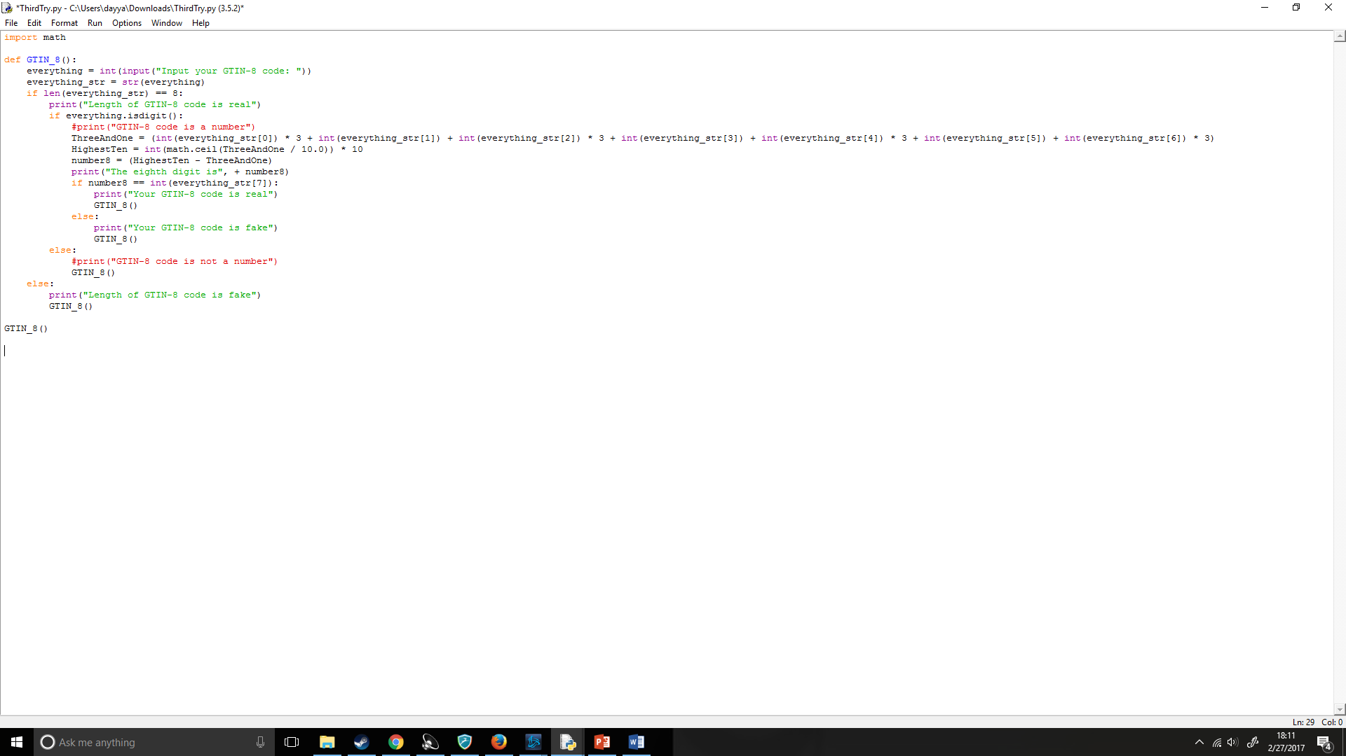

But when trying to enter a number it gave an error which stopped the program stating that the input was not an int:

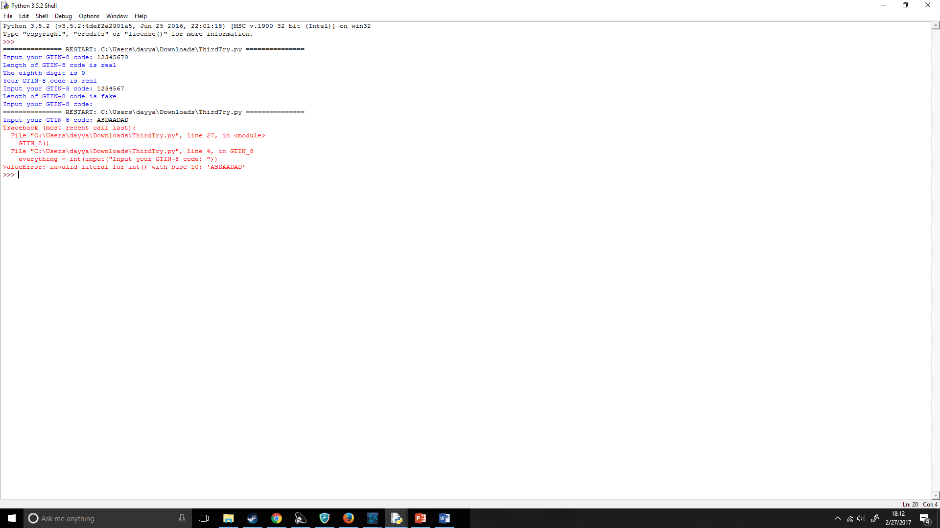

I then looked through the python documentation where I found .isdigit() which would check the string (as inputs by default are strings) if it was a digit (https://docs.python.org/3/library/stdtypes.html):

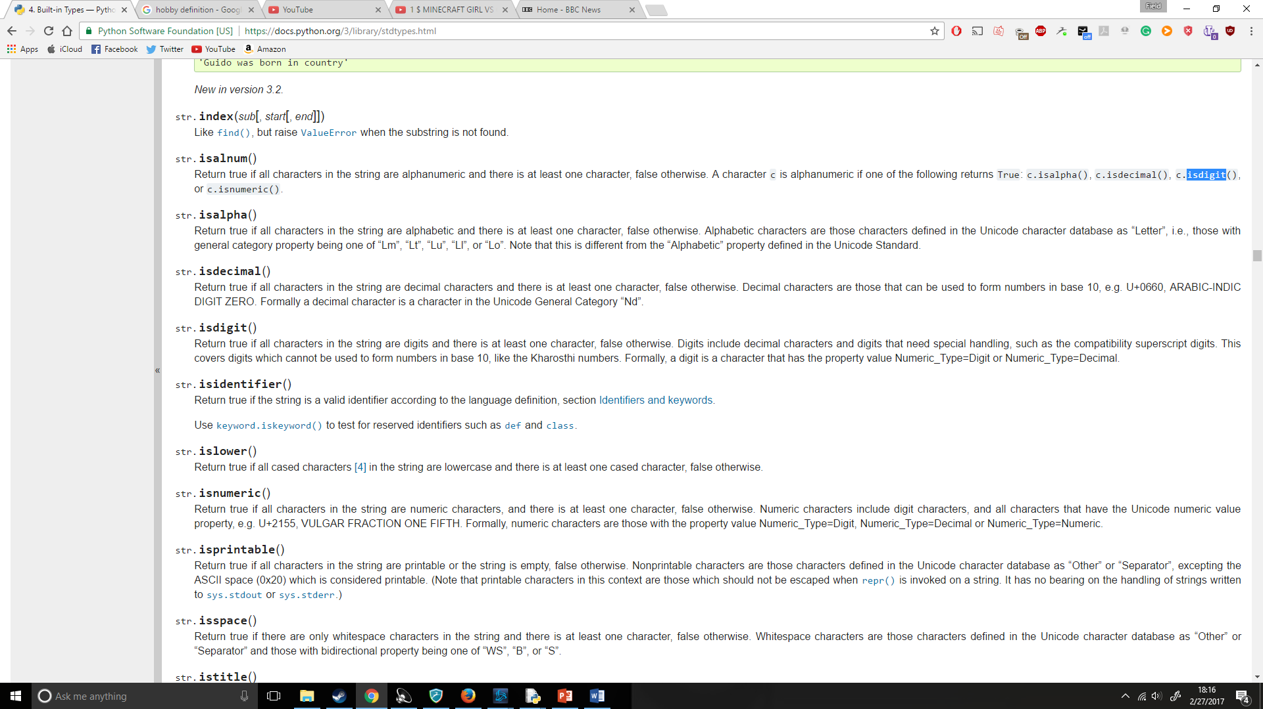

So, I then checked if everything is equal to a digit and if it returns True it would go on with the code:

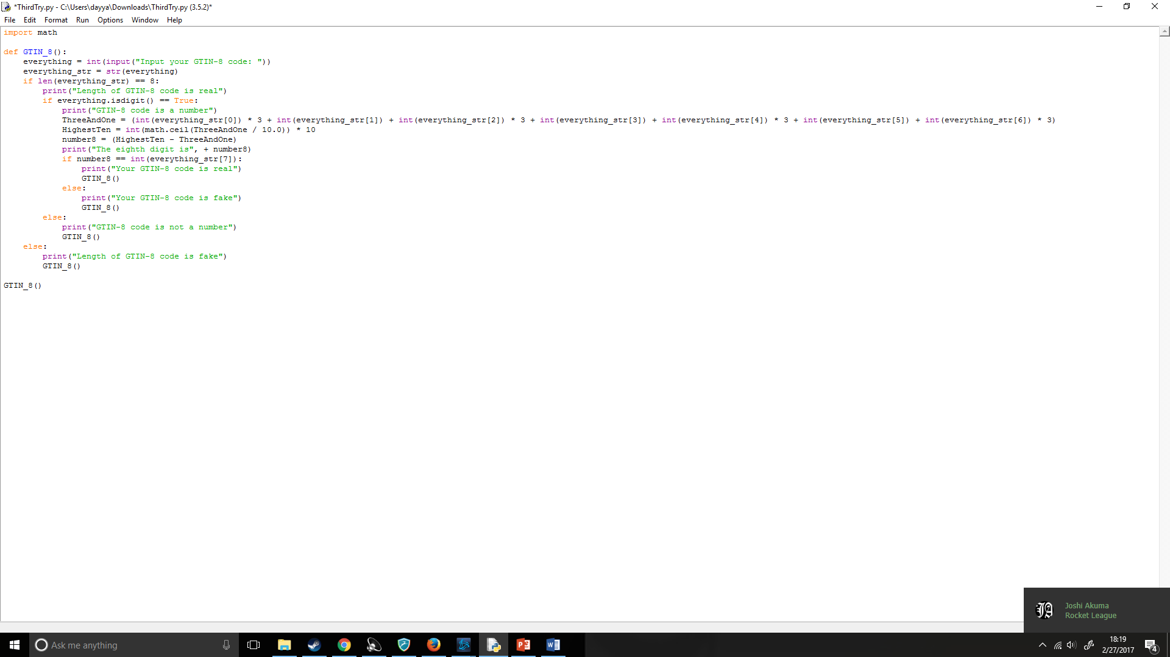

I then ran the code and;

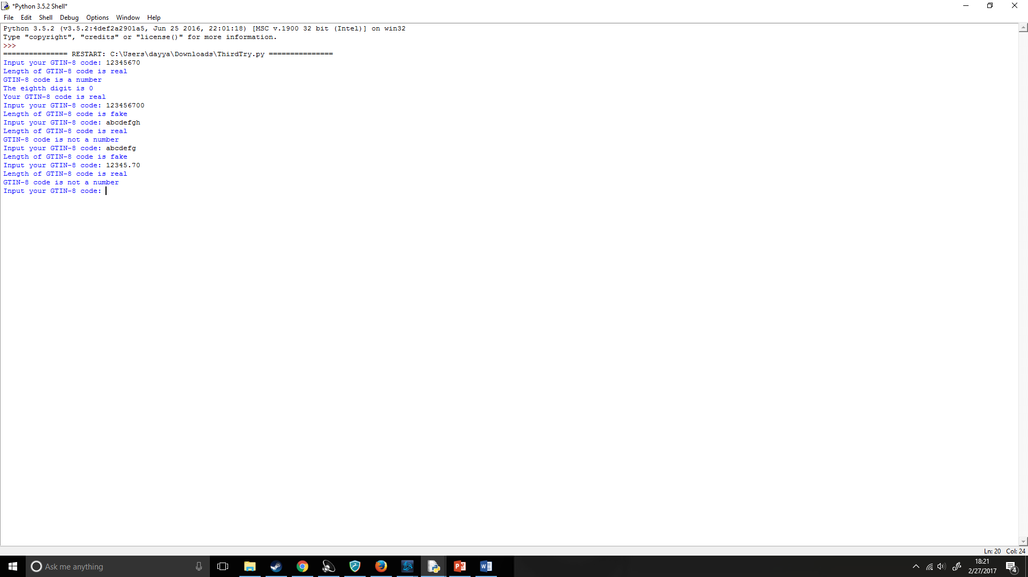

It worked correctly!

## Destructive Testing

### Section 1.0.0 (Length) –

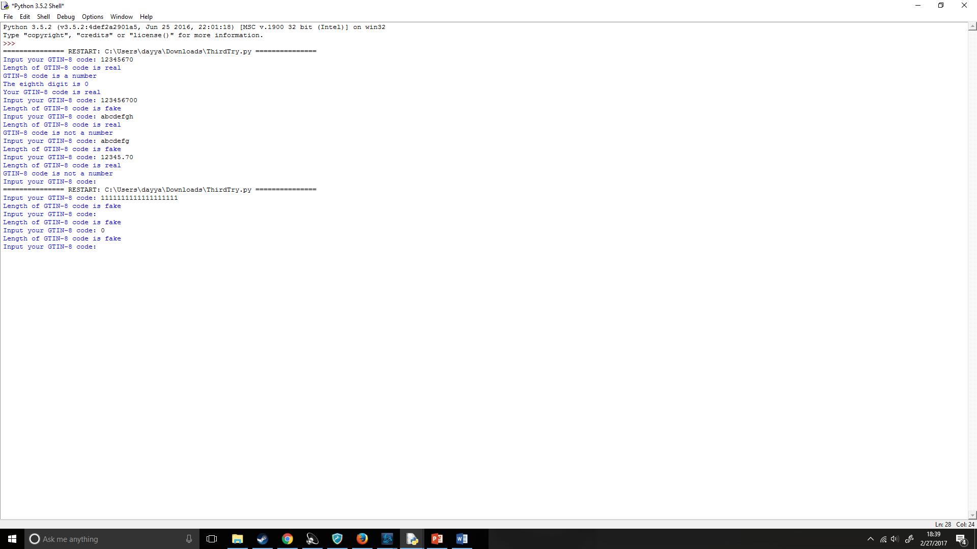

Preformed correctly, detects length of GTIN-8 code fine.

### Section 1.0.1 (Symbols) –

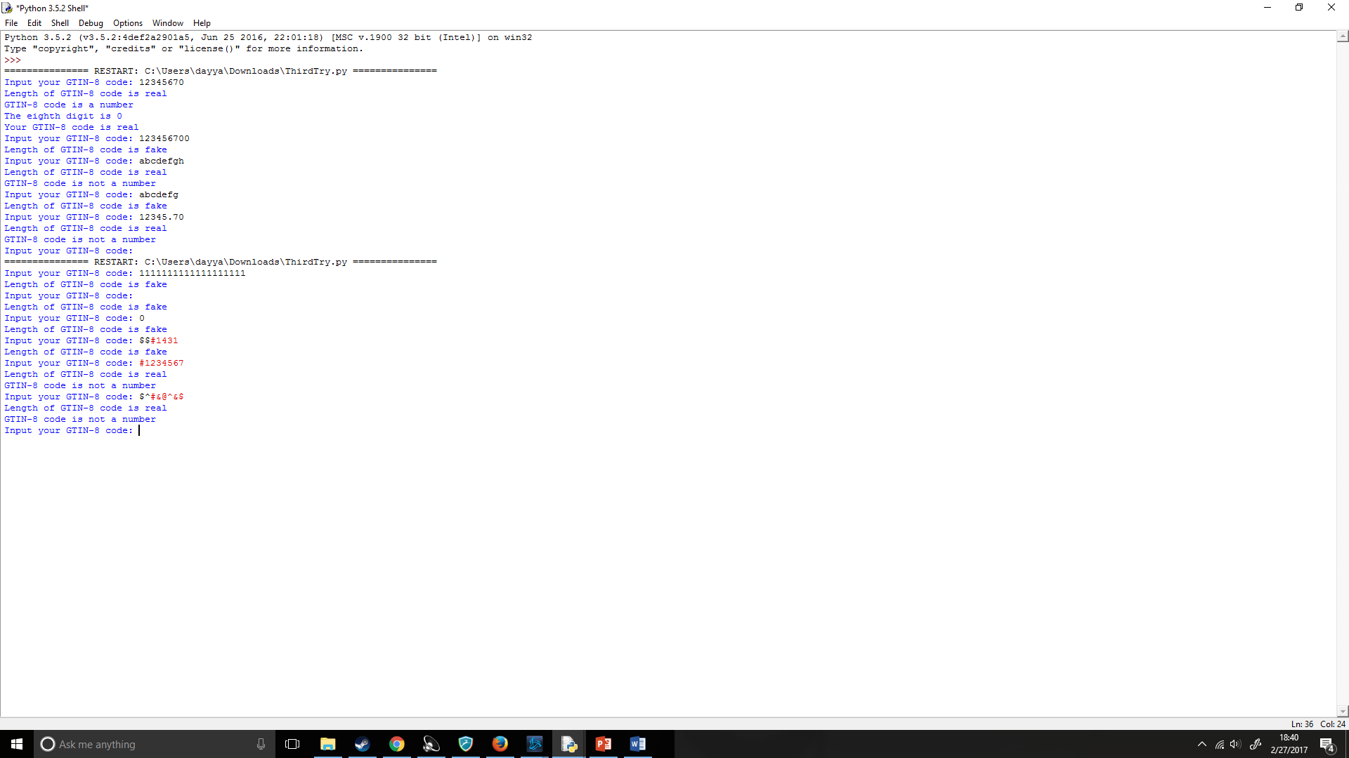

Preformed correctly, checked if the GTIN-8 continued symbols correctly.

### Section 1.0.2 (Spam) –

Preformed correctly, always returned to question when spamming

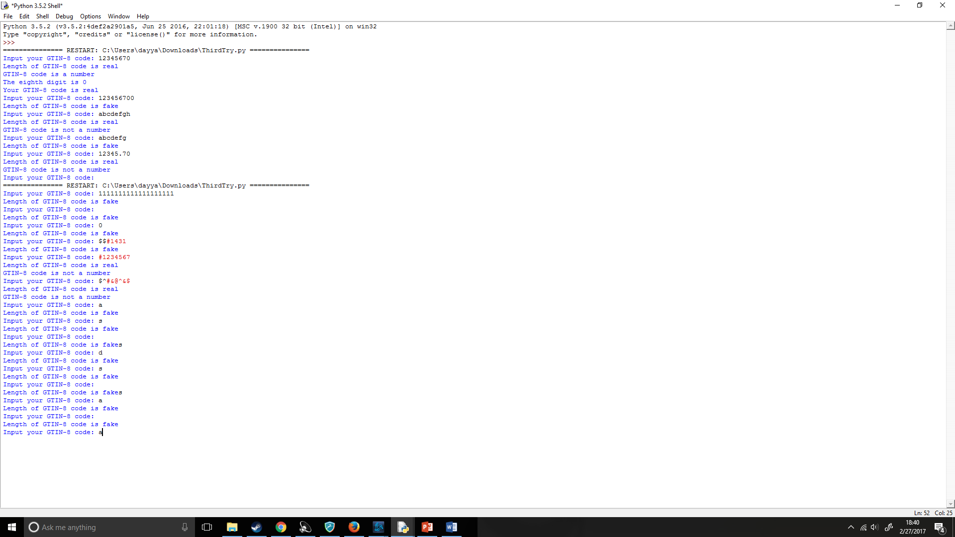

### Section 1.0.3 (Decimals) -

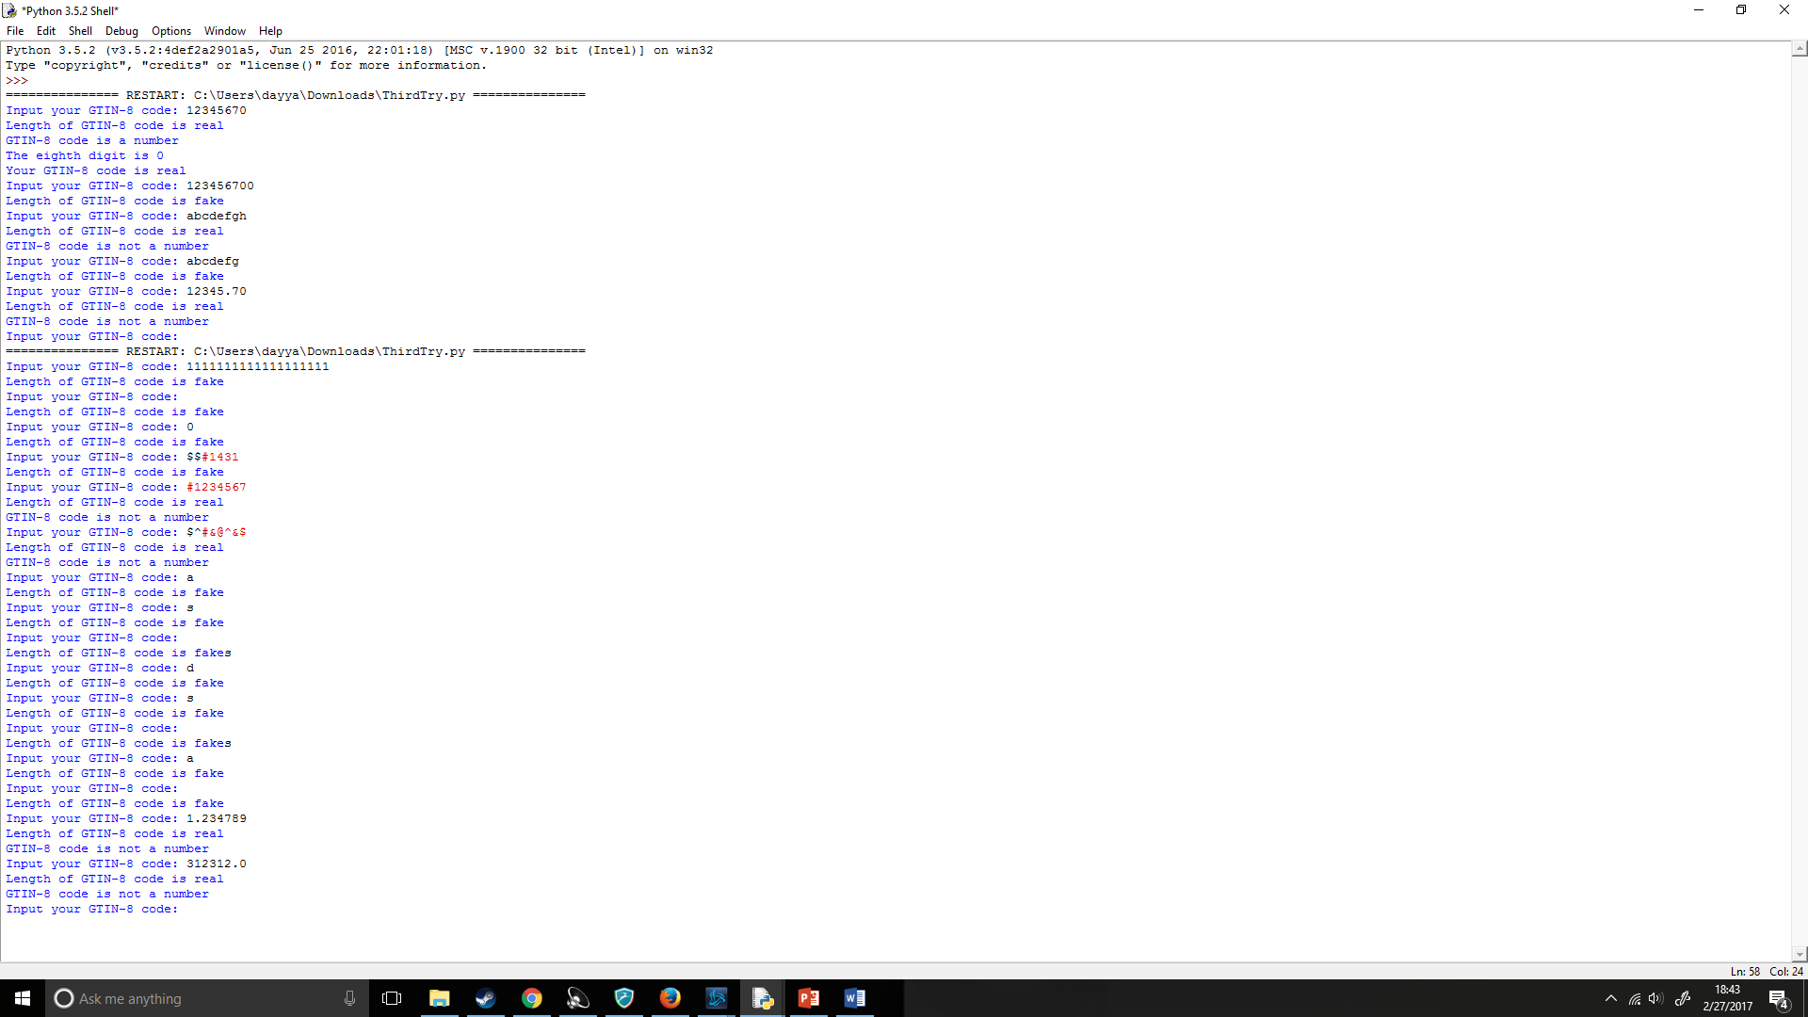

Preformed correctly, .isdigit() didn’t see decimal points as part of a digit

## Overall Code:

GTIN_8() was added to make the overall code more fluid and allowed better ease of use for the user.

### (i):

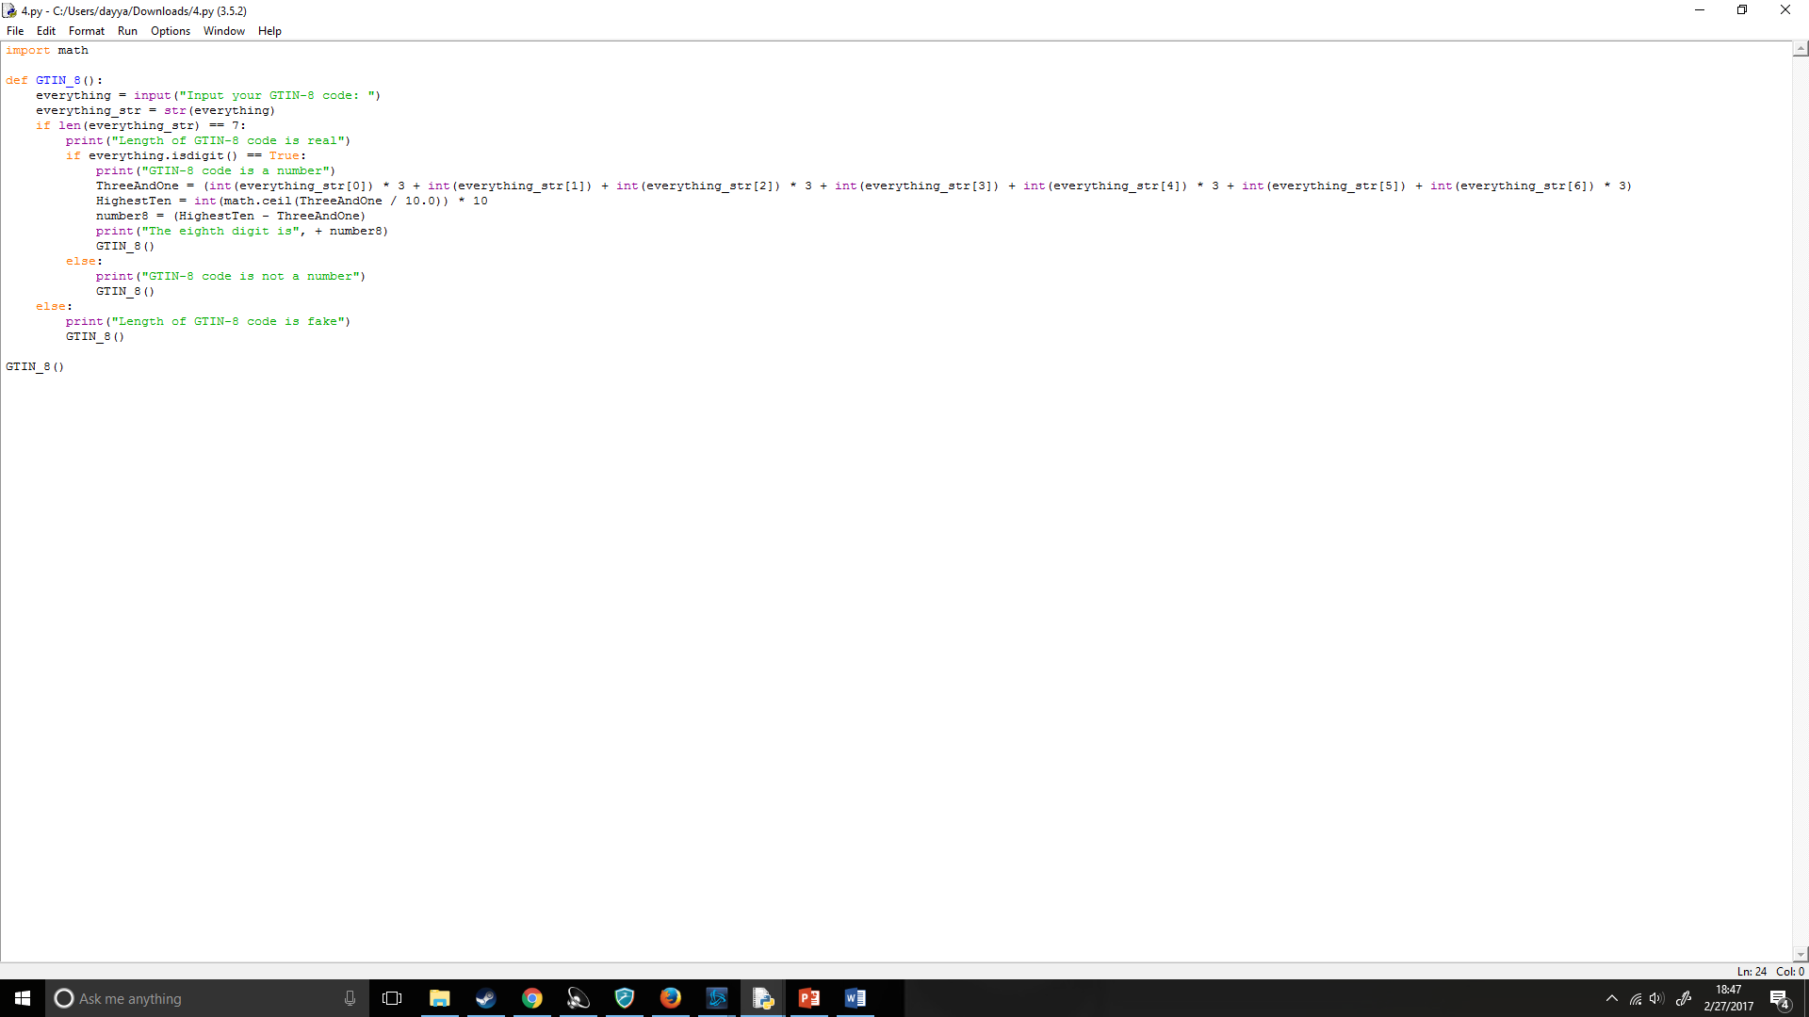

### (ii):

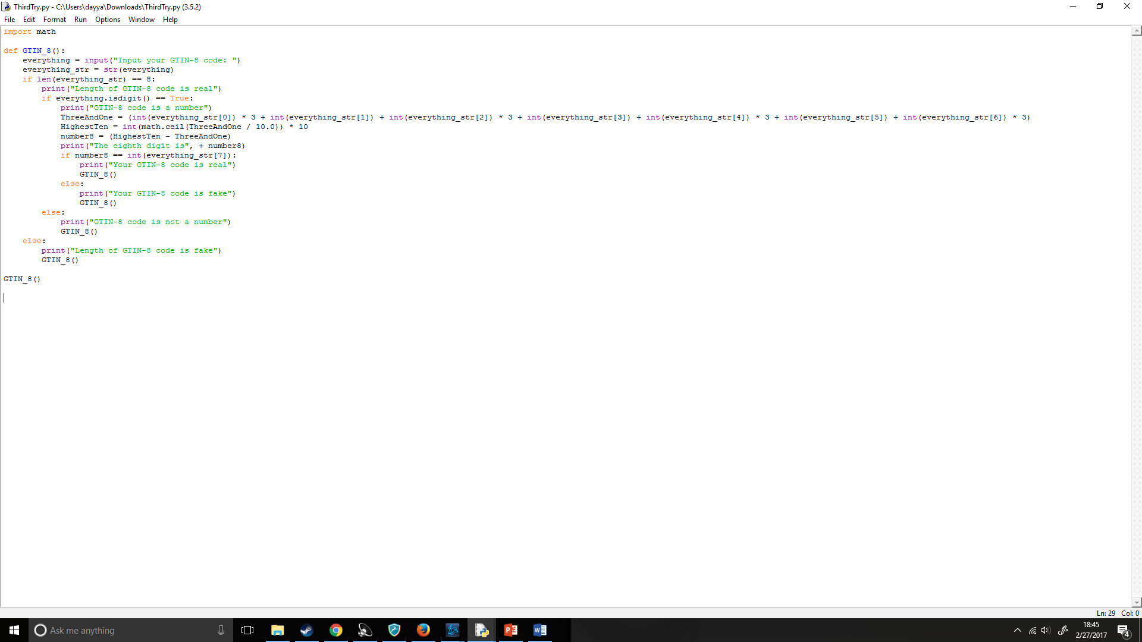

## Pseudo Code:

### (i)

INPUT GTIN-8 CODE: Added = (DIGIT1*3) +(DIGIT 2) +(DIGIT 3*3) +(DIGIT 4) +(DIGIT 5*3) +(DIGIT 6) +(DIGIT 7*3) RoundedUp = roundup(Added) EIGHT = RoundedUp – Added OUTPUT EIGHT ENDIF

### (ii)

INPUT GTIN-8 CODE: Added = (DIGIT1*3) +(DIGIT 2) +(DIGIT 3*3) +(DIGIT 4) +(DIGIT 5*3) +(DIGIT 6) +(DIGIT 7*3) RoundedUp = roundup(Added) EIGHT = RoundedUp – Added OUTPUT EIGHT IF DIGIT8 = EIGHT: OUTPUT “The code is real” ELSE: OUTPUT “The code is fake” ENDIF ENDIF

## Flowchart:

### (i)



### (ii)



## Evaluation:

In conclusion, I feel that my overall code is very efficient and during my final destructive testing I found no problems with the code. I feel that the code flowed very well and had very good user interface to access the GTIN-8 code input easily and easily understand what is the problems with their input if it is an incorrect GTIN-8 code without the annoying red text error popup. I also have a much better understanding of Python, specifically importing and import math. This has given me a much more precise understanding on how I can do much more complicated mathematical discussions considerably easier. I have also learnt about the importance of the python documentation and how useful it can be useful in finding how to program certain algorithms in a much shorter and easier manner. Doing this question gave me a stronger understanding of bug-fixing and testing and how to approach certain problems with your code as well as reading python error messages. I have also learnt the importance and helpfulness of functions and use of shortening and cleaning up my code. I found the usefulness of using a success criteria as it makes a sort of more simplistic pseudo code in my head making the code much easier to write and think about. Finally, it helped me learn in a better way how to preform destructive testing and testing in general in code, though since this question only required one input there was not much destructive testing that I could perform, this can be useful in making future programs have fewer bugs and preform much better.

# Question 2:

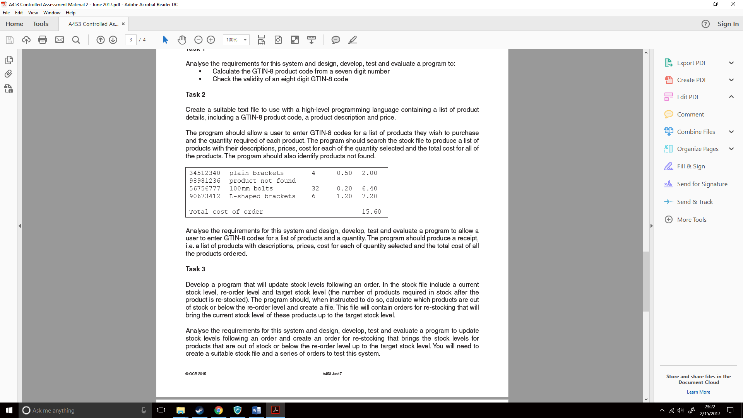

## What do I need to do?

1. Learn how to read text files,
2. Learn how to write text files with a list of the product’s description, price and cost,
3. Find certain lines from a text file per what GTIN-8 code the user enters,
4. Make a receipt text file, based on the products the user chose,
5. If a GTIN-8 is not found within the lines, produce an error.

## How will I do it?

1. Create functions for each of the programs, e.g. product_store() and product_list()
2. Print every line of a text file
3. Create if statements on checking if certain GTIN-8 codes are in the text file. E.g. if GTIN-8_Code is in text file;

print “GTIN-8 code found”

1. Create print options on printing a certain line based on what the GTIN-8 code is.

## How do I read and write text files?

At first I had no idea how to check stuff with text files in python, to learn about this I checked the Python for Key Stage 4 booklet by Zig Zag education where it showed the following:

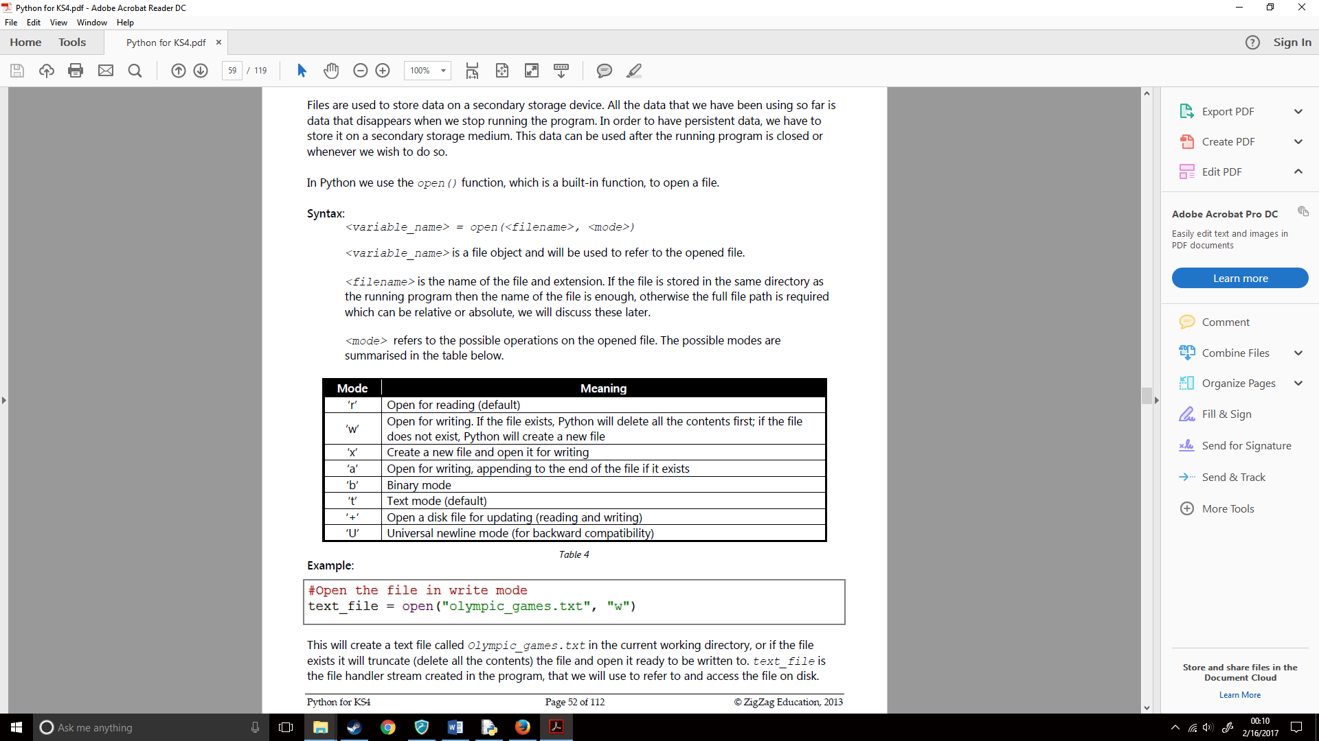

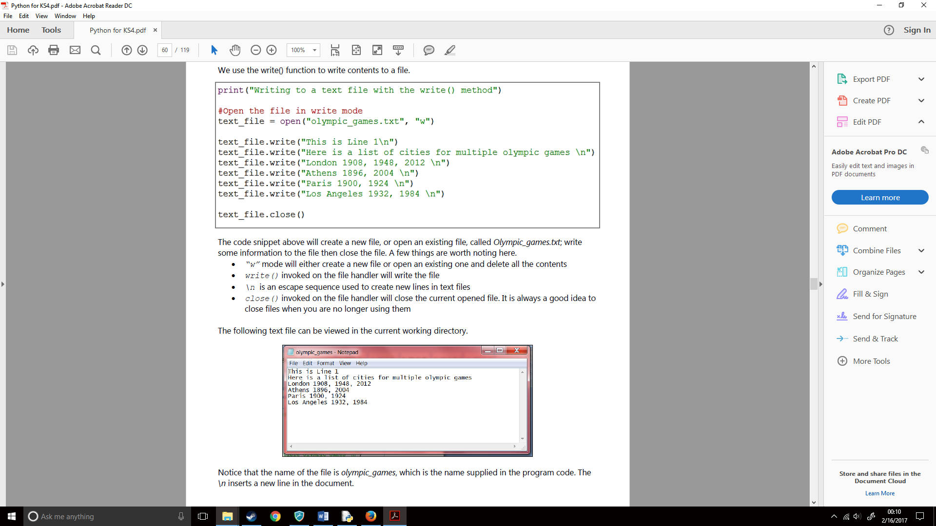

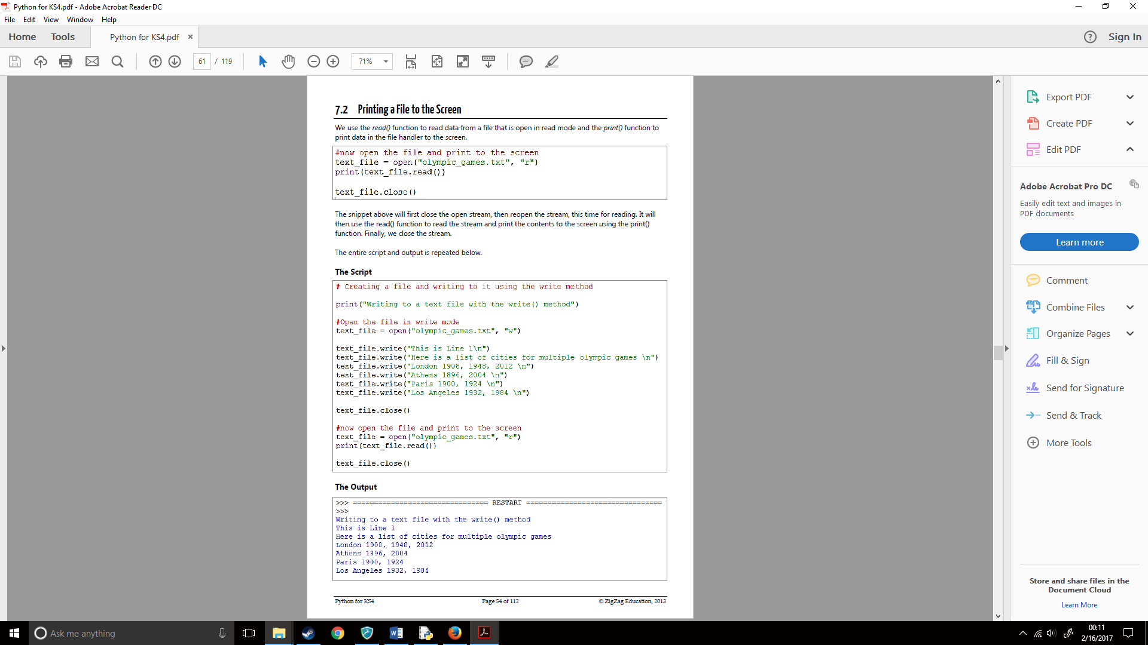

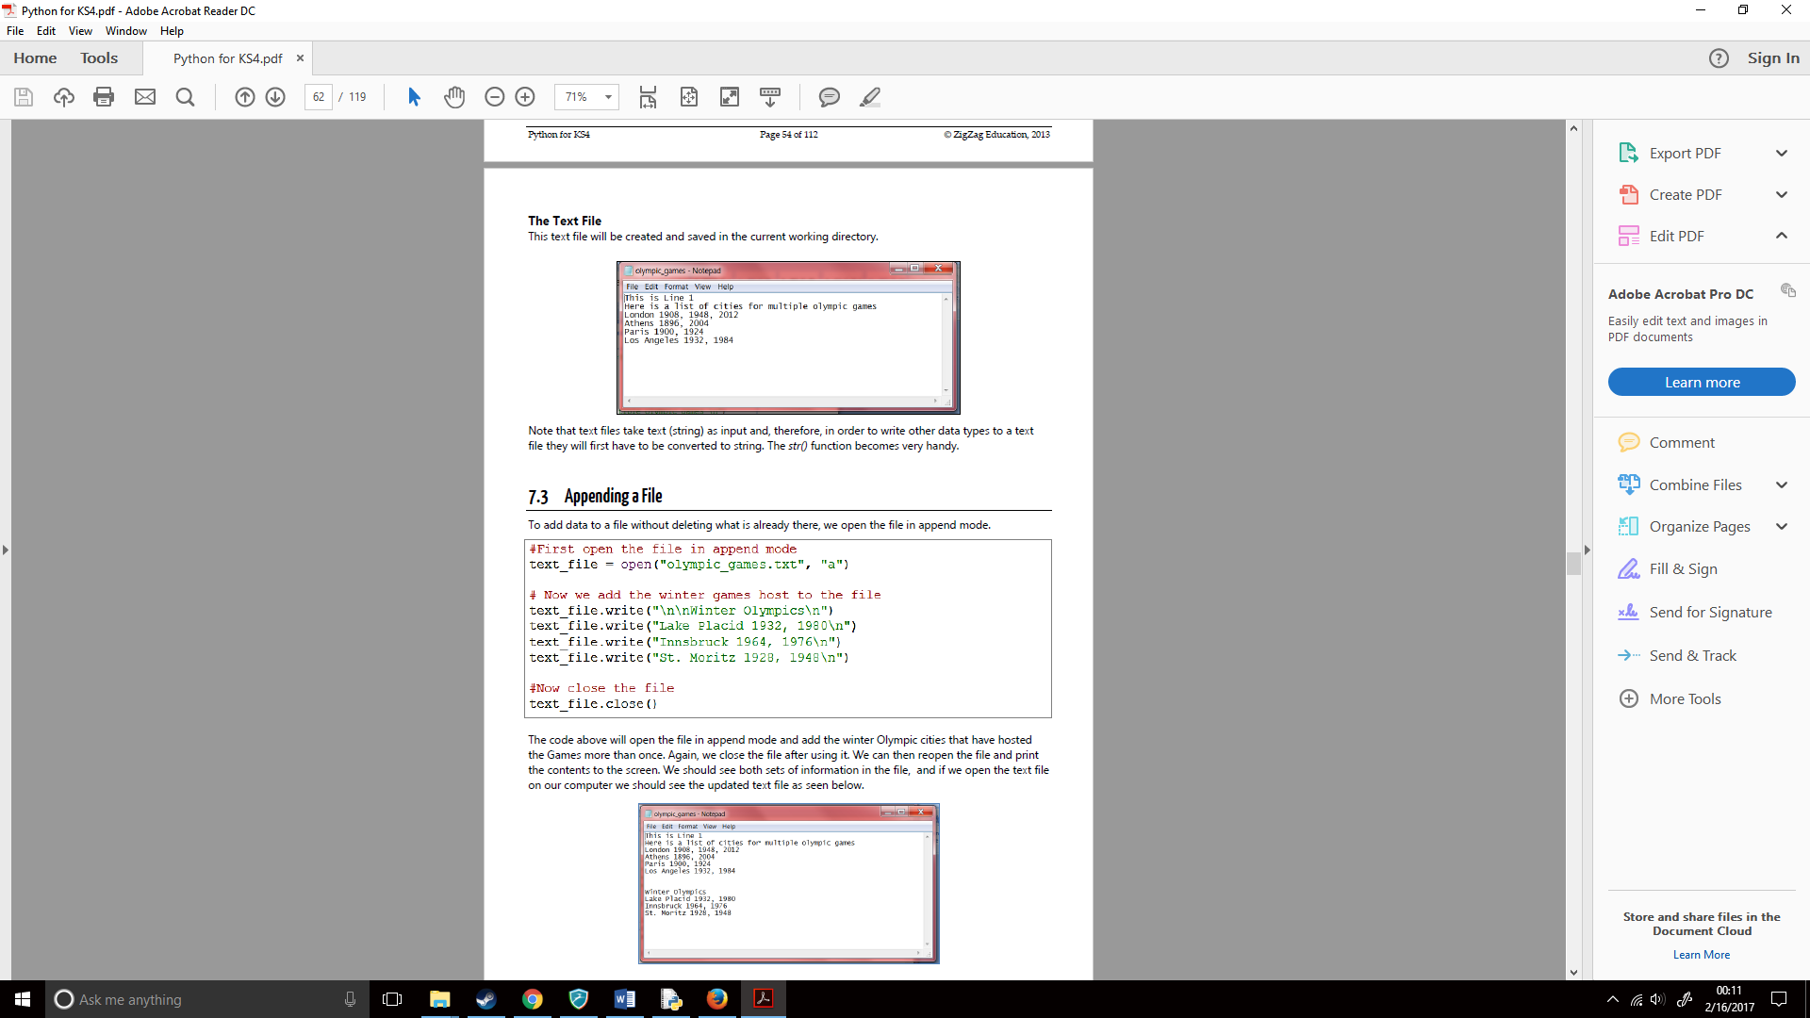

This gave me a strong grasp on how I would program my task. I first decided to do some testing with this code. So, I create a python file which would ask for the product name and then proceed to write it onto a txt file. So, using my knowledge with asking for inputs from the user, combined with the book talking about text files with python I created the following;

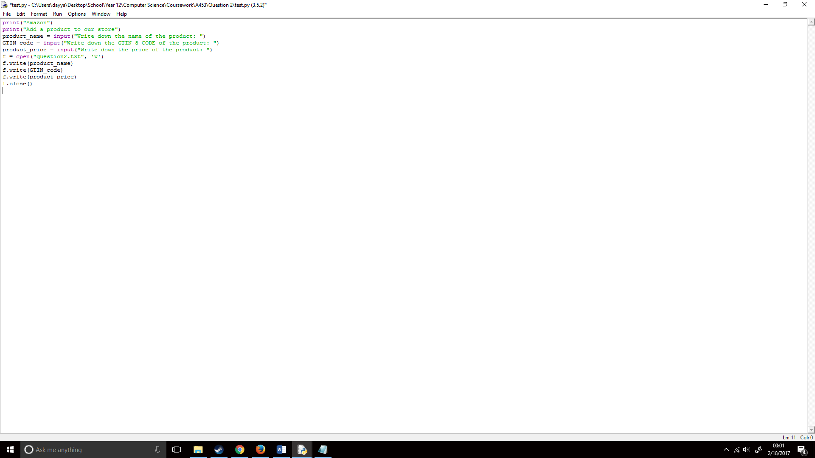

I then ran it;

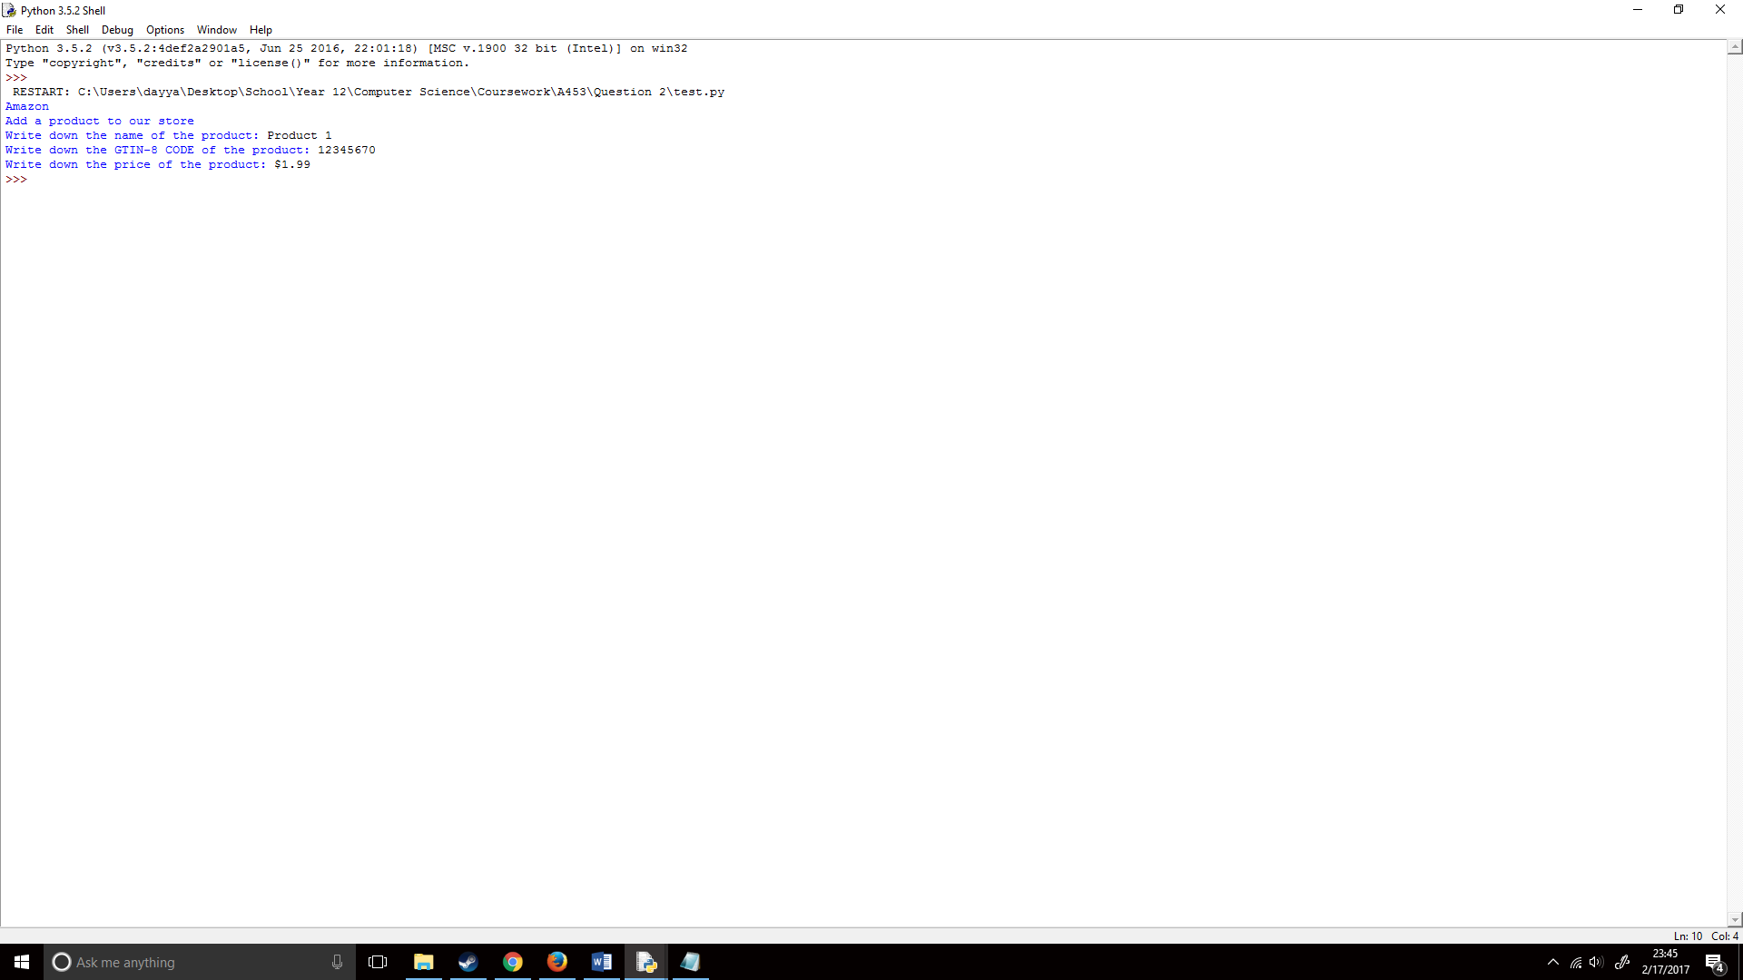 Which did show on a text file, however it all went on the same line;

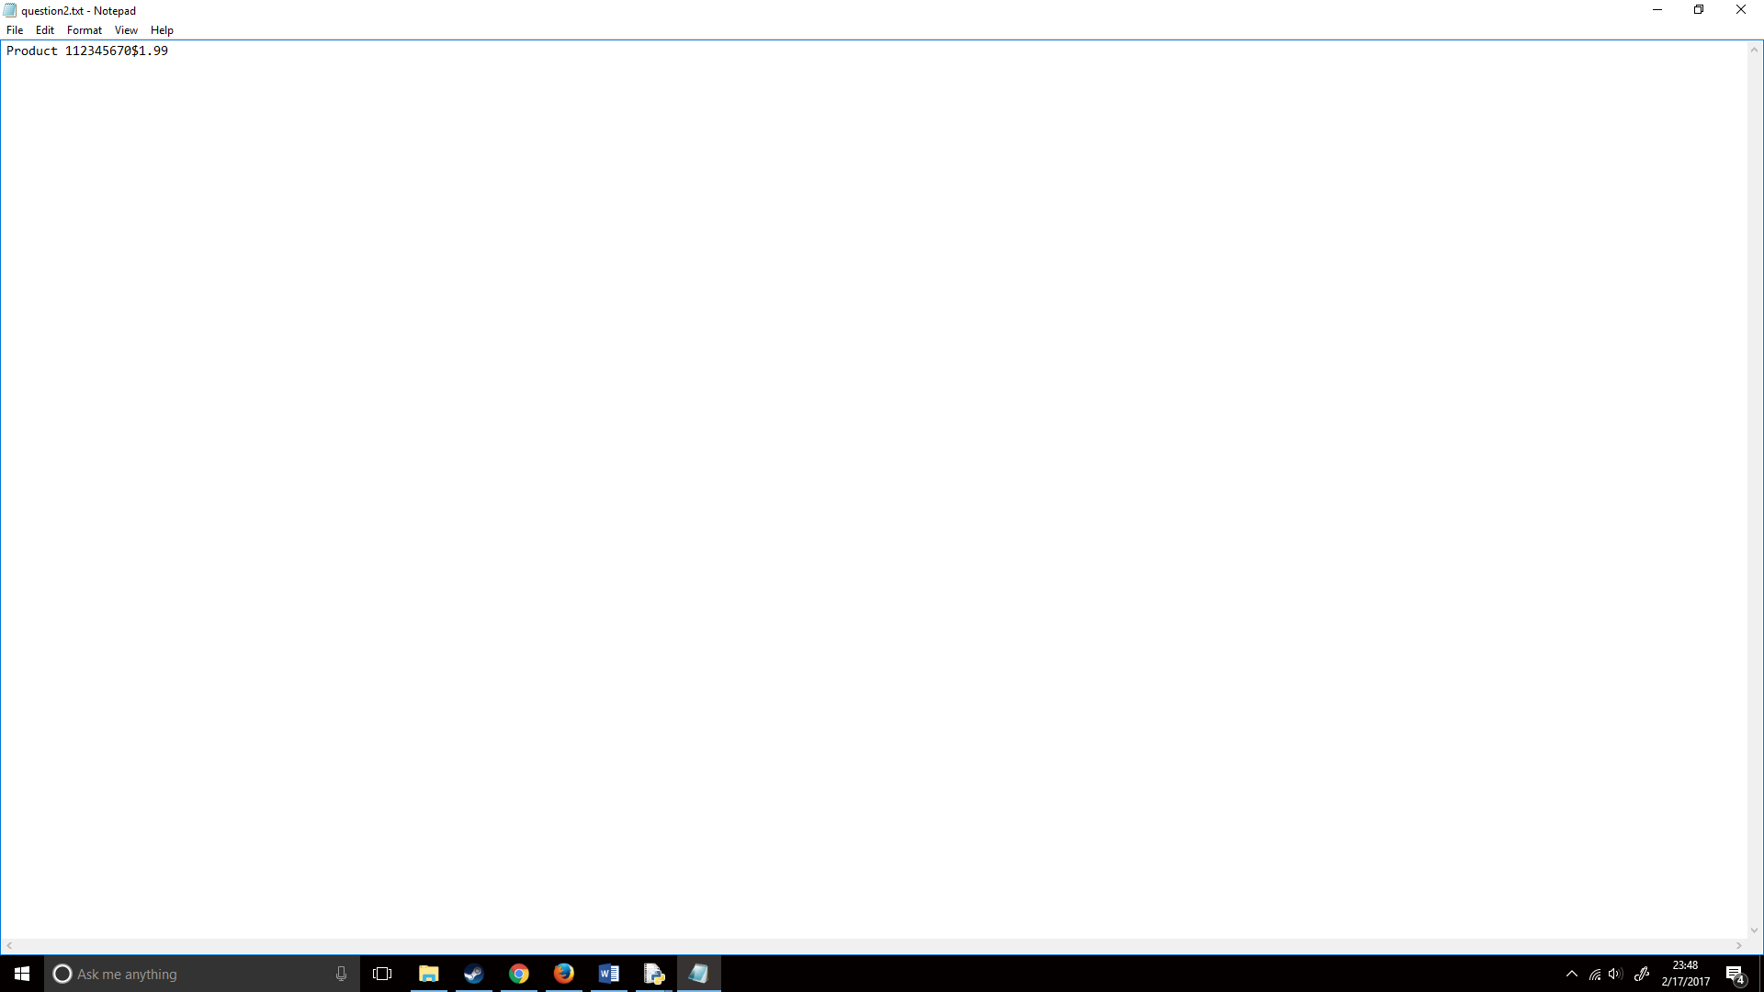

To fix this, I noticed on the textbook it added \n at the end of each of the lines when writing lines to a text file so, I then decided to research what this meant to find out how it worked. I found that it would create a new line in a string, the following showed this (https://www.quora.com/What-does-n-do-in-python/answer/Begtin-Ivan?srid=hndTI)s:

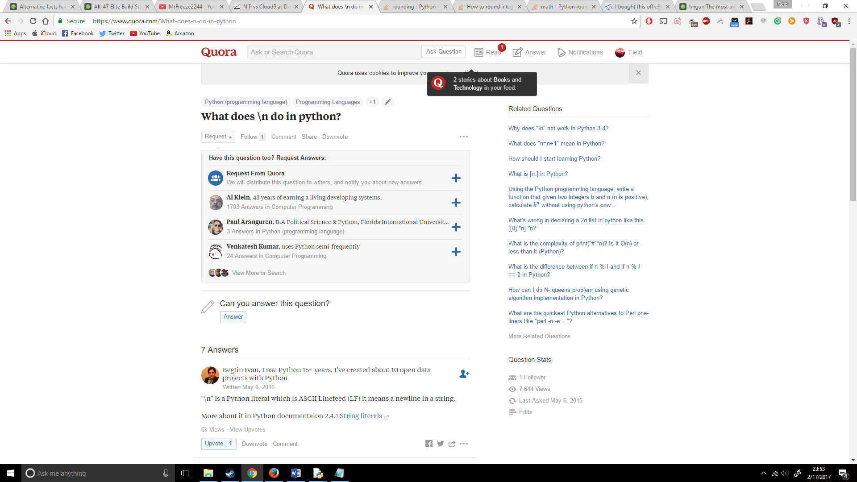

I proceeded to apply this to my code, so my code now looked like the following:

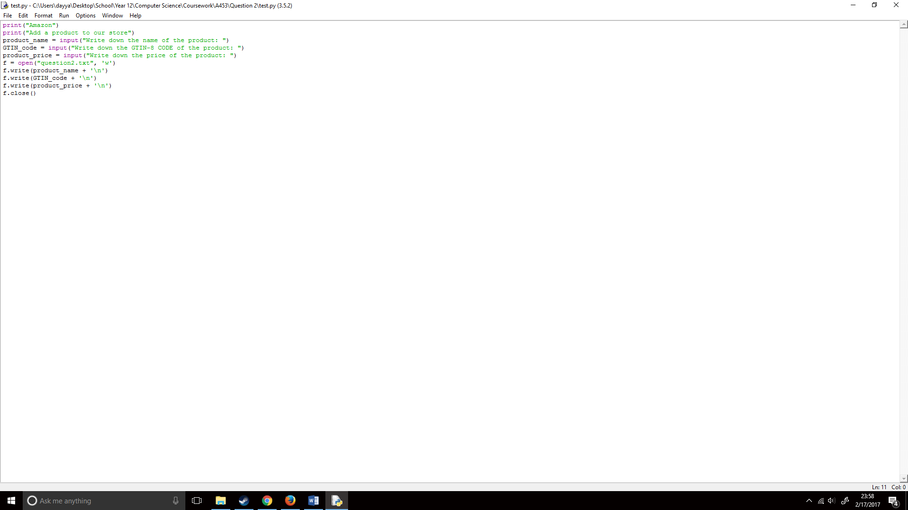

I then ran it and the text file showed this, meaning that it successfully worked!

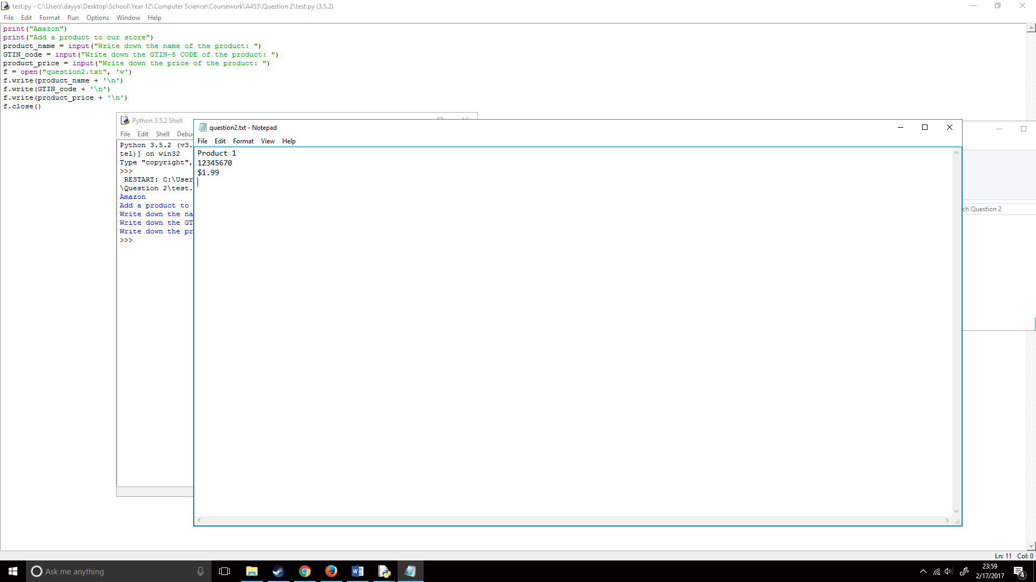

## How will I create my program?

Now that I knew how to work with text files in Python I proceeded to work on with my question 2 code. I first created the hub/start of the program and all the functions that I would be needing, this was simple enough and I encountered no problems when doing this:

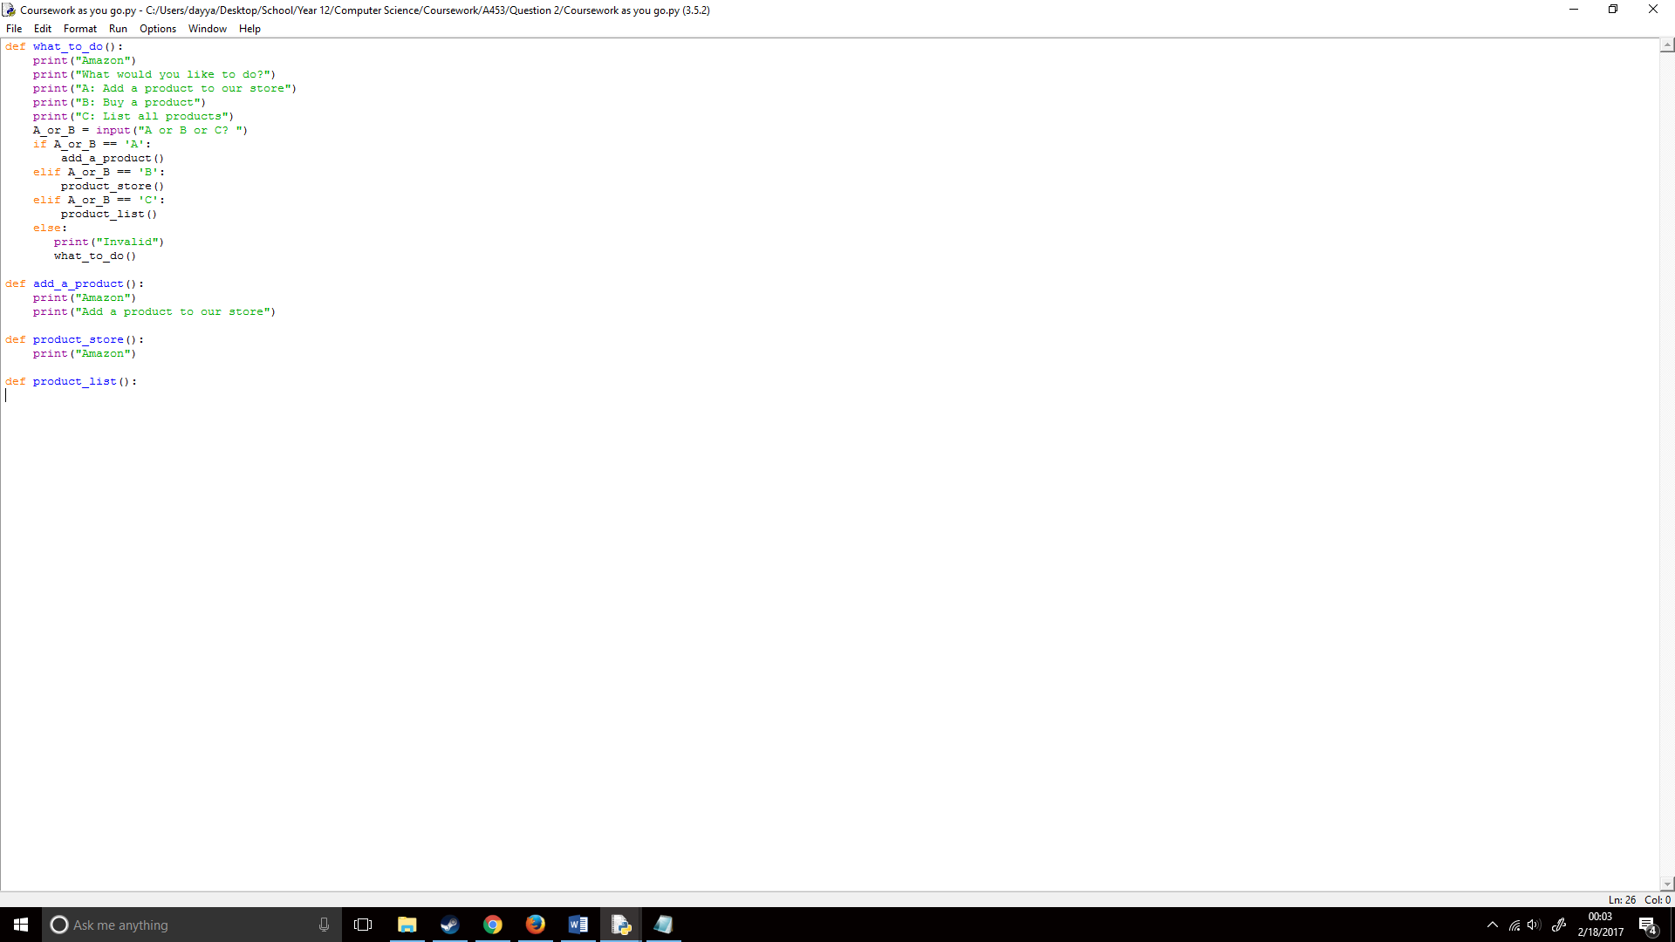

I then decided to add a level of functionality to each of the functions, such as inputs and setting f.open() up:

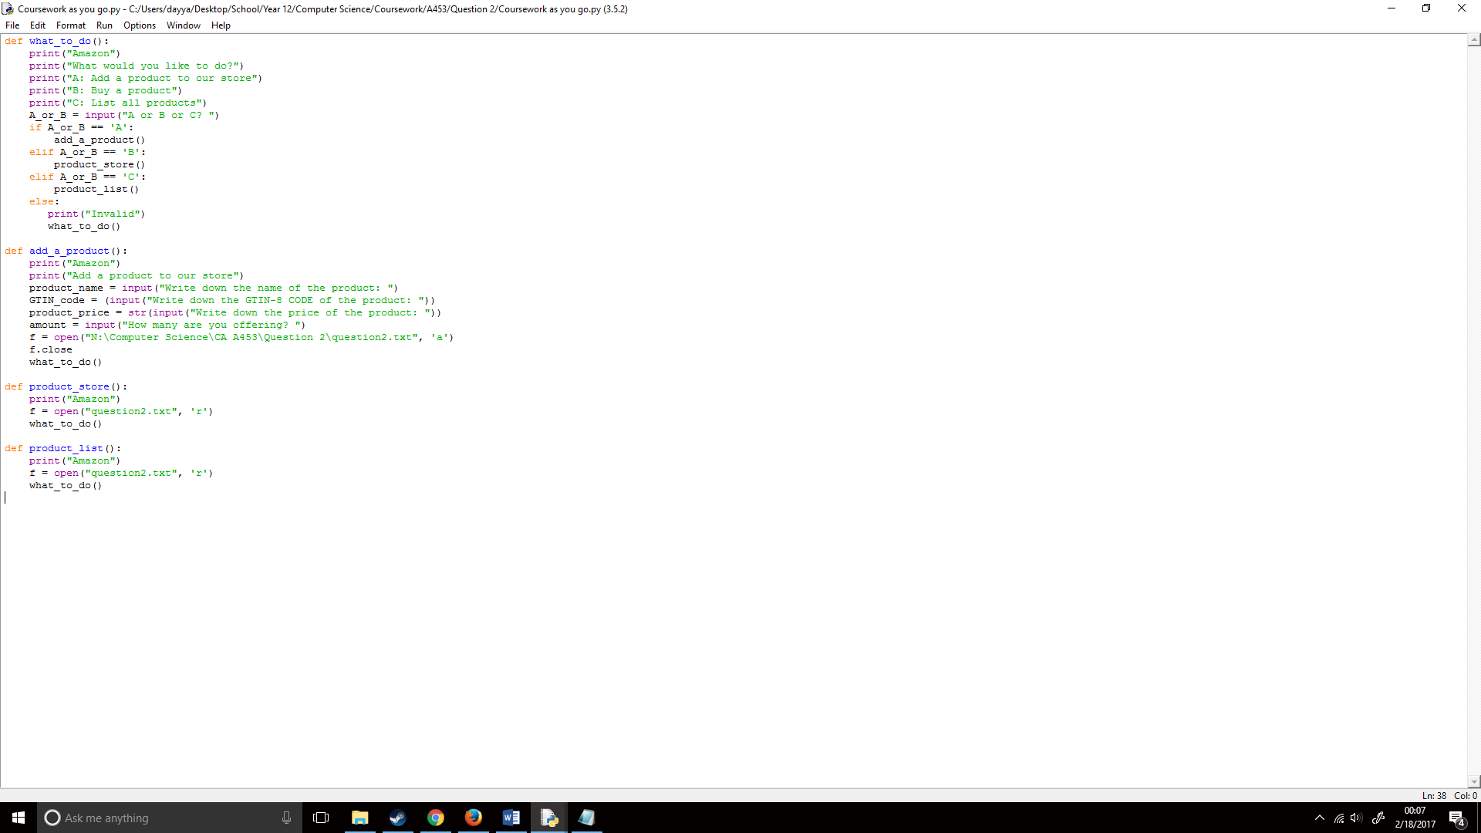

Later, I checked my OCR Computing for GCSE booklet where it showed the answer to a similar question than this:

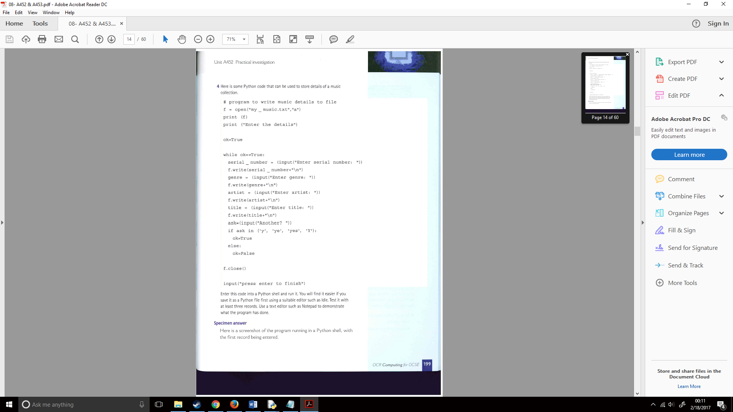

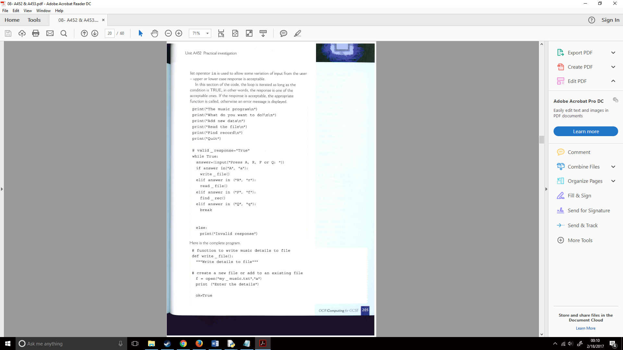

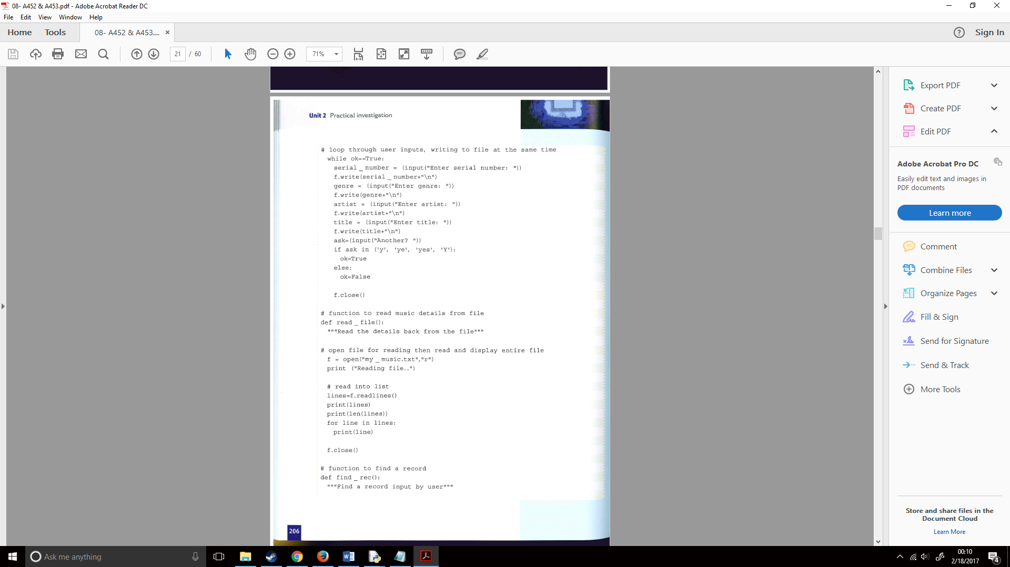

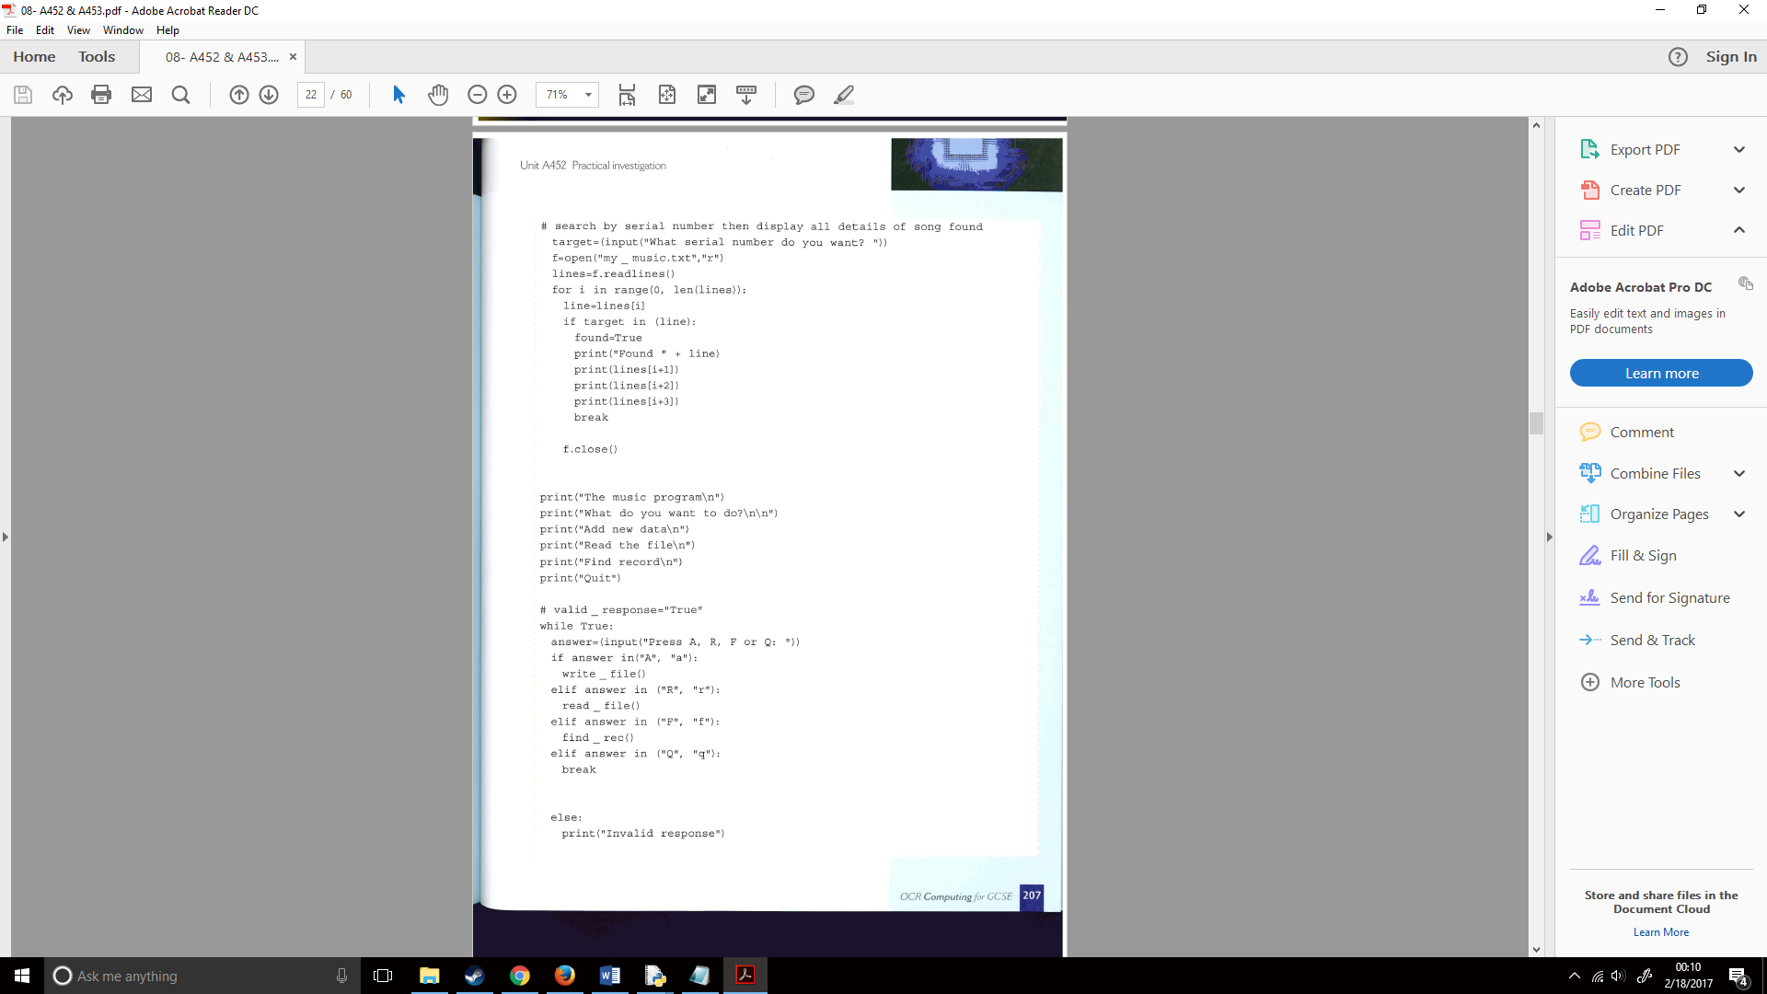

While reading through this booklet and the explanation of how the code worked I decided to apply this general idea to my own code. I first created a write functionality for my add_a_product() function, this worked by writing each of the files onto the text files with the text in quotation marks first, then the input provided by the user, and then finished off with a new line.:

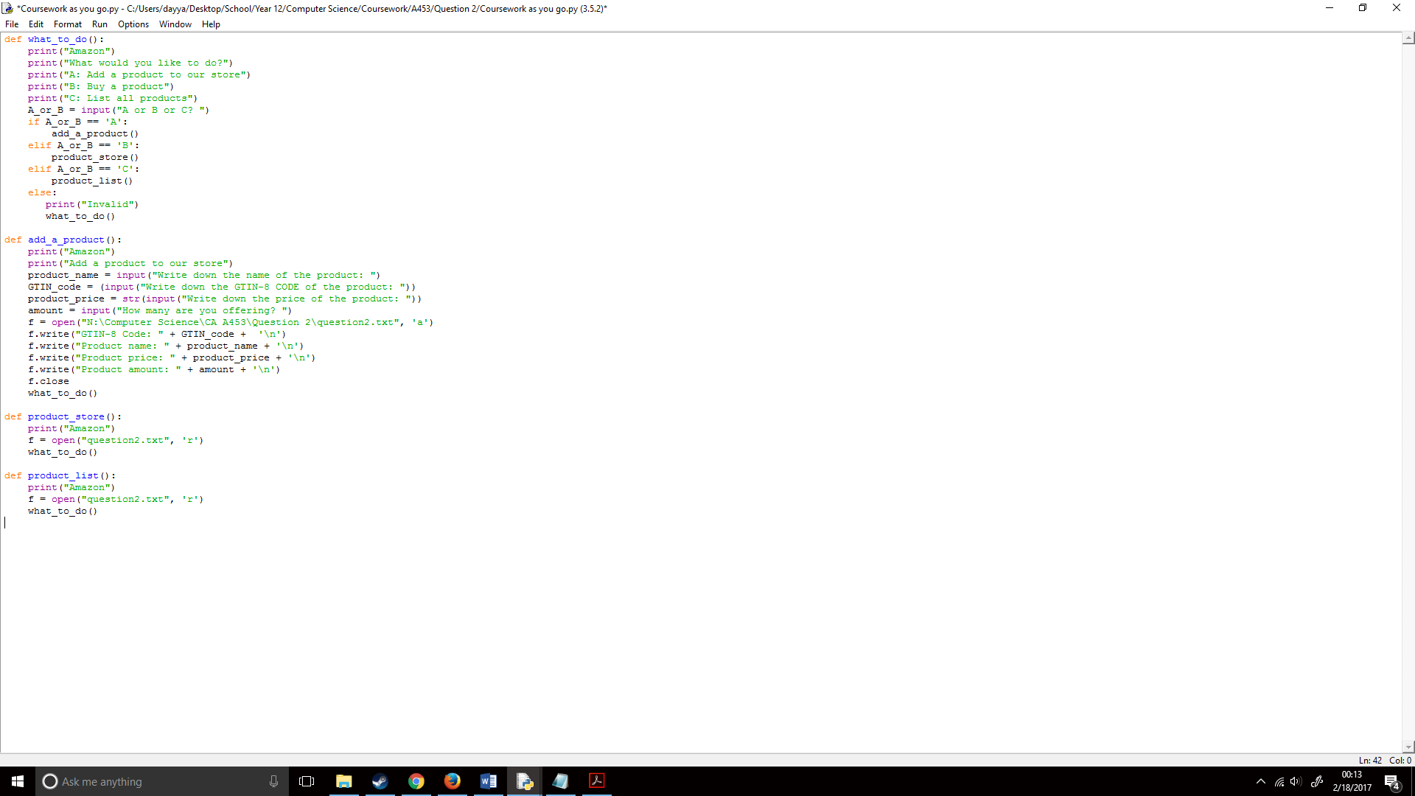

I then added the list functionality to my code, f.readlines() would read all the lines in the text file Products.txt, as f was equal to open = ‘Products.txt’ in read mode, I first listed all the lines that looked a bit like an array. I then printed the number of lines in the text file with text on it, to show it listed all the lines and finally it would get the number of lines in the text file and for each line in the text file it would print a new line each time it gets a line rather than printing it all out in one.:  
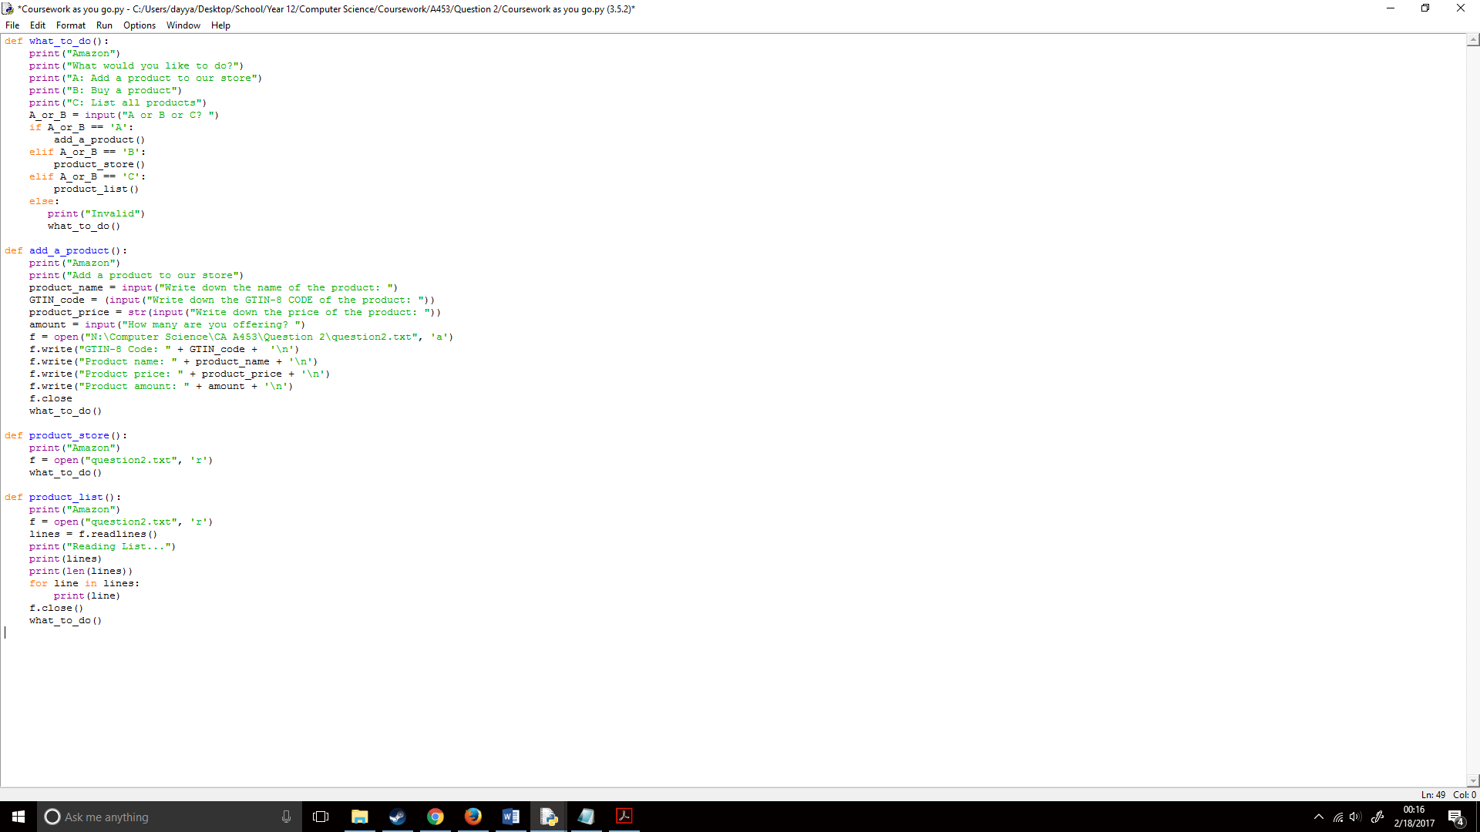

I finally added the product_store()/product_search() functionality, the for command would check between line 0 (the first line) all the way to the number of lines, this means it checks each of the lines in the text file. It then checks if the input provided by the user is in the text file and if it is it will print that line, then it would print the next line, and the next line and the next line so it prints all four lines which contain data about a product. This is done by checking the line of where the input provided by the user is in the text file, and set that to [i] (you can see that in line = lines[i]), this means if we add certain number to [i] it would print so many lines from the input provided by the user. If the product however is not found within the lines, it would print invalid and go back to the start.

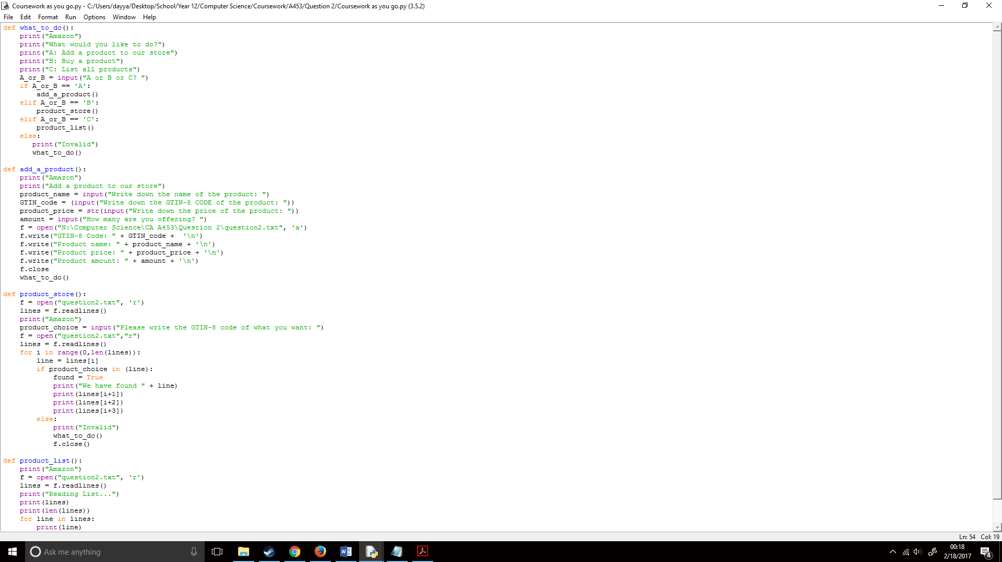

I then ran the code to see how it worked, I started with part A:

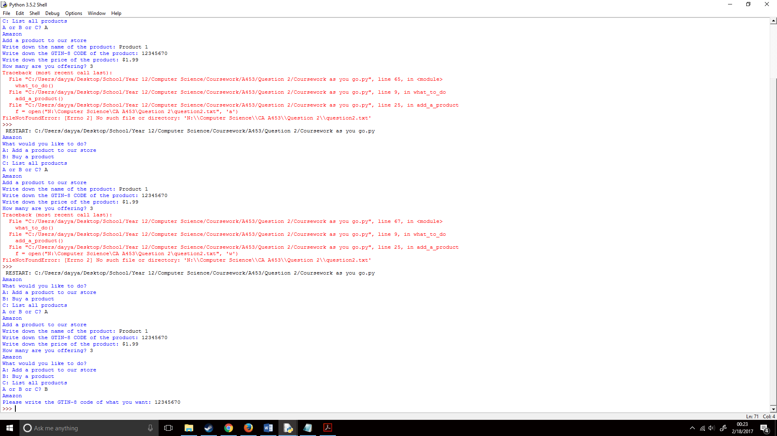

I then checked the text file which showed, it printed it out correctly which meant the code worked correctly:

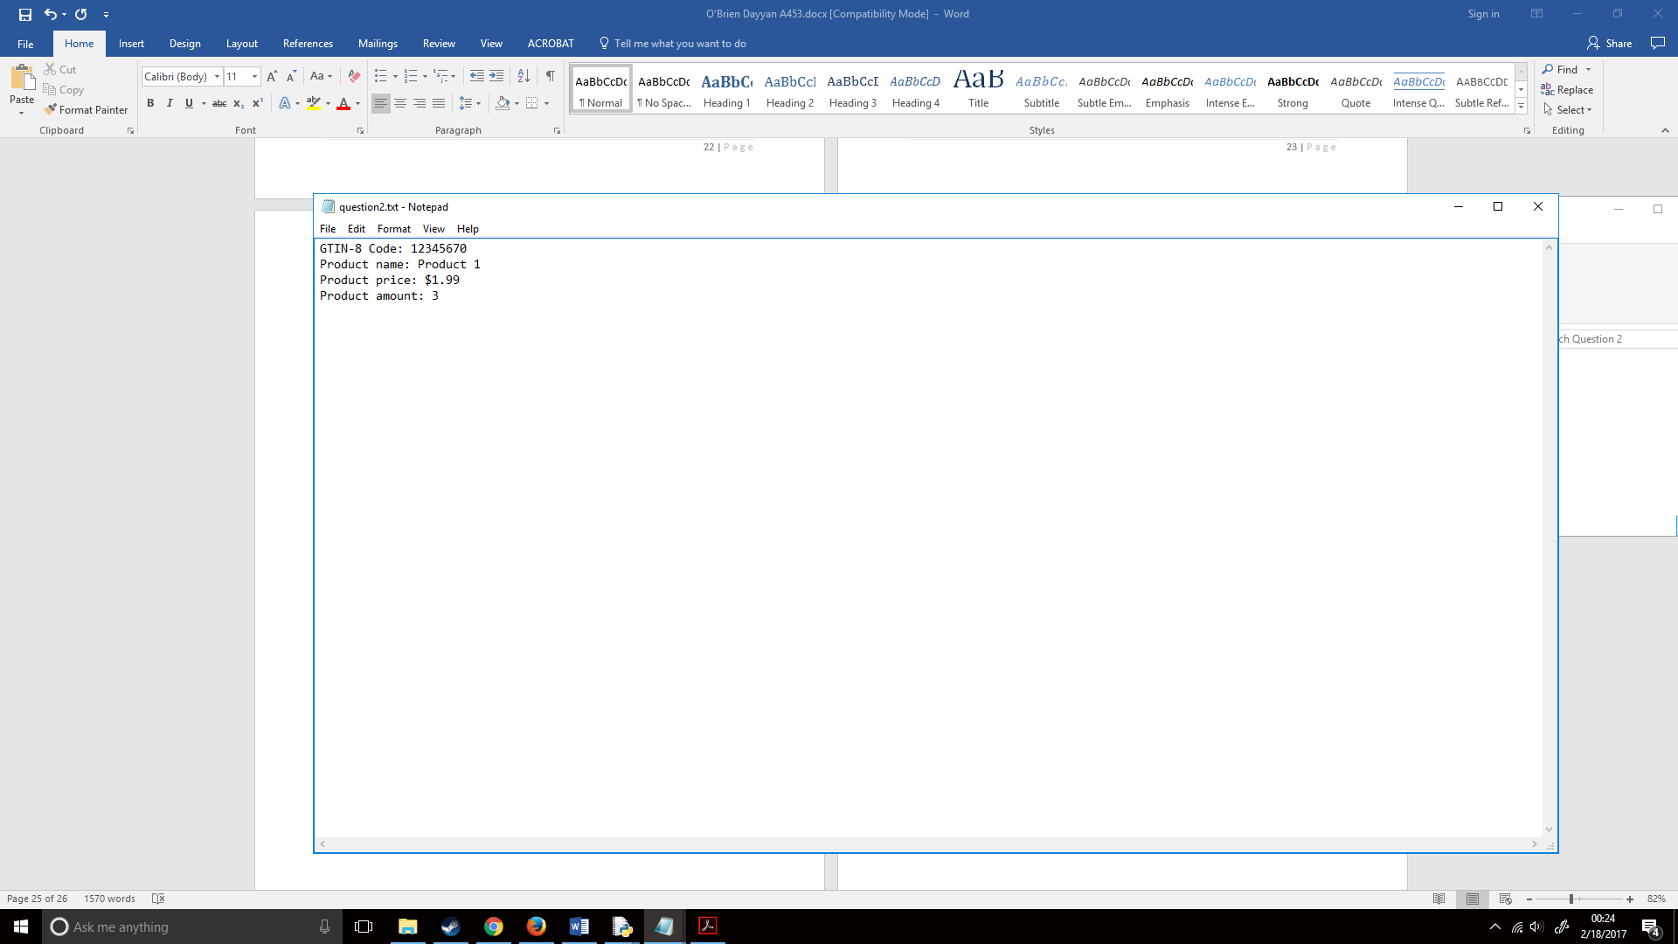

I then ran part B, this ran correctly and showed all the lines I wanted it to show;

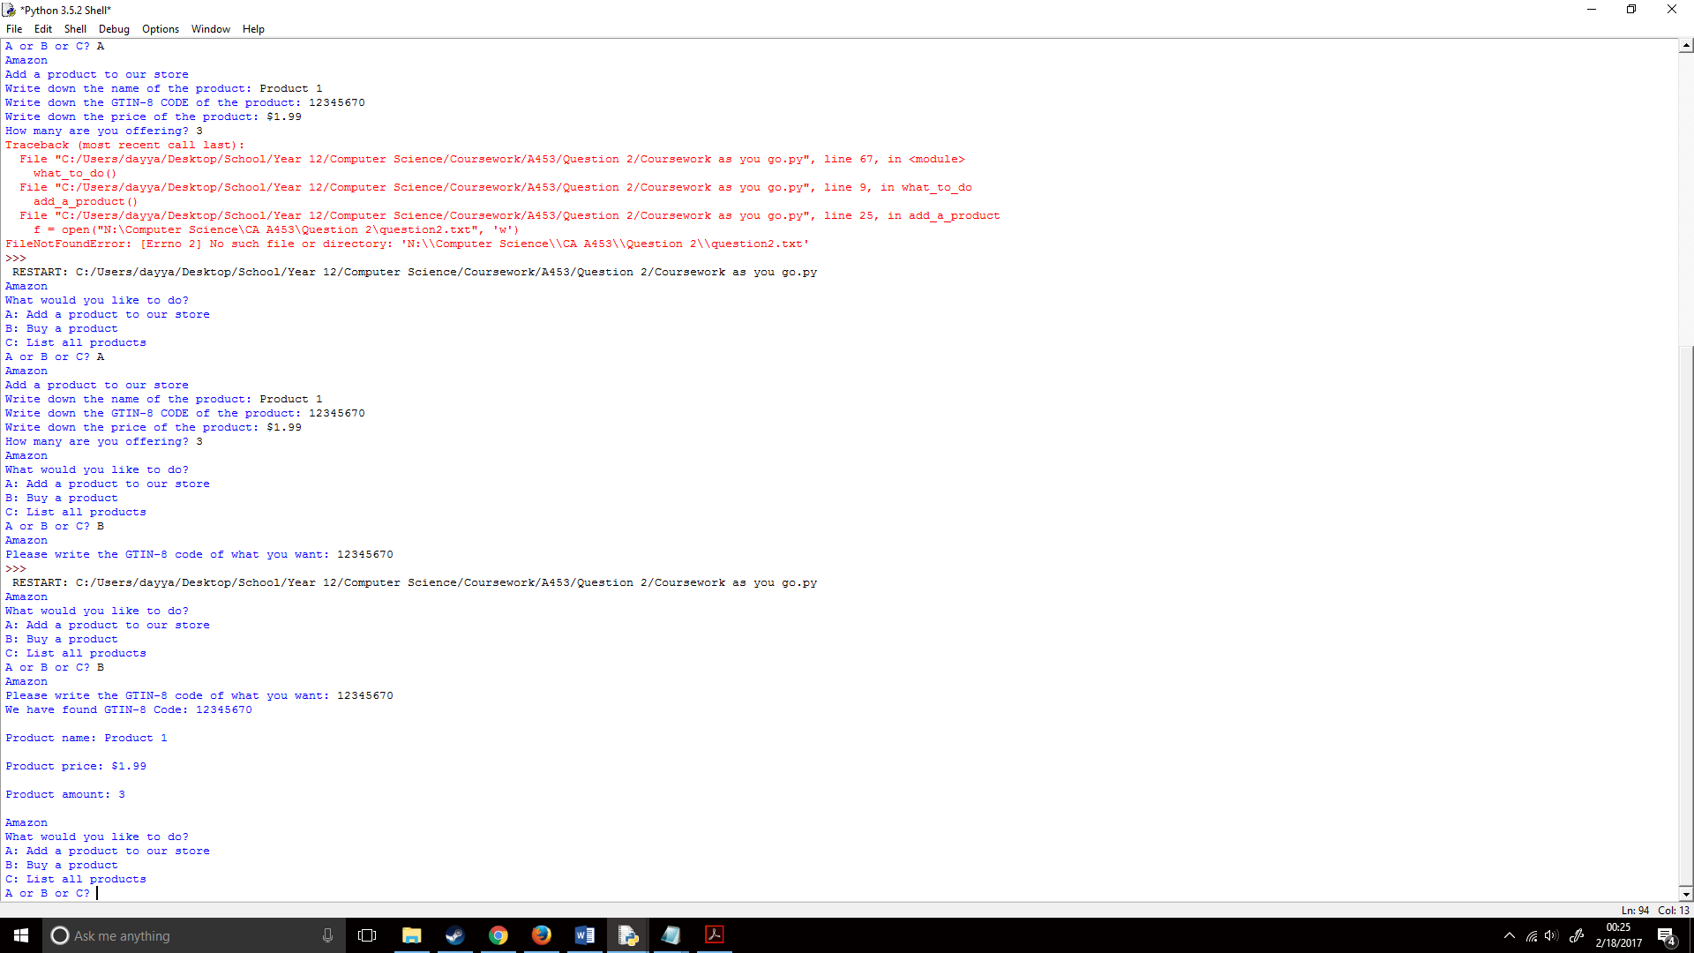

I finally ran part C, which showed the following, it worked correctly however only showed one item as I only added one product to the listing:

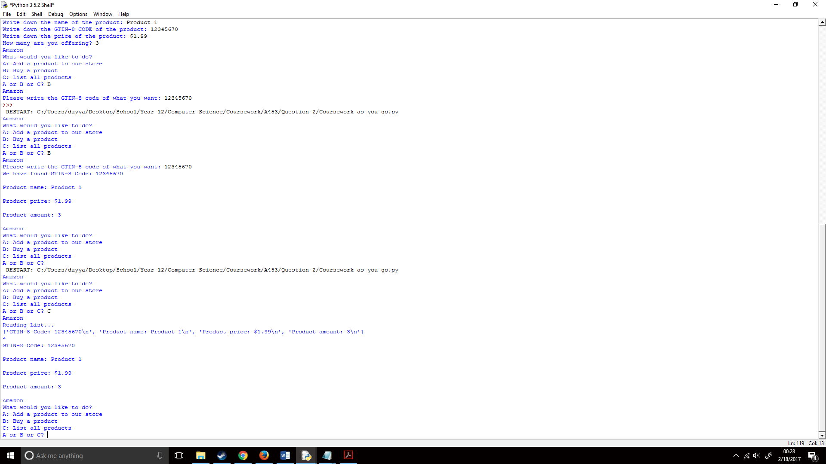

Now that this all worked correctly, I had to add all the products bought into a new text file. I wanted to do this by writing all the lines that I’m printing on part B and port them over to a new text file called Recipt.txt, I knew most of this, if not all had to be done after the line if product_choice in (line) & I had to replace the print’s with write functions, which would write onto the Recipt.txt file. I first, however had to add a product_quantity question:

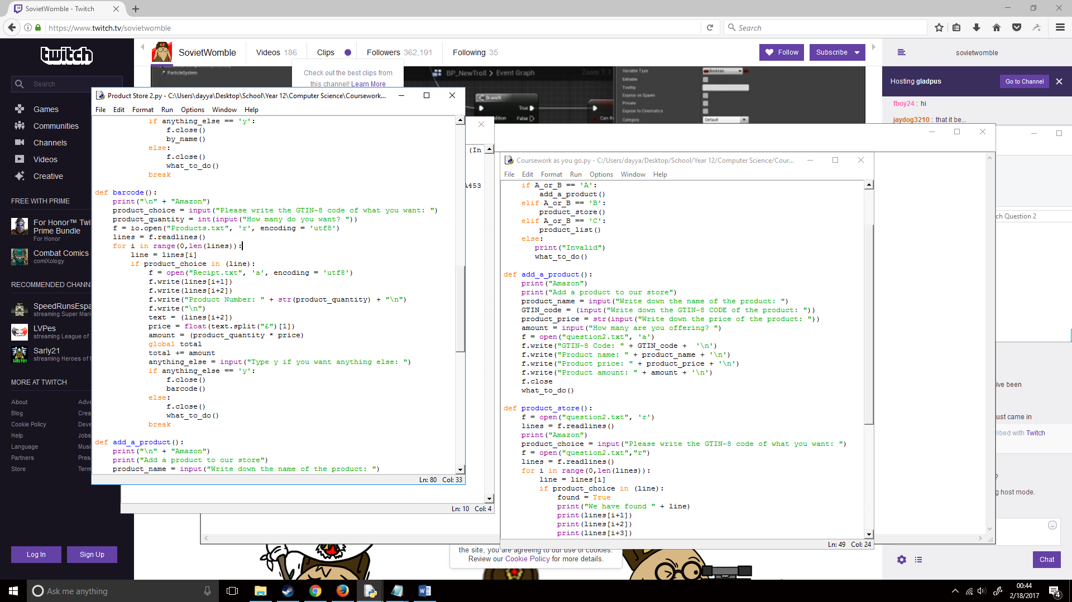

I then created a new f.write statement which would know set f to write onto Recipt.txt instead of Products.txt, this would be done after if product_choice in line, as to find the product I would need it to be set in Products.txt, and that’s only done after that. So, I wrote the following, it was in ‘a’ or append mode as I wanted to add lines after the text file without deleting it, not create a completely new text file.

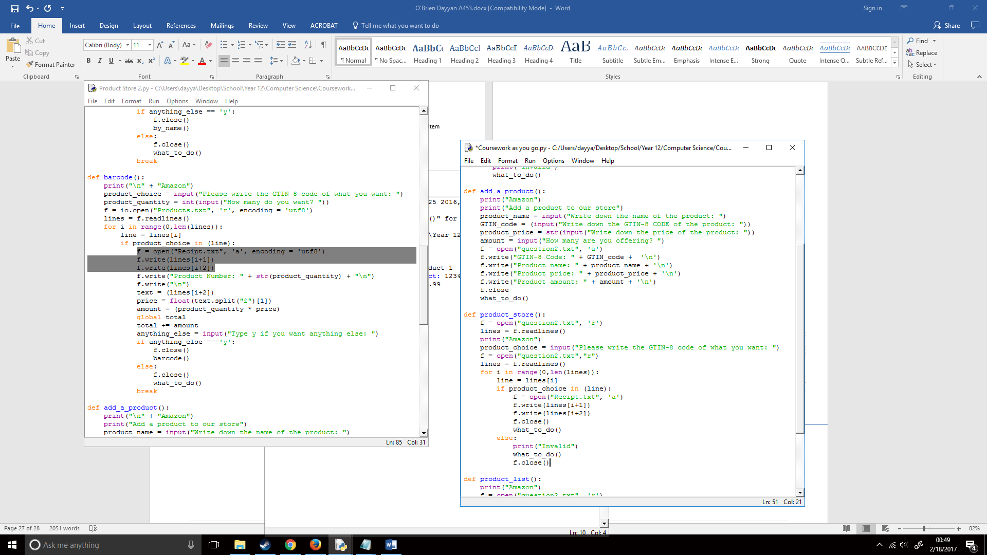

Now that f was set to the Recipt.txt, I wanted to write the same lines to that file, so I added the following straight after this. I didn’t write the quantity or the price as I needed to do math with that later to find out the overall total price of the products combined:



I then wrote the product quantity. I added “Product quantity:” at the start as I was getting this from the user input, not the text file where the description was already there. A created a new line after this as well;

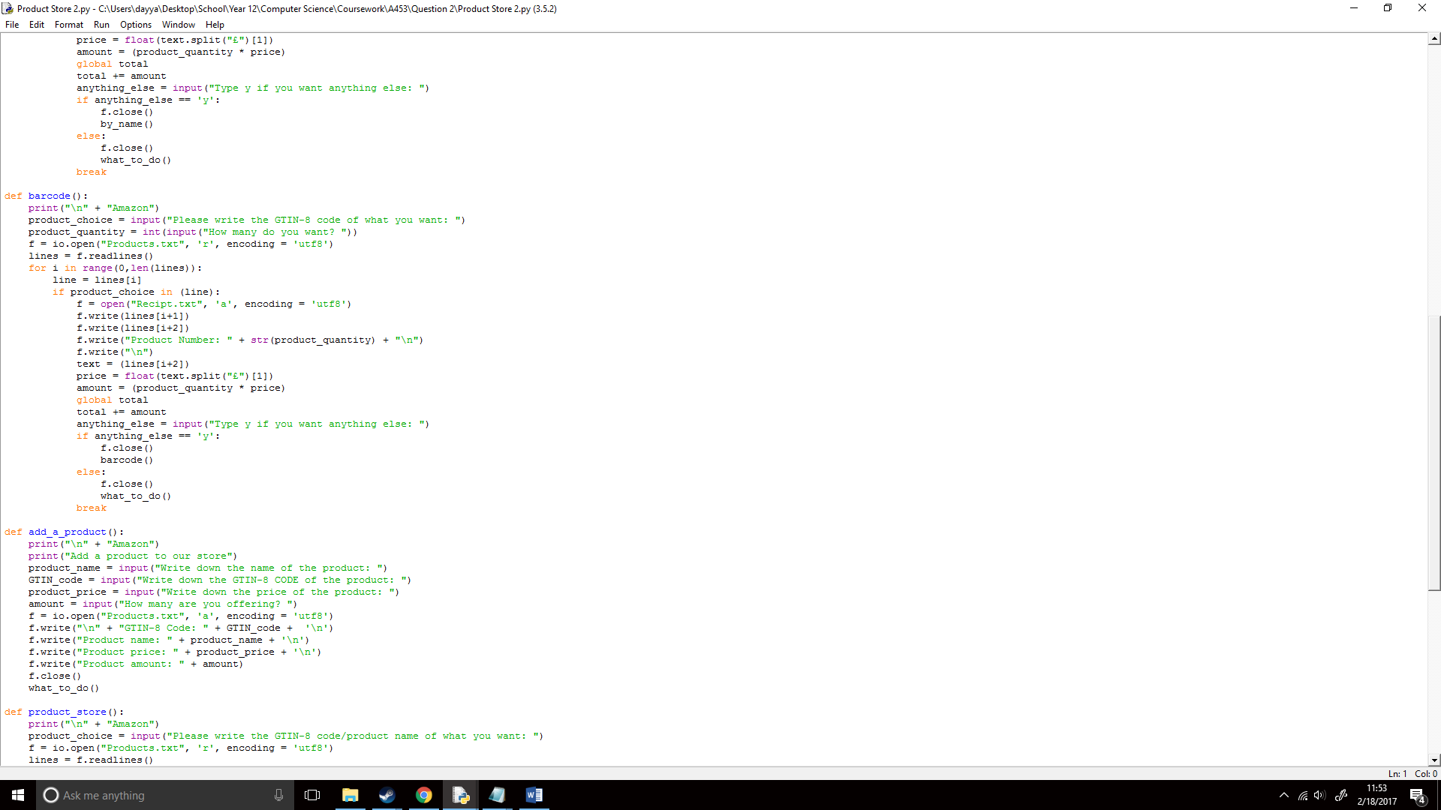

I now had to create a math function. I first had to remove the £ symbol and “Product Price” from the text file as I had to use it for maths but you need just the number to do that. So, I first created a variable of that line, I called this variable text:

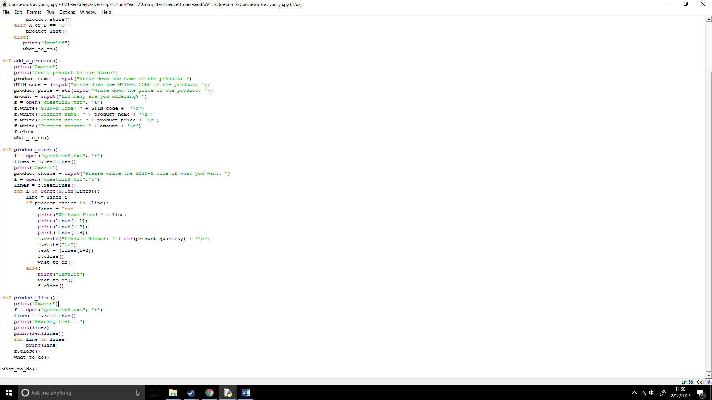

To remove the £ symbol I found a python command called split. This would split the string into smaller chunks (<http://www.pythonforbeginners.com/dictionary/python-split>):

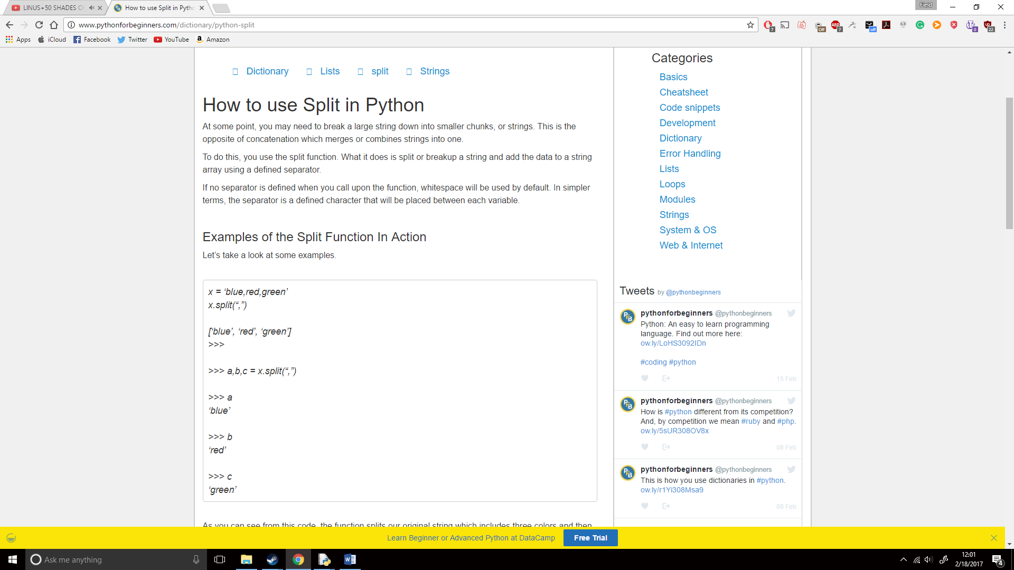

So, I created a new variable called price and set it to a float (as money can have decimal points in it):

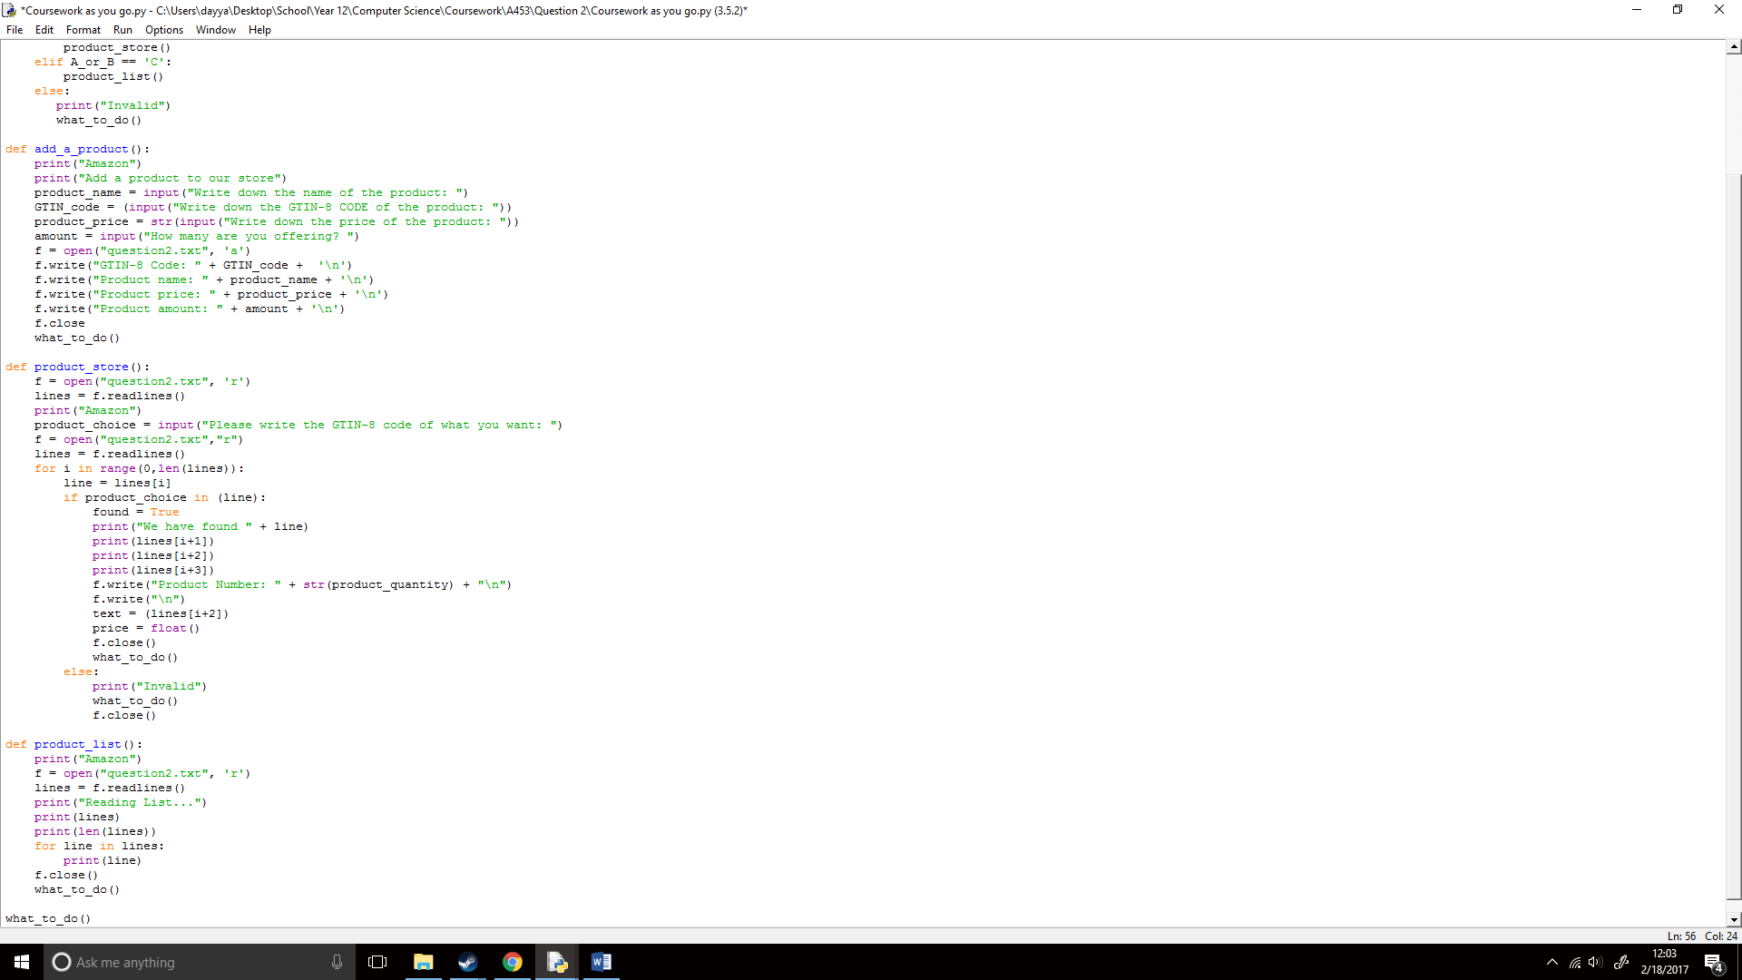

I then created a text.split, I used text as that was the variable for the line that I was using. I used the £ symbol as that was what I was splitting from the string, this would split the rest of the line too:

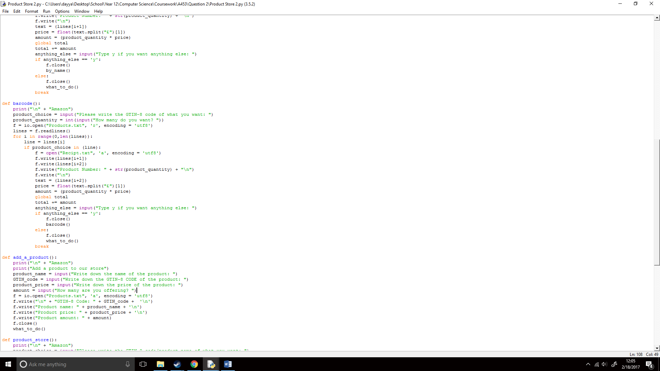

I know had to multiply the product_quantity by the new variable price to find the total cost of that product. This would be done by simply multiplying them as they were already set to float() and int(), I set this to a new variable called amount:

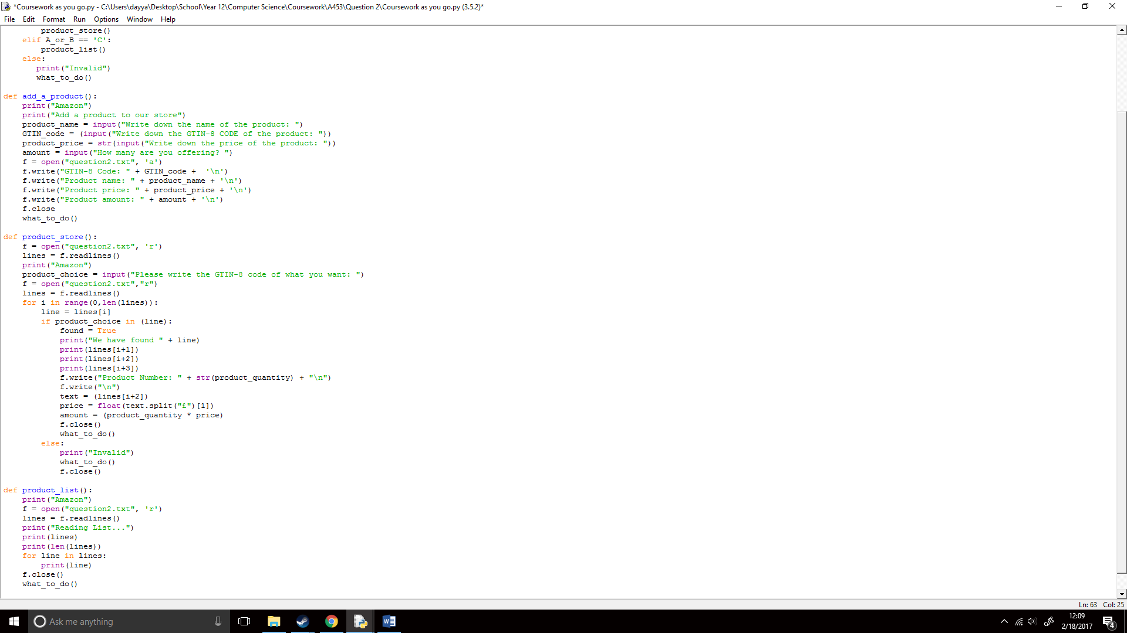

I now would have to add this amount to the total cost of everything bought by the user, upon researching I found a command called global, which would allow me to change local content. Which in this case was the txt files (<http://stackoverflow.com/a/4693385/5985905>):

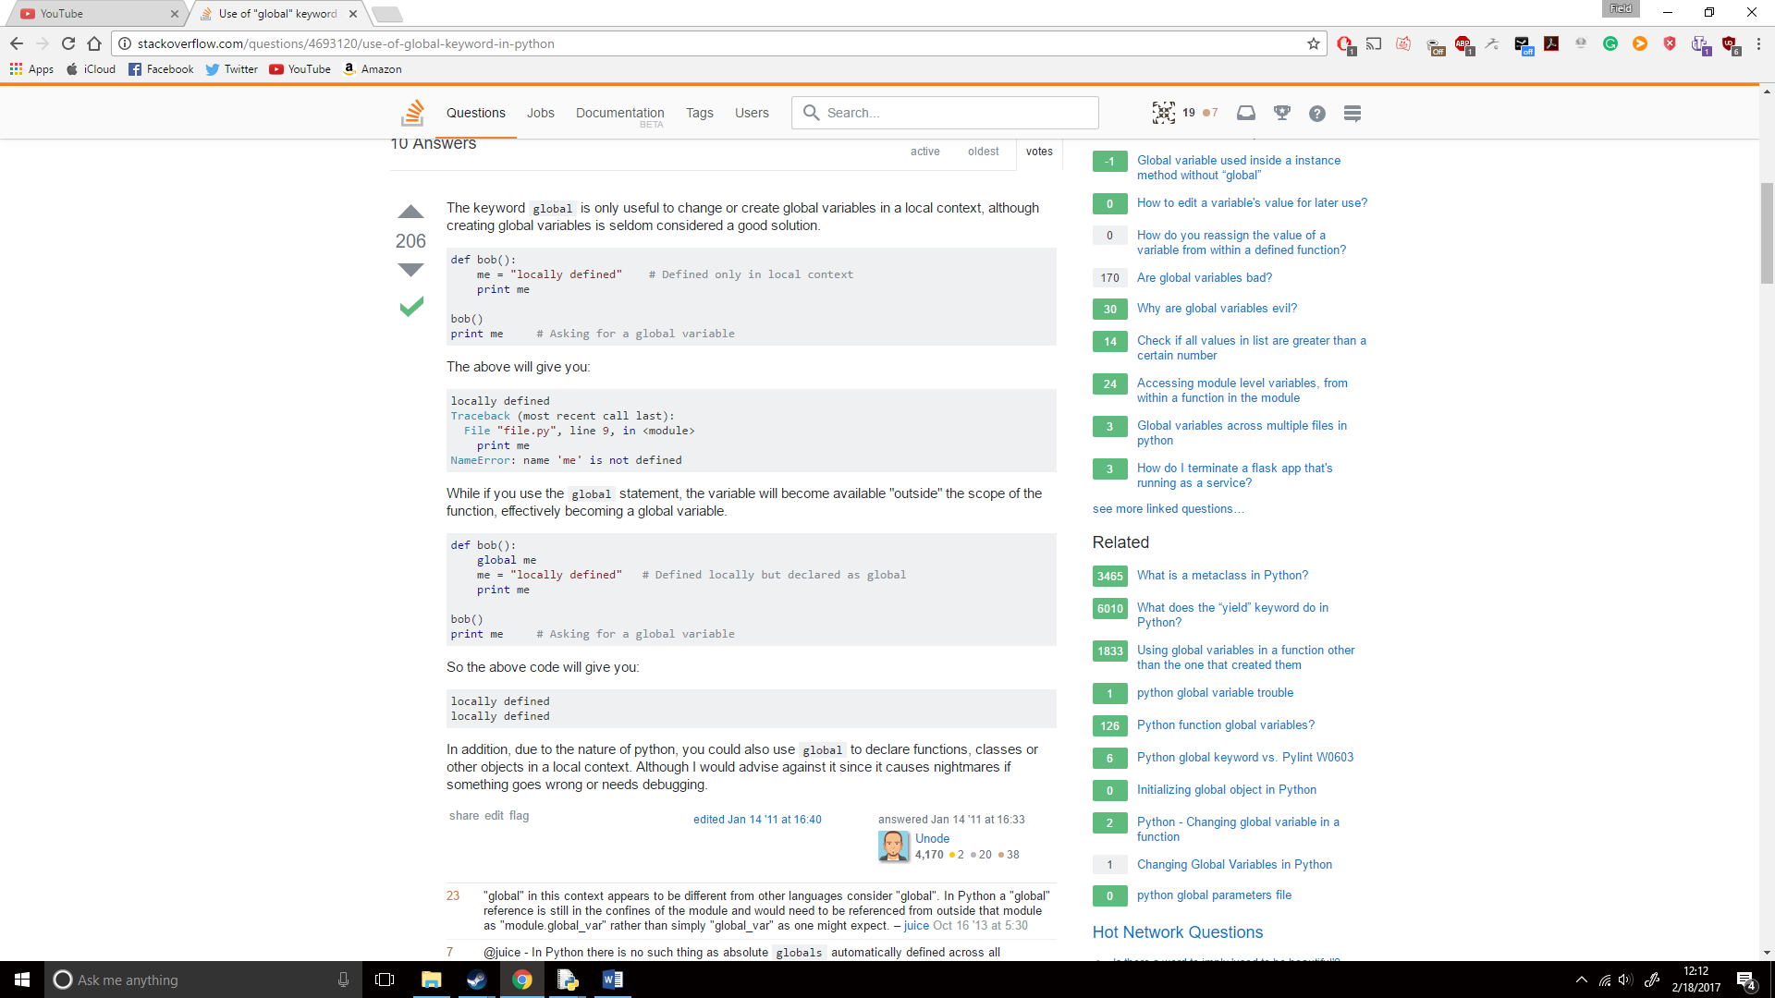

So, I created a global variable and added it to the total:

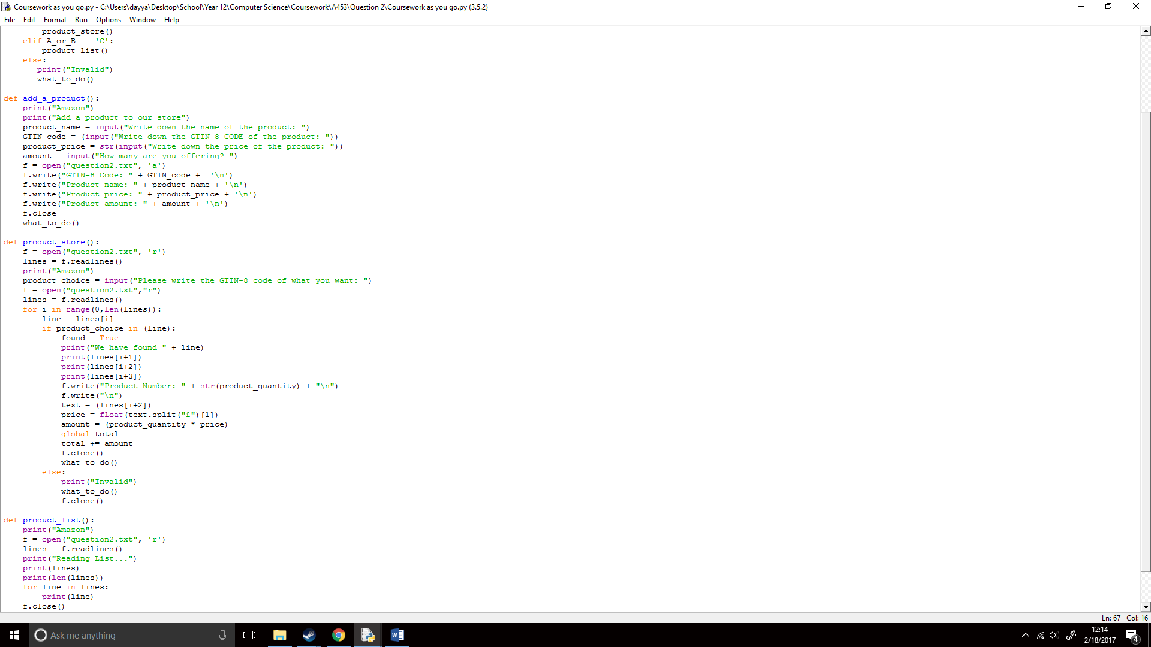

I wouldn’t add the total to the Recipt.txt file yet as more products would be added later, this would be done in a new function called receipt(), first however I wanted to add an input that asked if you wanted to get any more products, this was fairly simple and just allowed easier flow and user compatibility for this:

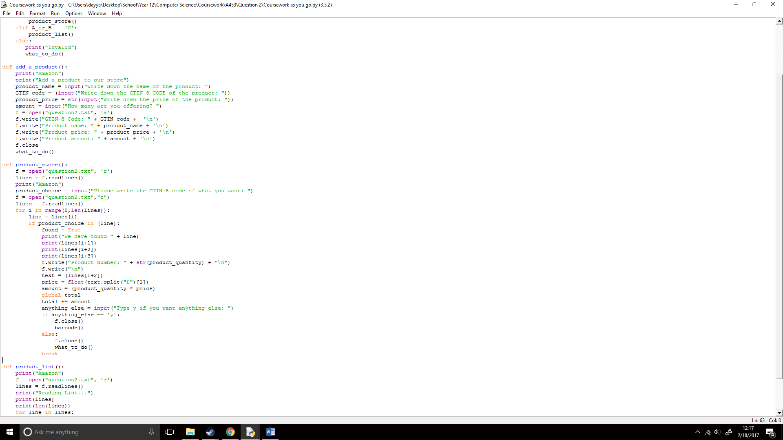

Now my whole function looked like this:

I now would create a recipt() function which would add the total price of the products to the Receipt.txt file. I first, printed all the lines in the Recipt.txt file, and then printed the total variable at the end of it. This function would be like the listing all products file except with the Recipt.txt file:

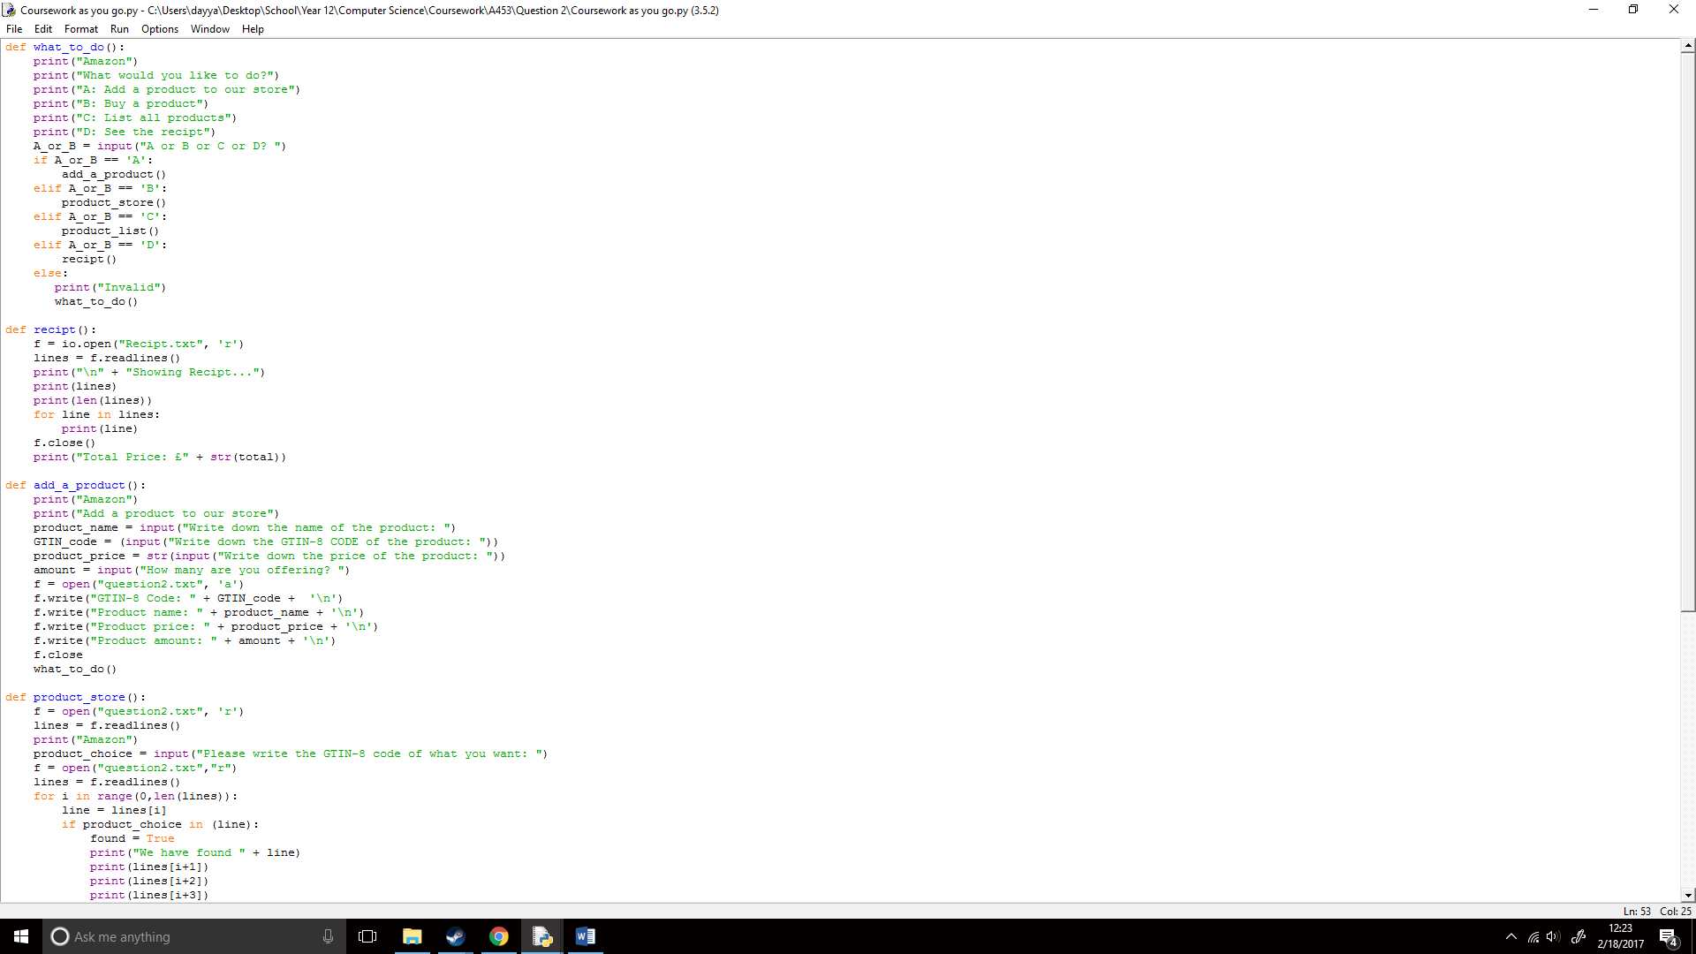

And the proceeded to write the total to the Recipt.txt file. I opened this in append mode as I wanted to add something to the end of it without clearing the whole file.

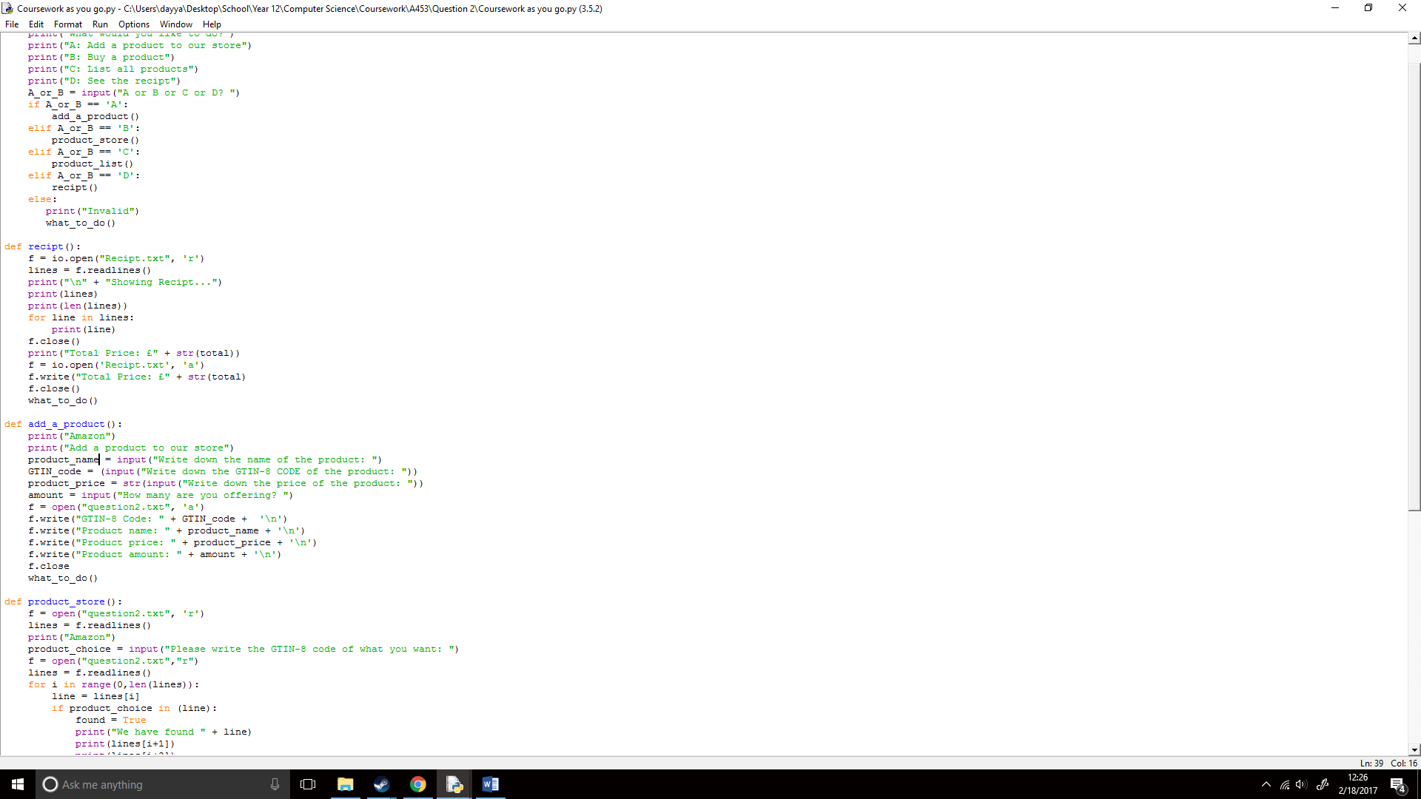

Now to run the file:

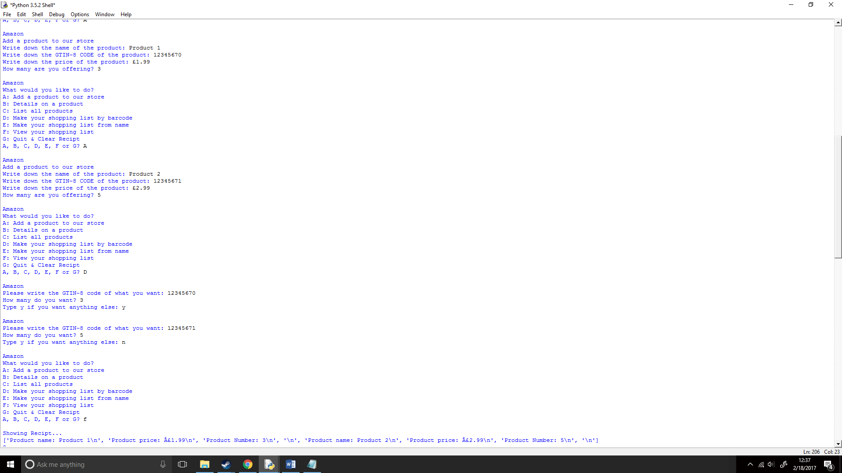





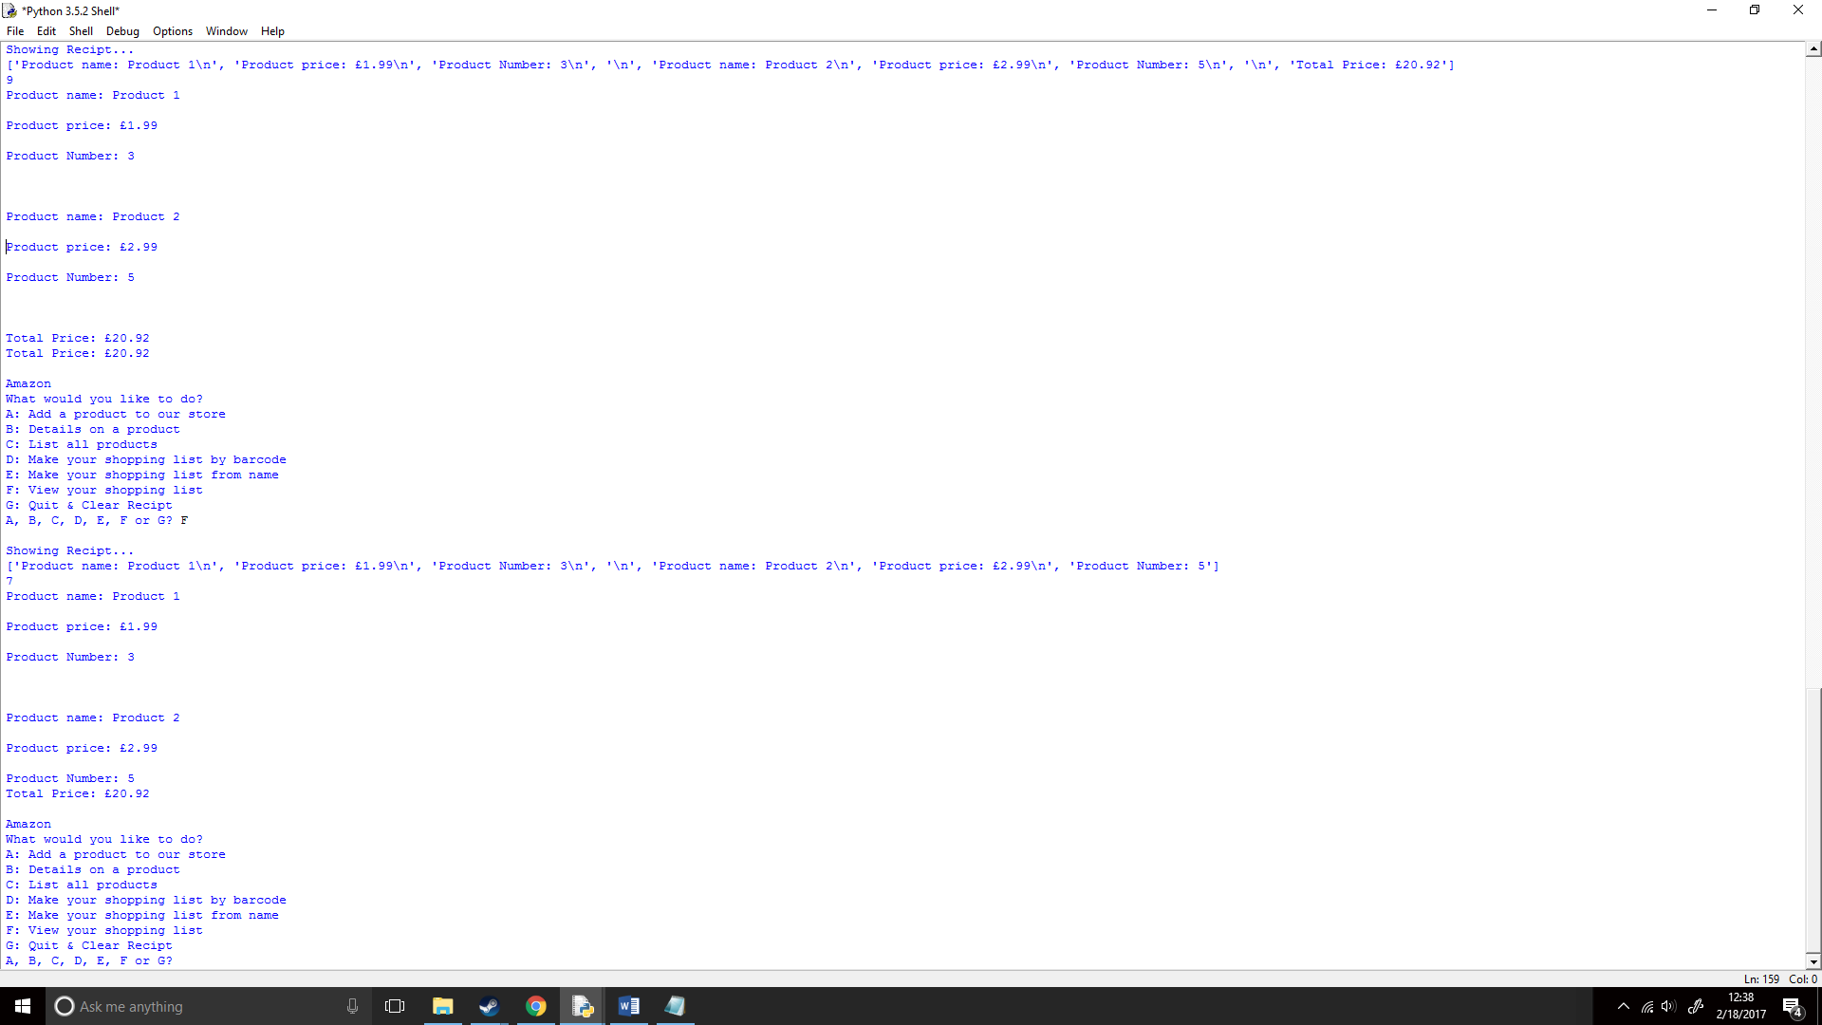

It worked successfully! Now I would have to improve bugs and add new features.

## How will I add more features to my program?

I first added a by_name() function which would allow adding a product to your Recipt.txt from a product name, this would be done like the now barcode() function, but with [i+]/[i-], with different numbers added or deducted depending on their respective places.

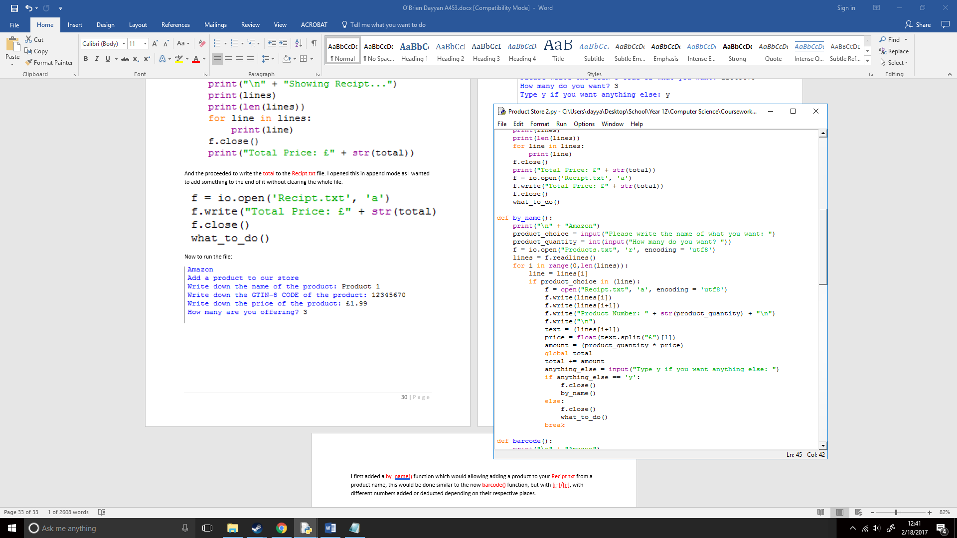

## How does the overall code look?

I then added an exit function for the Recipt.txt so you can exit the program and clear Recipt.txt file, this would prevent the recipt() function from being ran again which would write another product total to the end of the text file every time and cleaned up the code a bit. So, now my full code looked like this:

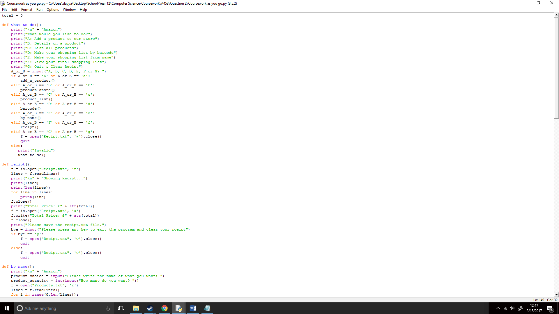

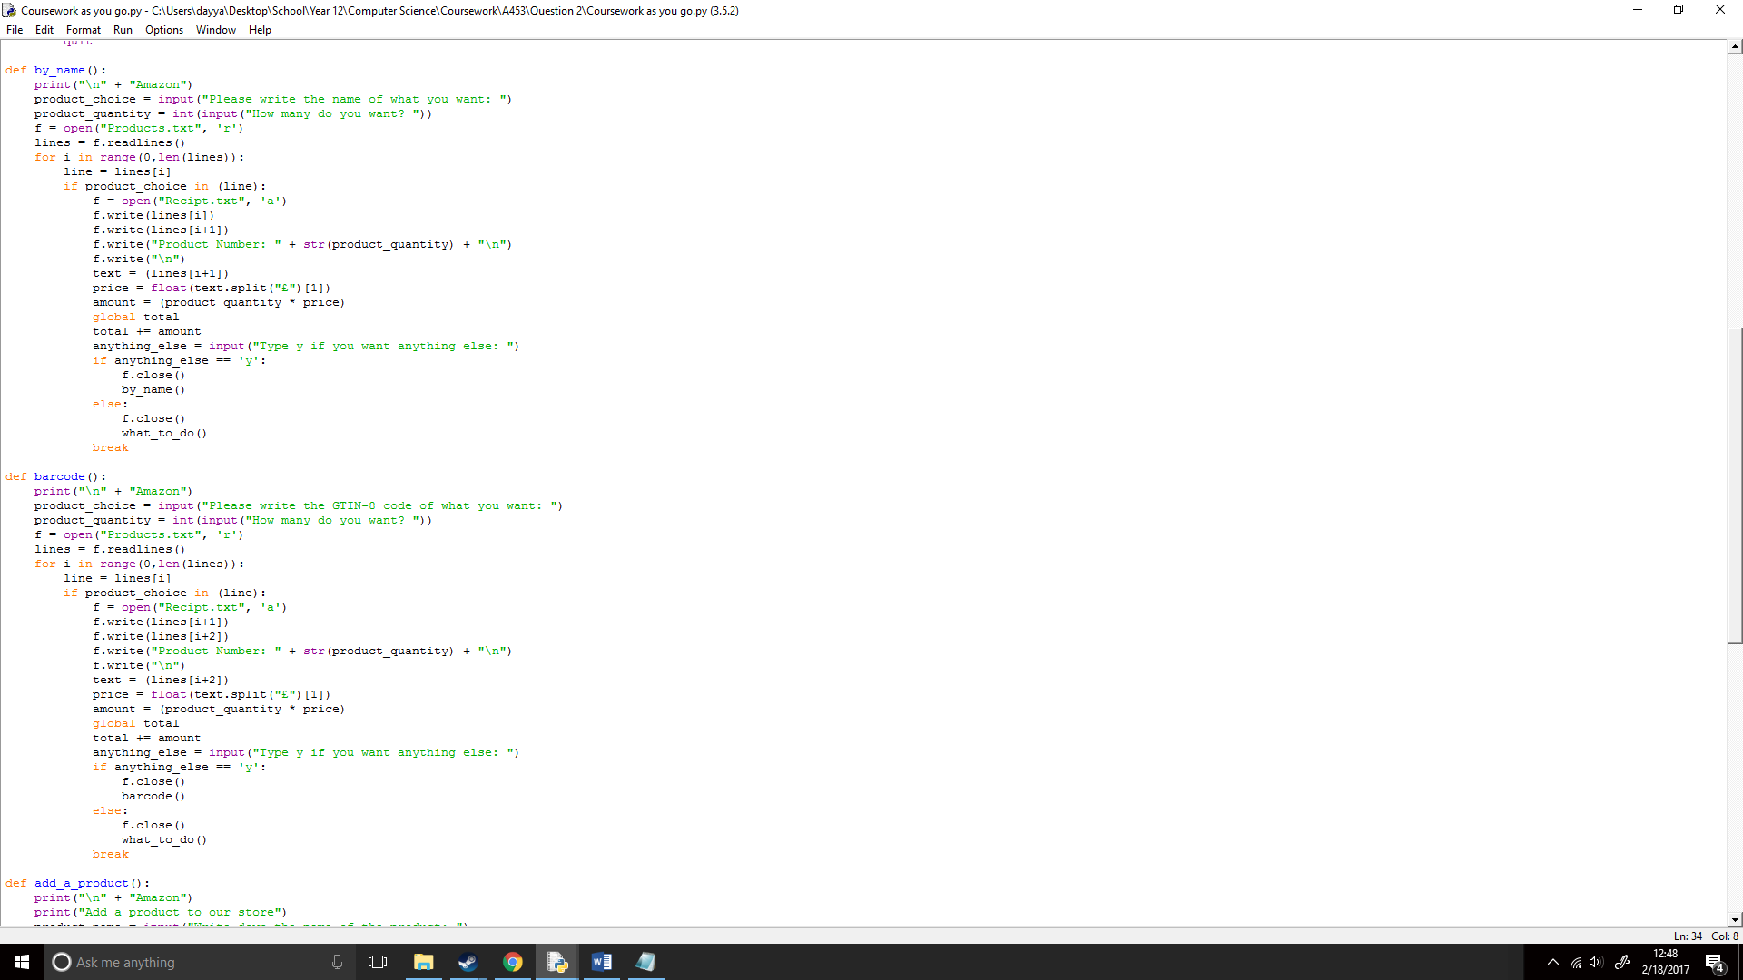

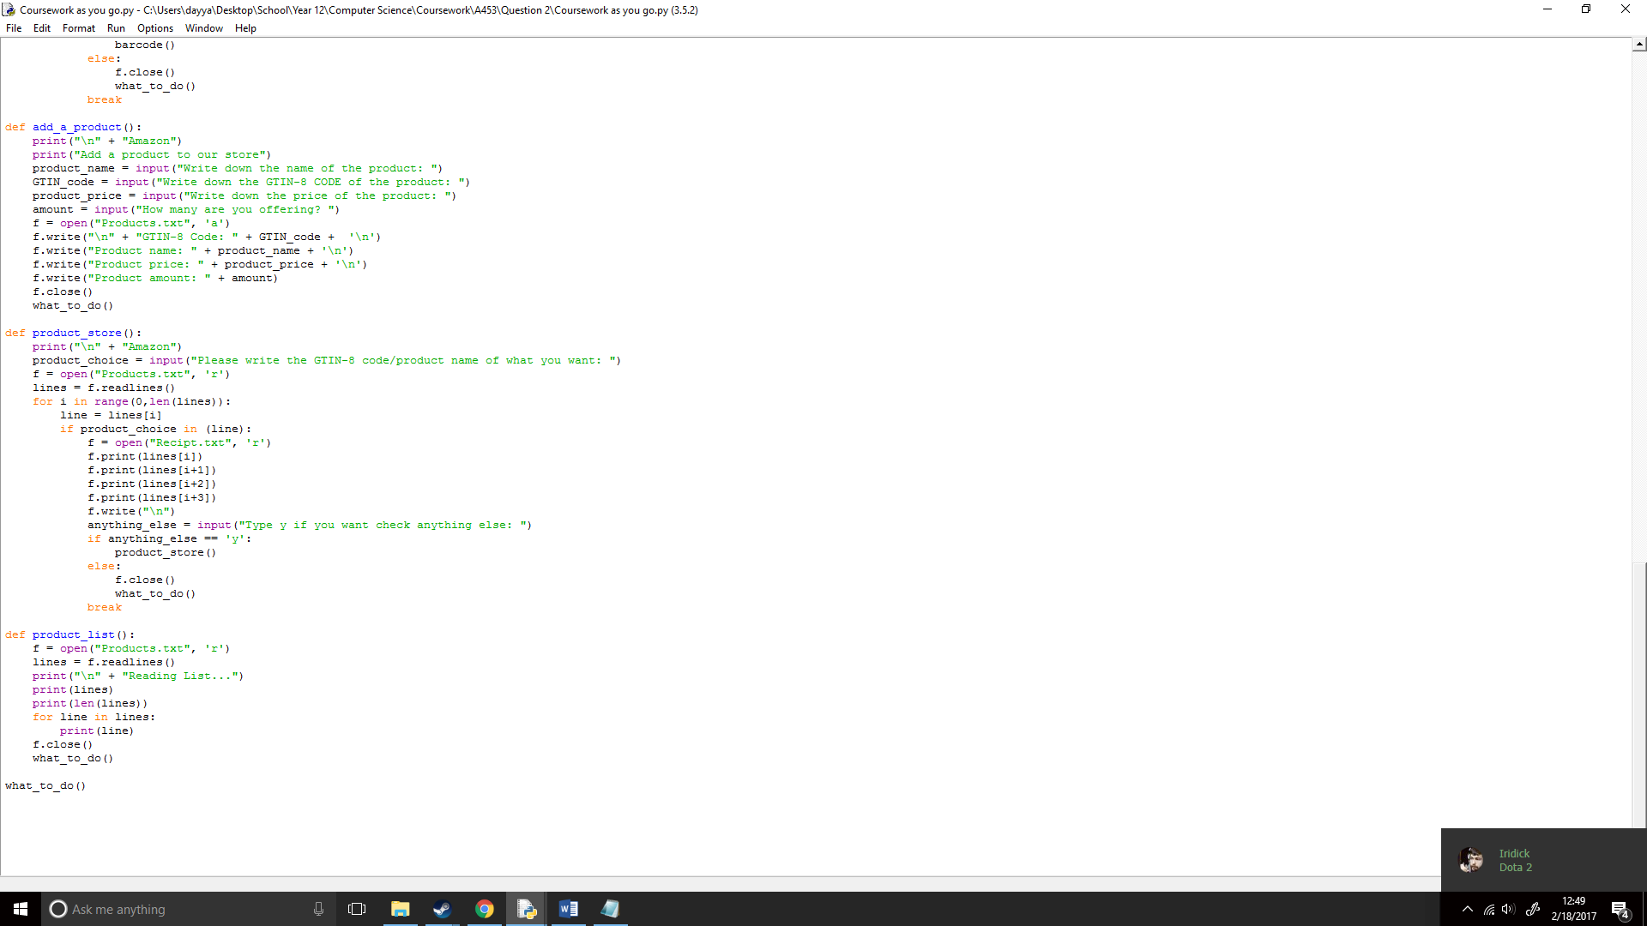

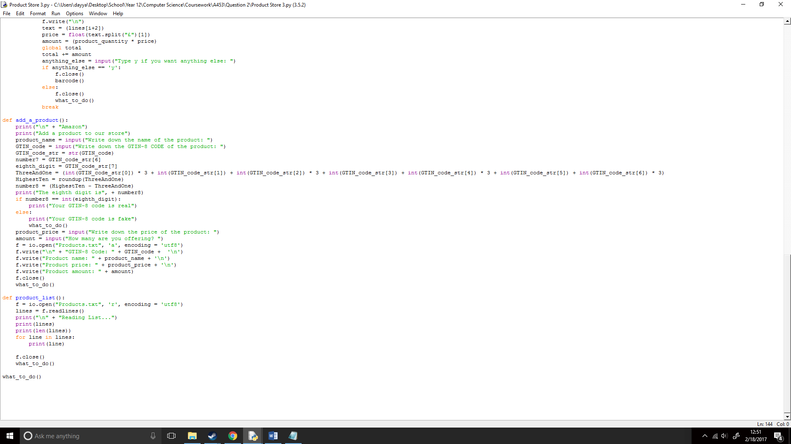I now wanted to add even more functionality to the overall code, so I implemented the GTIN-8 code confirmation from Question 1 into this code which would now check if the GTIN-8 code was real or fake:

My code was now complete!

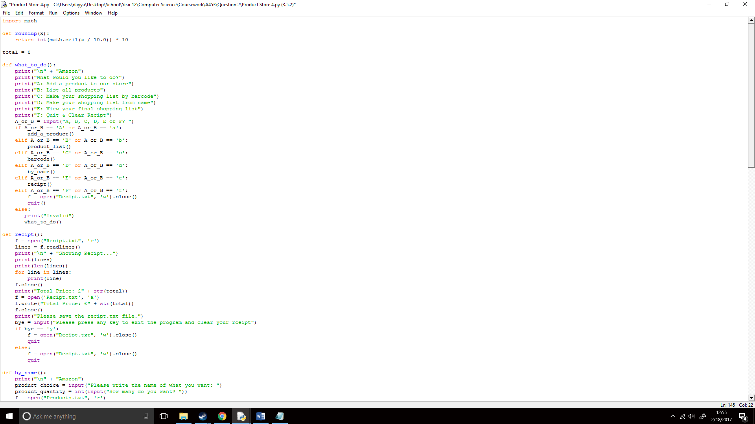

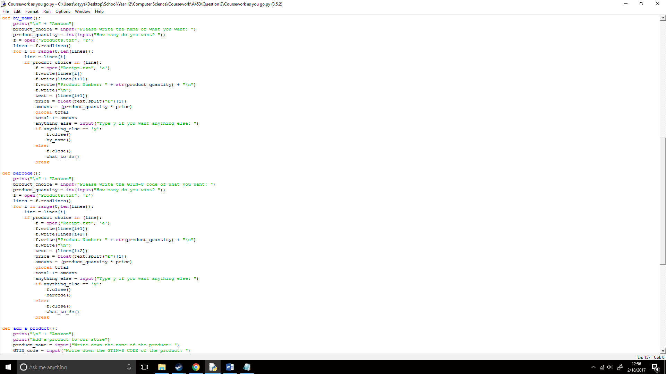

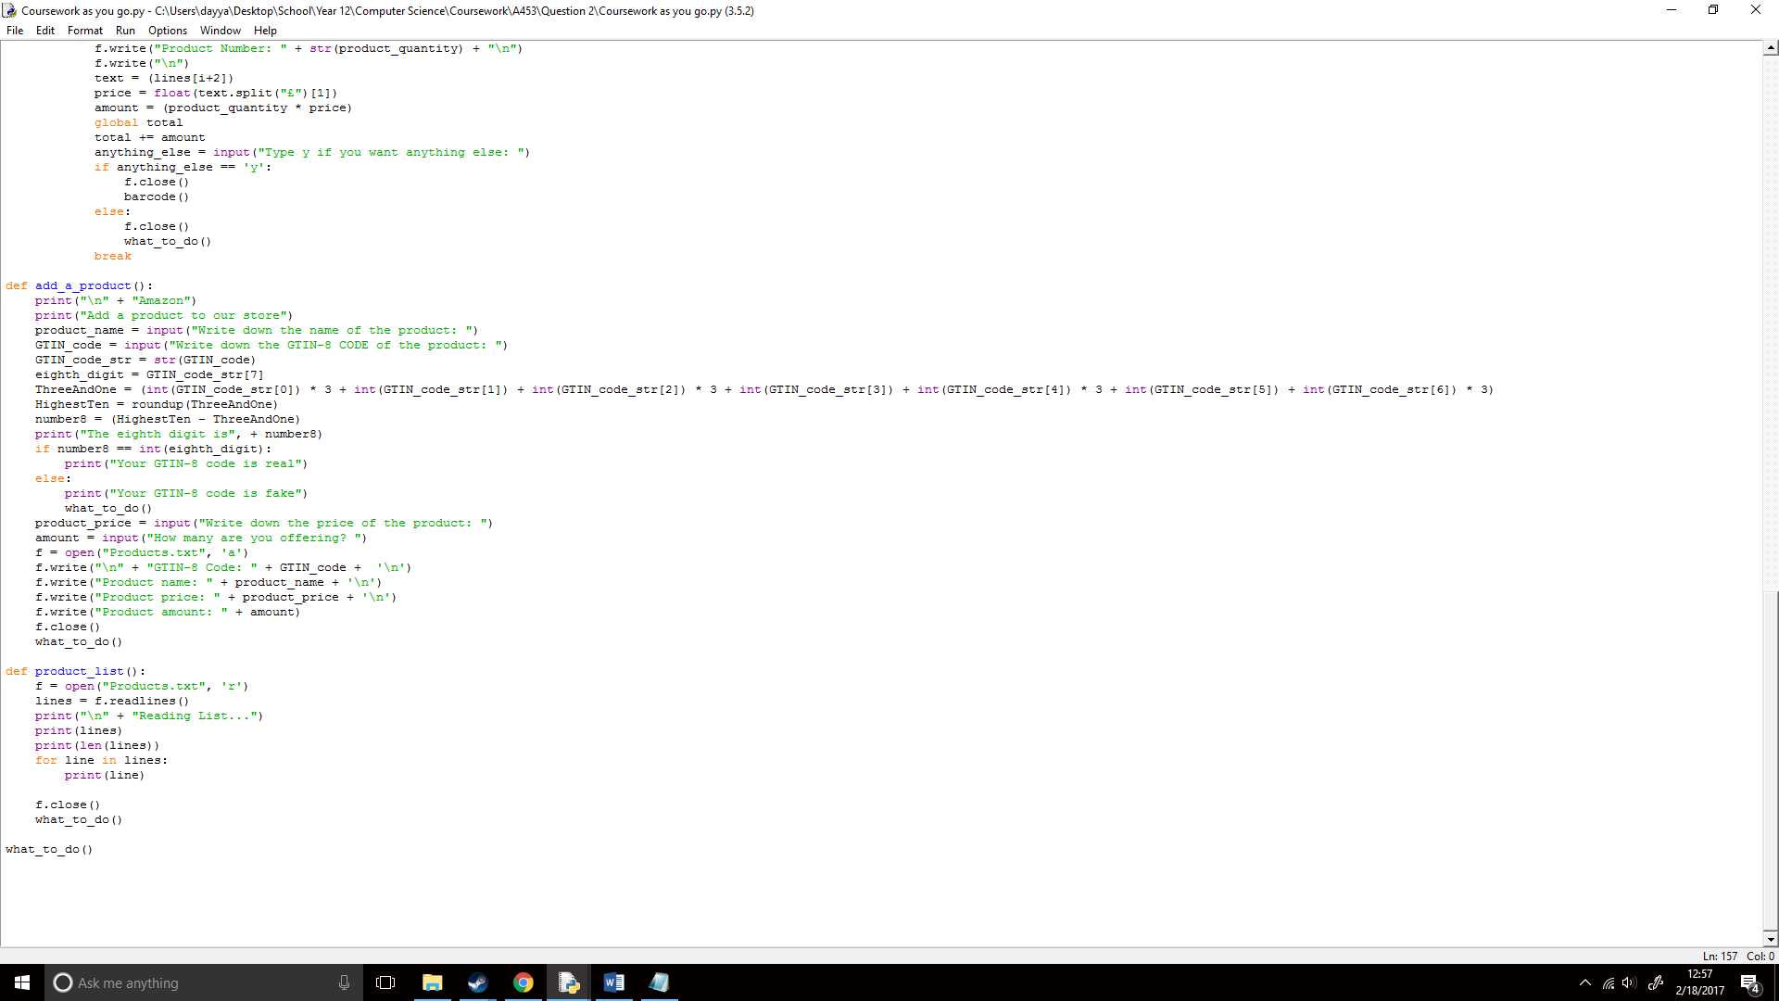I then ran the code and;

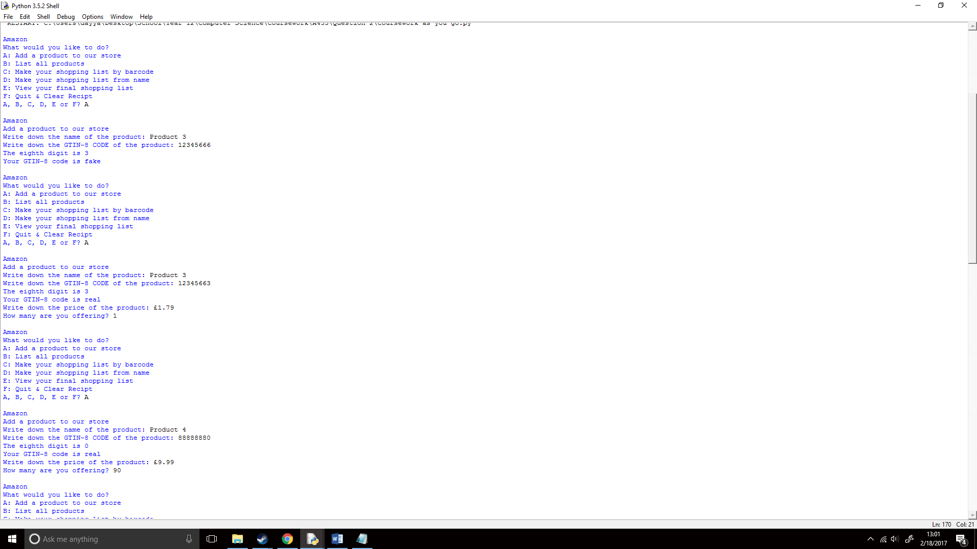

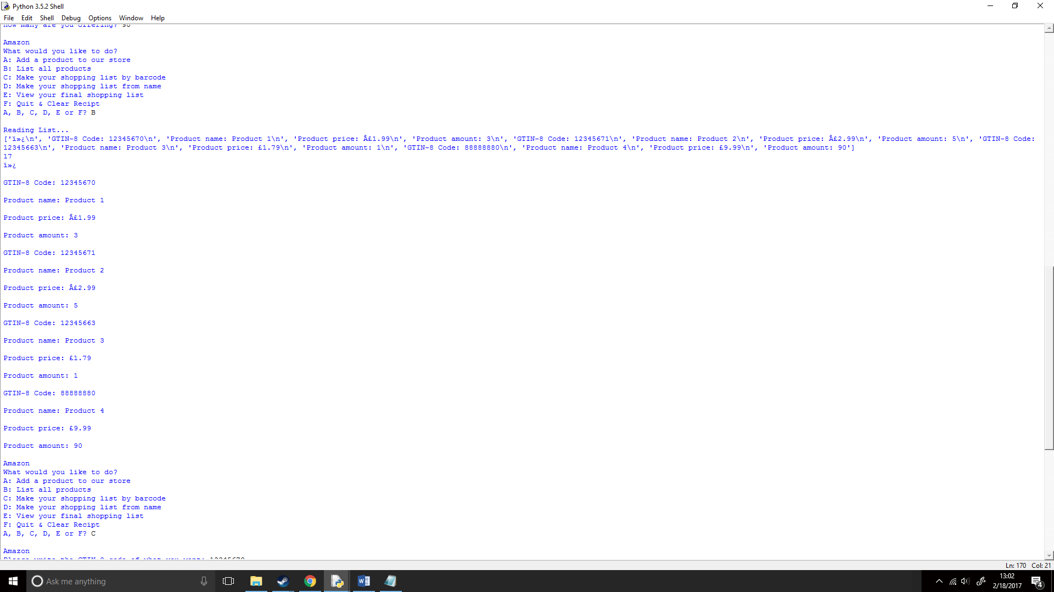

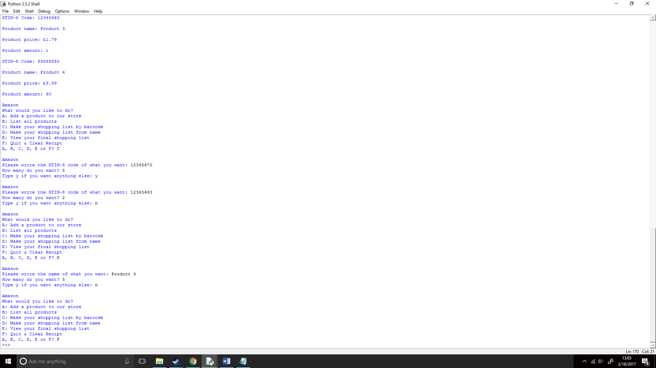

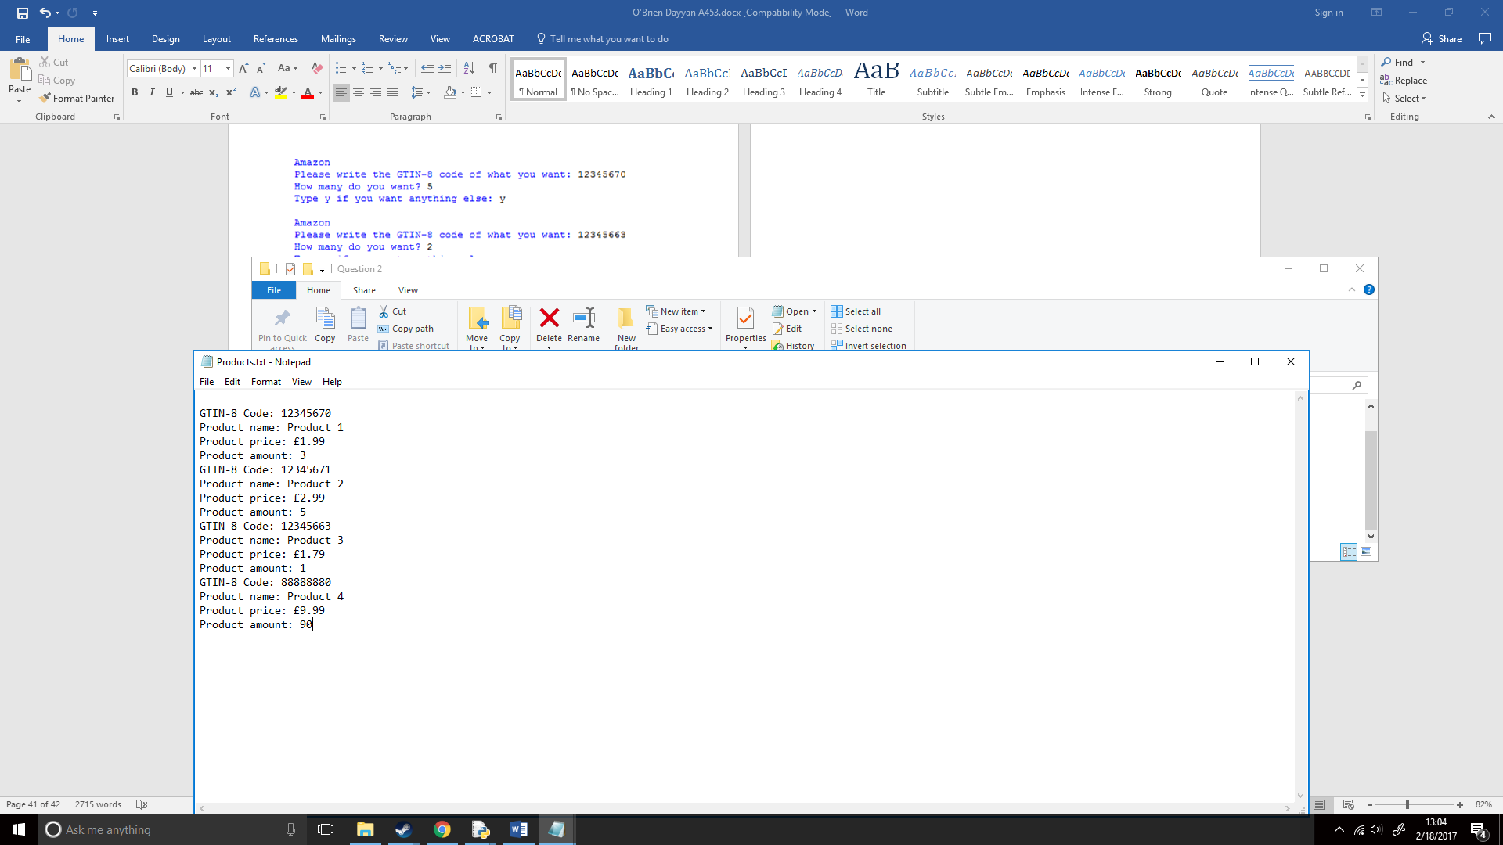

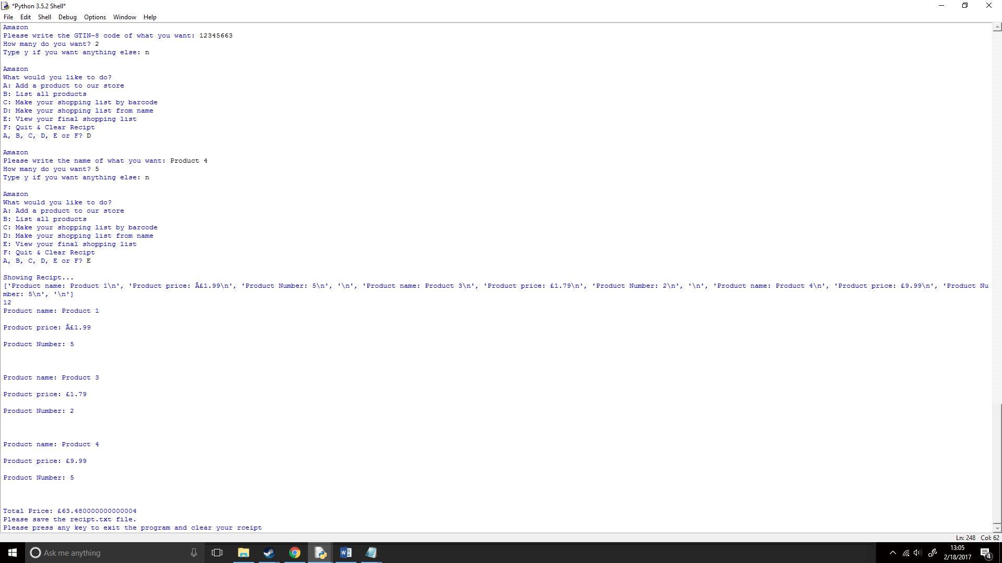

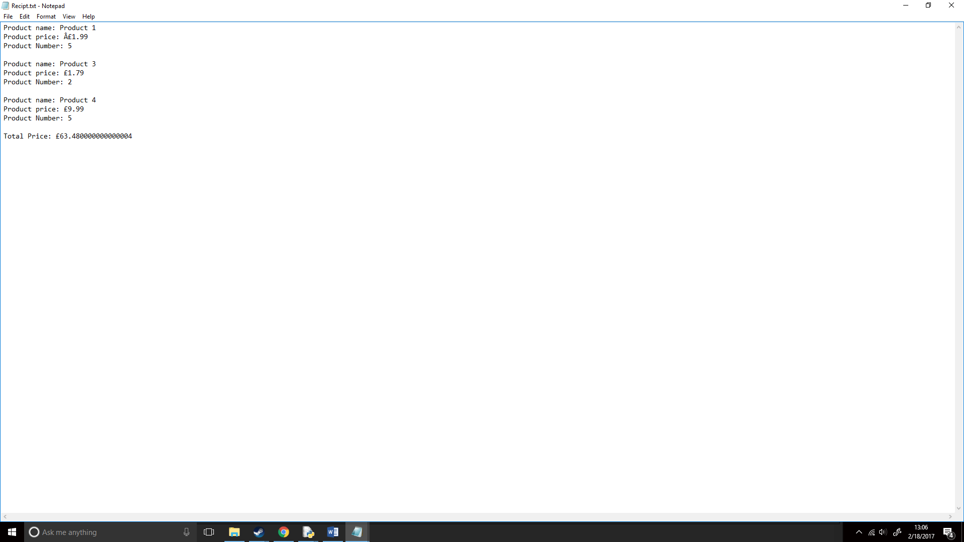

I found however, that the total price was not to the nearest hundredth and because money is always rounded downwards I would have to round it down to the nearest hundredth. I would do this with math.floor(x) (https://docs.python.org/2/library/math.html);

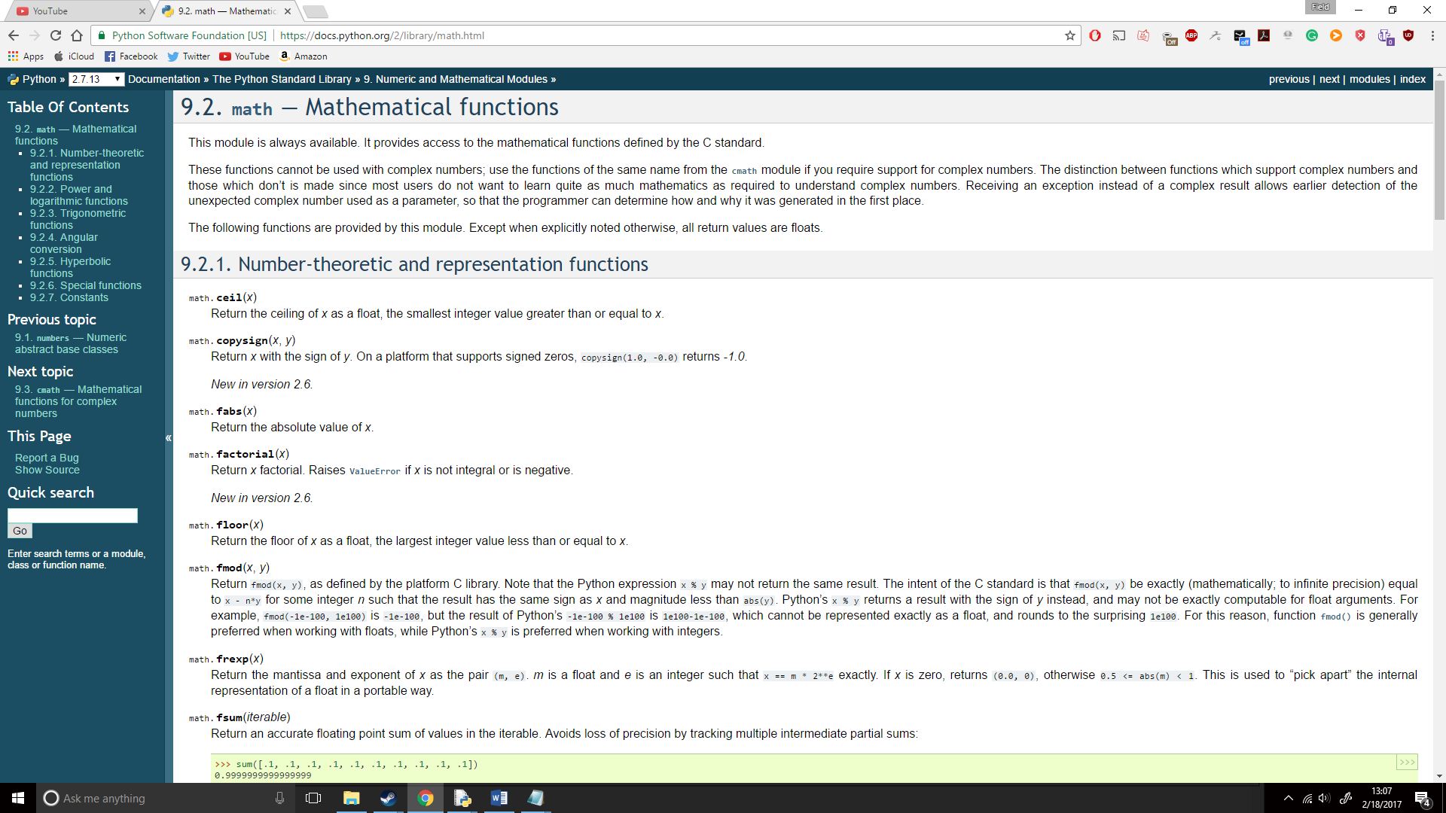

I would do this by creating a new variable called ntotal and this would multiply the total by 100 and round that down to the nearest integer and divide that rounded up integer by 100. 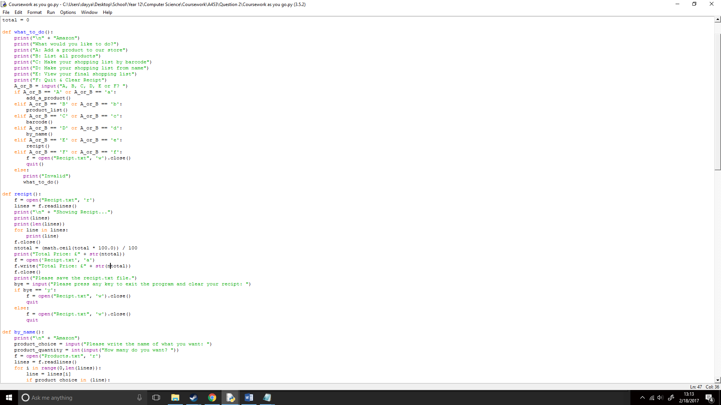

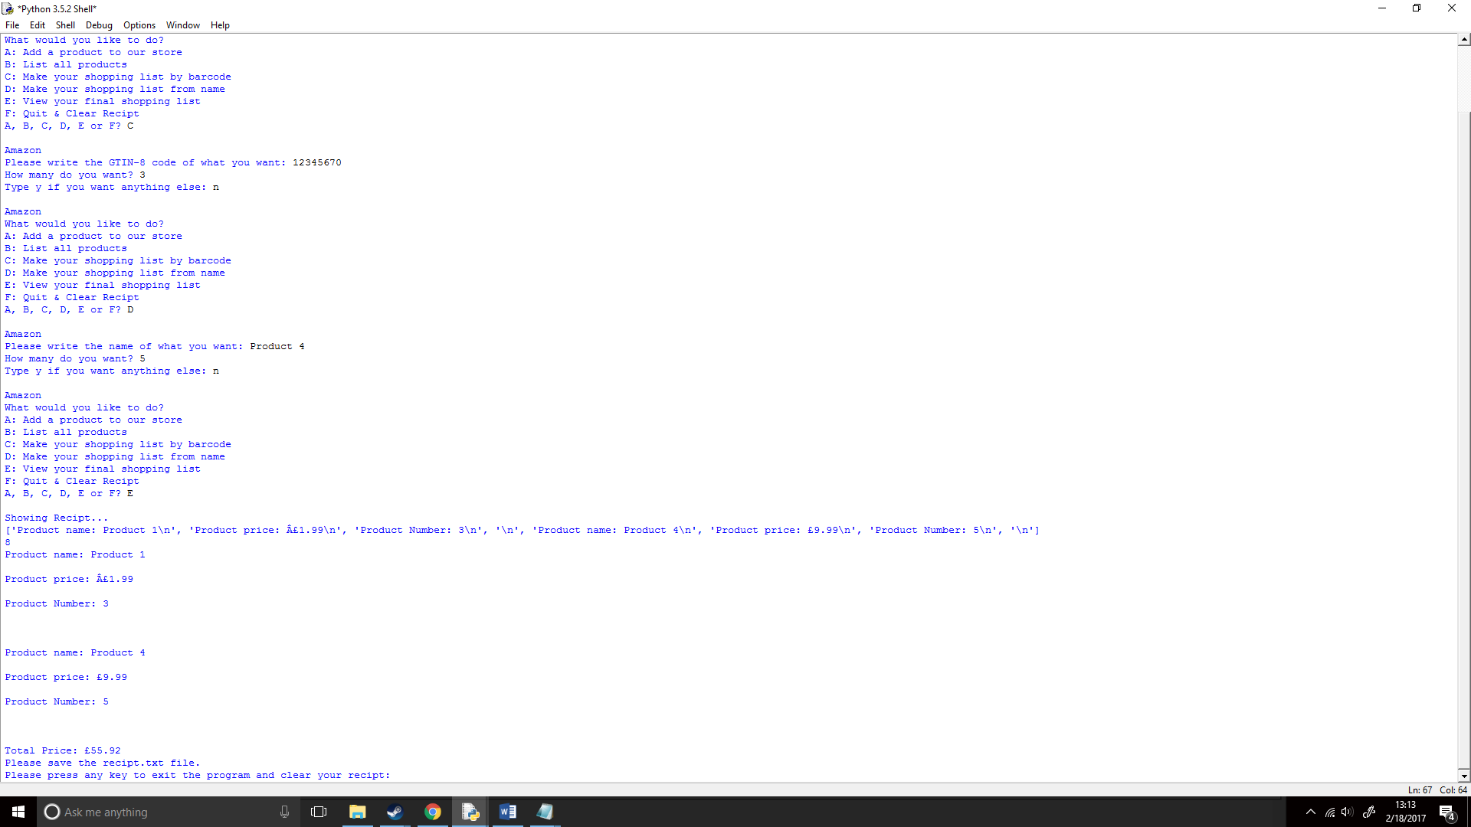When I ran it, it worked correctly!

## Pseudo Code:

IMPORT math

FUNCTION roundup(x):

RETURN int(math.ceil(x / 10.0)) * 10

ENDFUNCTION

total <- 0

FUNCTION what_to_do():

OUTPUT "\n" + "Amazon"

OUTPUT "What would you like to do?"

OUTPUT "A: Add a product to our store"

OUTPUT "B: List all products"

OUTPUT "C: Make your shopping list by barcode"

OUTPUT "D: Make your shopping list from name"

OUTPUT "E: View your final shopping list"

OUTPUT "F: Quit & Clear Recipt"

A_or_B <- input("A, B, C, D, E or F? ")

IF A_or_B = 'A' or A_or_B = 'a':

add_a_product()

ELSEIF A_or_B = 'B' or A_or_B = 'b':

product_list()

ELSEIF A_or_B = 'C' or A_or_B = 'c':

barcode()

ELSEIF A_or_B = 'D' or A_or_B = 'd':

by_name()

ELSEIF A_or_B = 'E' or A_or_B = 'e':

recipt()

ELSEIF A_or_B = 'F' or A_or_B = 'f':

f <- open("Recipt.txt", 'w').close()

quit()

ELSE:

OUTPUT "Invalid"

what_to_do()

ENDIF

ENDFUNCTION

FUNCTION recipt():

f <- open("Recipt.txt", 'r')

lines <- f.readlines()

OUTPUT "\n" + "Showing Recipt..."

OUTPUT lines

OUTPUT len(lines)

for line in lines:

OUTPUT line

ENDFOR

f.close()

ntotal <- (math.ceil(total * 100.0)) / 100

OUTPUT "Total Price: £" + str(ntotal)

f <- open('Recipt.txt', 'a')

f.write("Total Price: £" + str(ntotal))

f.close()

OUTPUT "Please save the recipt.txt file."

bye <- input("Please press any key to exit the program AND clear your recipt: ")

IF bye = 'y':

f <- open("Recipt.txt", 'w').close()

quit

ELSE:

f <- open("Recipt.txt", 'w').close()

quit

ENDIF

ENDFUNCTION

FUNCTION by_name():

OUTPUT "\n" + "Amazon"

product_choice <- input("Please write the name of what you want: ")

product_quantity <- int(input("How many do you want? "))

f <- open("Products.txt", 'r')

lines <- f.readlines()

for i in range(0,len(lines)):

line <- lines[i]

IF product_choice in (line):

f <- open("Recipt.txt", 'a')

f.write(lines[i])

f.write(lines[i+1])

f.write("Product Number: " + str(product_quantity) + "\n")

f.write("\n")

text <- (lines[i+1])

price <- float(text.split("£")[1])

amount <- (product_quantity * price)

global total

total += amount

anything_else <- input("Type y IF you want anything ELSE: ")

ENDIF

IF anything_else = 'y':

f.close()

by_name()

ELSE:

f.close()

what_to_do()

ENDIF

break

ENDIF

ENDFUNCTION

ENDFOR

FUNCTION barcode():

OUTPUT "\n" + "Amazon"

product_choice <- input("Please write the GTIN-8 code of what you want: ")

product_quantity <- int(input("How many do you want? "))

f <- open("Products.txt", 'r')

lines <- f.readlines()

for i in range(0,len(lines)):

line <- lines[i]

IF product_choice in (line):

f <- open("Recipt.txt", 'a')

f.write(lines[i+1])

f.write(lines[i+2])

f.write("Product Number: " + str(product_quantity) + "\n")

f.write("\n")

text <- (lines[i+2])

price <- float(text.split("£")[1])

amount <- (product_quantity * price)

global total

total += amount

anything_else <- input("Type y IF you want anything ELSE: ")

ENDIF

IF anything_else = 'y':

f.close()

barcode()

ELSE:

f.close()

what_to_do()

ENDIF

Break

ELSE

what_to_do

ENDIF ENDFUNCTION

ENDFOR

FUNCTION add_a_product():

OUTPUT "\n" + "Amazon"

OUTPUT "Add a product to our store"

product_name <- input("Write down the name of the product: ")

GTIN_code <- input("Write down the GTIN-8 CODE of the product: ")

GTIN_code_str <- str(GTIN_code)

eighth_digit <- GTIN_code_str[7]

ThreeAndOne <- (int(GTIN_code_str[0]) * 3 + int(GTIN_code_str[1]) + int(GTIN_code_str[2]) * 3 + int(GTIN_code_str[3]) + int(GTIN_code_str[4]) * 3 + int(GTIN_code_str[5]) + int(GTIN_code_str[6]) * 3)

HighestTen <- roundup(ThreeAndOne)

number8 <- (HighestTen - ThreeAndOne)

OUTPUT "The eighth digit is", + number8

IF number8 = int(eighth_digit):

OUTPUT "Your GTIN-8 code is real"

ELSE:

OUTPUT "Your GTIN-8 code is fake"

what_to_do()

ENDIF

product_price <- input("Write down the price of the product: ")

amount <- input("How many are you offering? ")

f <- open("Products.txt", 'a')

f.write("\n" + "GTIN-8 Code: " + GTIN_code + '\n')

f.write("Product name: " + product_name + '\n')

f.write("Product price: " + product_price + '\n')

f.write("Product amount: " + amount)

f.close()

what_to_do()

ENDFUNCTION

FUNCTION product_list():

f <- open("Products.txt", 'r')

lines <- f.readlines()

OUTPUT "\n" + "Reading List..."

OUTPUT lines

OUTPUT len(lines)

for line in lines:

OUTPUT line

ENDFOR

f.close()

what_to_do()

ENDFUNCTION

RUN what_to_do()

## Flowchart:https://documents.lucidchart.com/documents/609f151c-bf4b-4780-ad2c-6157ec55b5e8/pages/0_0?a=767&x=-39&y=-28&w=1005&h=1936&store=1&accept=image%2F*&auth=LCA%20f195af249400f99f1814e01ecb706e7bc9b02ec3-ts%3D1487432236https://documents.lucidchart.com/documents/d78707b1-918b-4b70-9c80-cb37fe97d05b/pages/0_0?a=708&x=25&y=-17&w=770&h=2134&store=1&accept=image%2F*&auth=LCA%20263f8bcc1e31c63321c3f3453112a1242969a153-ts%3D1487433424https://documents.lucidchart.com/documents/522f34d5-a057-4575-994a-8dc0eef88eee/pages/0_0?a=958&x=36&y=-57&w=968&h=2574&store=1&accept=image%2F*&auth=LCA%2034390df126dfd88db70c161a6b2070ca32372708-ts%3D1487434140https://documents.lucidchart.com/documents/522f34d5-a057-4575-994a-8dc0eef88eee/pages/0_0?a=1185&x=36&y=-57&w=968&h=2574&store=1&accept=image%2F*&auth=LCA%204d0271a87e3d30b9bd57b08ef03ccec7eb8e66da-ts%3D1487434140

# Question 3:



## What do I need to do?

1. Create a stock function
2. Create a stock level that can change
3. Check the stock level if it is below the reorder level
4. When restock, set a stock level when a product is restocked.

## How will I do it?

1. Create a stock function
2. Create a replace_line function
3. Change the stock string from a txt file into an integer so I can check if the stock level is below the reorder level.
4. When below stock level, replace it with the target stock level.

## What will the base structure be like?

First, I created a hub for the program this would go towards a refill function and an add stocks function. This was simple as I’ve done similar hubs in other questions:  
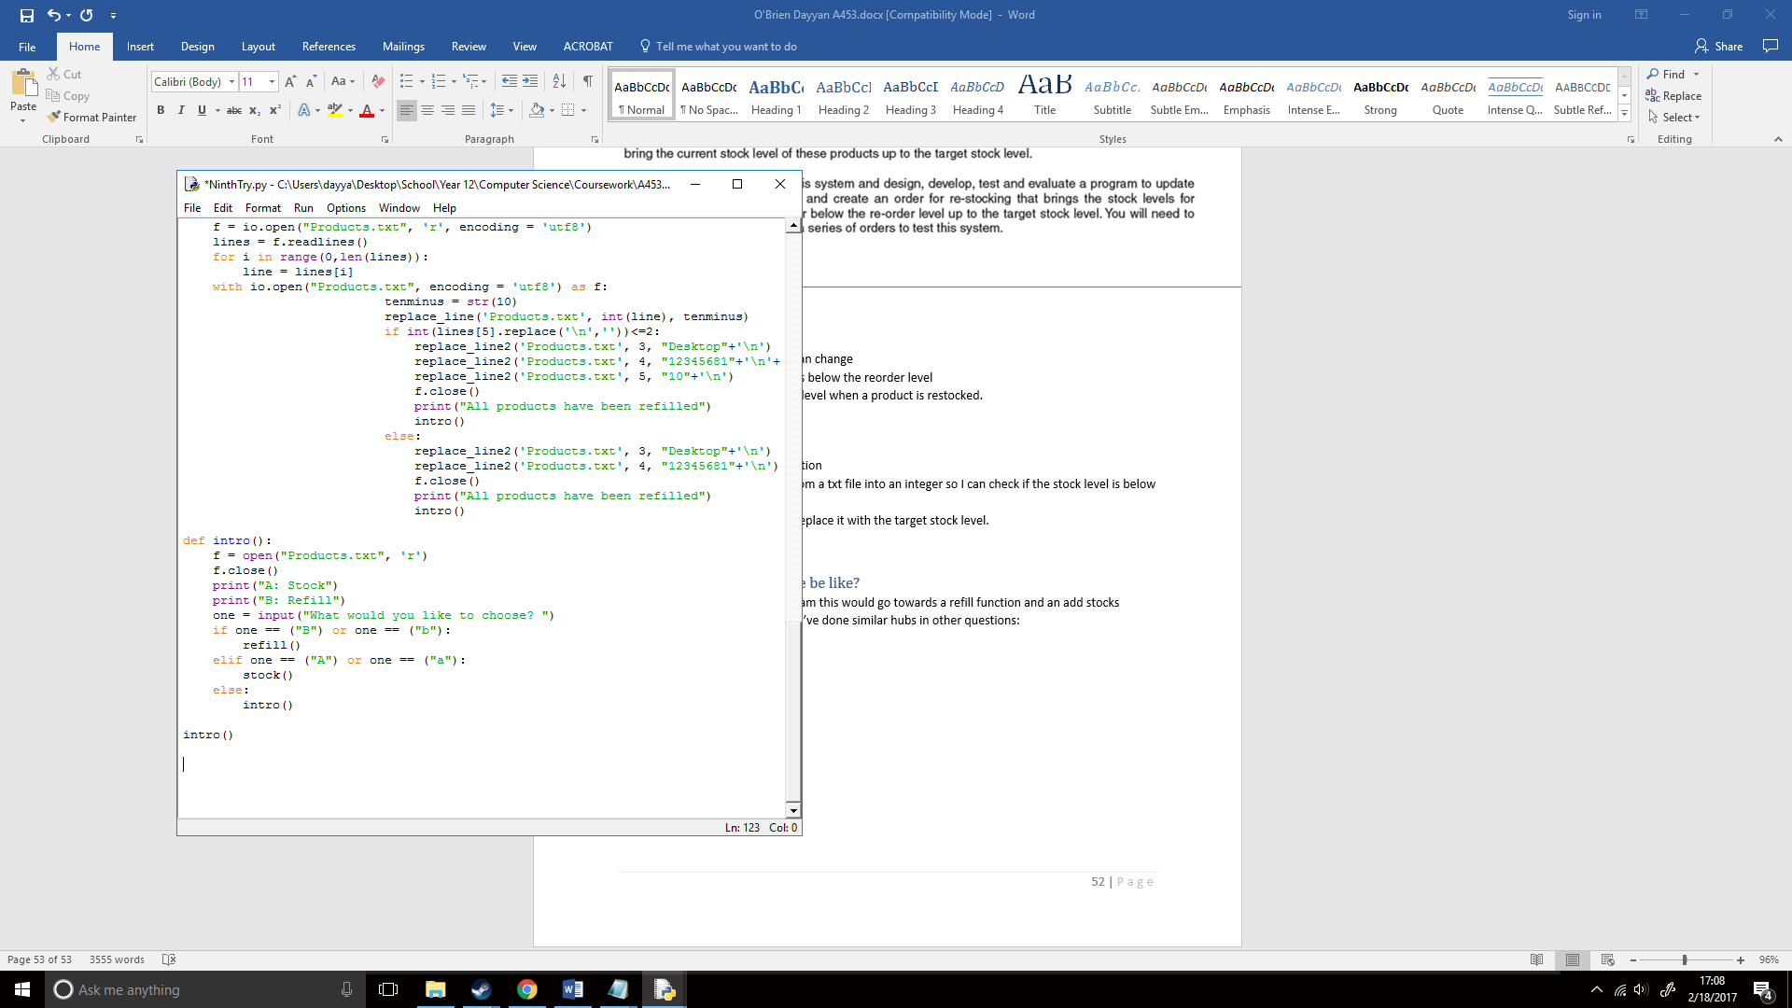

I then created a brief structure for each of the functions that I would be using:  
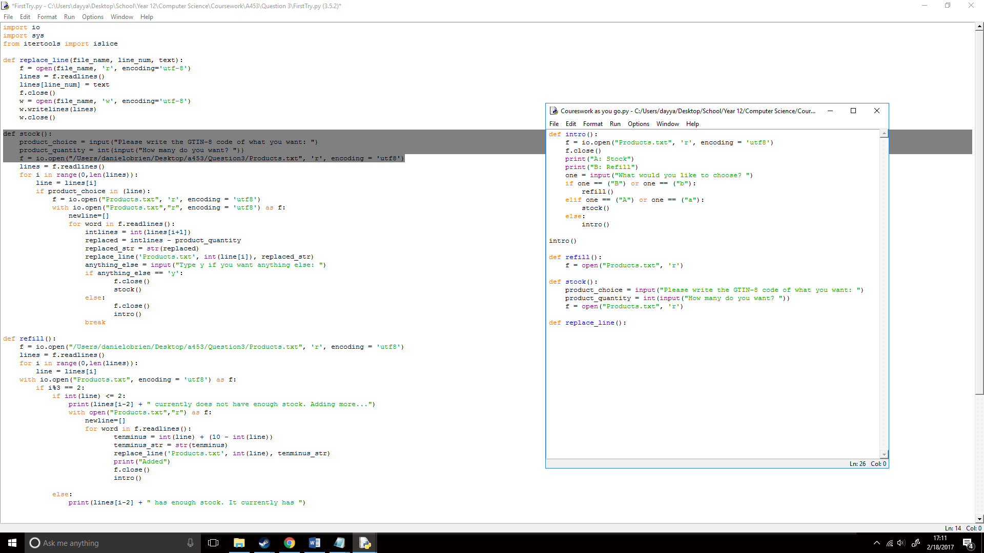

## How will I replace the lines?

Now I had to program the replace_line() function, I first added how I wanted to run the function in between the brackets.

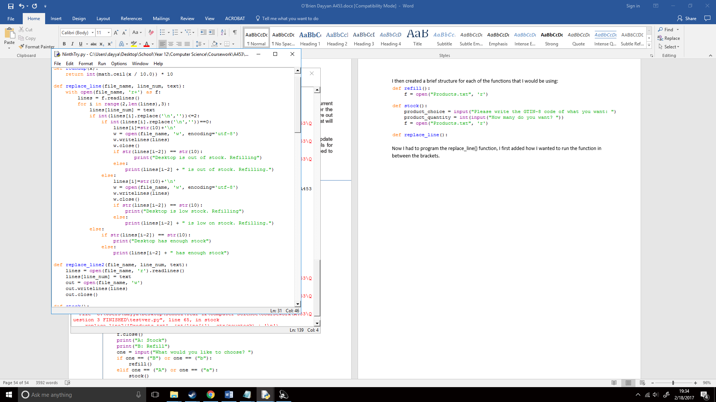

When I finish this function now, when running the function, I simply must type in that manner. I then opened my file with the first point file_name, this would mean when the file is opened it is opened with the file name that I set it. I opened this in r+ mode because it would open the file for reading and writing.



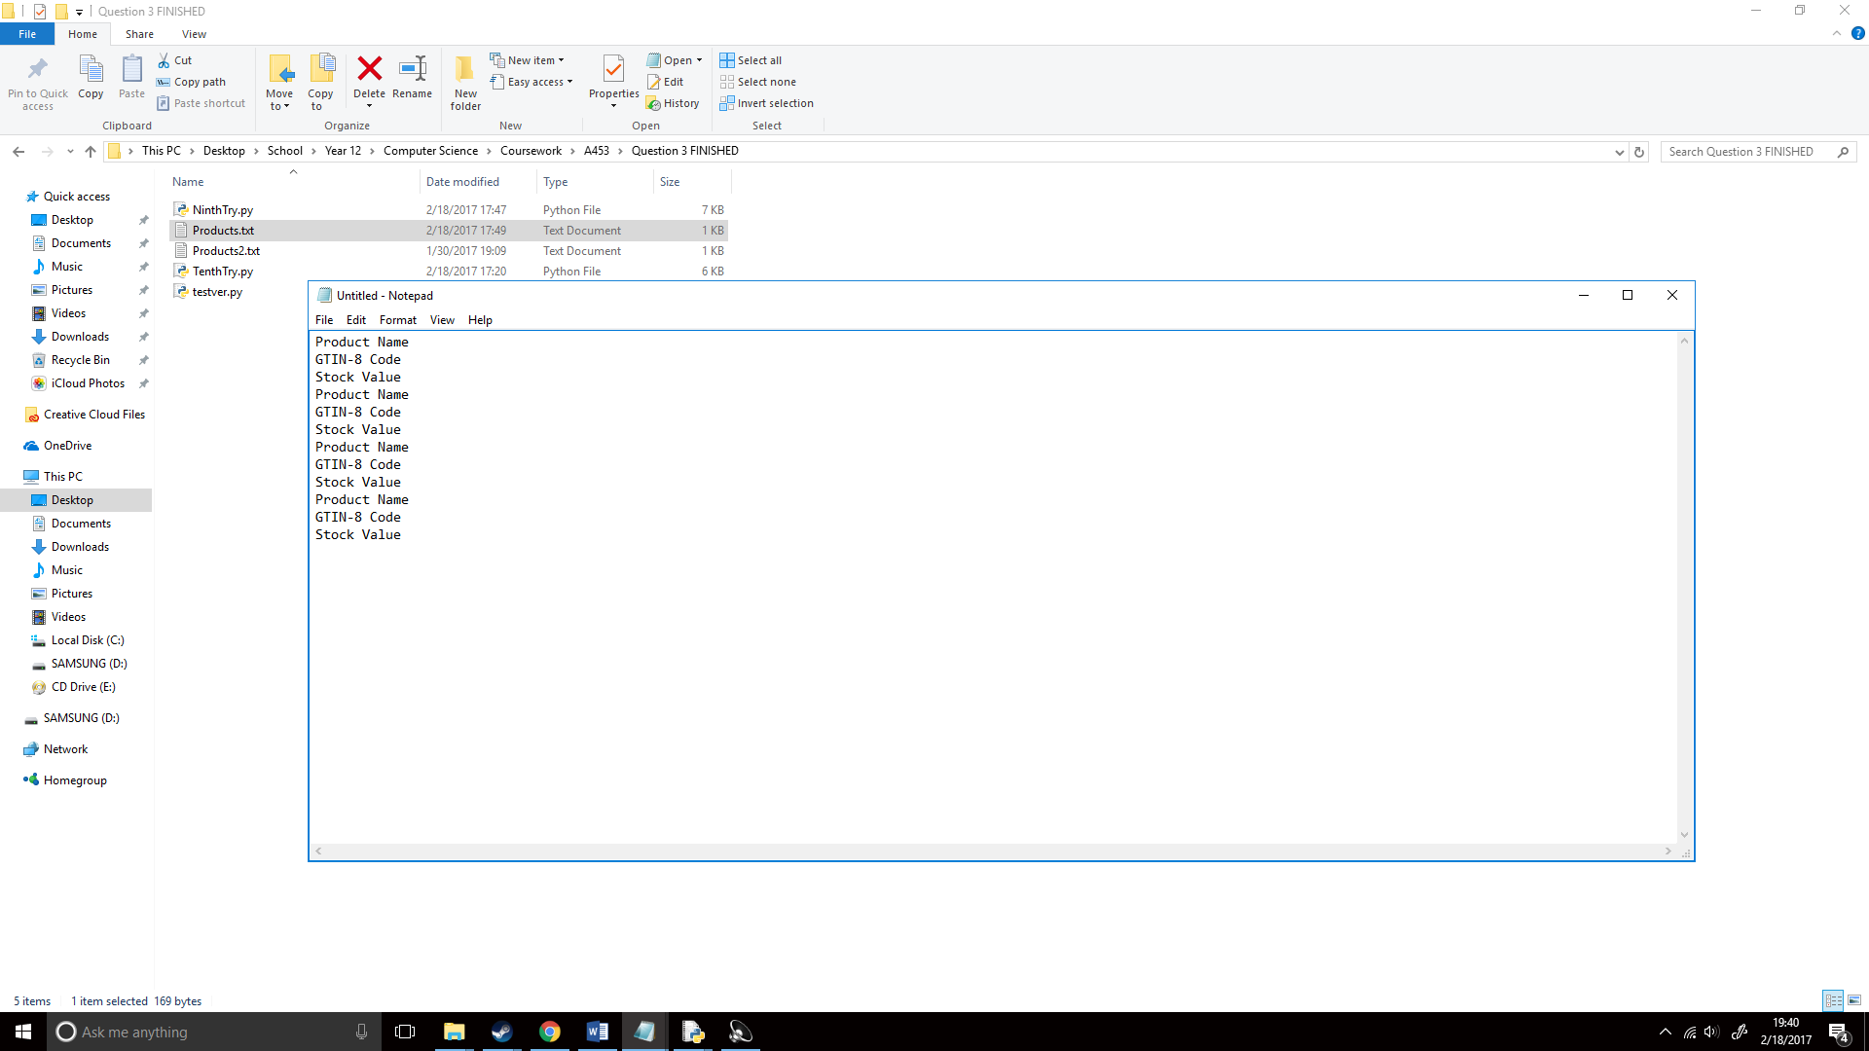Because I wanted to write the Products.txt file like below, I would have to check every third line, this would not be the first line however as that is not stock value. Because of this I created a for statement it would check every third line to the number of lines (so subsequently all the lines) from the third line (lines in python start from 0 not 1 so therefore I’m using two as the starting number.) I would set this line statement to [i] for ease of use:



I then wanted to check if the line is less than 2 which would be my re-order level. This would be done with an if statement, I had to change this line to an integer as the text file was a string and I can perform math if statements with strings in this example. I also set lines[line_num], so when I run the function I can simply write the line I want to replace and text is what I want to replace that line with.



I then wanted to run another if statement that would check if this stock value that is below 2 is equal to 0, as I already created a statement asking if it is below 2, I would run it under this statement so it can simply ask if it is equal to 0. I did one for <=2 and ==0 because I wanted different prints depending on the stock value. For example, “there is no stock available” in comparison to “there is few stock available”;

I then set line [i] to 10, I set it to 10 as this is what the value will be changed to if it is found to be below stock.

I then opened Products.txt in ‘w’ or write mode. I used writelines as writelines expects multiple strings while just write expects one.

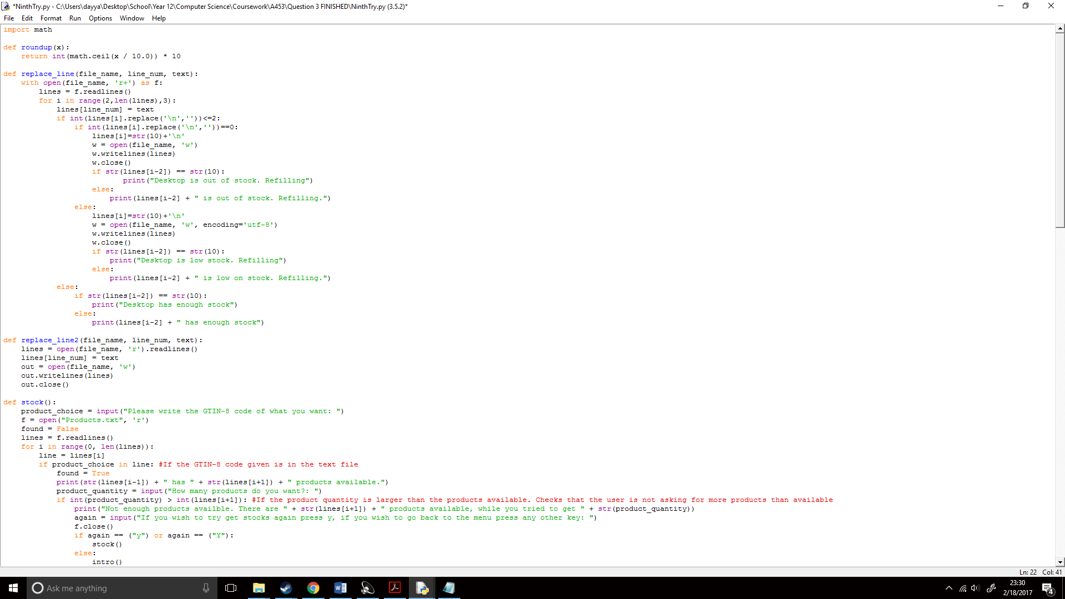

I wrote the same for <= 2;

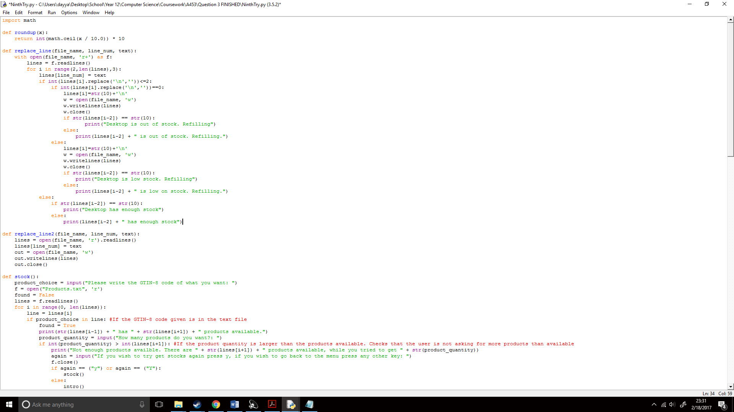

I finally added some prints to my code for when the line was replaced and if it had enough stock, so now my whole replace_line(file_name, line_num, text) function looked like this

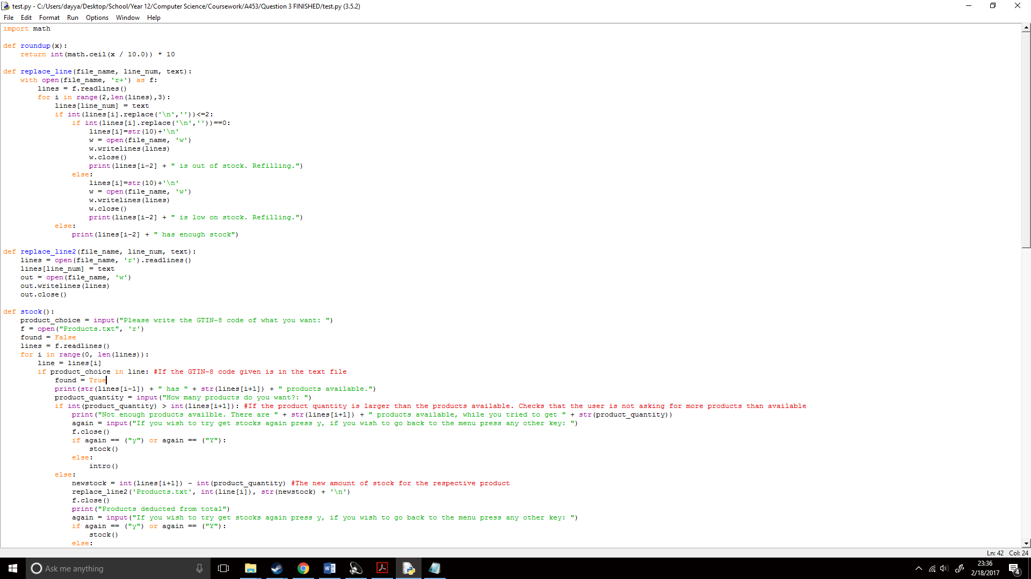

Now that the function was setup I would have to apply this to my refill() function to test it out. So, I set tenminus to 10 as this is what I was replacing the line with and wrote the function out as well as doing this with every line;

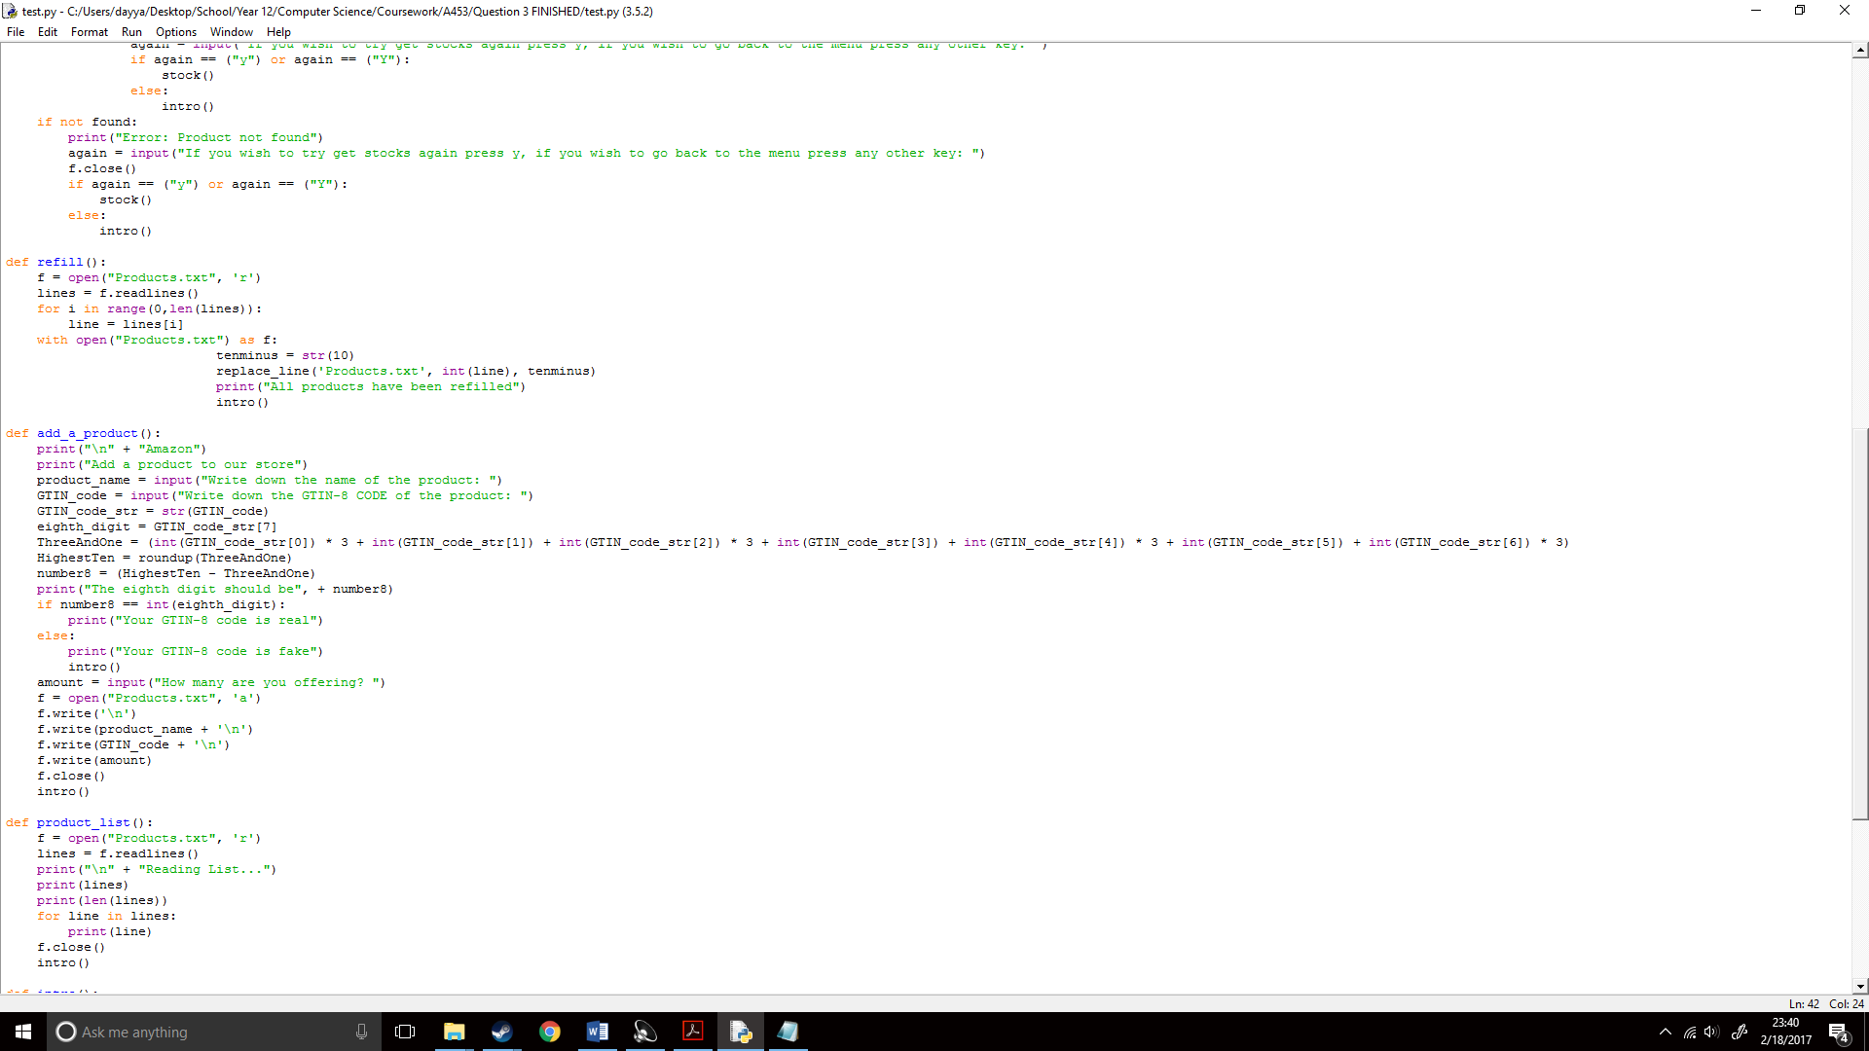

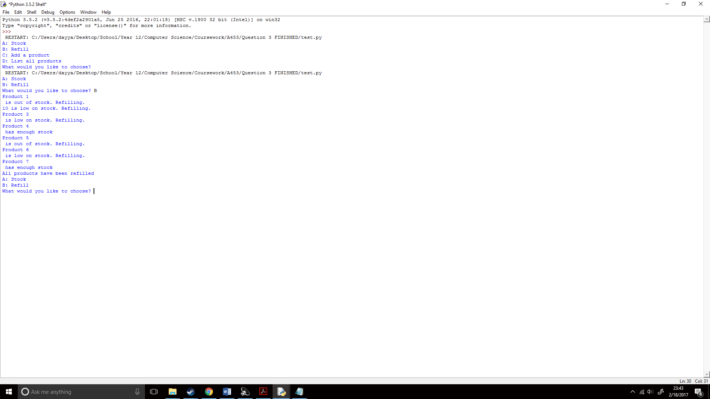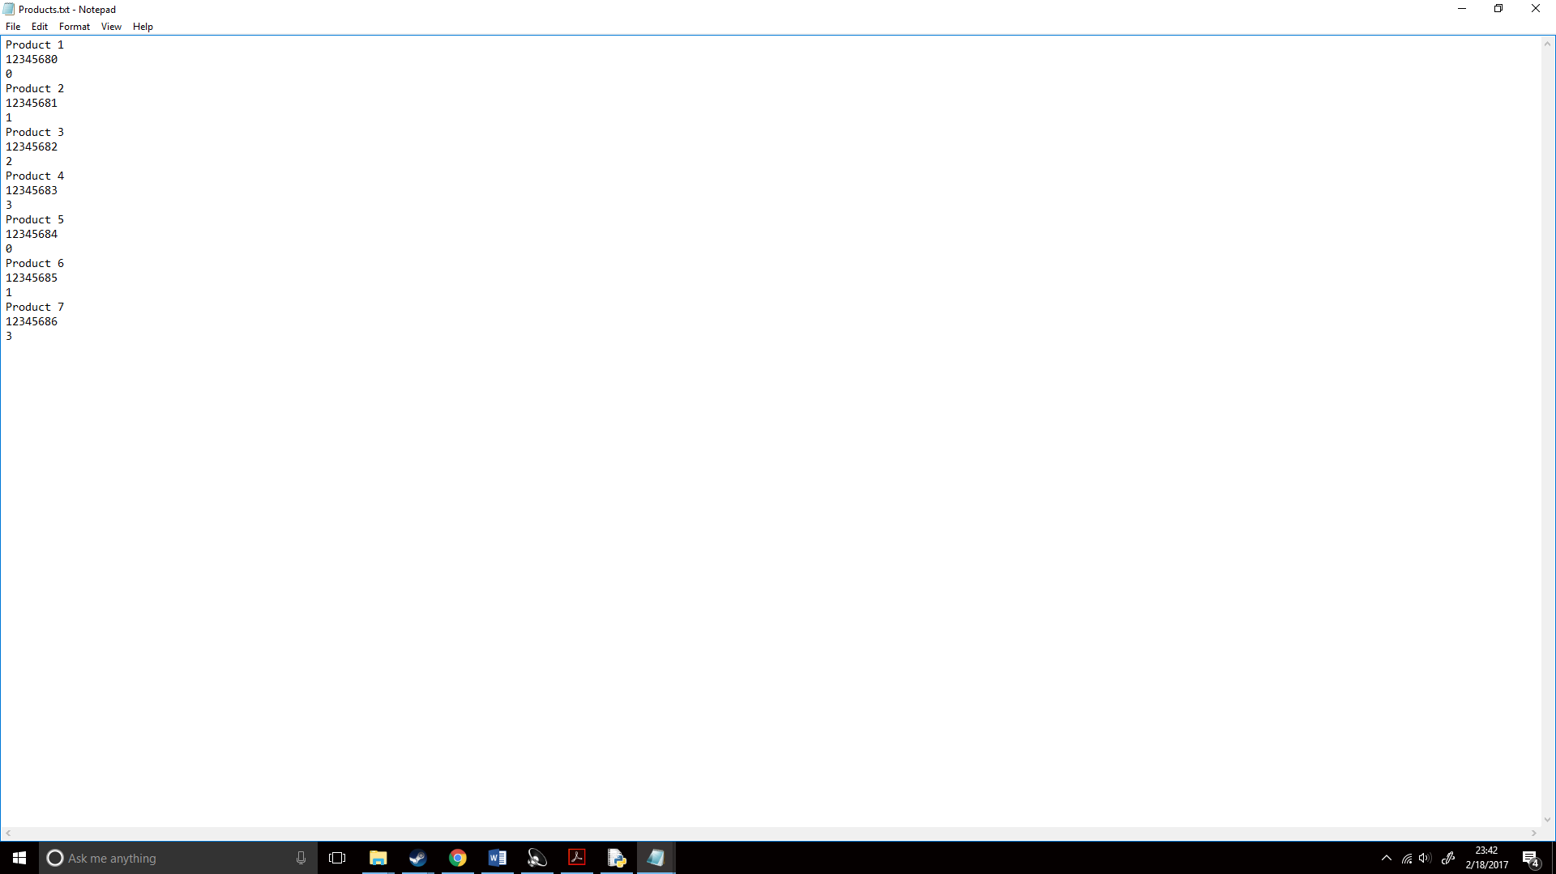I now ran the code to test how it was working thus far, I created a fake product list for testing purposes and then ran the code:

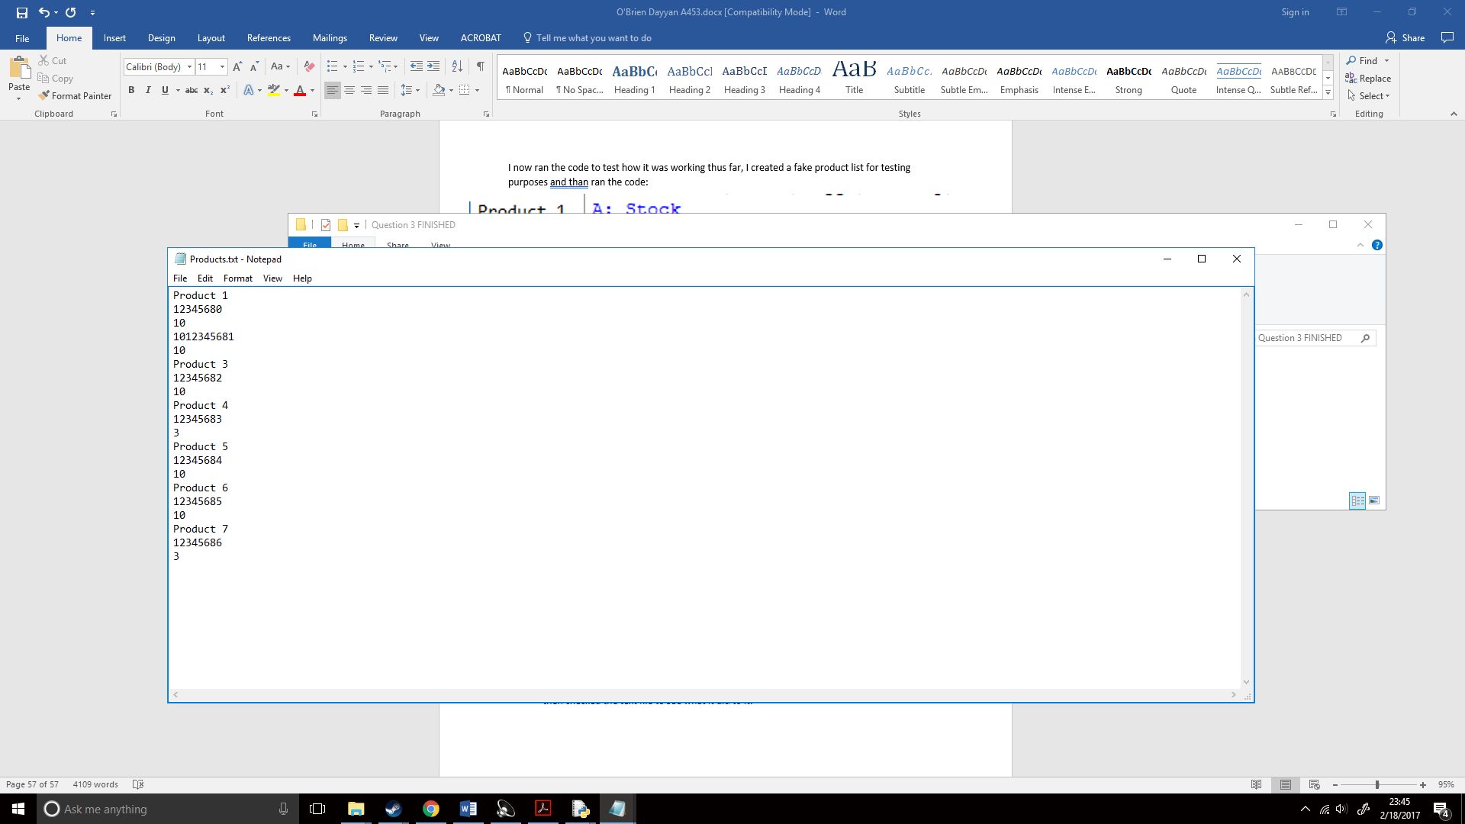I instantly noticed a problem where it showed 10 is low on stock rather than Product 2, I then checked the text file to see what it did to it. There was clearly another problem. It replaced most of the lines fine but at Product 2 it removed the line and moved the GTIN-8 code together with a 10. Now I had to start bug fixing. I first wanted to find what the cause of the problem was so I tried creating a few new lines to where Product 2 would be and then changed the replace_line functions so instead of for i in range(2,len(lines),3) it used for i in range(8,len(lines),3) so, my Products.txt looked like this:

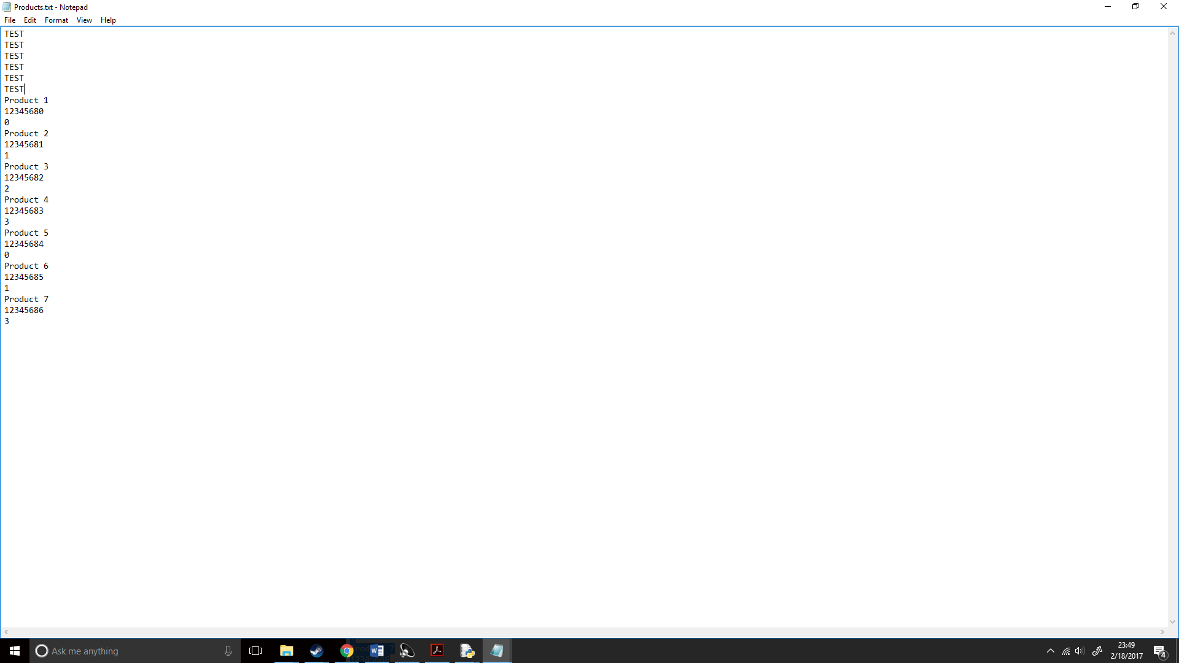

I then ran the code again, so far it looked good as it no longer showed the 10:

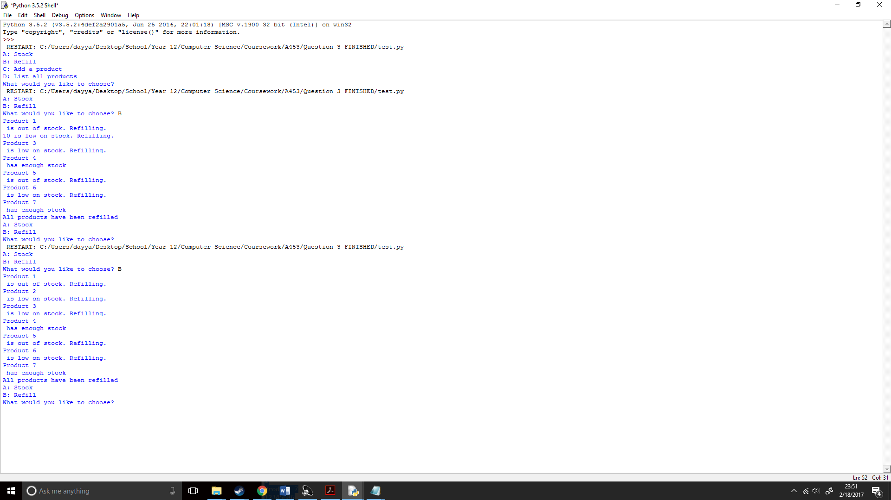

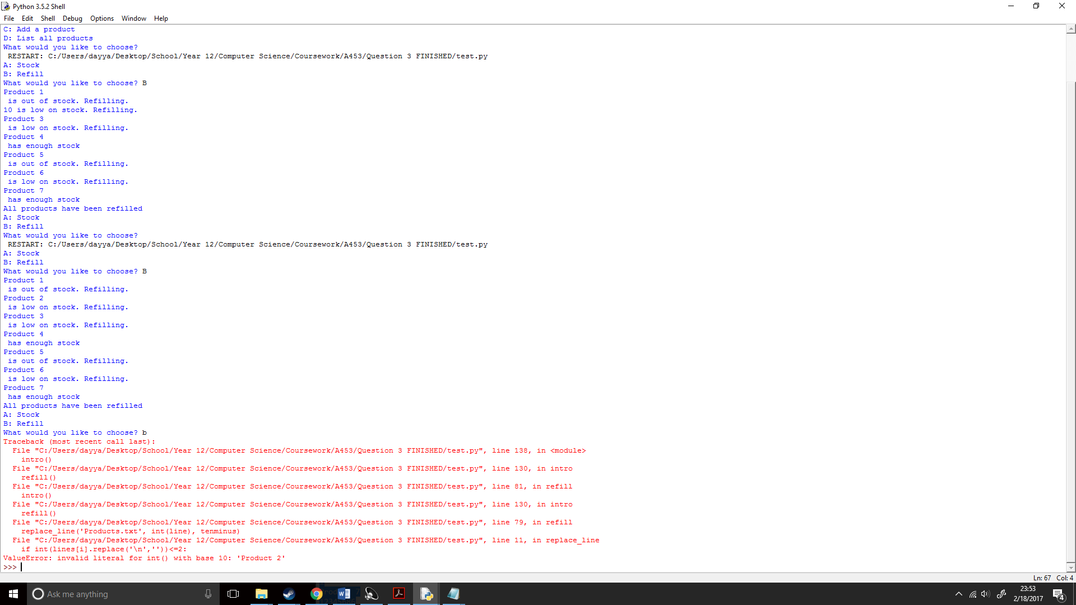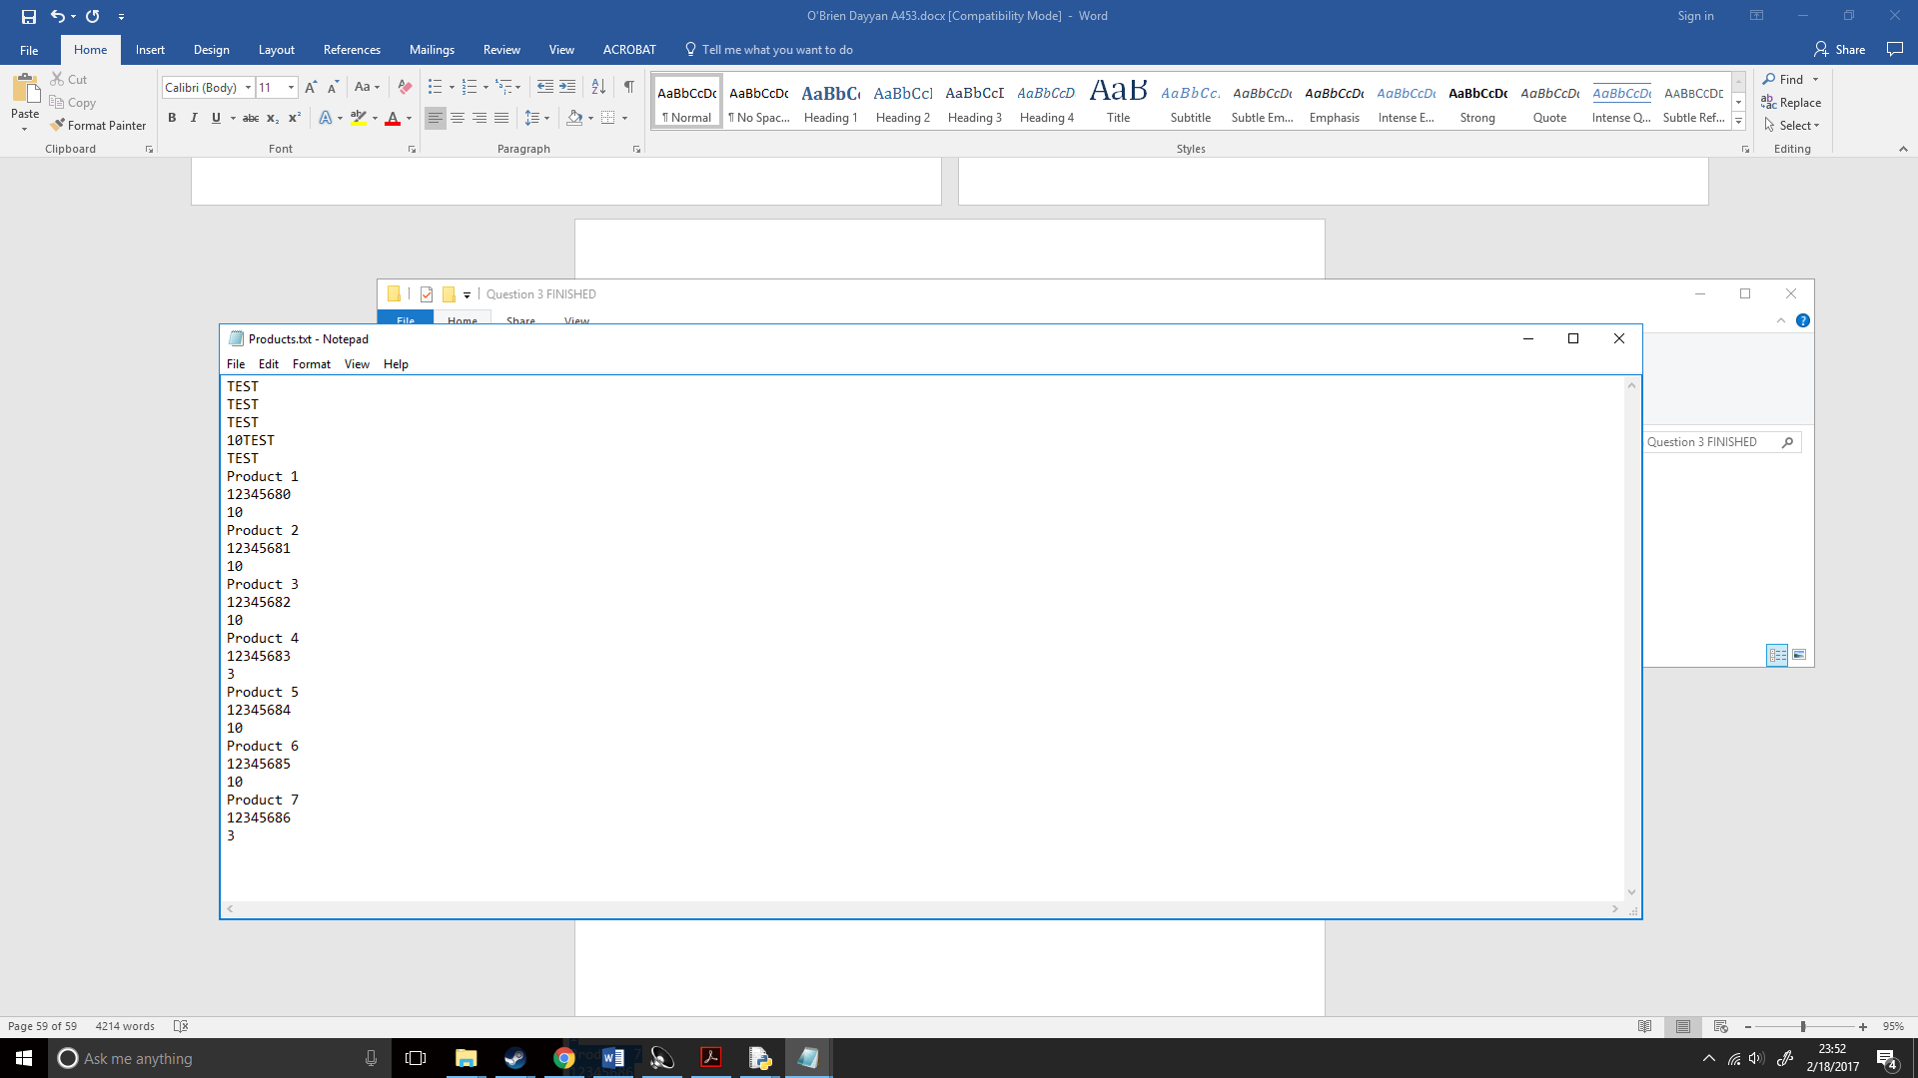But when I checked the text file, it messed up the structure so when I ran it again:

## How will I fix the bugs?

I found that because the line was removed it messed up the errors and the jumps in threes. To combat this I tried replacing lines 0-5 with TEST every time the code is ran, this way when the code is running again it hopefully wont mess up the formatting. I knew I had to create another replace_line function as the other one was checking for the value of the stock etc. and as these couldn’t be converted to integers I could use the if statements asking for the stock value.

So, upon research for replacing lines in python I found the following), when looking at it I found it was very similar my own replace_line function (<http://stackoverflow.com/a/4719576/5985905>):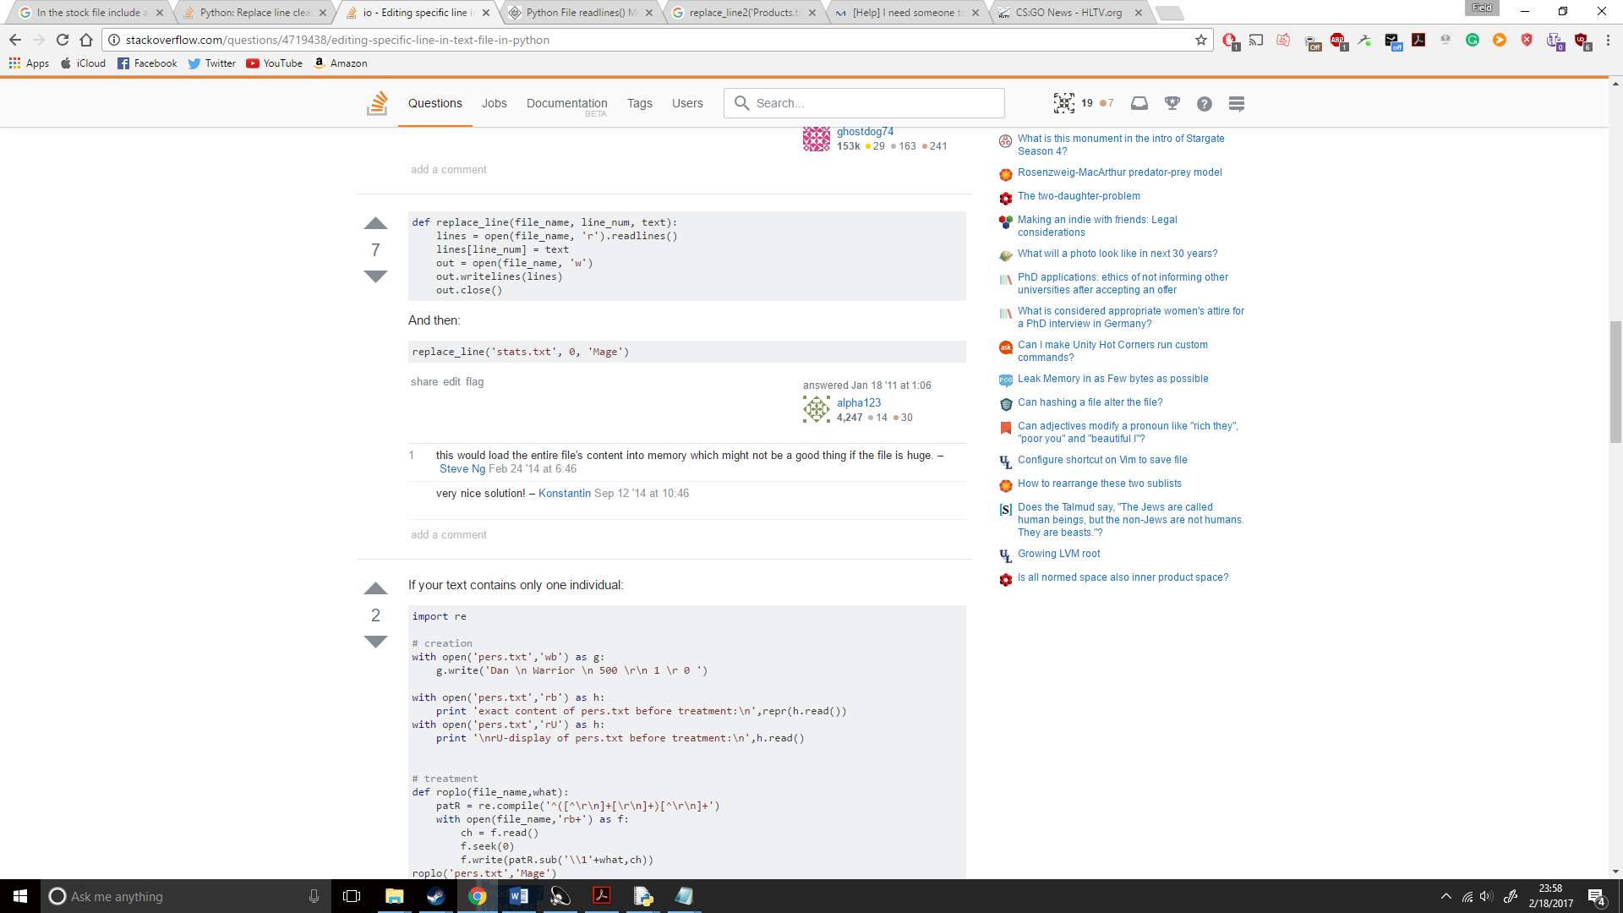

I then applied it to my code, I set it to replace_line2 as I didn’t want to overwrite the original replace_line function. From what I understood, this would read all the lines in the document. Then change the line I wanted changed and write the whole document again, and as my file would be fairly small it wouldn’t’ be a big deal. However, if it were the case if I had a huge file I would have to get around this in a different method.;

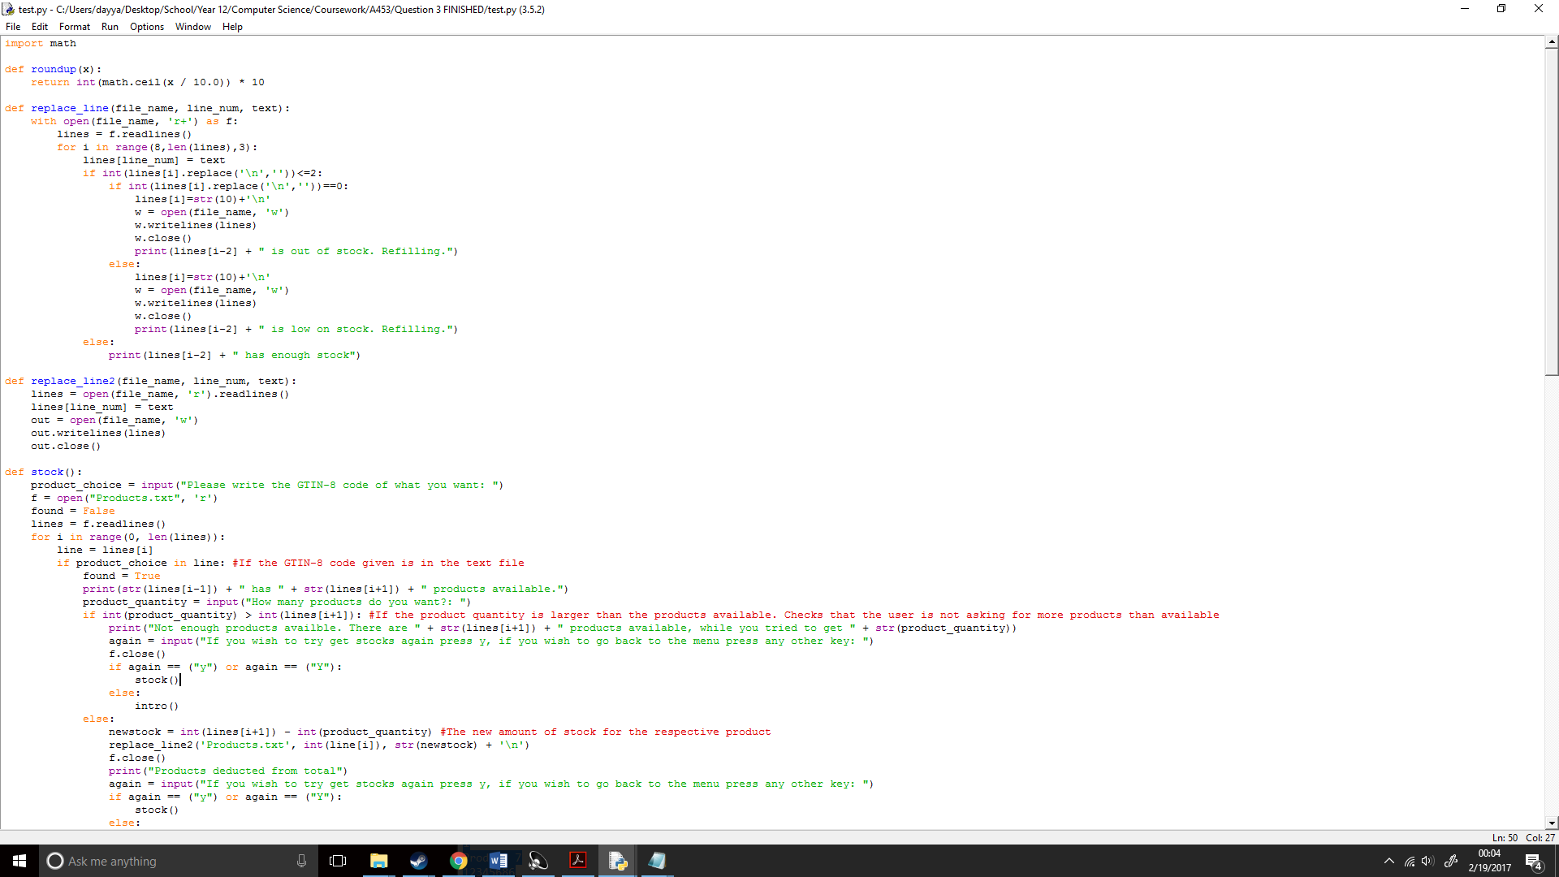

I then applied it to the refill() function: 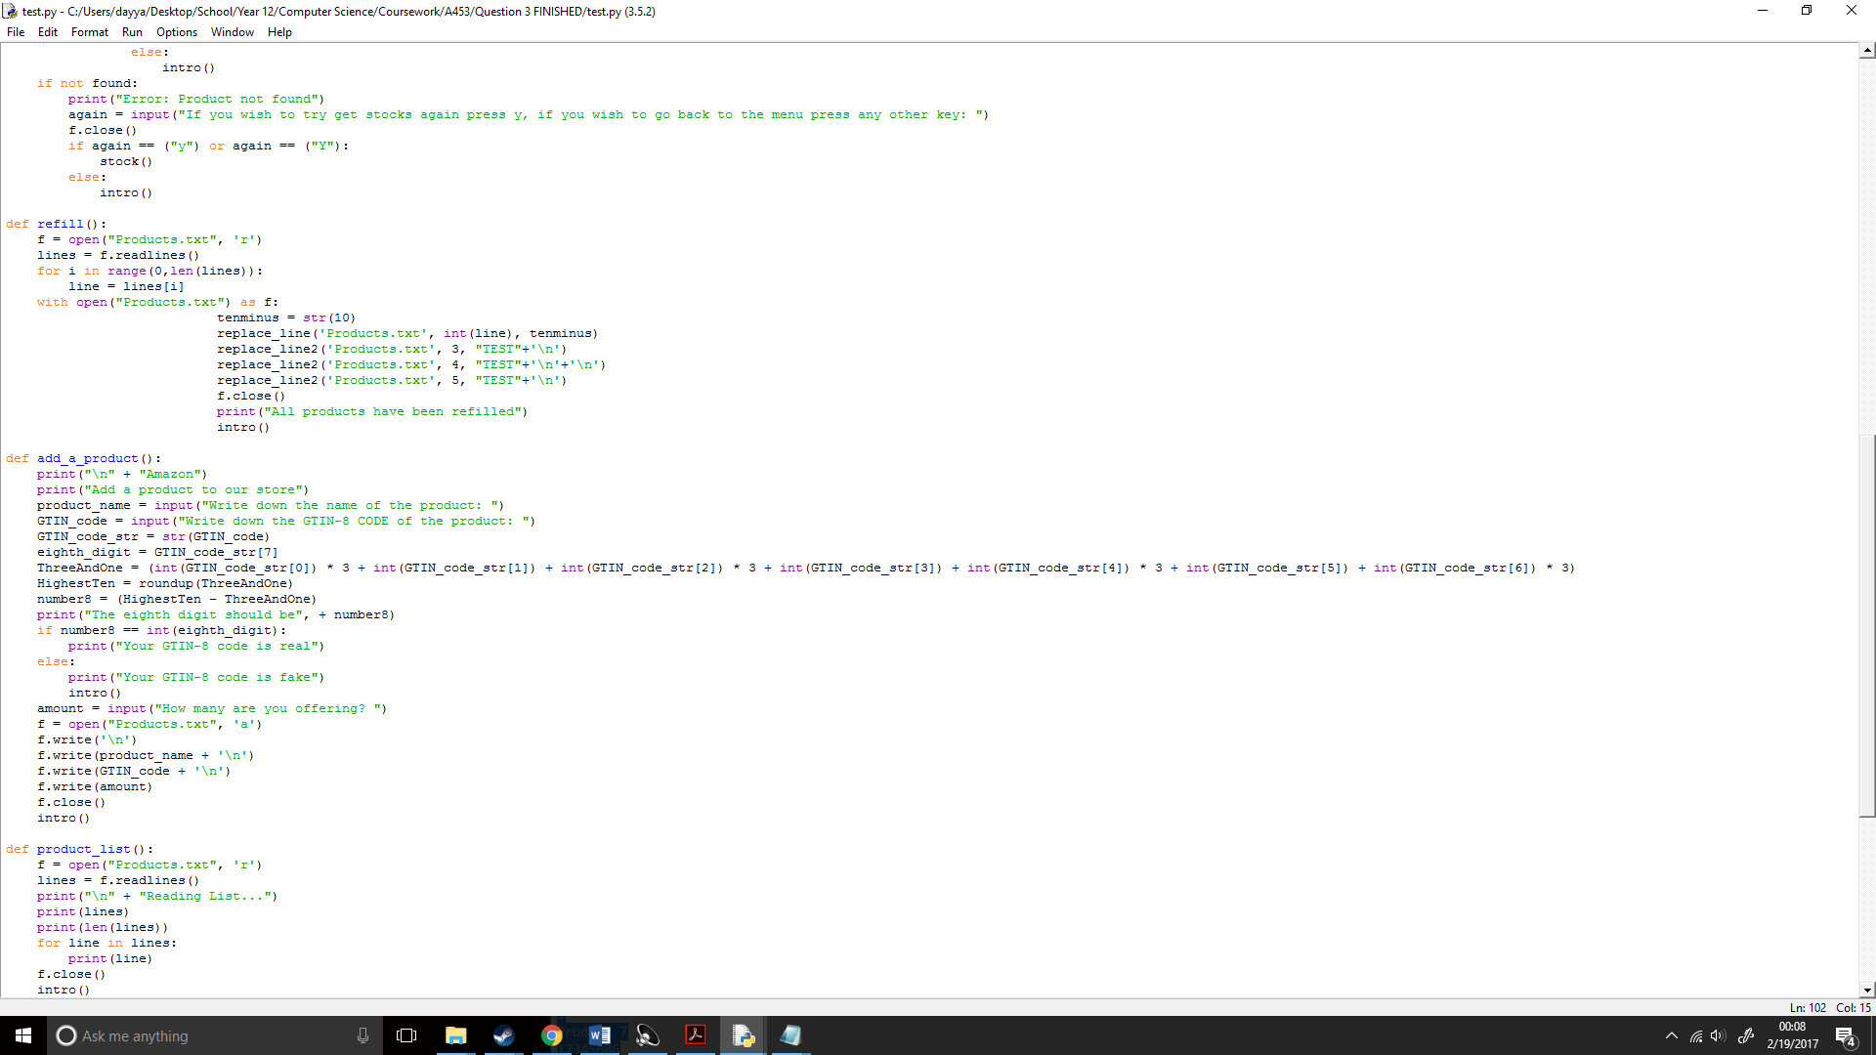

Then ran the code;

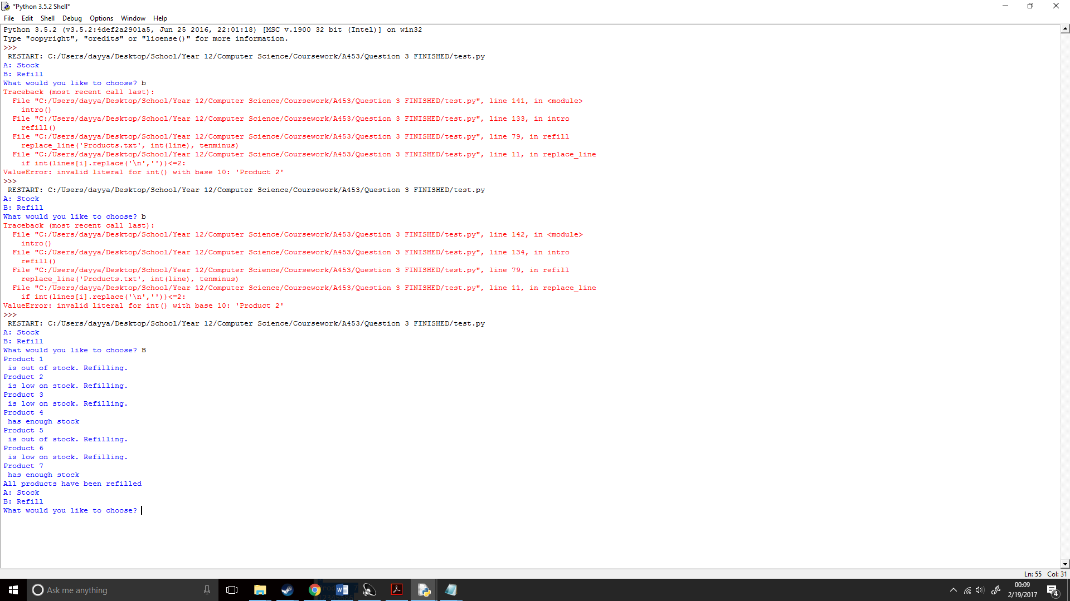

## How will I program the program to make it so the user can buy stock?

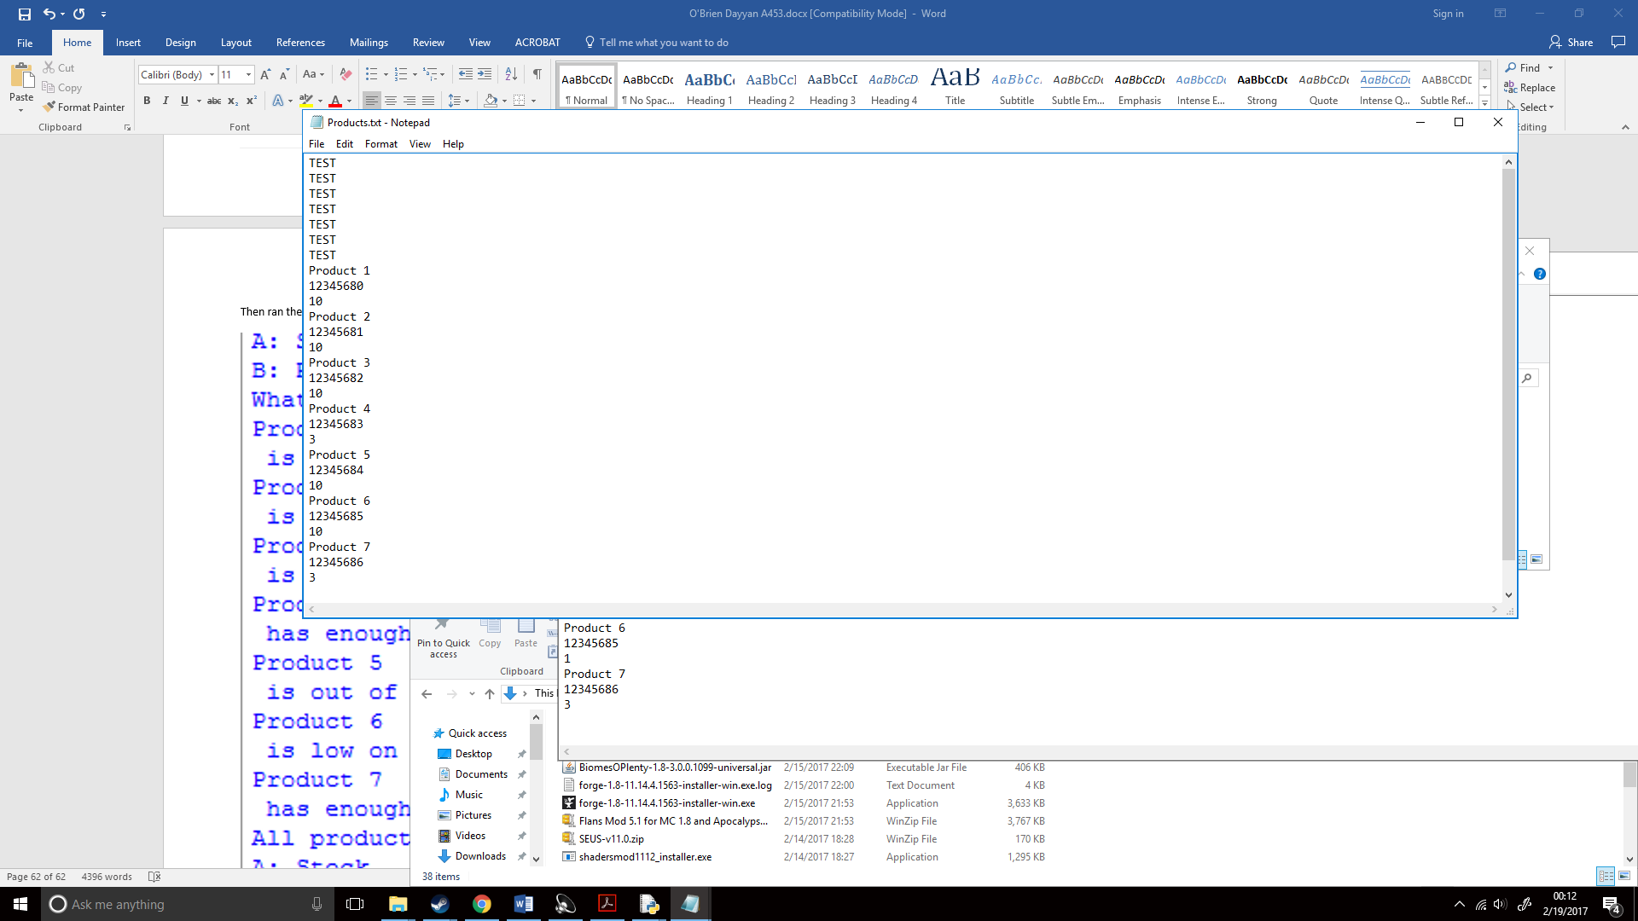 I then ran it again to make sure there were no 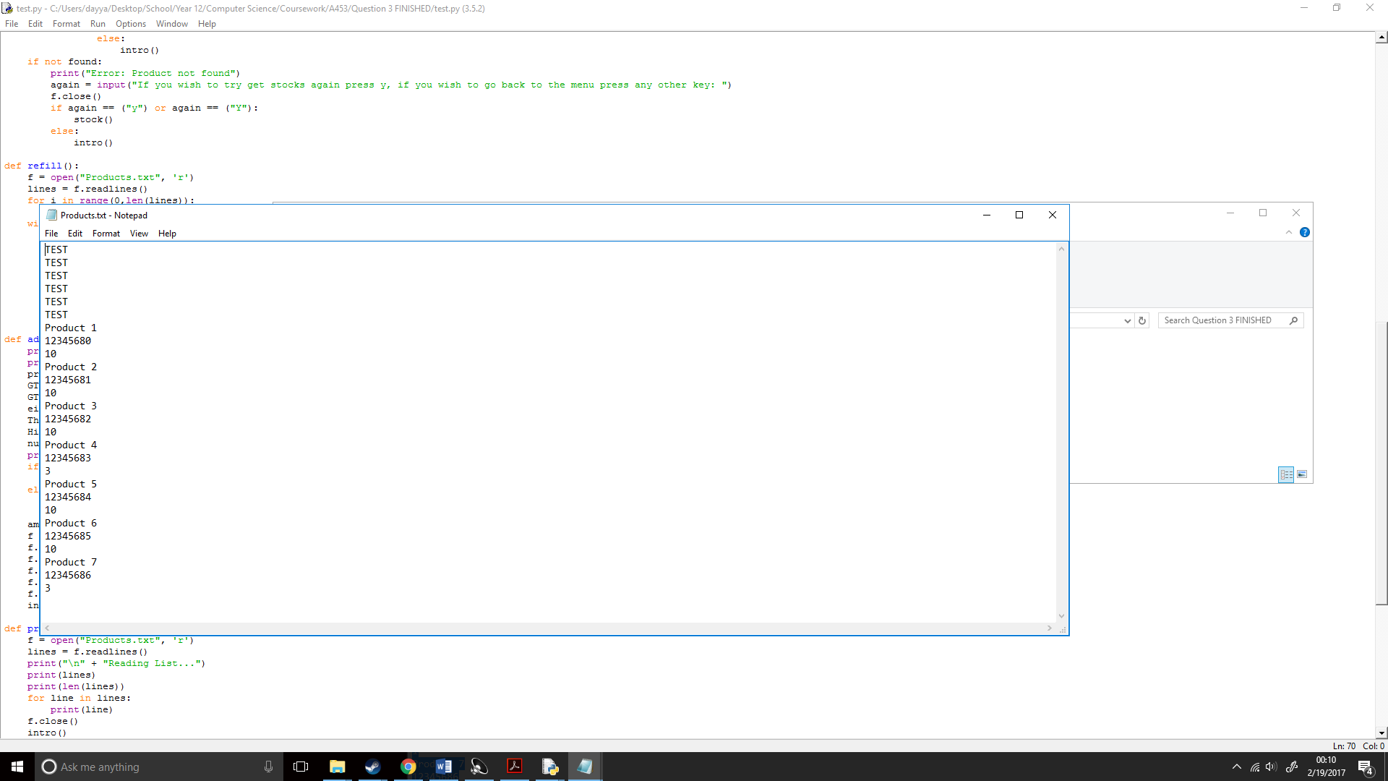problems and it worked, while it was a nuisance that text was at the start when you preview it I cannot show the first six lines and I could also replace the first six lines with text art. I would do this later. I first wanted to create my stock function. This would be similar to my barcode() and my by_name() function in the ways of searching for a keyword in a file. I started by copying and pasting my barcode function in:

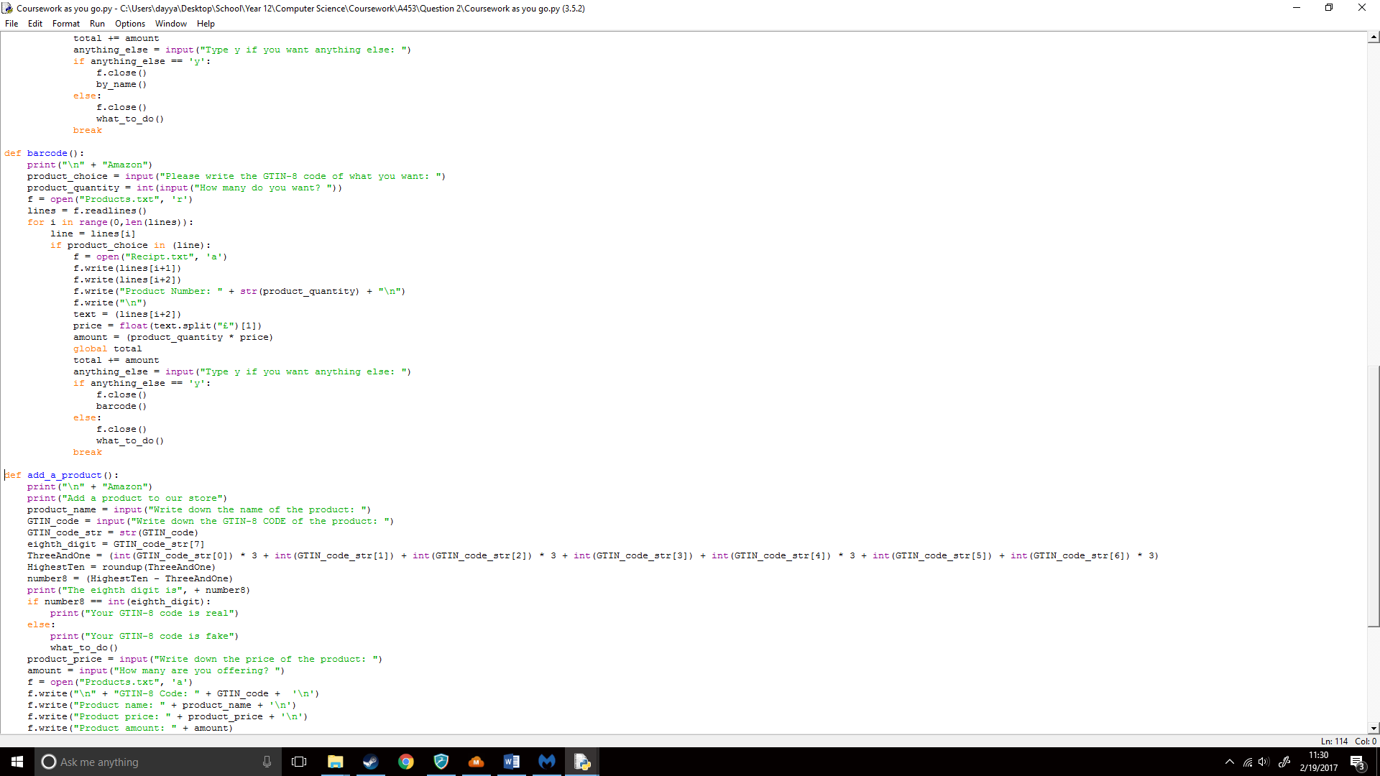

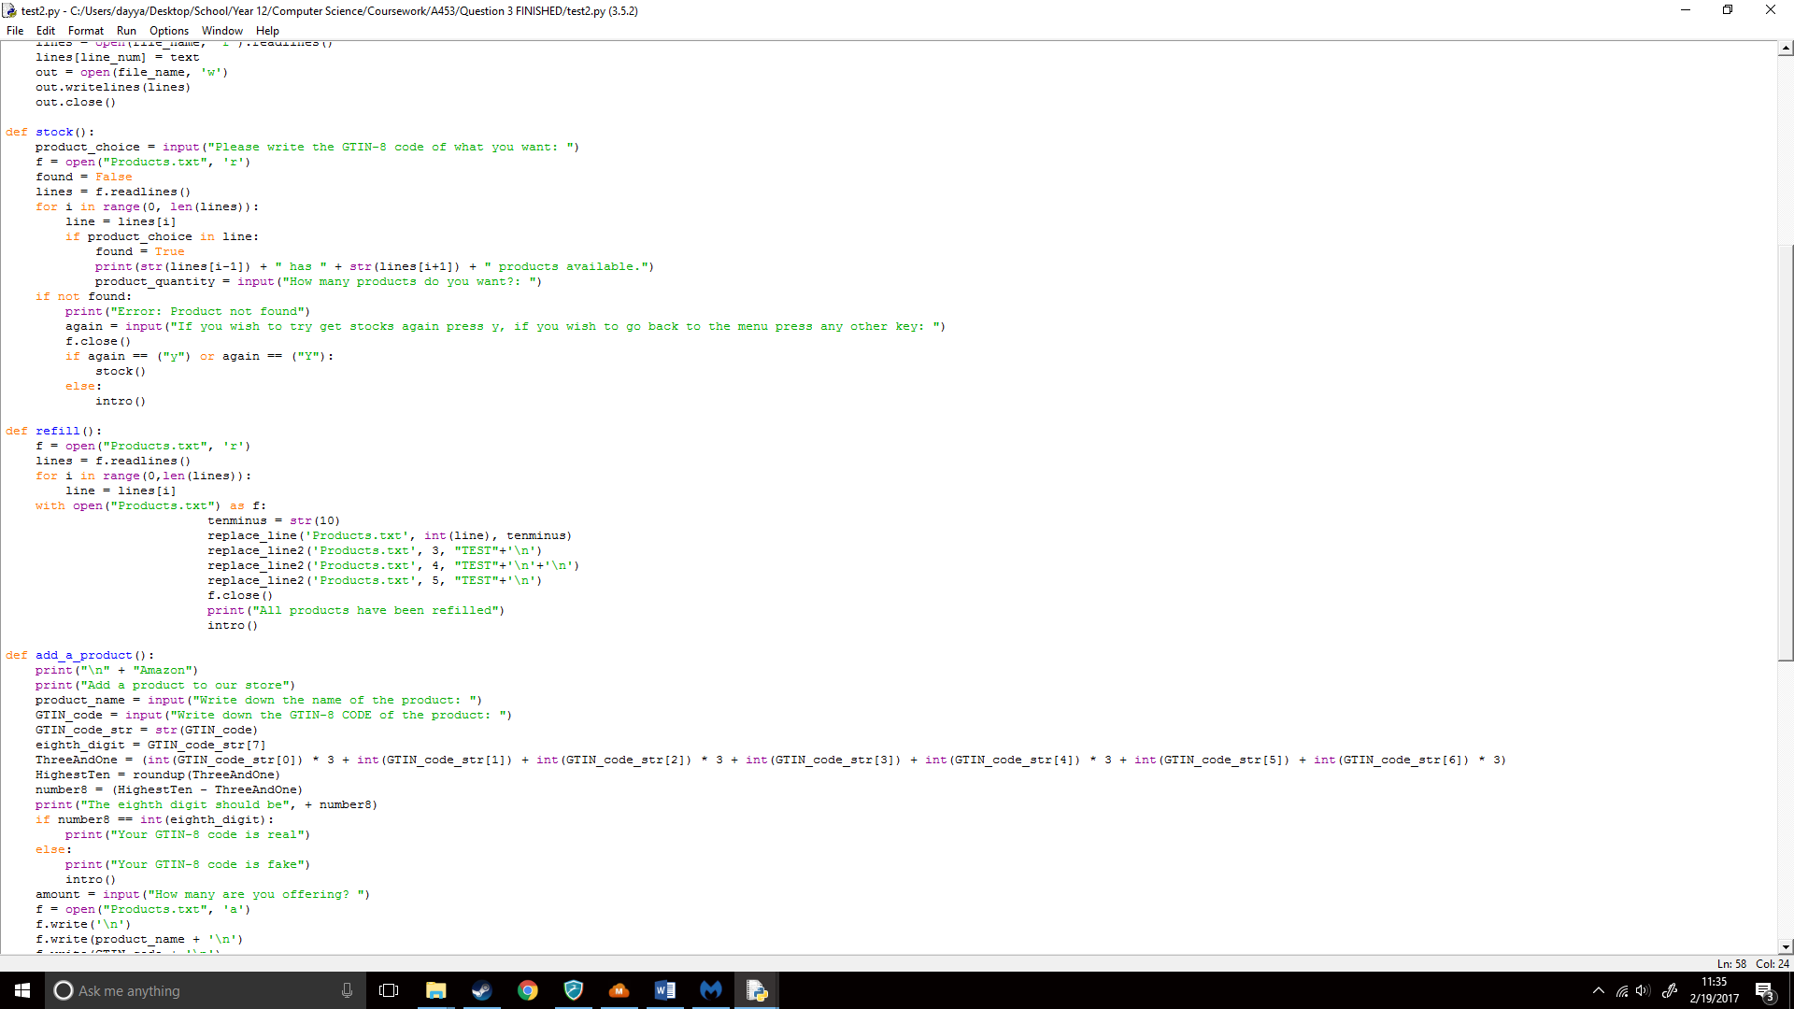I then slightly changed it around so it could fit in my stock() ideas. I started by removing lines I didn’t need:

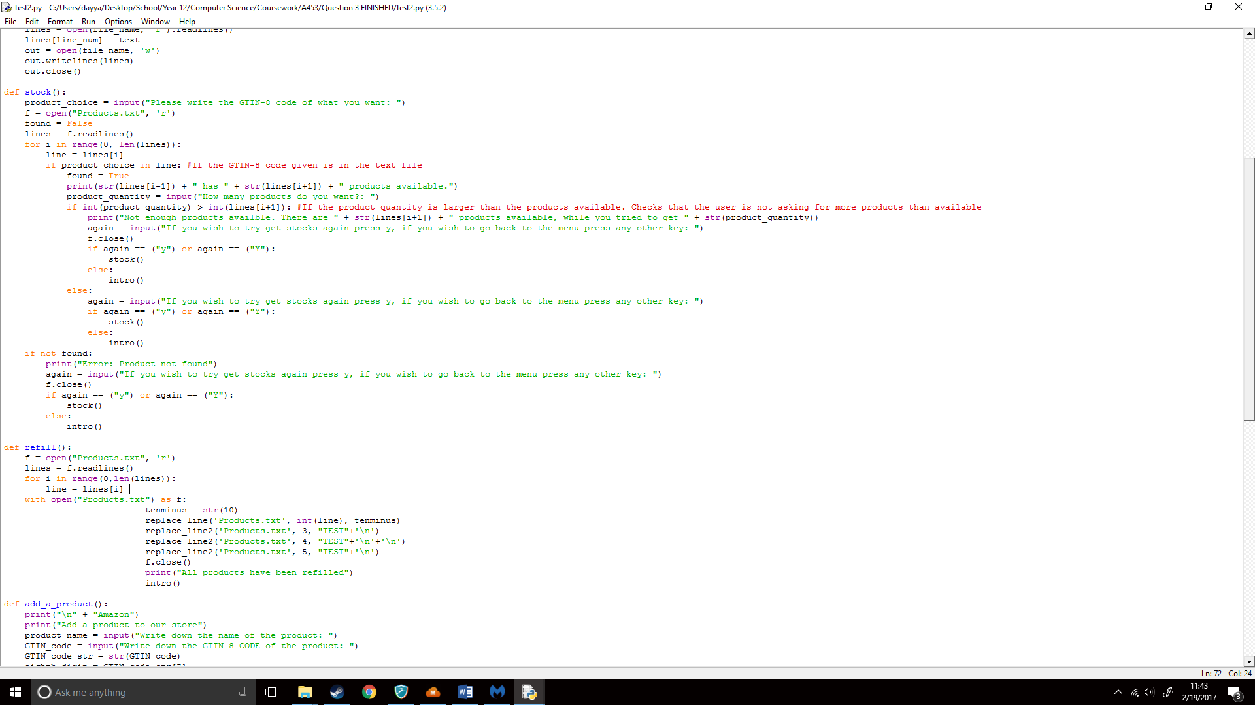I then wanted to check if the product quantity the user is trying to get is larger than the products available. And if so, it will perform an error. So, I checked if the quantity they provided was larger than the stock in the file was.

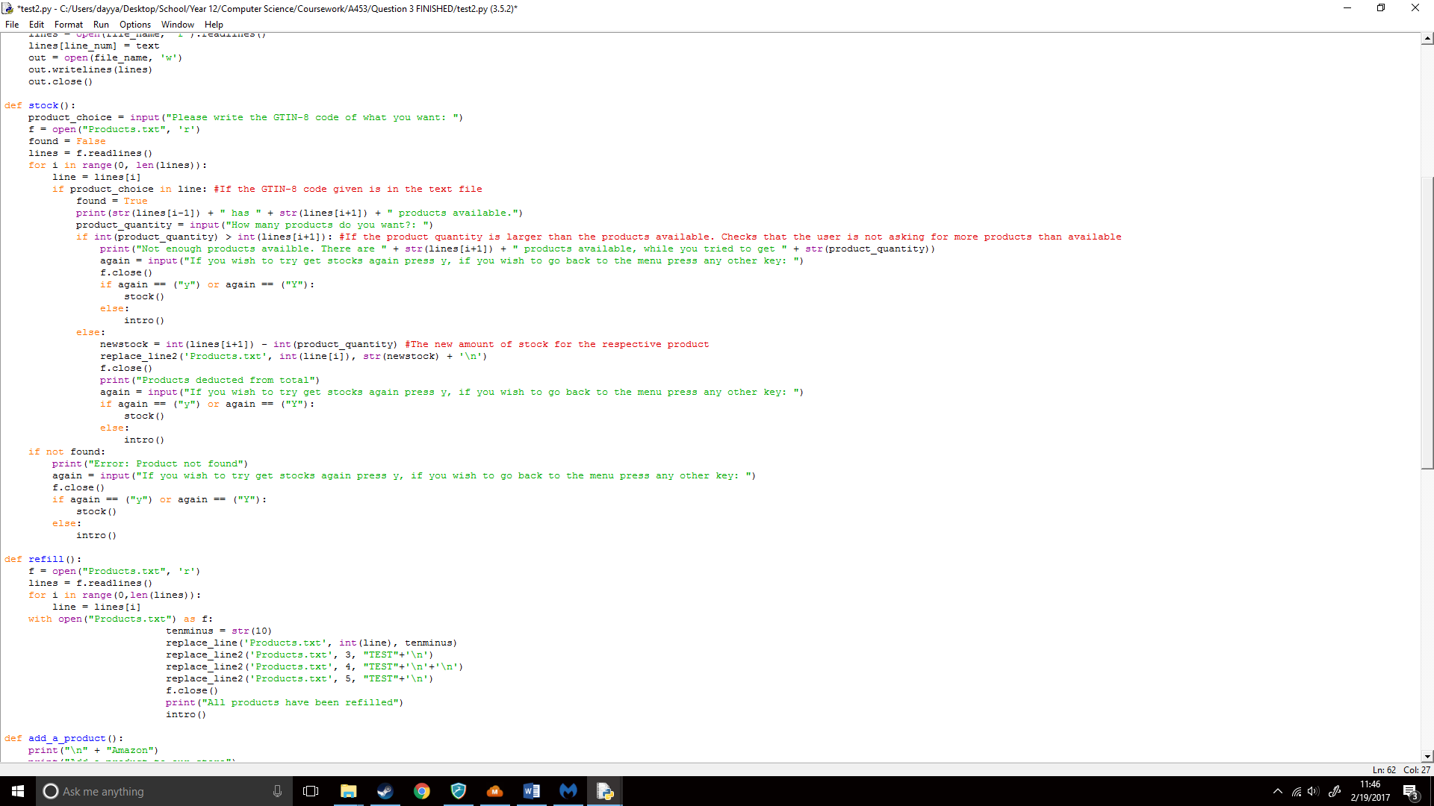If there was enough stock left I had to make it so it deducts the product_quantity from the stock in that line. And I would create a new variable based on this. I would then run the replace_line2 function where it would replace this new variable wherever the stock was, I had to turn line[i] and lines[i+1] into integers as by default in text files they are strings.

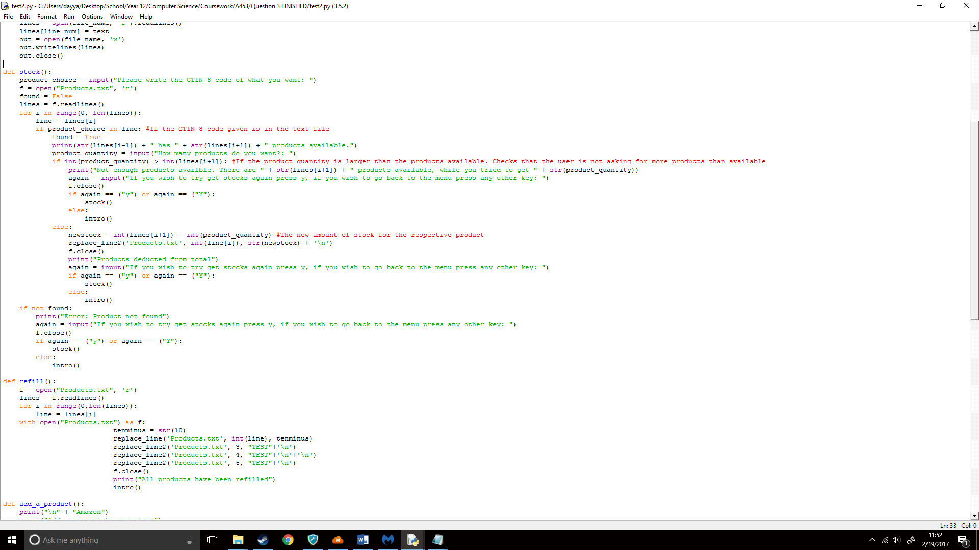This is why my full stock() function looked like:

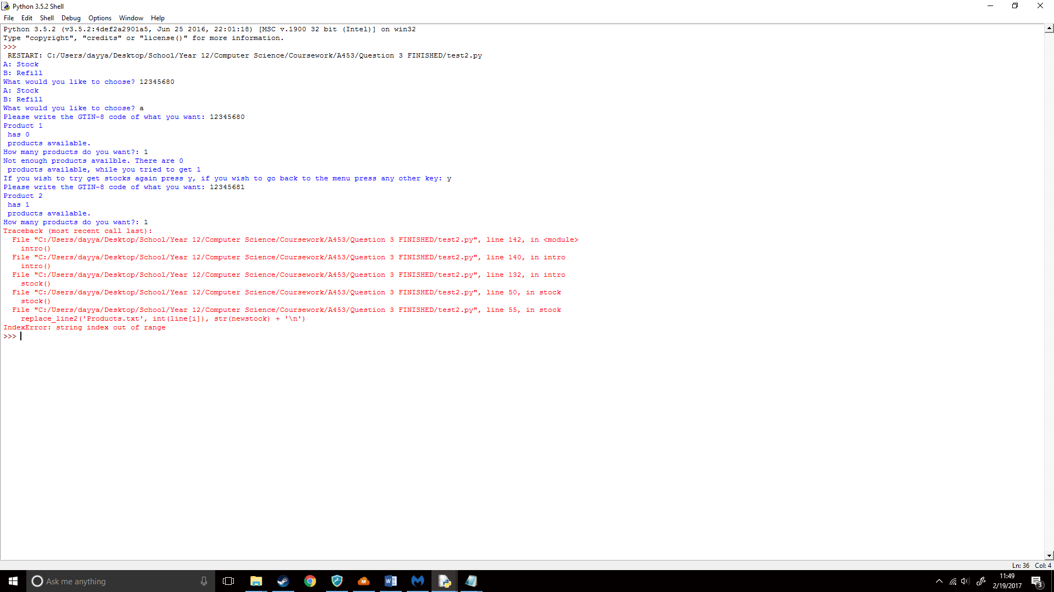Now that my stock function was finished I then ran my code:

Another error. This time it was IndexError: string index out of range, I knew I used the right lines for [i] and [i+1] before it as it found how many products was available and product name, hence it had something to do with the replace_line2 function. I first decided to check my text file and found that nothing changed from what it was before. I then decided to do some research on what this error meant and found that it mean I was trying to access something that wasn’t there. For example, if I wrote hi = “hello”, then wrote hi[5], it wouldn’t work as there are no letters after the o. This was weird however as I had enough space available and it printed the write things. I started to figure out what this problem was by printing the int(line[i]) to see if it gave the correct result:

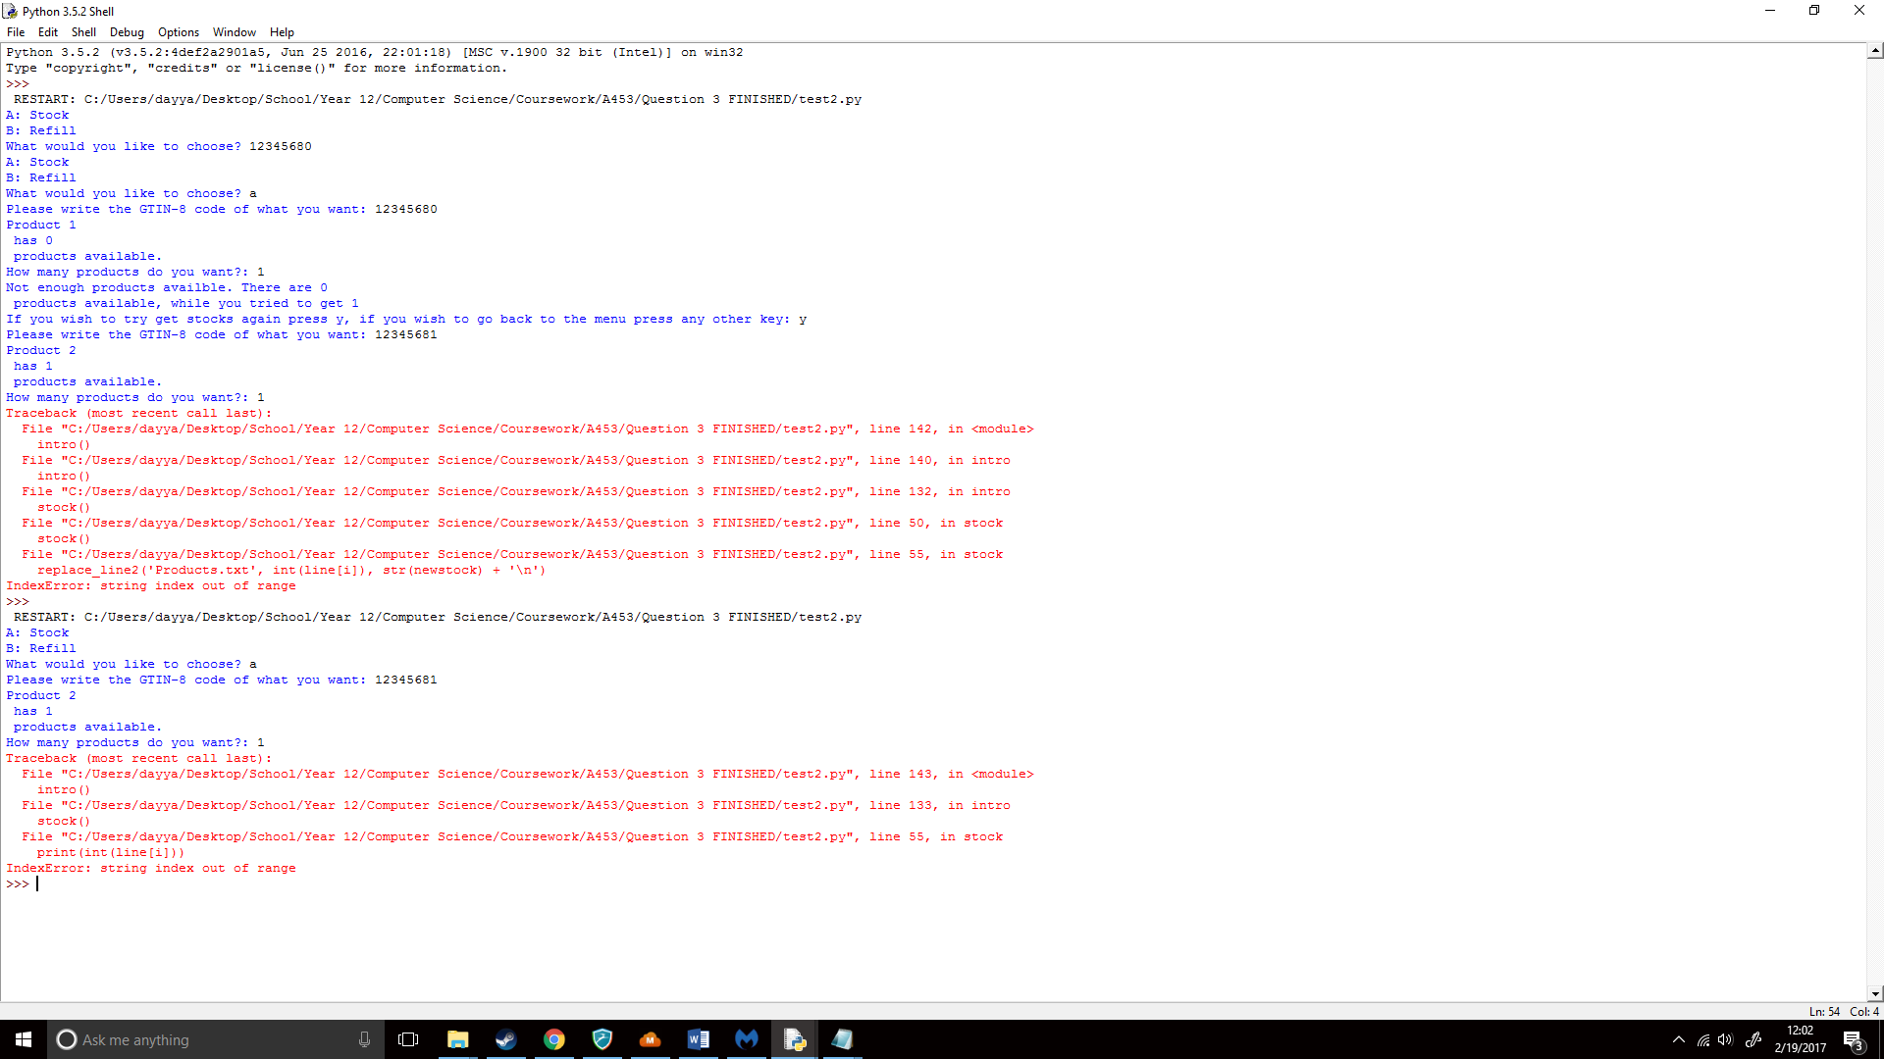

I had the same error again, this showed me it had something to do with line[i], I then tried changing [i] to give me an idea on what [i] is, I first tried printing [i-5] which gave the following:

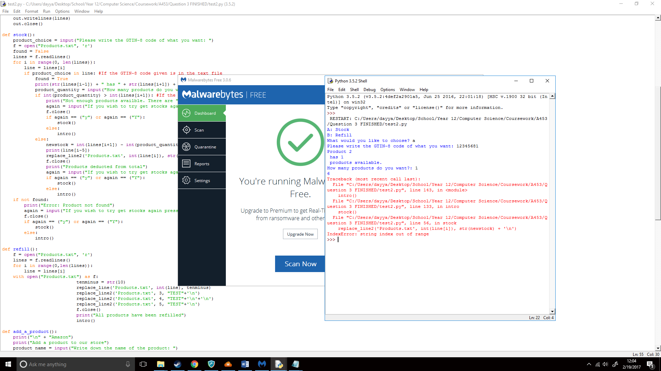

It showed 6, meaning that [i] was 11.

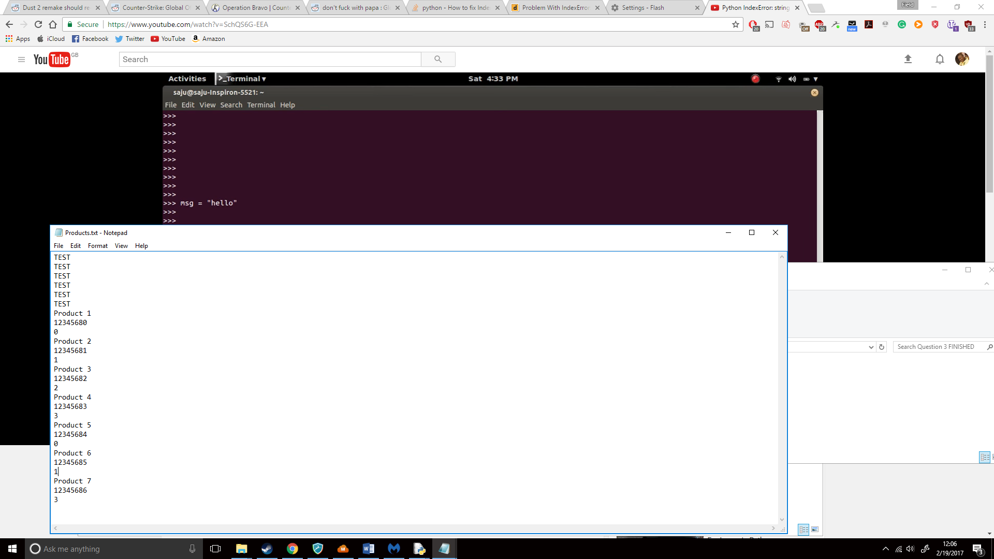

This was the 11th line, meaning that it was the correct line that I wanted to change.

I then tried making a new variable called int_5 and in it I took 5 from [i]. Then created a new variable where I added 5 to [i] called intnormal:

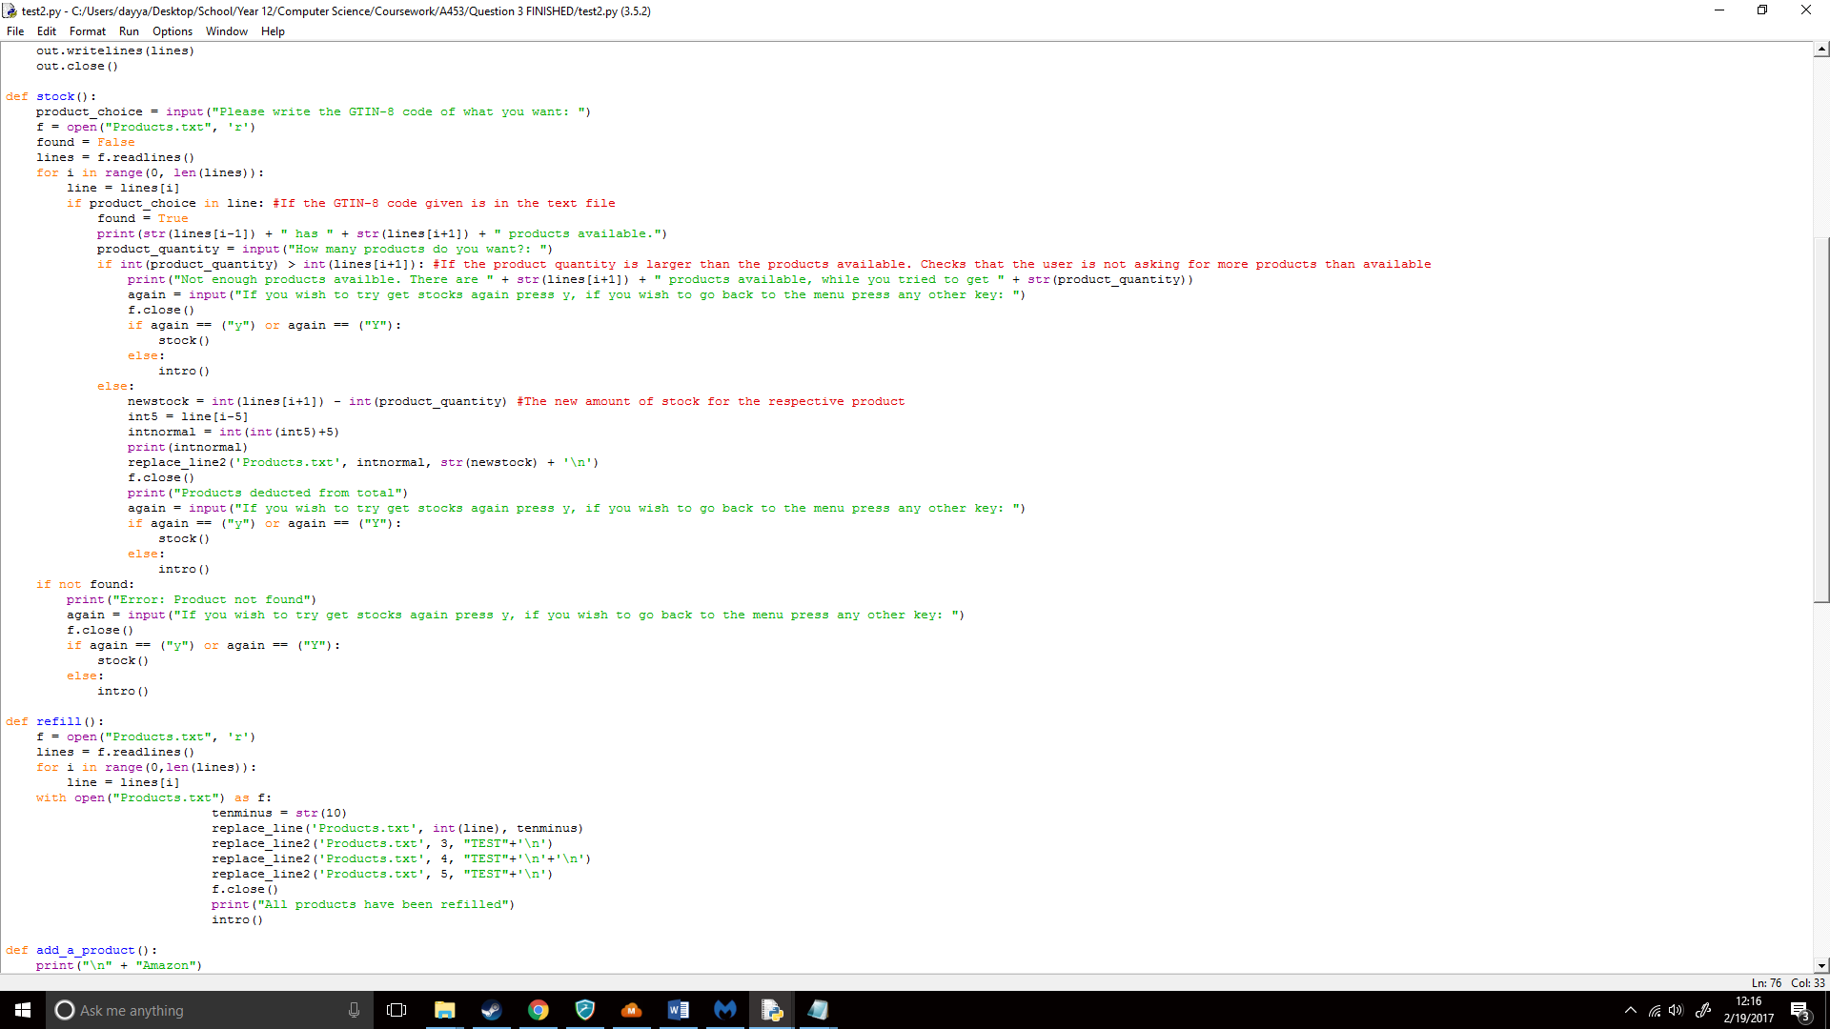

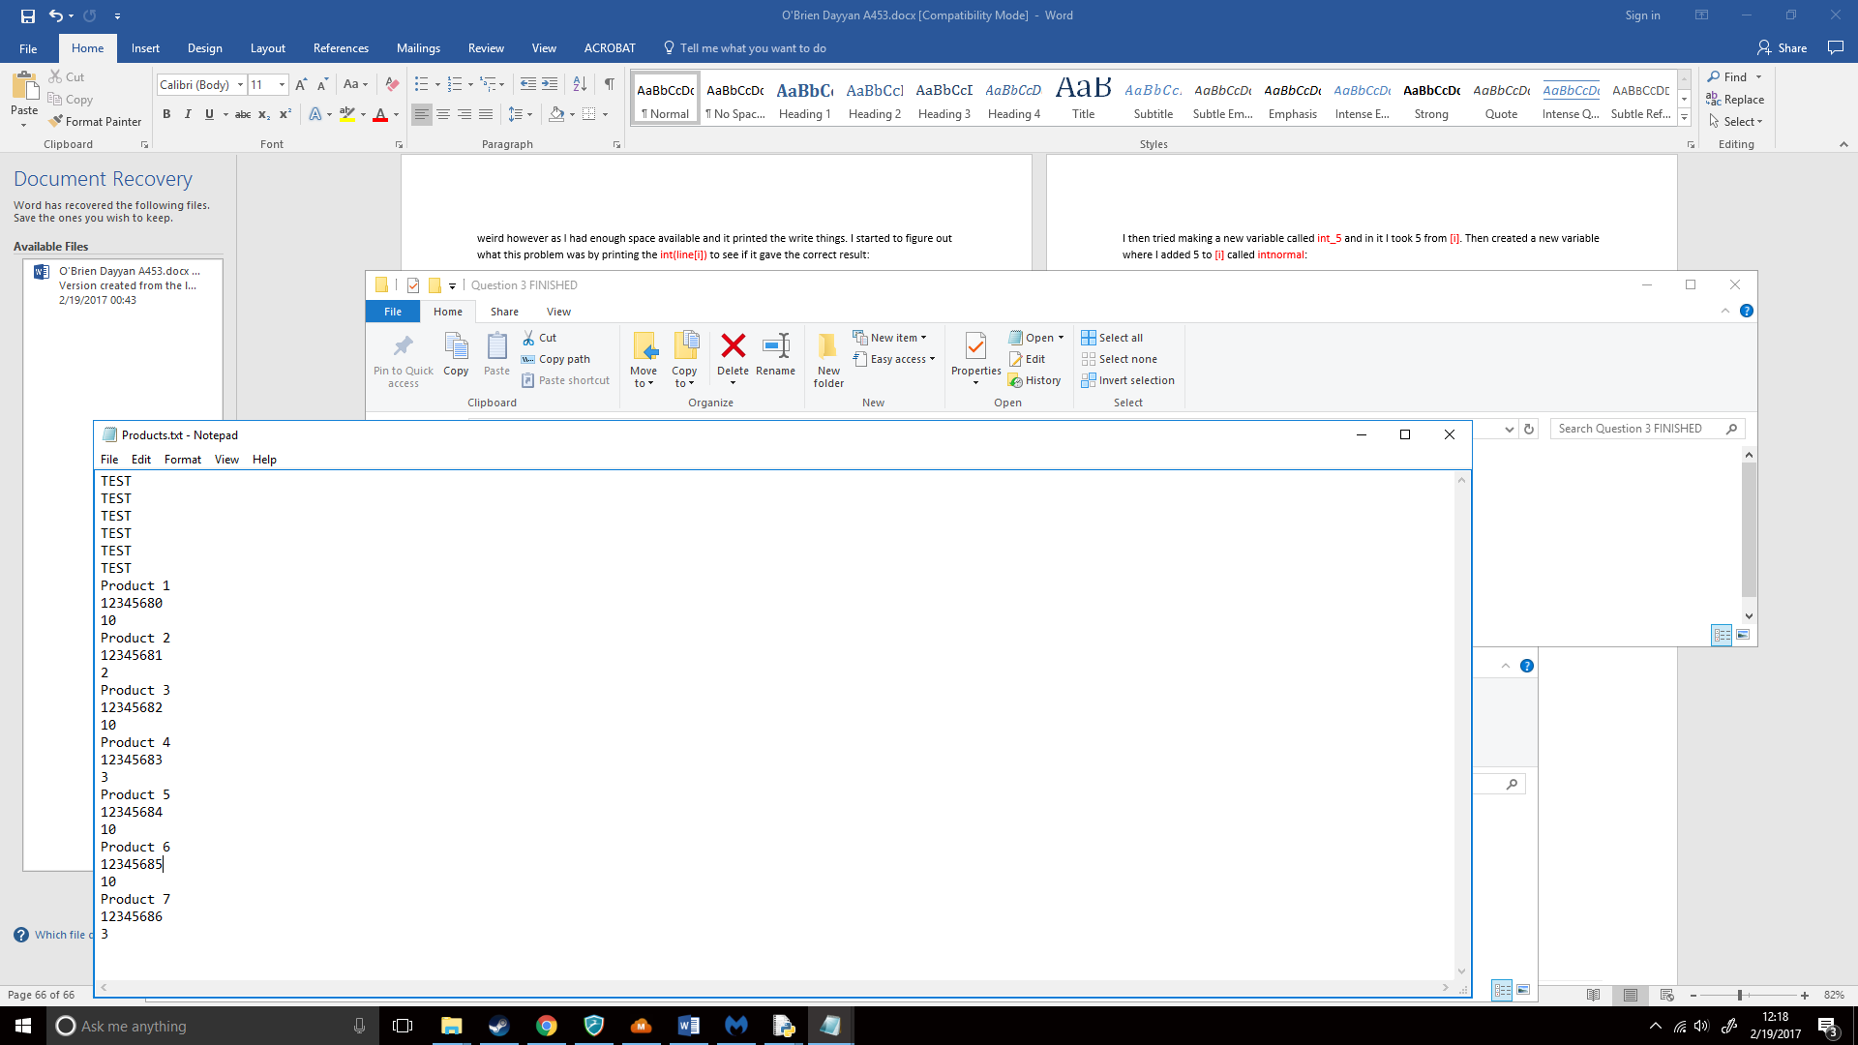I then ran the code again and;

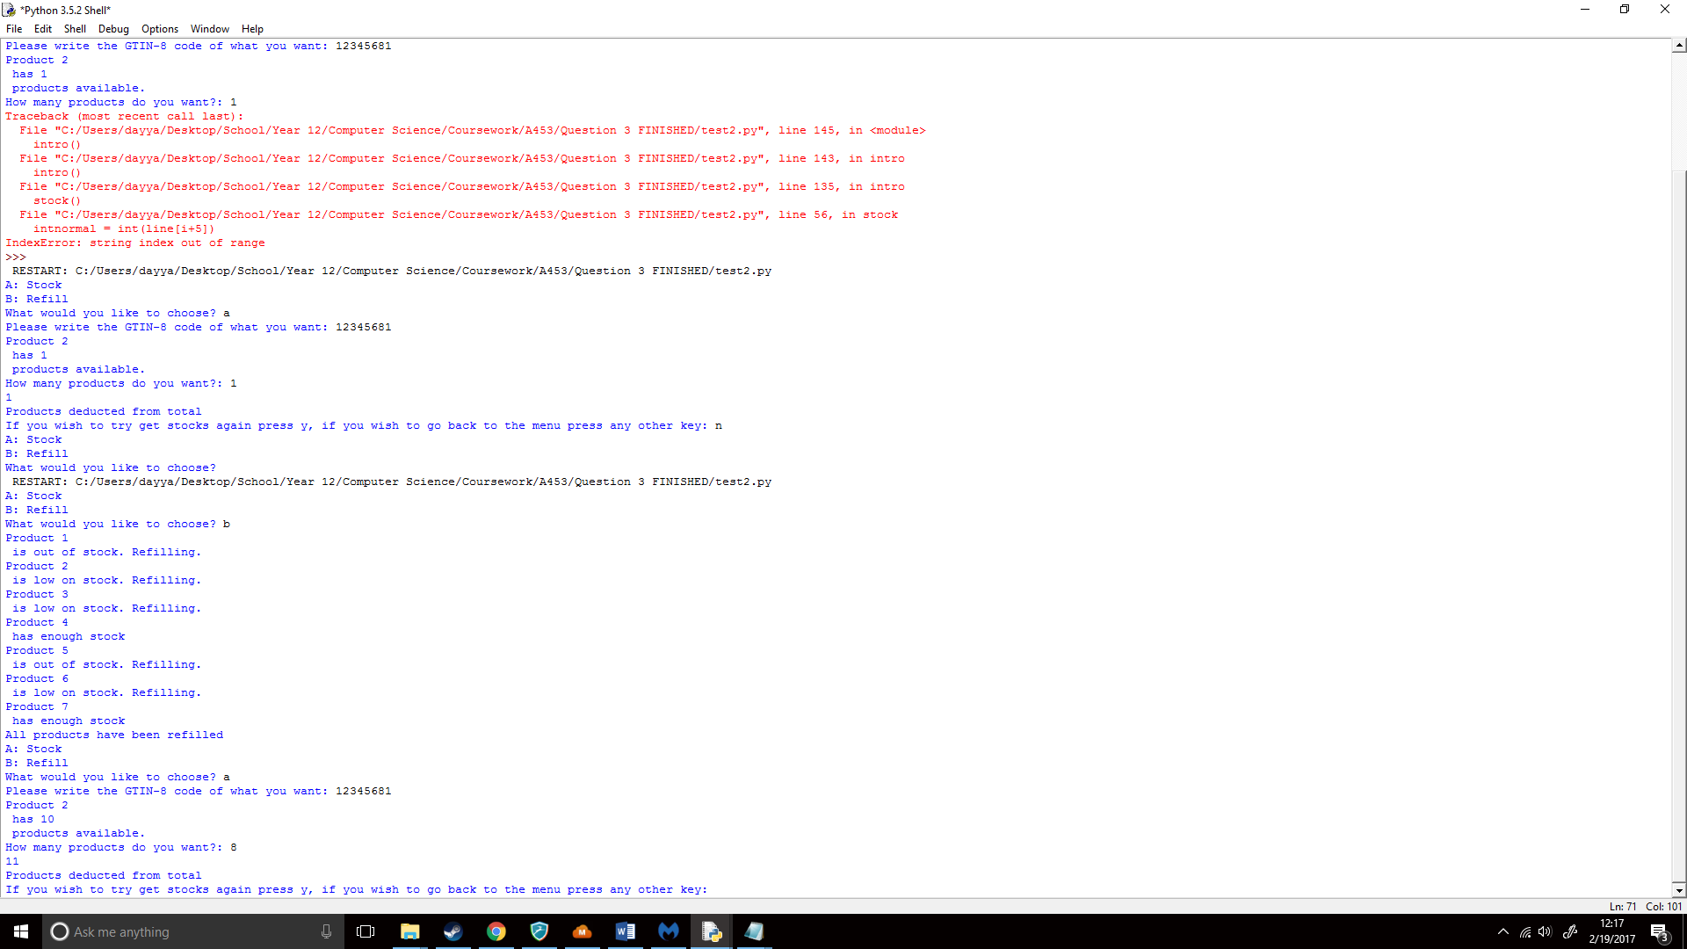

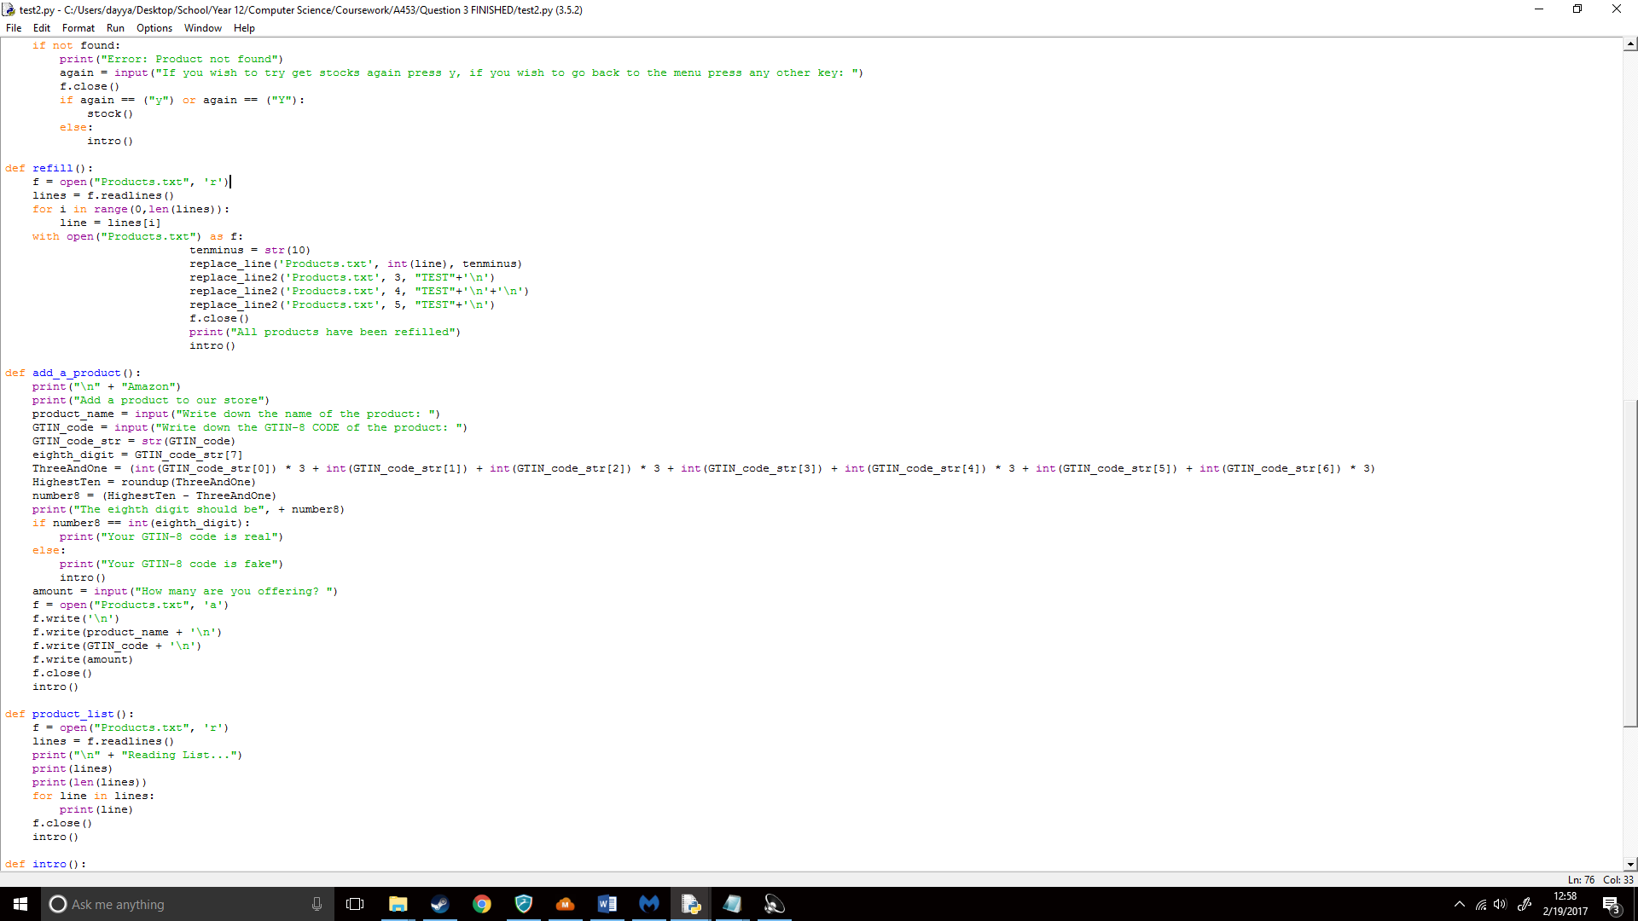It showed the correct line (11), so I then checked the Products.txt file to see if it still worked and I found that it worked correctly. Now, that it worked I would fix the TEST lines and add more functions. I then imported my add_a_product() function, I remove the product name etc. From the start of each line as that would introduce more errors when trying to change the stock around and would make it very difficult as I would have to use .split which I wasn’t completely confident with.

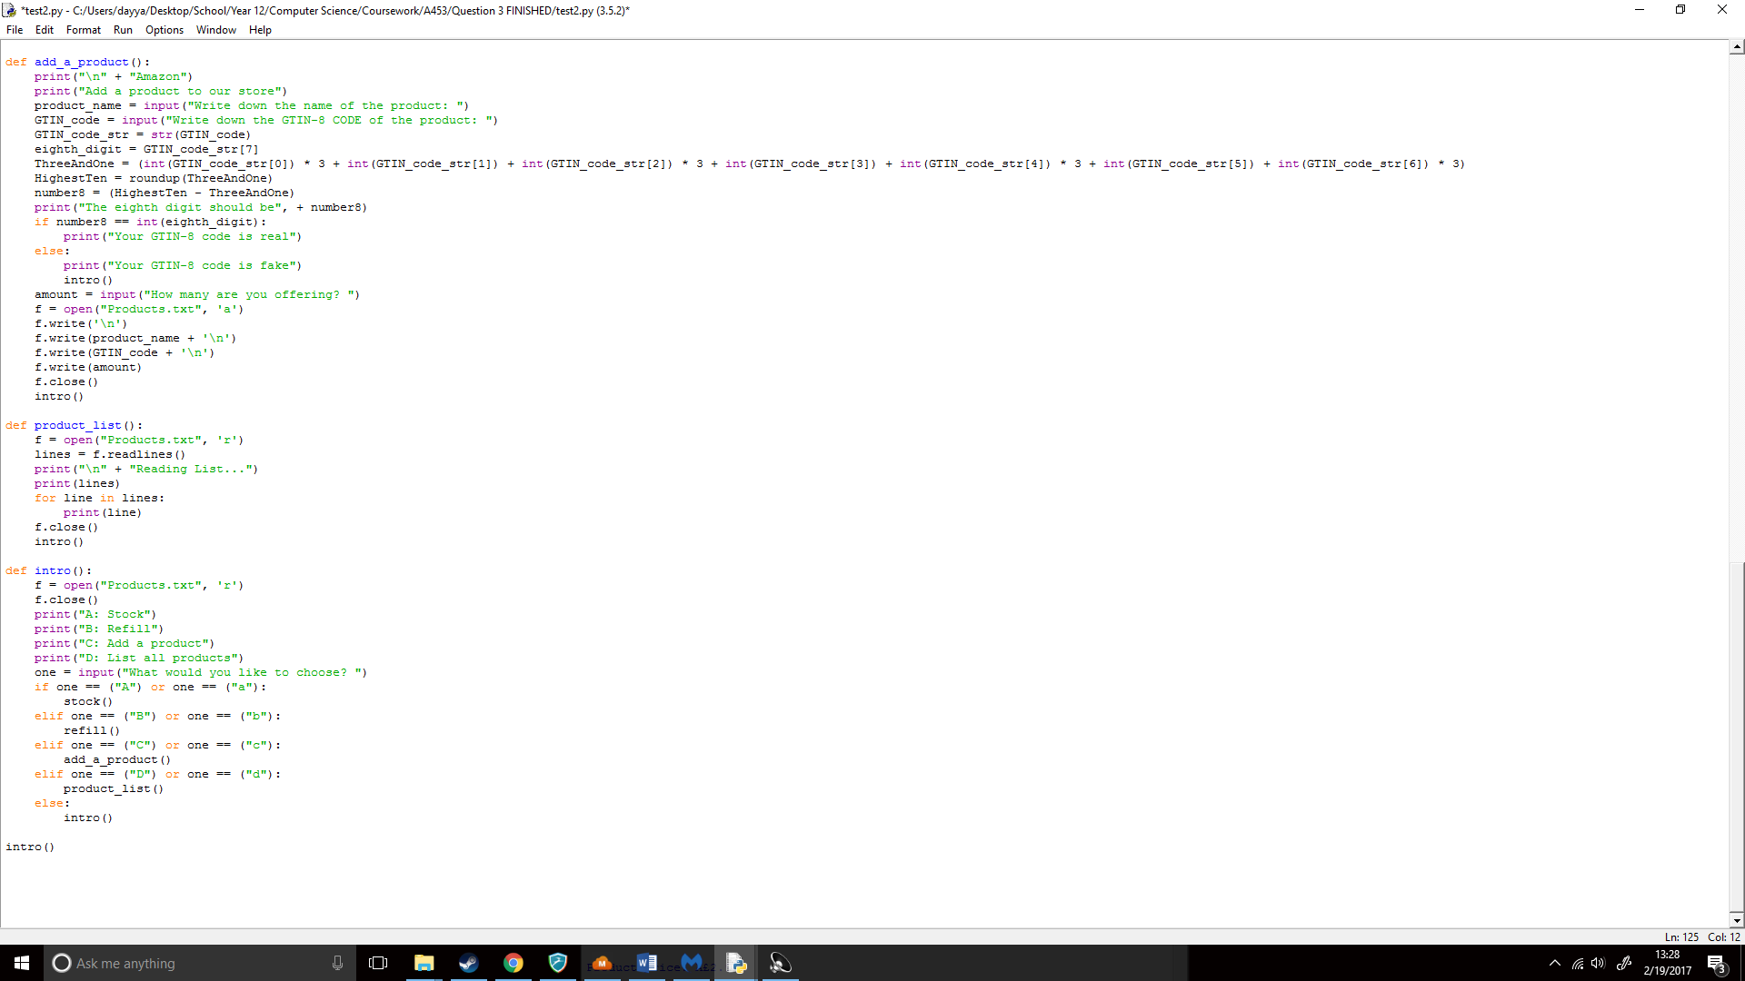I then implemented my list function, I first pasted my list function in:

I now had to set it to print the 6th line onwards. To do this I tried using the following, this would look at every line from the 6th to the last line:

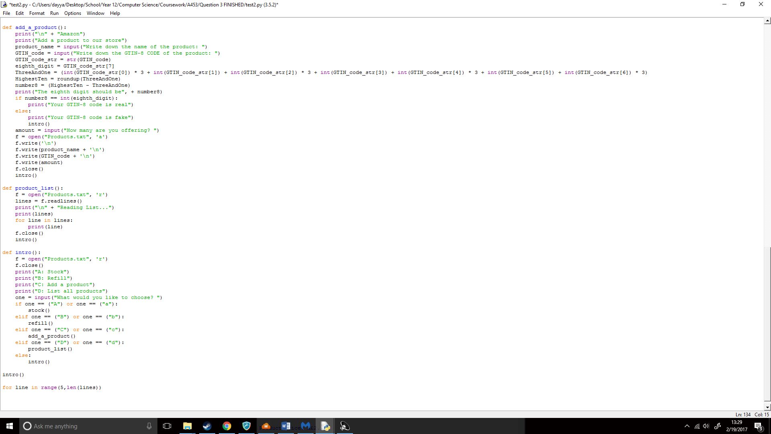

However, when printing it showed:

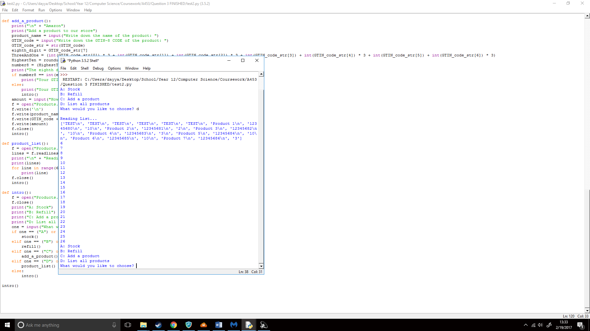

Which was wrong, as it printed where the lines were not what’s in the line. So instead I tried using sub sequence which I found from the Zig Zag guide for Python for KS4

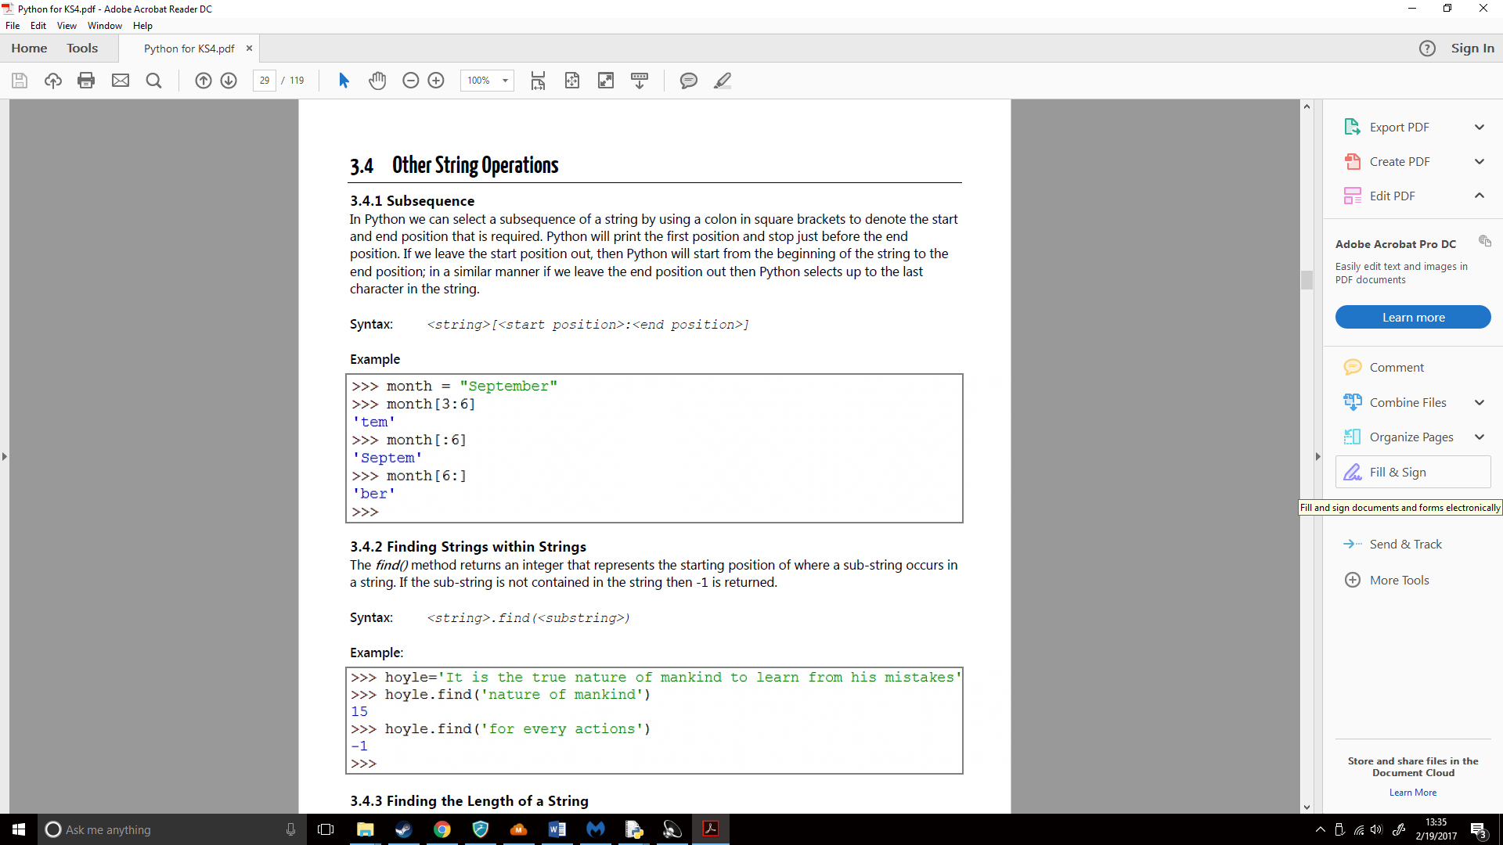

I then implemented this into my code:  
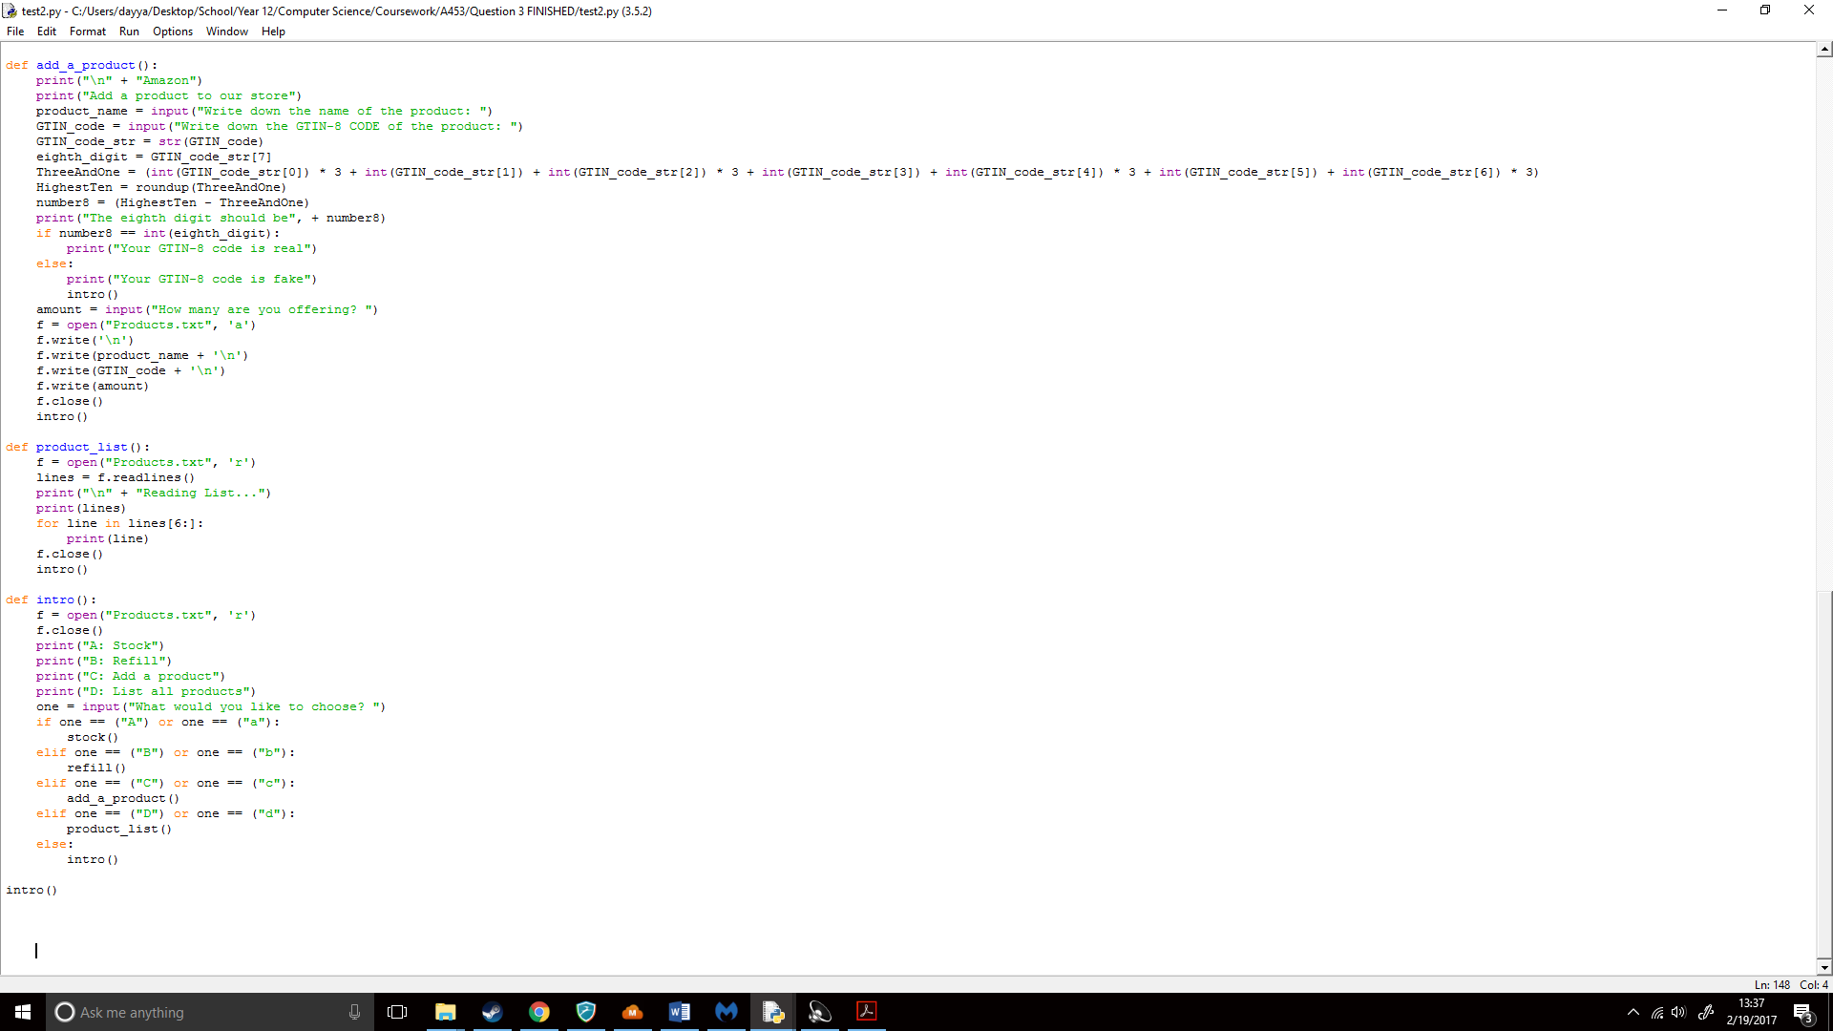

I then ran my code and;

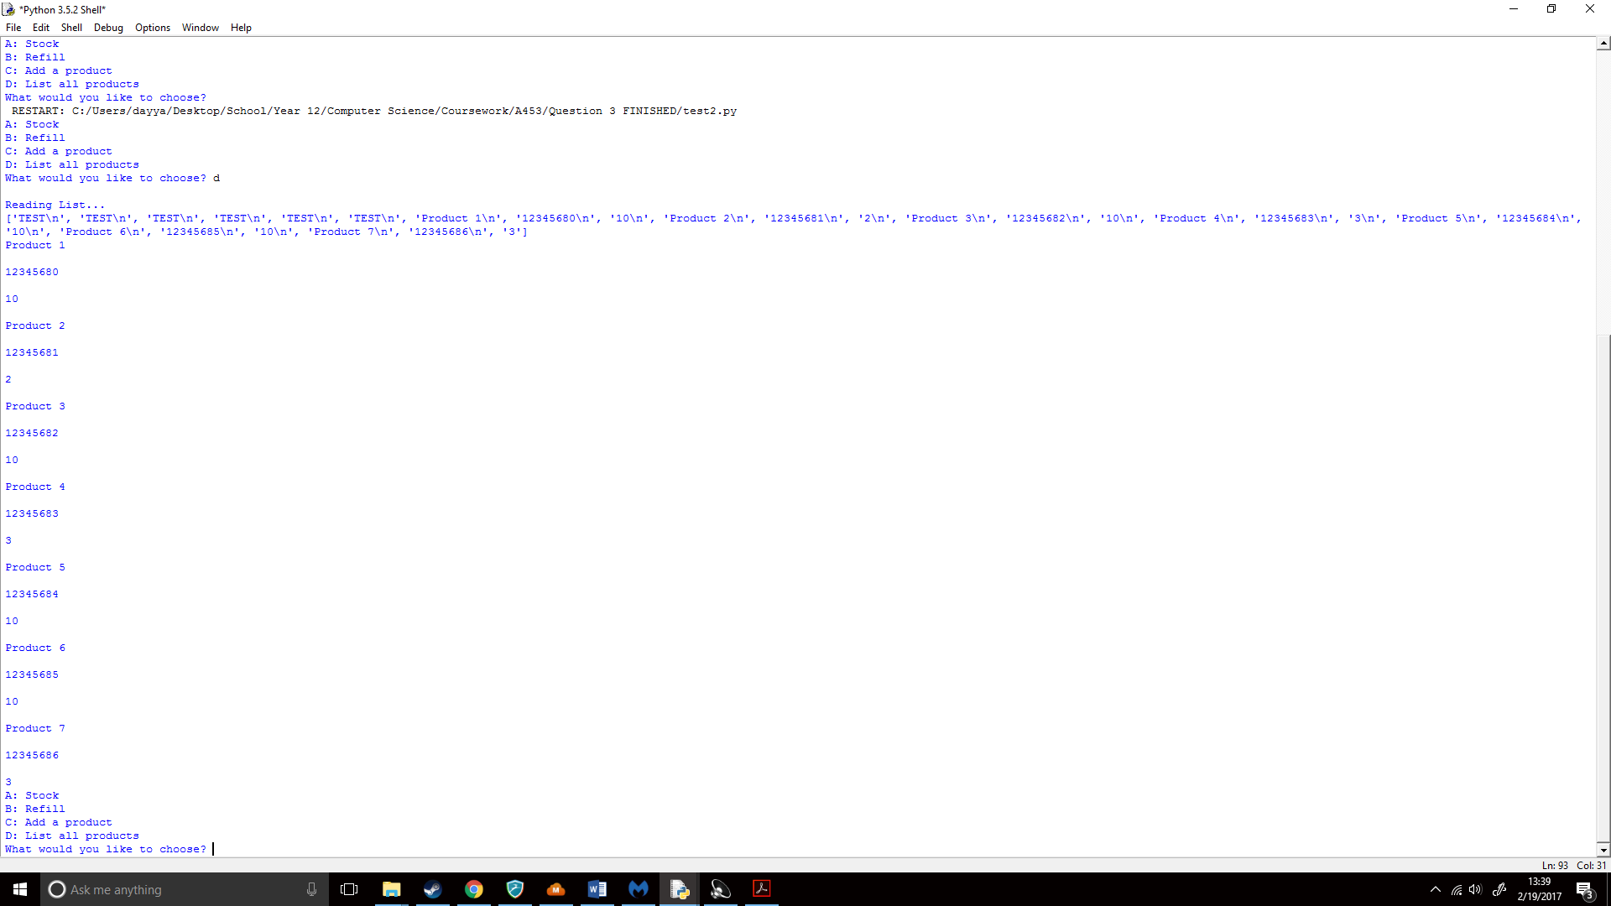

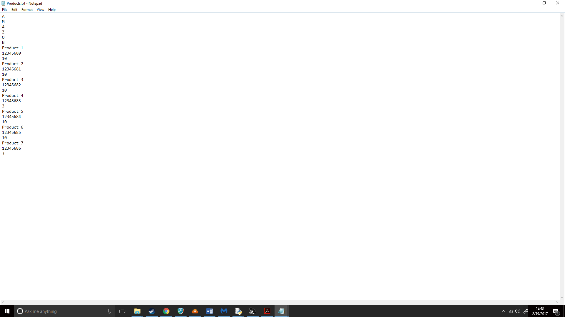It worked correctly! Now to remove the text and replace it. As Unicode didn’t work when I tried using it with Python I had to use normal lettering, but luckily since the TEXT was 6 lines long I could write AMAZON on each line:

## How does overall the code look?

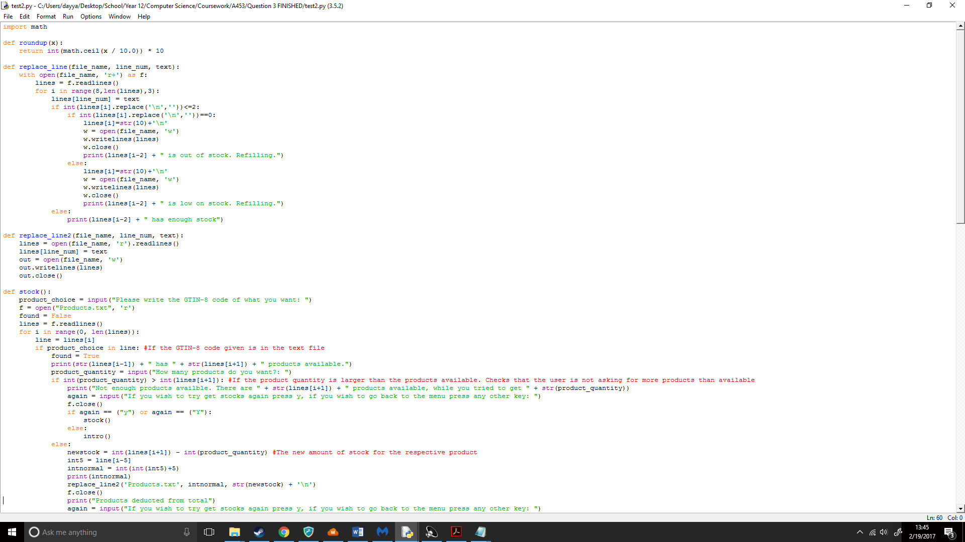My code was finally finished you can see all of it in the following:

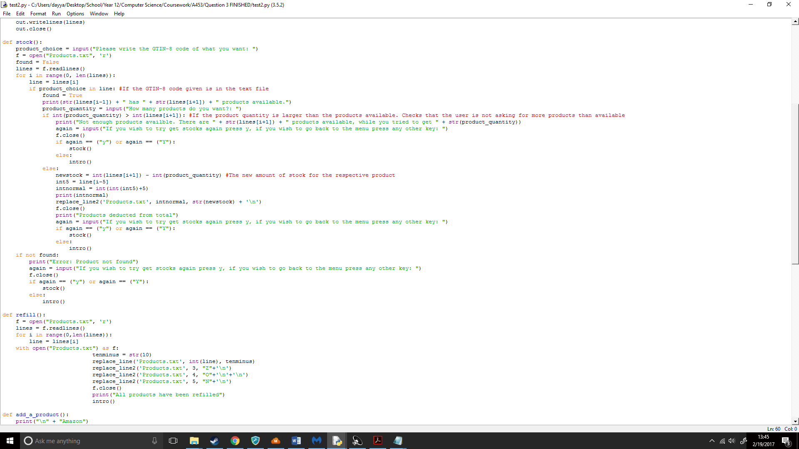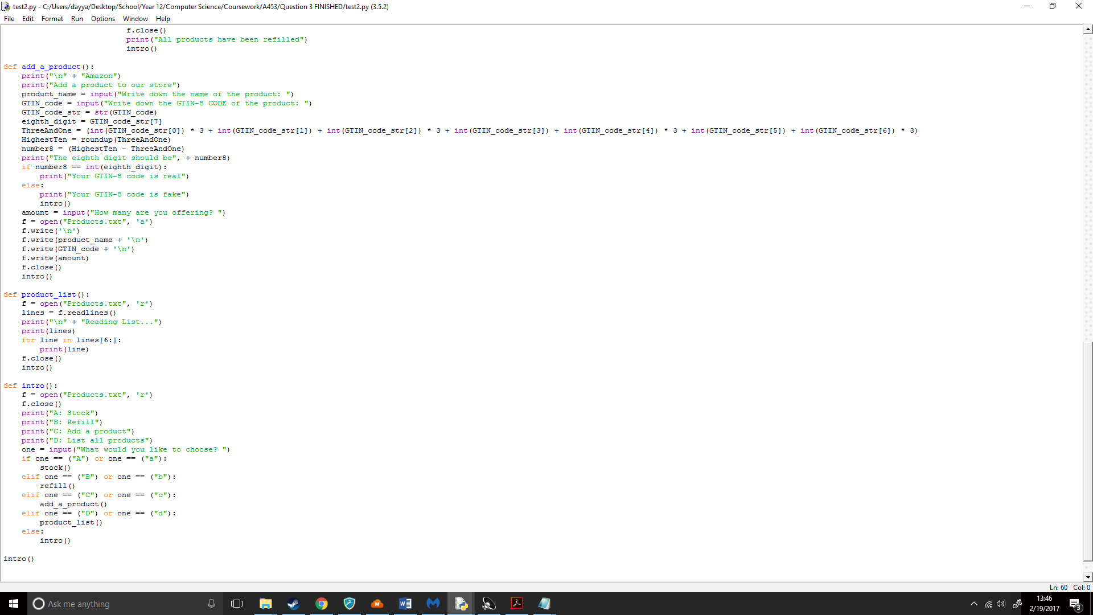

When running the code, it preformed like;

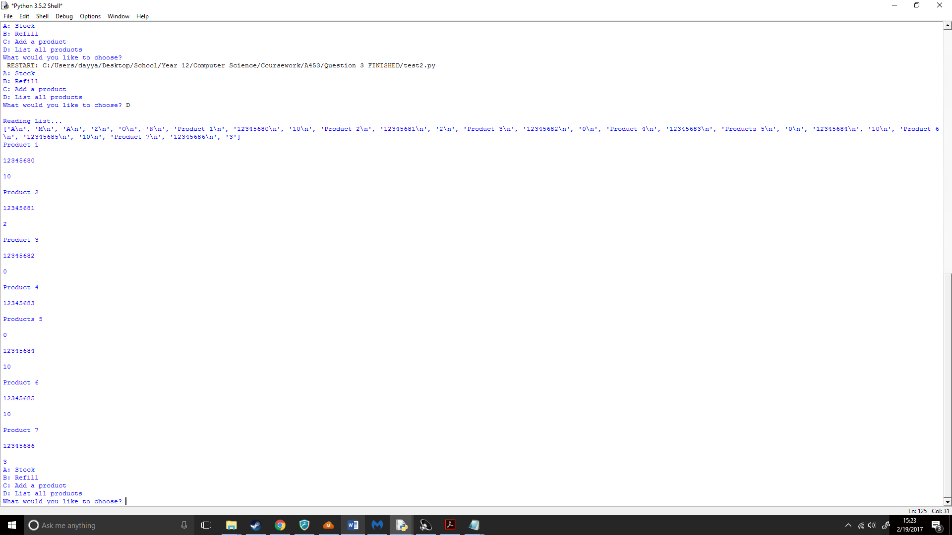

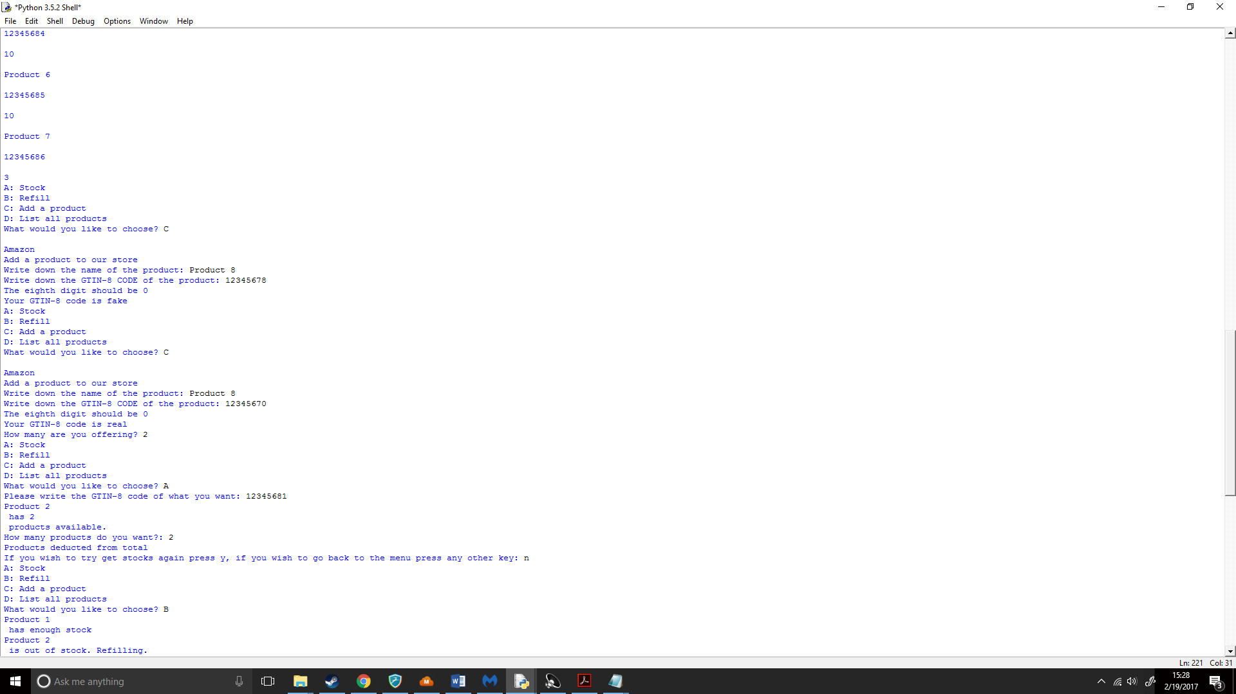

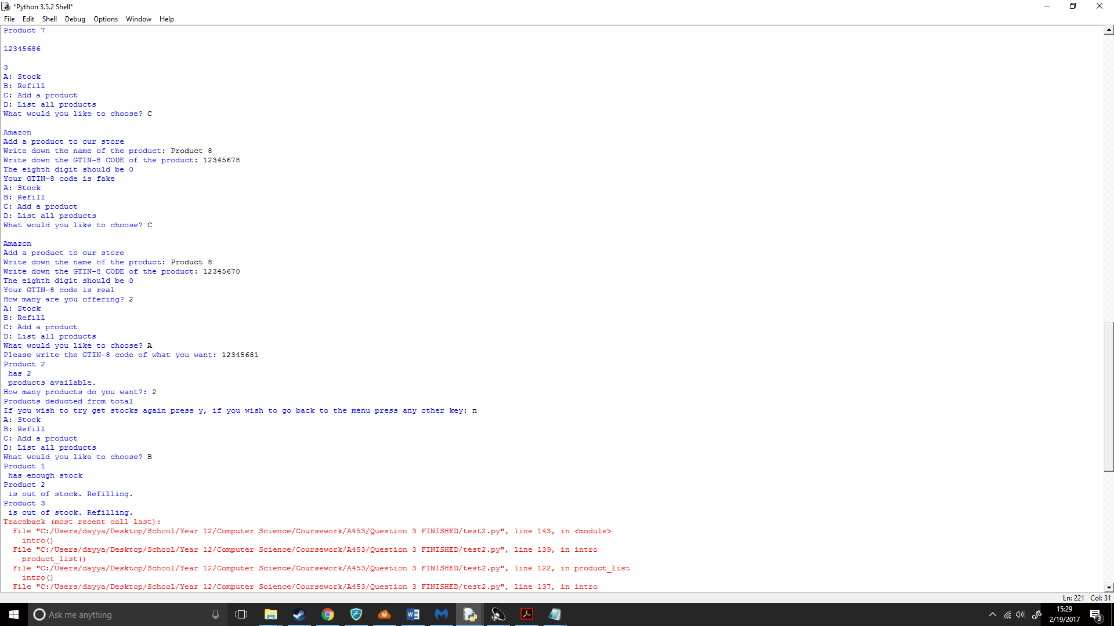

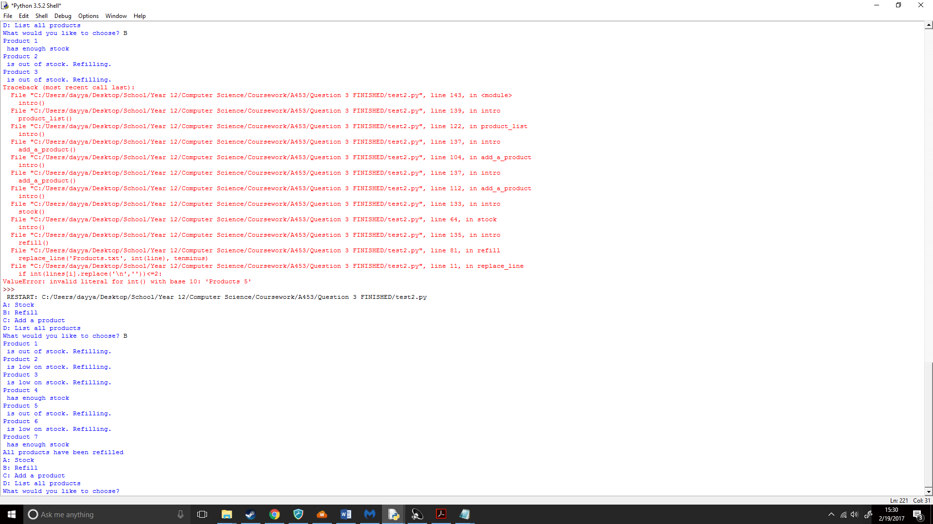

## Pseudo code:

import math

FUNCTION roundup(x):

RETURN int(math.ceil(x / 10.0)) * 10

ENDFUNCTION

FUNCTION replace_line(file_name, line_num, text):

with open(file_name, 'r+') as f:

lines <- f.readlines()

for i in range(8,len(lines),3):

lines[line_num] <- text

IF int(lines[i].replace('\n',''))<=2:

IF int(lines[i].replace('\n',''))==0:

lines[i]=str(10)+'\n'

w <- open(file_name, 'w')

w.writelines(lines)

w.close()

OUTPUT lines[i-2] + " is out of stock. Refilling."

ELSE:

lines[i]=str(10)+'\n'

w <- open(file_name, 'w')

w.writelines(lines)

w.close()

OUTPUT lines[i-2] + " is low on stock. Refilling."

ENDIF

ELSE:

OUTPUT lines[i-2] + " has enough stock"

ENDIF

ENDFUNCTION

ENDFOR

FUNCTION replace_line2(file_name, line_num, text):

lines <- open(file_name, 'r').readlines()

lines[line_num] <- text

out <- open(file_name, 'w')

out.writelines(lines)

out.close()

ENDFUNCTION

FUNCTION stock():

product_choice <- input("Please write the GTIN-8 code of what you want: ")

f <- open("Products.txt", 'r')

found <- False

lines <- f.readlines()

for i in range(0, len(lines)):

line <- lines[i]

IF product_choice in line:

found <- True

OUTPUT str(lines[i-1]) + " has " + str(lines[i+1]) + " products available."

product_quantity <- input("How many products do you want?: ")

IF int(product_quantity) > int(lines[i+1]):

OUTPUT "Not enough products available. There are " + str(lines[i+1]) + " products available, while you tried to get " + str(product_quantity)

ENDWHILE

again <- input("If you wish to try get stocks again press y, IF you wish to go back to the menu press any other key: ")

ENDIF

f.close()

IF again = ("y") OR again = ("Y"):

stock()

ELSE:

intro()

ENDIF

ELSE:

newstock <- int(lines[i+1]) - int(product_quantity)

int5 <- line[i-10]

intnormal <- int(int(int5)+10)

replace_line2('Products.txt', intnormal, str(newstock) + '\n')

f.close()

OUTPUT "Products deducted from total"

again <- input("If you wish to try get stocks again press y, IF you wish to go back to the menu press any other key: ")

ENDIF

IF again = ("y") OR again = ("Y"):

stock()

ELSE:

intro()

ENDIF

ENDIF

ENDIF

ENDFOR

IF not found:

OUTPUT "Error: Product not found"

again <- input("If you wish to try get stocks again press y, IF you wish to go back to the menu press any other key: ")

ENDIF

f.close()

IF again = ("y") OR again = ("Y"):

stock()

ELSE:

intro()

ENDIF

ENDIF

ENDFUNCTION

FUNCTION refill():

f <- open("Products.txt", 'r')

lines <- f.readlines()

for i in range(0,len(lines)):

line <- lines[i]

ENDFOR

with open("Products.txt") as f:

tenminus <- str(10)

replace_line('Products.txt', int(line), tenminus)

replace_line2('Products.txt', 3, "Z"+'\n')

replace_line2('Products.txt', 4, "O"+'\n'+'\n')

replace_line2('Products.txt', 5, "N"+'\n')

f.close()

OUTPUT "All products have been refilled"

intro()

ENDFUNCTION

FUNCTION add_a_product():

OUTPUT "\n" + "Amazon"

OUTPUT "Add a product to our store"

product_name <- input("Write down the name of the product: ")

GTIN_code <- input("Write down the GTIN-8 CODE of the product: ")

GTIN_code_str <- str(GTIN_code)

eighth_digit <- GTIN_code_str[7]

ThreeAndOne <- (int(GTIN_code_str[0]) * 3 + int(GTIN_code_str[1]) + int(GTIN_code_str[2]) * 3 + int(GTIN_code_str[3]) + int(GTIN_code_str[4]) * 3 + int(GTIN_code_str[5]) + int(GTIN_code_str[6]) * 3)

HighestTen <- roundup(ThreeAndOne)

number8 <- (HighestTen - ThreeAndOne)

OUTPUT "The eighth digit should be", + number8

IF number8 = int(eighth_digit):

OUTPUT "Your GTIN-8 code is real"

ELSE:

OUTPUT "Your GTIN-8 code is fake"

intro()

ENDIF

amount <- input("How many are you offering? ")

f <- open("Products.txt", 'a')

f.write('\n')

f.write(product_name + '\n')

f.write(GTIN_code + '\n')

f.write(amount)

f.close()

intro()

ENDFUNCTION

FUNCTION product_list():

f <- open("Products.txt", 'r')

lines <- f.readlines()

OUTPUT "\n" + "Reading List..."

OUTPUT lines

for line in lines[6:]:

OUTPUT line

ENDFOR

f.close()

intro()

ENDFUNCTION

FUNCTION intro():

f <- open("Products.txt", 'r')

f.close()

OUTPUT "A: Stock"

OUTPUT "B: Refill"

OUTPUT "C: Add a product"

OUTPUT "D: List all products"

one <- input("What would you like to choose? ")

IF one = ("A") OR one = ("a"):

stock()

ELSEIF one = ("B") OR one = ("b"):

refill()

ELSEIF one = ("C") OR one = ("c"):

add_a_product()

ELSEIF one = ("D") OR one = ("d"):

product_list()

ELSE:

intro()

ENDIF

ENDFUNCTION

intro()

## Flowchart:

